Oracle version

java(TM) platform 1.7.0_60e1

oracle IDE =4.0.0.13.80

select * from v$version

oracle database enterprise edition

Release 11.2.0.4.0

------

Linux Version

RHEL 7.6 (Fedora)

---

Autosys Version

R11.3

----

Weblogic Version

11GR1 (10.3.5)

Aix version

AIX altaswq1 1 6

1=Print OS release

6=Prints the OS version

Tomcat version 8

Git version 2.23.3

Elastic search version 6.8.6 and 7.16

**====================================================**

# **Unix**

<https://www.linuxtrainingacademy.com/linux-commands-cheat-sheet/>

<https://gist.github.com/LeCoupa/122b12050f5fb267e75f>

shell Scripting- <https://www.youtube.com/watch?v=zWVV31NYi1U>



**What is Unix?**

The Unix operating system is a set of programs that act as a link between the computer and the user.

The computer programs that allocate the system resources and coordinate all the details of the computer's internals is called the operating system or the kernel.

Users communicate with the kernel through a program known as the shell. The shell is a command line interpreter; it translates commands entered by the user and converts them into a language that is understood by the kernel.

## **Scripts**

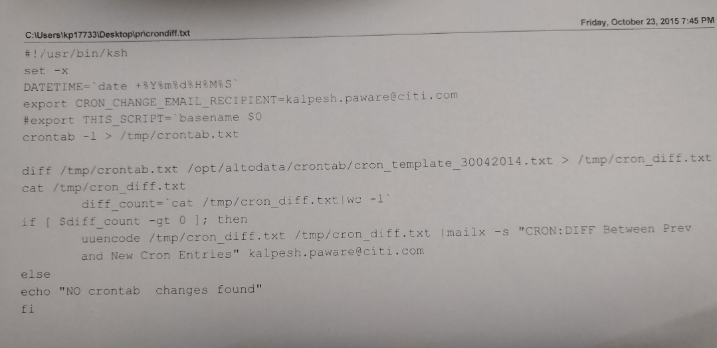

Monitor the application health

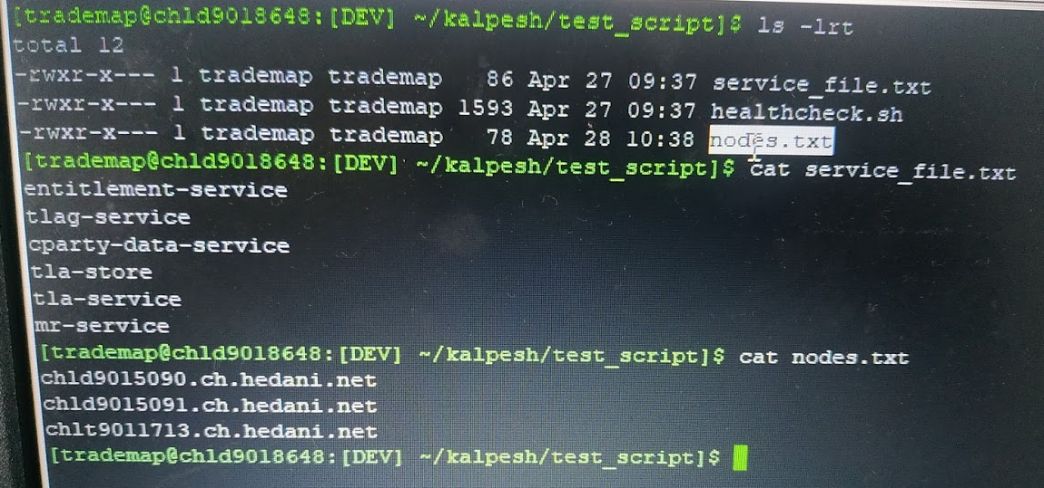

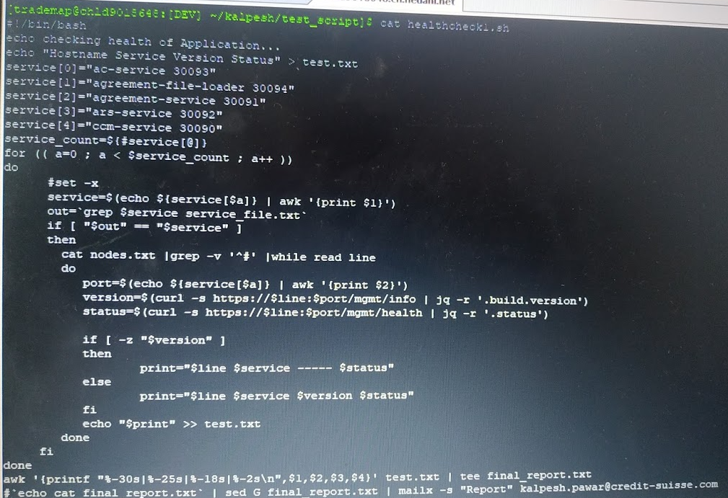

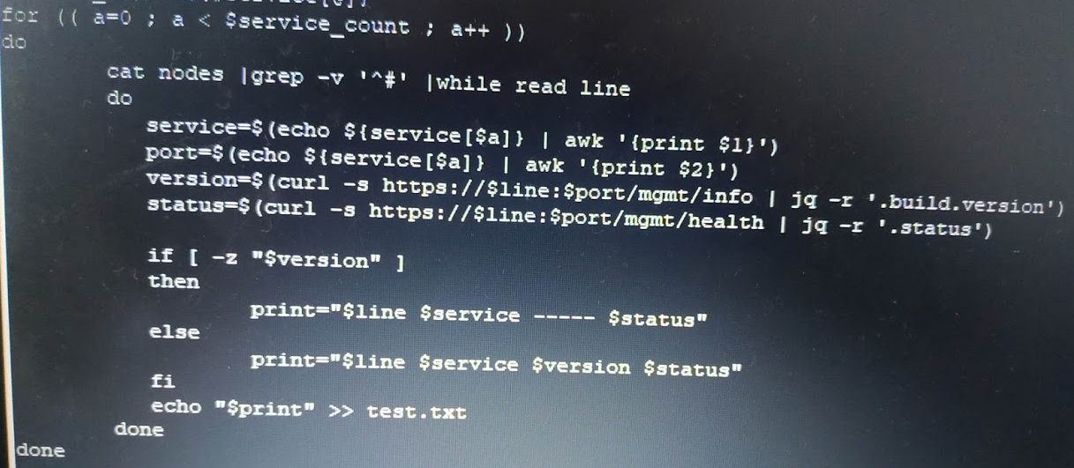

[**Is Shebang line is compulsory**](https://unix.stackexchange.com/questions/423186/diff-how-to-ignore-empty-lines)

shebang line is needed in the file and only if it's meant to be run as executable (as opposed to sh file.sh invocation. It is not actually needed by script, it is for the system to know how to find interpreter.

[**diff - how to ignore empty lines**](https://unix.stackexchange.com/questions/423186/diff-how-to-ignore-empty-lines)

-b, --ignore-space-change

ignore changes in the amount of white space

-w, --ignore-all-space

ignore all white space

----listing directory-------------------

ls -d */

ls -l | grep '^d'

-----------Script for accesssing data from many servers-----

for i in `cat /home/vinod/all_componenet.txt`;

do echo $i;

ssh -t -q -o ConnectTimeout=5 -o UserKnownHostsFile=/dev/null -o StrictHostKeyChecking=no

root@$i cat /etc/passwd|awk -F ":" '{print $1}'|sort|uniq >> /home/vinod/details_users.txt;

done

----------How to read file line by line----------------

#!/bin/bash

input="/path/to/txt/file"

while read line

do

echo "$line"

done < "$input

----------Script to grep the output from particular log file-------

cat number.txt |while read line;

do

grep "$line" /home/sasoro/access.log;

echo $line;

done

-------------------------------------

cat files.txt | awk '{print $NF} |while read line

do

files="$files '$line',"

echo $files

done

=====for loop how to simulate multiple transaction ./simulateflex.ksh GB GB3 50001 X

for i in 50001 500002 50003

do

./simulateflex.ksh GB GB3 $(i) X

done

=======Create files with perticular date and then create multiple files =========

------touch -t MMDDHHMMYY filename

touch -t 06201230 SEPAHUB3.log

---create more files

i=0

while [ $i -lt 5000 ]

do

cp -p SEPAHUB3.log temp.log.$i

let i=i+1

done

======================================================

let i=1;

while [ $i -lt 51 ]

do

cp S222.I S333$i.I

touch S333$i.I.lock

let i=i+1

done

=======check to send the reports===

#!/bin/bash

PATH="/var/www/html/server_logs"

DATE=`/bin/date +\%Y-\%m-\%d`

da="IncidentTypeReport_$DATE.csv"

if [ -f $PATH/$da ]; then

/bin/rm -rf $PATH/$da

fi

/usr/bin/curl -i -k --head http://10.137.6.197/IM_type.php | /bin/grep -i "200 OK"

if [ $? = 0 ]; then

echo " PFA "|/bin/mailx -s "Reactive Proactive incident report" -a $PATH/$da -r saso.appsupport@ril.com

else

echo " "|/bin/mailx -s "Failed: Reactive Proactive incident report" -r rangaswamy.naidu@ril.com uday.shaw@ril.com

fi

### File Checks

Write a script whether file exist in dir

Echo “enter a name \c”

Read fname

If [ -f fname ]

Then

Echo “file is present”

Else

Echo “don’t provide crazy input”

Fi

=====

For directory cheking

[-d fname ]

[-c fname] -Character Special

[-b fname] – Block Special

[-r fname]- read pemission

[-w fname] -write

[-x fname] -execute

[-s fname]-Size of the file.

Example

*Check if /etc/resolve.conf file is exist*

FILE=/etc/resolv.conf

**if** [ -f "$FILE" ]; **then**

echo "$FILE exists."

**else**

echo "$FILE does not exist."

**fi**

FILE=/etc/docker

**if** [ ! -f "$FILE" ]; **then**

echo "$FILE does not exist."

**fi**

You can file exist without the if else

test -f /etc/resolv.conf && echo "$FILE exists."

## **Find Commands**

1) Find Files Under Home Directory

find /home -name tecmint.txt

/home/tecmint.txt

2) Find Files Using Name in Current Directory

find . -name tecmint.txt

3) Find Files Using Name and Ignoring Case

find /tmp -iname test.sh

4) Find Directories Using Name

find / -type d -name Tecmint

/Tecmint

5) Find PHP Files Using Name

# find . -type f -name tecmint.php

./tecmint.php

6) Find all PHP Files in Directory

find . -type f -name "*.php"

./tecmint.php

./login.php

./index.php

7) Find Files With 777 Permissions

find . -type f -perm 0777 -print

8) Find Files Without 777 Permissions

find / -type f ! -perm 777

9) Find Sticky Bit Files with 551 Permissions

find / -perm 1551

10)Find Read Only Files

find / -perm /u=r

11) Find Executable Files

find / -perm /a=x

12) Find Files with 777 Permissions and Chmod to 644

find / -type f -perm 0777 -print -exec chmod 644 {} \;

13) Find Directories with 777 Permissions and Chmod to 755

find / -type d -perm 777 -print -exec chmod 755 {} \;

14) Find and remove single File

find . -type f -name "tecmint.txt" -exec rm -f {} \;

15) Find and remove Multiple File

find . -type f -name "*.txt" -exec rm -f {} \;

16) Find all Empty Files

find /tmp -type f -empty

17) Find all Empty Directories

find /tmp -type d -empty

18) Find all Hidden Files

find /tmp -type f -name ".*"

19) Find Single File Based on User

find / -user root -name tecmint.txt

20) Find Last 50 Days Modified Files

find / -mtime 50

find all the files which are modified 50 days back.

21)Find Last 50 Days Accessed Files

find / -atime 50

To find all the files which are accessed 50 days back.

22)Find Last 50-100 Days Modified Files

find / -mtime +50 –mtime -100

23)Find Changed Files in Last 1 Hour

find / -cmin -60

24)Find Modified Files in Last 1 Hour

find / -mmin -60

25)Find Accessed Files in Last 1 Hour

find / -amin -60

26)Find 50MB Files

find / -size 50M

27)Find Size between 50MB – 100MB

find / -size +50M -size -100M

28)Find and Delete 100MB Files

find / -size +100M -exec rm -rf {} \;

29) Find Specific Files and Delete

find / -type f -name *.mp3 -size +10M -exec rm {} \;

30)check the total line of all the files in a directory

find . -type f -exec wc -l {} +

## **SED Commands**

**ADD**

sed -i '1i\'"I am fine man" $Filename Add the line at the start of the file

sed -i '$ a\'"DATTAAAA" $Filename Add the line at the end of file

**Replace**

sed 's/unix/linux/' file.txt replaces the word "unix" with "linux" in the file

sed 's/unix/linux/2' file.txt Replacing the nth occurrence of a pattern in a line

sed 's/unix/linux/g' file.txt Replacing all the occurrence of the pattern in a line.

sed 's/unix/linux/3g' file.txt Replacing from nth occurrence to all occurrences in a line.

sed '3 s/unix/linux/' file.txt Replacing string on a specific line number.

sed '1,3 s/unix/linux/' file.txt Replacing string on a range of lines

**Print**

sed -n '1,2p' testdata Printing first two lines

sed -n '5,6p' testdata Printing 5- and 6-line lines

sed -n '$p' testdata Print the last line

**Delete**

sed '2 d' file.txt delete particular line from file lines.

sed '1d' sed-demo.txt delete first line

sed '$d' sed-demo.txt delete last line

sed '5,7d' sed-demo.txt delete range of lines

sed '1d;5d;9d;$d' sed-demo.txt delete mulitple lines

sed '/^$/d' sed-demo.txt delete empty and blank line

sed '/fine/d' testdata >data delete lines having word fine from a file

## **Unix Architecture**

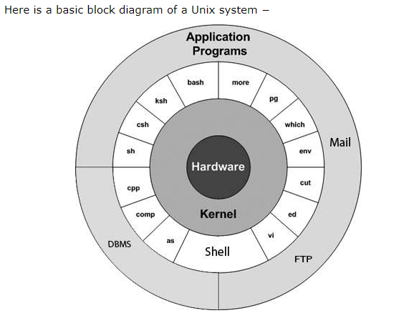

The main concept that unites all the versions of Unix is the following four basics −

* **Kernel** − The kernel is the heart of the operating system. It interacts with the hardware and most of the tasks like memory management, task scheduling and file management.
* **Shell** − The shell is the utility that processes your requests. When you type in a command at your terminal, the shell interprets the command and calls the program that you want. The shell uses standard syntax for all commands. C Shell, Bourne Shell and Korn Shell are the most famous shells which are available with most of the Unix variants.
* **Commands and Utilities** −
* **Files and Directories** −.

## **Linux Features**

* **Multiuser capability:**
* **Multitasking:**
* **Portability:**
* **Security:**
* **Live CD/USB:**
* **Graphical User Interface (X Window system):**
* **Support's customized keyboard:**
* **Application support.**
* **File System**
* **Open Source**

## **Linux Distributions List**

* Ubunu
* Linux Mint
* Debian
* Red hat Enterprise
* Fedora

## **Linux Filesystem**

* / "Root",the top of the file system hierarchy
* /home home dir for other users than root,store data files
* Boot it contains bootable (OS startup files) files for linux like --> init
* /bin, Binaries and other executable programs

It contains commands used by all users including root user

/sbin It contains commands used by only root user

* /etc it contains all Configuration Files (/etc/passwd)
* /opt Optional or third-party software
* /tmp Temporary space,typically cleared on reboot
* /usr by default software are installed in this dir /usr/bin, /usr/sbin,
* /opt optional application software packages
* /var Variable data, most notably log files
* /dev device files.this include terminal devices,hub,usb which is attached

==================================================

## **Linux Boot Process**

* **BIOS**
* **BOOT LOADER**
* **KERNEL**
* **RUN LEVEL**

1. **BIOS -Basic input/output System check**

Checks/Test hardware component (Hardware/USB/DVD)

Post process of BIOS boot loader runs

1. **Boot Loader**

**LILO/GRUB**-Linux loader, its boot loader for the linux system.it is used to load Linux into the memory and start the OS.

Main conf file is /etc/LIOL.conf.

now adays instead of LILO grub(grab unified boot loader) is using.

Once it is done it is passed to kernel

1. **Linux kernel**

kernel is the core of the operating system. It establishes communication between devices and software. Moreover, it manages the system resources. Basically it has four responsibilities:

* **device management:** A system has many devices connected to it like CPU, memory device, sound cards, graphic cards, etc. A kernel stores all the data related to all the devices in device driver (without this kernel won't be able to control the devices). Thus kernel knows what a device can do and how to manipulate it to bring out the best performance. It also manages communication between all the devices. Kernel has certain rules that has to be followed by all the devices.
* **Memory management:** Another function that kernel has to manage is the memory management. Kernel keeps a track of used and unused memory and make sure that processes shouldn't manipulate data of each other using virtual memory address.
* **Process management:** In process management kernel assign enough time and gives priorities to processes before handling CPU to other process. It also deals with security and ownership information.
* **Handling system calls:** Handling system calls means a programmer can write a query or ask the kernel to perform a task.

1. **Run Level**

Run level are controlled by init programme

Init Configuration is stored in /etc/inittab

**init**

It is the first process executed by the kernel during the booting of a system. It is a daemon process which runs till the system is shutdown. That is why, it is the parent of all the processes. First of all, **init** reads the script stored in the file **/etc/inittab.**Command **init** reads the initial configuration script which basically take care of everything that a system do at the time of system initialization like setting the clock, initializing the serial port and so on.

By reading this file, **init** determines how the system should be set up in each run level and sets default run level.

After determining default runlevel for the system, **init** starts all background processes required to run the system. First it runs each of the kill script (their file name starts with a K) with a stop parameter. Then it runs all start scripts (their file name starts with an S) to start all services and applications.

There are basically 8 runlevels in unix. I will briefly tell something about the different init levels and their use.

Run Level:  At any given time, the system is in one of eight possible run levels.  A run level is a software configuration under which only a selected group of processes exists.  Processes spawned by init for each of these run levels are defined in /etc/inittab. init can be in one of eight run levels, 0-6 and S  or  s (S and s are identical). The run level changes when a privileged user runs /sbin/init.

init 0 :  Shutdown (goes thru the /etc/rc0.d/* scripts then halts)

init 1  :  Single user mode or emergency mode means no network no multitasking is present in this mode only root has access in this runlevel

init 2  :  No network but multitasking support is present .

init 3  :  Network is present multitasking is present but with out GUI .

init 4  :  It is similar to runlevel 3; It is reserved for other purposes in research.

init 5  :  Network is present multitasking and GUI is present with sound etc.

init 6  :  This runlevel is defined to system restart.

init s   : Tells the init command to enter the maintenance mode. When the

system enters maintenance mode from another run level, only the system console

is used as the terminal.

***init.d*** is the sub-directory of */etc* directory in Linux file system. init.d basically contains the bunch of start/stop scripts which are used to control (start,stop,reload,restart) the daemon while the systeem is running or during boot. If you look at */etc/init.d* then you will notice all the scripts for different services of your system.

**How to check the kernel messages of system boot up later**

dmesg

===================================================

**SWAP space**-If amount of physical memory (RAM) is full. If system requires more resources and RAM is full then inactive pages/processes move to SWAP memory.

Swap partition -Size of SWAP is twice the double amount of physical memory

You can say that it is virtual RAM

It is used when RAM does not have enough space to hold all programs that are executing.

**Inode-**Information about the file(metadata) such file size, ownership, accessed time is stored in Inode while data (content) is stored in data block

Each file is given a unique name by the operating system which is called as the inode.

**LVM-Logical volume manager**

It is required to resize filesystem size online.

We required LVM partition in Linux.

Size of LVM partition can be extended and reduce using the lvextend and lvreduce commands

====================================================

## **UNIX QUESTIONS**

* **What is Linux?**

Linux is a UNIX based operating system. It is an open source operating system that was designed to provide free and a low-cost operating system for the computer users.

* **What is the difference between UNIX and Linux?**

UNIX was originally started as a propriety operating system for Bell Laboratories, which later release their commercial version while Linux is a free, open source and a non-propriety operating system for the mass uses.

* **What is Linux Kernel?**

Linux Kernel is low-level system software. It is used to manage the hardware resources for the users. It provides an interface for user-level interaction.

* **Is it legal to edit Linux Kernel?**

Yes. You can edit Linux Kernel because it is released under General Public License (GPL) and anyone can edit it. It comes under the category of free and open source software.

* **What is LILO?**

LILO is a boot loader for Linux. It is used to load the Linux operating system into the main memory to begin its operations.

* **What is the advantage of open source?**

Open source facilitates you to distribute your software, including source codes freely to anyone who is interested. So, you can add features and even debug and correct errors of the source code.

* **What are the basic components of Linux?**

Just like other operating systems, Linux has all components like kernel, shells, GUIs, system utilities and application programs.

* **What is the advantage of Linux**?

Every aspect comes with additional features, and it provides a free downloading facility for all codes.

* **Define shell**

It is an interpreter in Linux.

* **Name some shells that are commonly used in Linux.**

The most used shells in Linux are bash, csh, ksh, bsh.

* **Name the Linux which is specially designed by the Sun Microsystems.**

Solaris is the Linux of Sun Microsystem

* **Name the Linux loader.**

LILO is the Linux loader.

* **Write about an internal command.**

The commands which are built in the shells are called as the internal commands.

* **If the programmer wishes to execute an instruction at the specified time. Which command is used?**

The 'at' command is used for the same.

* **What is the basic difference between BASH and DOS?**

BASH commands are case sensitive while DOS commands are not case sensitive.

DOS follows a convention in naming files. In DOS, 8 character file name is followed by a dot and 3 characters for the extension. BASH doesn't follow such convention.

* **What does dos2unix and Unix2dos command**

dos2unix command : converts a DOS text file to UNIX format.

Unix2dos command : converts a Unix text file to DOS format

* **What is a root account?**

The root account is like a system administrator account. It provides you full control of the system. You can create and maintain user accounts, assign different permission for each account, etc.

* **What is CLI?**

CLI stands for Command Line Interface. It is an interface that allows users to type declarative commands to instruct the computer to perform operations.

* **Which popular office suite is available free for both Microsoft and Linux?**

Open Office Suite is available free for both Microsoft and Linux. You can install it on both of them.

* **Suppose your company is recently switched from Microsoft to Linux and you have some MS Word document to save and work in Linux, what will you do?**

Install Open Office Suite on Linux. It facilitates you to work with Microsoft documents.

* **What is SMTP?**

SMTP stands for Simple Mail Transfer Protocol. It is an internet standard for mail transmission.

* **What is Samba? Why is it used?**

Samba service is used to connect Linux machines to Microsoft network resources by providing Microsoft SMB support.

* **Is Linux Operating system virus free?**

No, There is no operating system till date that is virus free, but Linux is known to have less number of viruses.

* **What is the difference between soft and hard mounting points?**

In the soft mount, if the client fails to connect the server, it gives an error report and closes the connection whereas in the hard mount, if the client fails to access the server, the connection hangs; and once the system is up, it again accesses the server

* **What are the modes used in VI editor?**

There are 3 types of modes in vi Editor:

* Regular mode or command mode
* Insertion mode or edit mode
* Replacement mode or Ex-mode
* **How to grep word without printing whole line**

grep -o “word”

* **what is the 000 permission**
* **what is difference between cat and more and less**

Cat displays file contents. If the file is large the contents scroll off the screen before we view it.

'more' is like a pager which displays the contents page by page.

**If you deployed application on Sunday and when you deployed it was working fine but when you come on Monday it gets crashed how will you resolved it**.

**If application fails to start what will you check**

**how to check the last successful command in linux or How to access the last return value in bash?**

$?

* **Difference in whitespace between two files on Linux**

**diff -w** it will ignore the all-whitespaces

* **How to get the last file in Linux**

ls -lrt | tail -1

**How to do ssh without password(passwordless) & sftp without password**

* Generate the public key private key pair. ...
* Change directory to . ...
* Copy the rsa public key to the remote host on path /home/ssh/authorised_key
* login to the remote host with **password**. ...
* Rename the public key file, id_rsa.pub, to authorized_keys ; ...
* Change the key file and directory permissions.

[**How to run a .sh-script from any path in a terminal?**](https://stackoverflow.com/questions/29235154/how-to-run-a-sh-script-from-any-path-in-a-terminal)

* Create yourself a directory $HOME/bin. Put all your executable scripts in it (make them executable with chmod +x script if need be**††**). This way, there's one place to look for the scripts you want to run.
* Add $HOME/bin to your PATH. I put mine at the front: PATH="$HOME/bin:$PATH, but you could put it at the back if you prefer.
* Update your .profile or .bash_profile (or possibly .bashrc) file to set PATH. Beware of a continually growing PATH, though

**what is file command**

File command tells you information about the file

file <filename>

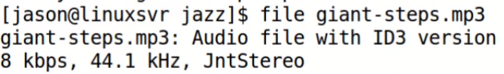

**How to check if there are no parameters provided to a command?**

if [ $# -eq 0 ]; then

echo "No arguments provided"

exit 1

fi

-eq,-ne,-gt,-lt,-ge,-le

### Control Operators ($?,$$,$0,$#)

$? --The exit status of the last command executed.

$$ --give the PID of current shell

$! --The process number of the last background command.

$0 --The filename of the current script.

$# --The number of arguments supplied to a script.

; -- More than one command can be used in the single line

# -- Comments

& -- run the command in the background

|| -- logical or

\ -- escape character

exmaple

#!/bin/ksh

echo "File Name: $0"

echo "First Parameter : $1"

echo "Second Parameter : $2"

echo "Quoted Values: $@"

echo "Quoted Values: $*"

echo "Total Number of Parameters : $#"

*output of the above script*

File Name: test.sh

First Parameter : kalpesh

Second Parameter : pawar

Quoted Values: kalpesh pawar

Quoted Values: kalpesh pawar

Total Number of Parameters : 2

**36) Create a read-only file in your home directory and give permission?**

### File Permission and Sticky Bit on Directory

$ touch filename

"chmod" command? What do you understand by this line “r-- -w- --x?

Below are the various ways to give permission

chmod 400 file

chmod u+x,g+r,o+w

chmod u-x,g-r,o-w

chmod a+w file (write pemission to all)

chmod u=rwx,g=rw,o=r file

**How to add/remove sticky bit**

Files can be protected in a directory from getting removed by other users who do not own it by preventing it with **sticky bit**

chmod +t new1 or chmod 1777 new1

chmod -t new1 or chmod 0777 new1

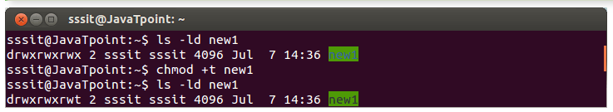

**37) How will you find which operating system your system is running on in UNIX?**

uname -a (you can get whether system is 32 bit or 64 bit or kernel version)

**38)How to list the files**

ls -lrt

**39)How will you run a process in background? How will you bring that into foreground and how will you kill that process?**

By using nohup and & at the end of command

nohup mycommand &

background use "&" in command line.

for foreground use - fg jobid

**40)** ---top five processes---

ps -aef |sort -r |head -5

* ps -e display all processes
* pe -ef display all processes, full
* ps -eH display a process tree
* ps -p <processed>
* pstree -aup <pid>

if you want to kill all processes at once then use command **kill 0**

**40)** How to find if script is running or not

Ps -aux | grep “script name”

**41)** How can we find the process name from its process id?

We can use “ps –p ProcessId”

**40) How do you know if a remote host is alive or not?**

ping or telnet

**41) How do you copy file from one host to other or over Network?**

### SCP and SFTP

* SCP -secure copy

scp file1.txt file2.txt kp17733@altamwv1:/tmp/kalpesh

or

scp kp17733@altamwv1:/tmp/kalpesh/file.tar .

* SFTP – SSH/Secure file transfer protocol

sftp username@hostname

sftp > put -r locale_directory

Graphical Clients

* FileZilla
* WinScp
* Cyberduck

**42) How do you find which process is taking how much CPU and maximum memory?**

The top command displays all the running process within the environment of your system. It helps in monitoring system usage and performances. It is mainly used to detect load on the server by system administrators.

top -c

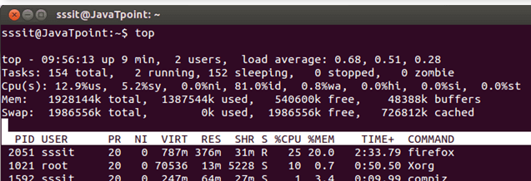

**What is load average in CPU (Top Command)**

System **load**/**CPU Load** – is a measurement of **CPU**over or under-utilization in a Linux system; the number of processes which are being executed by the**CPU** or in waiting state. **Load average** – is the**average** system **load** calculated over a given period of time of 1, 5 and 15 minutes

**43) How do you check how much space left in current drive ?**

df -h

du -sh is used to check the size folder

The 'df' command tells about the disk space used in the file system. It defines the number of blocks used, number of blocks available and the directory where file system is mounted.

**44) difference between du and df or**

**how to check for the free disk space (file system)**

### DF and DU difference -

DF(disk free) looks at disk used blocks directly in filesystem metadata.

Because of this it returns much faster that du but can only show info about the entire disk/partition. ...

df -k

df -g

df -m

DU(disk usage) is used more than df in day to day project as it shows the disk usage as per directory level.

Basically, df reads the superblock only and trusts it completely. du reads each object and sums them up.

**45) In a file word UNIX is appearing many times? How will you count number?**

grep -c "Unix" filename and using wc -l

**46) Switching Users and Running Commands as others**

su oracle

sudo superuser

Changing the sudo Configuration

vi /etc/sudoers

**47) How do you find for how many days your Server is up?**

uptime

**48) Find Last 50 Days Modified Files**

# find / -mtime 50

**49 )Find Specific Files and Delete**

# find / -type f -name *.mp3 -size +10M -exec rm {} \;

**50)find and delete files older than 5 days in a folder**

find /path/to/files* -mtime +5 -exec rm {} \;

**51) How to start the script**

#!/bin/sh -shebang

If you don’t use the shebang line in the script, then it will use the current shell

**52) Crontab**

### Crontab Details –

0 20 * * * /home/oracle/scripts/export_dump.sh

# +------------- min (0 - 59)

# ¦ +-------------- hour (0 - 23)

# ¦ ¦ +--------------- day of month (1 - 31)

# ¦ ¦ ¦ +---------------- month (1 - 12)

# ¦ ¦ ¦ ¦ +----------------- day of week (0 - 6) (0 to 6 are Sunday to

# ¦ ¦ ¦ ¦ ¦ Saturday, or use names; 7 is also Sunday)

# ¦ ¦ ¦ ¦ ¦

# ¦ ¦ ¦ ¦ ¦

# * * * * * command to execute

run after every 30 seconds

*/30 * * * *

What is mean my all * in crontab

So * * * * \***means** every minute of every hour of every day of every month and every day of the week

***“How to disable the crontab without touching the crontab file”***

If you have the root access, then use below comamnd

sudo /etc/init.d/crond stop

sudo /etc/init.d/crond start

else take backup of crontab file and then remove it

Back up the crontab: crontab -l > my_cron_backup.txt

How to add jobs- Crontab -e

Then you can empty/remove it: crontab -r

**:** **Two files of crontab command are**:

* cron.allow – It decides which users need to be permitted from using crontab command.
* cron.deny – It decides which users need to be prevented from using crontab command.

**53) What is the difference between cmp and diff**

### Difference between CMP and Diff -

**diff** – Basically, it tells about the changes which need to be made to make files identical.

sdiff -side by side comparison

vimdiff- Highlight difference in vim

**cmp** – Basically it compares two files byte by byte and displays the very first mismatch.

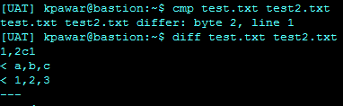

**54) what it the difference between ls and more,view,cat**

cat-display whole file

more -starts from first

**55) how do you find which processes are using a particular file or**

**How do you check if file is being used by another process in linux**

lsof command

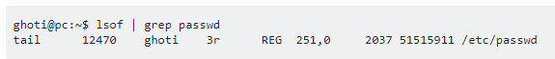

lsof | grep filename.tar.gz

**56) what is FQDN**

It is “*fully qualified domain name”* and u can get it using command -hostname -f

### Memory and CPU checking

**58) how to check the total memory allotted to machine.**

vmstat

(free -m,/proc/meminfo,vmstat -a)

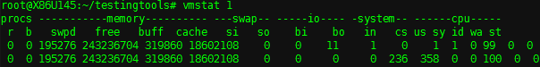

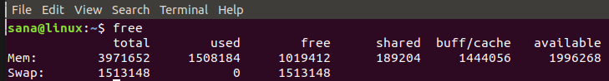

**59) how to check the total CPU allocated to machine.**

1. lscpu command
2. cat /proc/cpuinfo
3. top or htop command
4. nproc command
5. sar -r
6. hwinfo command
7. dmidecode -t processor command
8. getconf _NPROCESSORS_ONLN command

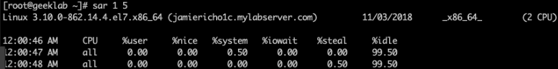

**60) how to get information about hardware component, bios, serial number**

dmidecode

**61) How to check ip address –**

ifconfig or ip -r

**62) What environment variables are, what they do and how to control them**

---Viewing Environment Variable--

$printenv

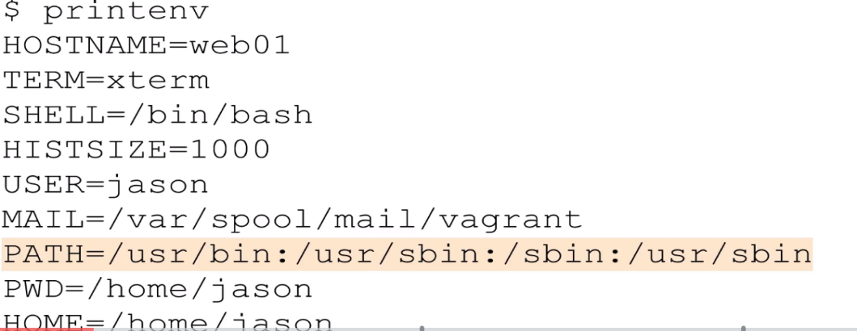

---Check the value of Environment Variable—

echo $HOME

printenv HOME

---Creating Environment Variables---

export VAR=’value’

---disable the environment variable---

unset ‘value’

**63) how do you see service is running**

Service nginx status

systemctl status nginx (newer version)

**64) how would you check for the open ports on Linux machine**

netstat -tulpn |grep 8080

t-tcp,u-udp,l-listening,

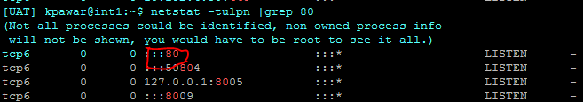

**65) how do you mount new hard-drive/partition**

mount -t type **<device>** **<directory>**

The mount command attaches the filesystem of an external device to the filesystem of a system. It mounts the external storage devices like hard disks, pen drives, USBs etc.

ls /mnt --there always mount dir on root

mount /dev/sda2/mnt

checking existing mount - **mount** -this command is used

mount volume at boot level below file is used

/etc/fstab

**66) find particular log in the file**

grep "01/Oct/2016:1[3-4]:2[0-5]" access.log |grep 400 |wc -l ------- check the error log between 13:20 to 14:25 and count

grep "01/Oct/2016:1[3-4]:[2-3]0" access.log |grep 400 |wc -l ------- check the error log between 13:20 to 14:30

**67) what is umask value**

0022

68) what is start-up script in Linux

Init script

**69) swap column using awk**

awk ' { t = $1; $1 = $2; $2 = t; print; } ' input_file

**70) suppose if any command is not running on a machine then what is that means.**

That means command is not install

**71) how to copy file have separated words ....**

while copying put the file in single quote ''

**72) How to count number of line from the file**

wc -l <file-name>

**73) How to solve java.lang.OutOfMemoryError: Java heap space**

The user can open unlimited number of files, and the program keeps the opened objects in the memory.

I could increase the max heap size using command line option to java,

* An easy way to solve OutOfMemoryError in java is to [increase the maximum heap size](http://javarevisited.blogspot.com/2011/08/increase-heap-size-maven-ant.html) by using JVM options "-Xmx512M", this will immediately solve your OutOfMemoryError. This is my preferred solution when I get OutOfMemoryError in Eclipse, Maven or ANT while building project because based upon size of project you can easily run out of Memory.here is an example of increasing maximum heap size of JVM, Also its better to keep -Xmx to -Xms ration either 1:1 or 1:1.5 if you are setting heap size in your java application  
    
  **export JVM_ARGS="-Xms1024m -Xmx1024m"**  
    
  The second way to resolve OutOfMemoryError in Java is rather hard and  comes when you don't have much memory and even after increase maximum heap size you are still getting java.lang.OutOfMemoryError, in this case, you probably want to profile your application and look for any memory leak. You can use [Eclipse Memory Analyzer](http://www.eclipse.org/mat/) to examine your heap dump or you can use any profiler like Netbeans or JProbe. This is tough solution and requires some time to analyze and find memory leaks.

**75) how to check how many users are logged in to the system**

!) who -u

!) finger

!) whoami

!) last -a

!) users

!)w

**76) How to check how many shells are there in linux server**

cat /etc/shells

**77) How to debug the problems encountered in shell script/program?**

Ans: Though generally it depends on the type of problem encountered. Given below are some common methods used to debug the problems in the script.

* Debug statements can be inserted in the shell script to output/display the information which helps to identify the problem.
* Using “set -x” we can enable debugging in the script.

**78) What is the difference between = and ==?**

Ans: = -> This is used for assigning value to the variable.

== -> This is used for string comparison.

**79) How to open a read-only file in Unix/shell?**

**Ans:** Read-only file can be opened as shown below:

vi –R <File Name>

**80) How can the contents of a file inside jar be read without extracting in a shell script?**

tar -tvf <file>.tar

81) **I want to connect to a remote server and execute some commands, how can I achieve this?**

We can use ssh to do this:

ssh username@serverIP -p sshport

Example

ssh root@122.52.251.171 -p 22

Once above command is executed, you will be asked to enter the password

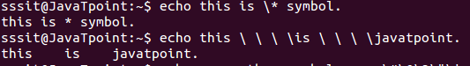

### Replace the word in file (Sed and Perl)

sed s/Unix/UNIX/g filename

/usr/bin/perl -p -i -e 's#unix#linux#g' file

:%s/sdd_pte/sdd_dev/g

perl -p -i -e 's#<ABC>#<PQR>#g' *.I

perl -p -i -e "s#vishal#kaaaa#g" dharmendra.txt

/usr/bin/perl -p -i -e 's#unix#linux#g' file

sed -i '2s/hi/Hello/' file ----on 2nd line only

**What are the 3 standard streams in Linux?**

**Input,Output and Redirection**

0 – Standard Input  
1 – Standard Output  
2 – Standard Error

* **standard input (stdin) :** The stdin stream is numbered as stdin (0). The bash shell takes input from stdin. By default, keyboard is used as input.
* **standard output (stdout) :** The stdout stream is numbered as stdout (1). The bash shell sends output to stdout. Output goes to display.
* **standard error (stderr) :** The stderr stream is numbered as stderr (2). The bash shell sends error message to stderr. Error message goes to display.
* > : standard output
* >> - standard output and appends the existing content
* < : standard input
* << - standard input and appends the content
* 2>file : Redirect standard error to file
* 2>>file - standard error
* 2>&1:combines stderr and standard output

**dev/null**

Check whether a program runs successfully without seeing output on the screen. You may not want to save the output in a file either.

General forms for /dev/null use

* Send standard out to /dev/null:

command > /dev/null

cmp file1 file2 > /dev/null

* Send standard error to /dev/null:

command 2> /dev/null

* Send both standard out and standard error to /dev/null:

command > /dev/null 2>&1

**I want to read all input to the command from file1 direct all output to file2 and error to file 3, how can I achieve this?**

command <file1 1>file2 2>file3

**What is the difference between grep and egrep and Fgrep?**

egrep is the same as grep -E. fgrep is the same as grep -F

egrep is Extended grep that supports added grep features like “+” (1 or more occurrence of a previous character),”?”(0 or 1 occurrence of a previous character) and “|” (alternate matching)

egrep -il 'ABC.I|DEF.I|GHI.I' *

**How do we create command aliases in a shell?**

alias aliasname=”Command whose alias is to be created”.

alias cls=’clear’

--Remove the Alias--

unalias -a

**How are hard drives and floppy drives referred in linux filesystem**

Floppy Drive- /dev/fd0 and /dev/fd1

Hard Drive - /dev/had,/dev/hdb,/dev/hdc

Printer - /dev/lp*

Name assigned to communication port /dev/ttyS*

**what is the maximum length of filename under Linux**

- Maximum of 255 character

- the limit does not include the path name

**priority of the jobs can be changed by using the ‘nice’command**

Priority ranges from -20 to 19 where, -20 is the highest priority and 19 is the lowest priority

Command -nice [OPTION][COMMAND[ARG]…]

nice -10 cat > file1 then check value ps -command of NICE value under ni

**where are exactly the passwords are stored**

/etc/passwd

**What if difference between soft link(symbolic) and hard link**

### Soft link and Hard Link

**Soft link** is same concept as the shortcut from windows. Size of the soft link is lesser than that of original file. If you delete the original file then the soft link associated with the original file also get deleted. (inode number is different for both the files)

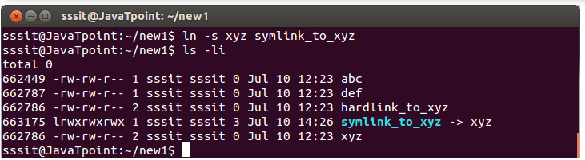

**hard link** is like copy. The size of hard link is same as the original file and if you delete the original file then hard link will not be get deleted

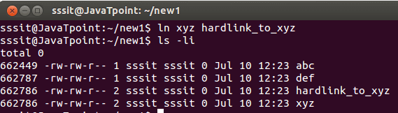

Find the hard link using the inode numbers

find / -inum 662786 2**>** /dev/null

Soft link created for file and directories whereas hard links are created for the directories

**how to create the partition from the raw disk**

Using the fdisk utility we can create the partition

fdisk -l |less check the partition details

fdisk /dev/sda Create the Partition

**where the kernel modules are located**

They are located in /lib/modules and have had the extension .ko ("kernel object") since version 2.6 (previous versions used the .o extension). The lsmod command lists the loaded kernel modules

**what is the difference between find and locate**

The command locates and find are used to search a file by their filename. But difference is that locate command is a background process and searches the file in database whereas, find command searches in filesystem. The locate command is much faster than find command

**96) How to use the cut command**

### Cut Command

bash-4.3$ cat players

Name-Sport-Age

kp-tenis-30

jp-cricket-20

rp-basketball-40

sd-phelps-25

bash-4.3$ cut -d"-" -f 1,3 players

Name-Age

kp-30

jp-20

rp-40

sd-25

**How to set one at the end**

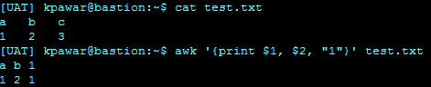

**How to Swap two columns**

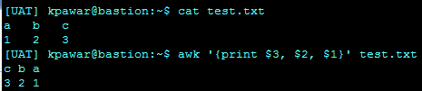

Usin FS(Field Seperator and OFS=Output field Seperator)

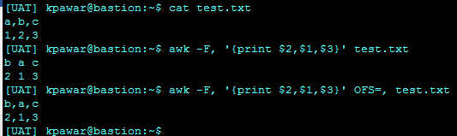

----Using cut command for the same----

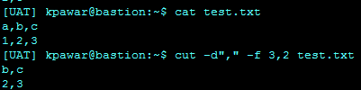

**97) List of special files**

- 🡪 Normal File

D 🡪Directory

L 🡪Symolic Links

P 🡪Named Pipe

B 🡪 Blocked Device

C 🡪Characted Device

S 🡪 Socket

**98) Linux change group and change owner command**

### Chown and Chgrp

chown -R ndmhubeng:altosys /ndmhub/sepa

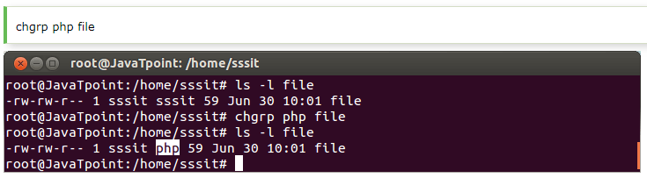

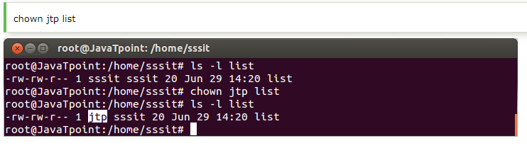

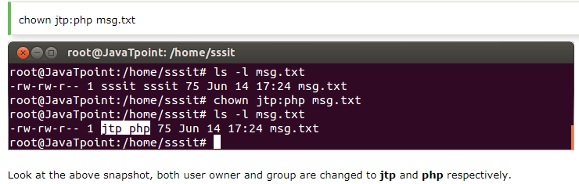

**99) Creating alias**

alias ll='ls -l'  (for a command)

alias path='cd /home/sssit/Downloads/sample'  (alias for a path)

unalias c  (Remove Alias)

**100) Wild Cards in Linux (search the files with speedy way)**

### Wild Cards in Linux

ls file * ; ls file? ; ls file ??; ls office[a-z]; ls office[0-9]

ls ca[nt]* -🡪 Can,Cat,Candy,Catch

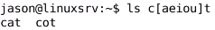

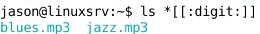

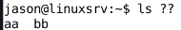

**101) Shell Option**

**set -u** option, will treat undefined variables as error.

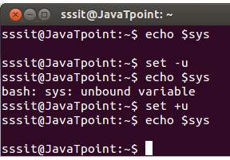

**102) How to check the history**

History 10;

Ctrl+R

**103) How to check the history size set to our systrm**

echo $HISTSIZE

to change the size- HISTSIZE 1200

the above commands to file $HISTFILE

Shell History is stored in memory and on disk

~/.bash_history

~/.history

~/.histfile

**104) Shutdown**

The shutdown command brings down system in a secure way. All the logged-in users are notified about the system shutdown.

**Runlevel 0** halts the system

**Runlevel 6** reboots the system

**Runlevel 1** is default state.

**105) env command**

This is shell command

**106) shred command**

The shred command allows us to delete our files securely making it very much difficult to recover that file by anyone.

Erasing a file with rm command only erases the file system entry and keeps the content of the file intact.

It is quite easy to recover removed files content using some software’s.

To prevent from data recovering, shred overwrite the data multiple times by doing maximum destruction of the data.

107) Installing Software/Package

### Installing Software/Package (Yum,apt-get)

Package-Collection of files that makeup an application

On RedHat

* yum search string
* yum info [package]
* yum install [-y] package
* yum remove package
* rpm -qa - list all installed packages
* rpm -ql package list package’s file
* rpm -qf /path what package belongs to this file
* rpm -ivh package.rpm install package
* rpm -e package uninstall package

The major differences between YUM and RPM are that yum knows how to resolve dependencies and can source these additional packages when doing its work. ... Both tools can perform an install, and RPM will even allow you to install multiple versions simultaneously, but YUM will tell you that that package is already installed.

On DEB distributions such as

Debian/Linux mint/ubuntu

* apt-get install -y package install package
* apt-get remove package remove package
* dpkg -l list installed package
* dpkg -L list all files in package

108) print nth line of a file in unix

cat sample_data_1.txt | head -25 | tail -1

pawar_ka@Kalpesh-P MINGW64 ~/test (master)

$ cat testing

1

2

3

4

5

6

7

pawar_ka@Kalpesh-P MINGW64 ~/test (master)

$ cat testing |head -5

1

2

3

4

5

pawar_ka@Kalpesh-P MINGW64 ~/test (master)

$ cat testing |head -5 |tail -1

5

pawar_

1. How to view only directoy name only using pwd command In linux



1. How to copy file from local windows machine to cloud based linux machine

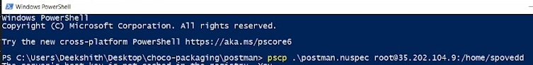

111)

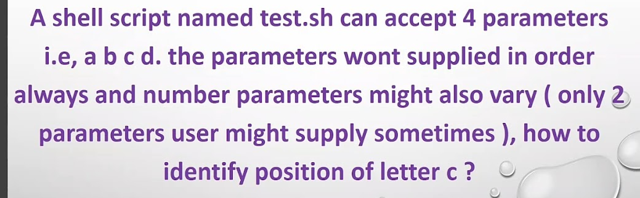

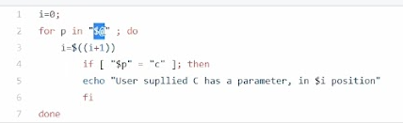



### User and Group Management

Password file /etc/password

Password File Content

Username:password:UID:GID:Comment:home_dir:shell

root:x:0:0:root:/roor:/bin/bash

joe:x:1000:1000:joe Hen:/home/joe:/bin/bash

Encrypted Password Stored in /etc/shadow and it is readable by root

* **Groups**

1) groups web Display group membership using groupadd

2) groupadd web Create the group

3) groupdel web delete the group

4) groupmod web modify group

4) /etc/group Check the groups

group_name: password: GID: account1, accountN

sales:x:1000: john, Mary

* **useradd**

command - useradd [options] username

1. useradd ajay

Or

useradd -c “Account for Kalpesh” -g writer -G tv -m -s /bin/bash Kalpesh

-c ---Commnet

-m ---Create Home Dir

-s ---Shell Path

-g ---group

-G ---additional group

1. How to create the group in linux

groupadd mygroup

1. how to add user in group

gpasswd -a ajay mygroup --add one user in group

gpasswd -m ajay,kalpesh mygroup --add one user in group

* **passwd grant**

**Networking**

**TCP/IP -**Transmission Control Protocol/Internet protocol

TCP-Controls data exchange

IP-Sends data from one device to another

TCP/IP is used for transmitting data over network

### Linux Networking Commands

1) ifconfig or ip a or ip addr Display and manipulate route and network interfaces.

Get details of specific interface

ifconfig eth0

ifconfig lo

ifconfig wlan0

2)ip -a It is a replacement of ifconfig command.

Get details of specific interface

ip a show eth0

ip a show lo

ip a show wlan0

3)traceroute Network troubleshooting utility.

install traceroute-sudo apt-get install inetutils-traceroute

traceroute javatpoint.com

traceout6 this is for IPV6

4) tracepath Similar to traceroute but doesn't require root privileges.

tracepath javatpoint.com

5) ping / telnet To check connectivity between two nodes.

ping javatpoint.com

ping -c 5 2.2.2.2

6) netstat Display connection information and to check the perticular port is up or not

netstat -tunlp | grep 443

netstat -an |grep 3306|wc -l

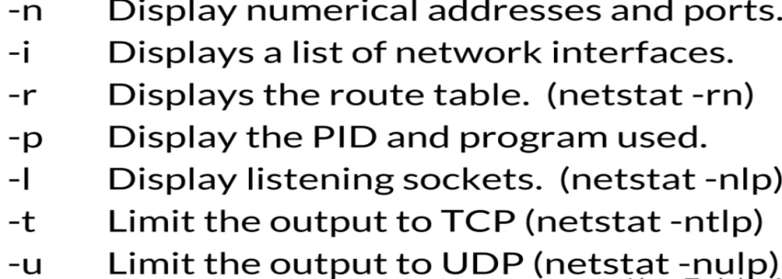

7) ss It is a replacement of netstat.

8) dig Query DNS related information((domain name).

dig javatpoint.com

9) host Performs DNS lookups/Resolving DNS names.

host javatpoint.com

host 144.76.11.18

10) nslookup Find DNS related query.

nslookup javatpoint.com

11) route Shows and manipulate IP routing table.

route -n

12) hostname To identify a network name.

hostname -f to get fully qualified name

sudo hostname xyz.com

13) curl or wget To download a file from internet.

wget google.com/doodles/new-years-day-2012

14) whois Will tell you about the website's whois.

whois javatpoint.com

15) vmstat -s

vmstat is a computer system monitoring tool that collects and displays summary information about operating system memory, processes, interrupts, paging and block I/O. Users of vmstat can specify a sampling interval which permits observing system activity in near-real time.



16) free -m (The free command gives information about used and unused memory usage and swap memory of a system.)

SWAP memory is virtual ram



18) sar -u 2 3 ---gives the CPU utilization



19) iftop -to monitor the network traffic ...

The default **iftop command** displays the bandwidth usage of the first ethernet device. # **iftop**. You can also specify a particular interface with the -i option as shown below. # **iftop** -i eth0. While **iftop** is running, you can press any one of the following keys to display more output.

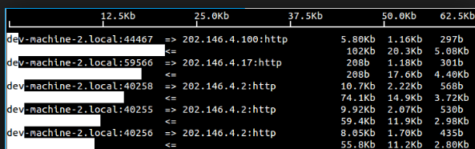

20) route

The route command displays and manipulate IP routing table for your system.

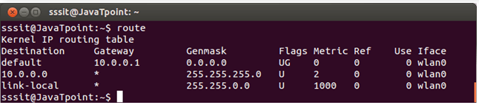

21) what is pmap command

The command pmap reports memory map of one process or multiple processes. It displays information about memory usage and address space of a process. To check pmap of a process we need PID of the process.

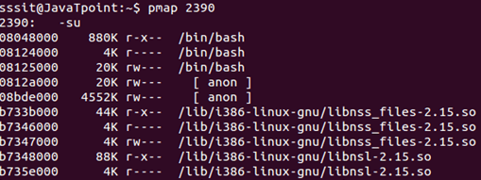

stat <filename>

This command is used to check the file access,modified and change time

==================================================

# **What is Blue Green Deloyment**

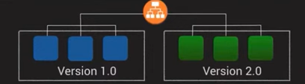

You maintain **two identical environments**:

* **Blue** = current live environment (production)
* **Green** = new version of the app, fully tested and ready to go

**How It Works**

1. **Deploy to Green**:  
   You deploy your new version to the *Green* environment (not live yet).
2. **Test Green**:  
   Run tests, validate functionality, ensure everything works as expected.
3. **Switch Traffic**:  
   Once confident, you route user traffic from *Blue* to *Green* (usually via load balancer update or DNS switch).
4. **Blue Becomes Backup**:  
   Keep the *Blue* environment intact temporarily. If something goes wrong, you can easily roll back by switching traffic back to Blue.

**Benefits**

* **Zero downtime**: Users don’t experience service interruption.
* **Easy rollback**: Just switch back to the previous environment.
* **Safe testing**: New version can be fully validated before going live.

# **DEVOPS**

1. Kubernetes cheat sheet: <https://lnkd.in/e5huKvG>

2. Docker cheat sheet: <https://lnkd.in/euVgEym>

3. Git and GitHub cheat sheet: <https://lnkd.in/eqmYz7Y>

4. Ansible cheat sheet: <https://lnkd.in/eUcJGfW>

5. Linux command cheat sheet: <https://lnkd.in/eemfYJU>

6. Open Shift cheat sheet: <https://lnkd.in/euUv23d>

7. Helm cheat sheet: <https://lnkd.in/eupFcpy>

8. Jenkins cheat sheet: <https://lnkd.in/eEdSkWX>

Simple DevOps Project

<https://github.com/ValaxyTech/DevOpsDemos/tree/master/SimpeDevOpsProjects>

### What is DevOps

DevOps is collaboration with the different team for the faster delivery.

DevOps is not technology, but it is methodology (idea) which improves the collaboration between developers and operations team using various automation tools.

These tools are implemented using various stages which are part of the DevOps lifecycle.

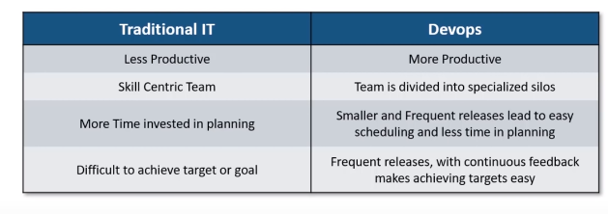

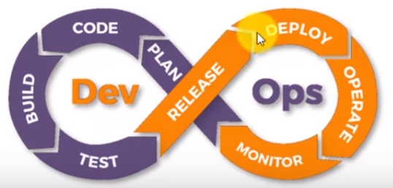

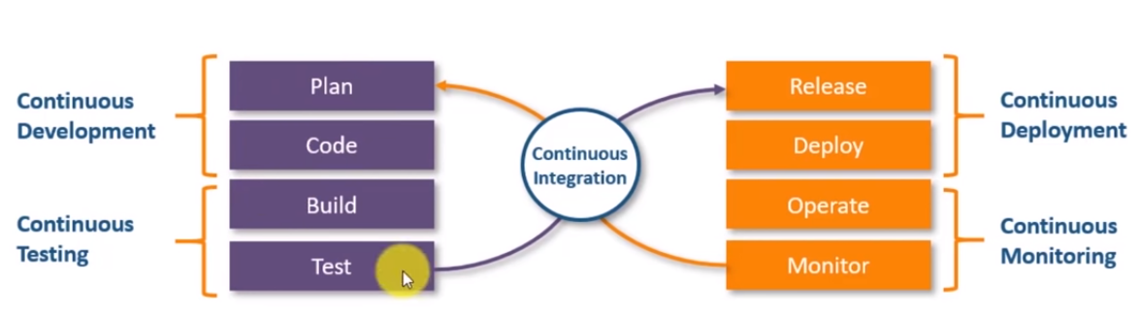

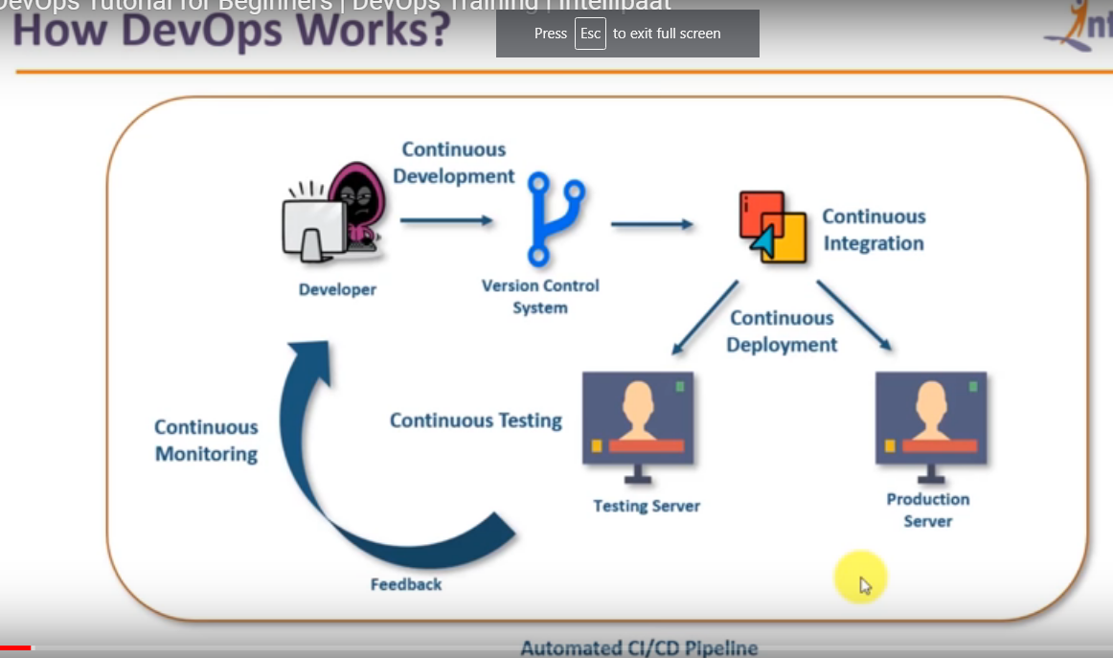

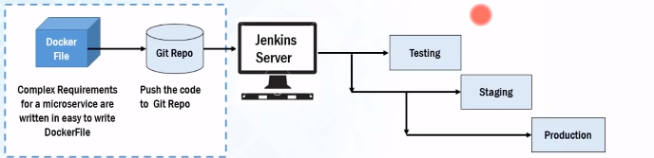

# **GIT** (version control tool)



**what is the difference between Git and GitHub?**

**Git is** a version control system that lets you manage and keep track of your source code history. **GitHub is** a cloud-based hosting service that lets you manage **Git** repositories. If you have open-source projects that use **Git**, then **GitHub is** designed to help you better manage them

### Three stages

1. Working directory - Where code is written
2. Staging directory - Code is ready and add it to staging area
3. Local Repo - Commit stage for the push

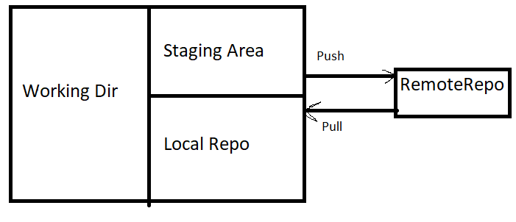

### Centralised VCS vs Distributed VCS

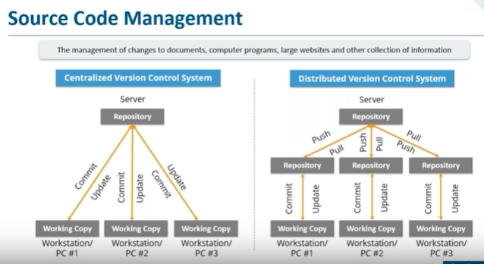

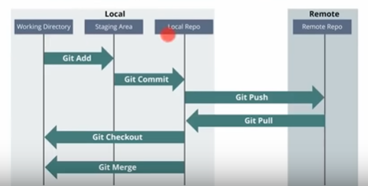

**Centralised VCS disadvantages.**

| **Centralized Version Control** | **Distributed Version Control** |
| --- | --- |
| In CVS, a client need to get local copy of source from server, do the changes and commit those changes to centeral source on server. | In DVS, each client can have a local branch as well and have a complete history on it. Client need to push the changes to branch which will then be pushed to server repository. |
| CVS systems are easy to learn and set up. | DVS systems are difficult for beginners. Multiple commands needs to be remembered. |
| Working on branches in difficult in CVS. Developer often faces merge conflicts. | Working on branches in easier in DVS. Developer faces lesser conflicts. |
| CVS system do not provide offline access. | DVD systems are workable offline as a client copies the entire repository on their local machine. |
| CVS is slower as every command need to communicate with server. | DVS is faster as mostly user deals with local copy without hitting server everytime. |
| **If CVS Server is down, developers cannot work.** | **If DVS server is down, developer can work using their local copies.** |

### Current Branching strategies in your project

In each project default branch is master branch.it created when we run the git init command at start.

Currently in our project first we create the feature branch from dev branch and make changes in the feature branch, once all changes and testing are done then we merge the feature branch to Dev branch.

There are separate release branches for the UAT and production.

Like 1.2.3.1 and use for the deployment

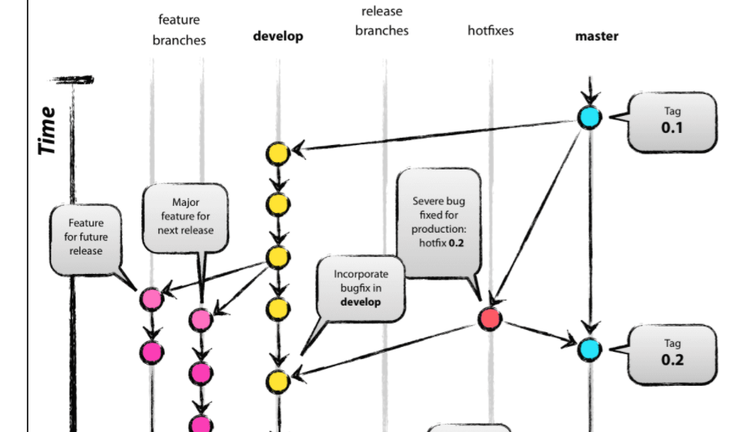

* main (or master): production-ready code
* develop: integration branch for features
* feature/*: feature branches from develop
* release/*: prep branch for releases
* hotfix/*: quick patches to main

**Pros:**

* Clear separation of concerns (features, releases, fixes)
* Great for structured release cycles

**Cons:**

* Can be heavy and complex
* Not ideal for continuous deployment

### Git Commands



1) git --version

2) git status -->this will give you error it looks for file .git

3) now create new folder i.e GitLab and go to command prompt from that path

4) "git init" ---->This command will create the file .git in the same path from where you open the command prompt

4) create the txt file in the same dir and the run the "git status" command you will get the file name with message untracked files

5) if you want tracked the file use below command

"git add filename" then again run "git status" command -->this time you will get message to changes to be committed means file is in staging dir

6)if you to un-stage it then use below command

git rm --cached filename ----(this will again go 4th point)

07) If you again want to add in staging then use the "git add filename" command again

8) Before committing you should have the github account and then run below command

git config --global user.email "pawar.kalpesh.86@gmail.com"

git config --global user.name "pawarkalpesh86"

git config –list # View current config

git remote -v # View remotes

git remote add origin <url> # Add a remote

9) commit the files use below command

git commit -m "committing file" ----> All the files in the staging dir will get committed (-m is for message i.e files will be saved in the git filesystem)

git commit -m "committing particular file" filename

10) To add the files in one go

"git add -A"

11) if you want remotely then use below command

git config --global user.email "pawar.kalpesh.86@gmail.com" or git config --global user.name "pawarkalpesh86"

git remote add origin https://github.com/pawarkalpesh86/FirstProjcet.git

git remote set-url origin https://github.com/pawarkalpesh86/FirstProjcet.git

12)Pushing the staging files to github account (Copy file from local repo to remote/central repo)

git push -u origin master

🡪 On Chlid

git push -u origin chlild or

git push --set-upstream origin f1

if then also it give error then go to local dir where the files are created with .git folder then open that folder and check the config file in that the github path should be your repository path

go to previous commit <latest commit point saves into to the .git folder>refs-->heads

13) git clean: Remove **untracked files**

**What it does:** Deletes files and directories **not tracked by Git** (i.e., not staged or committed).

git clean –fd

* -f: Force deletion
* -d: Remove untracked directories

**14) Revert a commit that has been pushed and made public**

Check the previous commit using git log and then run the command

* Git revert <commit id>
* git reset <commit point> --->Commit Point should be known

Git reset <Commit ID>

1) git reset --soft <commit> ---local changes will not be deleted even though it reset to last commit

2) git reset --mixed <commit>

3) git reset --hard <commit> ---local changes will be deleted

### Difference between reset and revert

git reset and git revert both undo changes, but they do so in **very different ways**, especially in terms of **history** and **collaboration safety**.

Git Reset --> Delete file from the staging area (git reset filename) which you added from working dir

Git Hard reset --> Delete files from staging area as well as from the working dir (git reset -- hard)



Assuming we have below few commits as below (e.g)

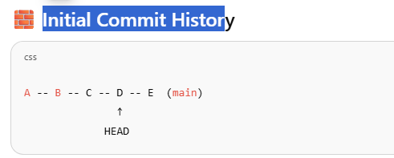

Let's say:

* Each letter is a commit.
* You're currently at E.
* You realize D was a bad commit and want to undo it.

Option 1: git reset --hard D

**What Happens**

* HEAD and branch pointer move back to D
* Commits E is removed from history
* Working directory is reset to match D

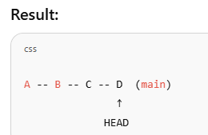

❌ **Commit E is lost**

* You cannot get it back unless you use git reflog
* Bad for shared branches — others will see diverging histories

Option 2: git revert D

**What Happens**

• Git creates a **new commit** (let’s call it F) that undoes whatever D did

* History is preserved, nothing is removed

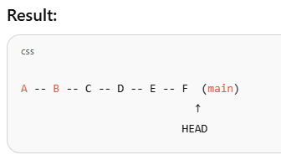

✅ **Safe for shared history**

* Everyone sees the same commits
* Easy to audit what went wrong and how it was fixed

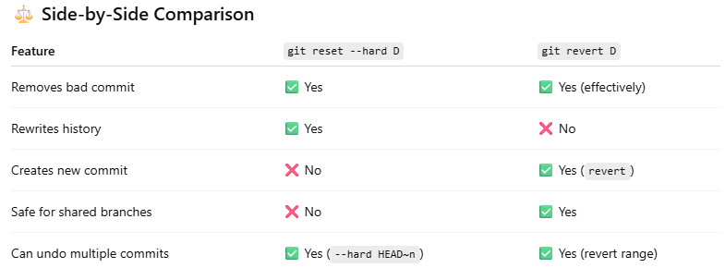

**Rule Of Thumb:**

✅ Use **reset** for local/private clean-up  
✅ Use **revert** for shared/public undo

15) **Git Log**

this command gives you who has done the latest changes with commit point and his name and time

git log --oneline --graph --decorate -a

**or**

git log --oneline --graph --decorate –branches

git log --stat hellow.txt

**How to check what changes are done for particular file in different commit**

$ git log --oneline --graph --decorate --stat hellow.txt

* 99c8bc2 (HEAD -> master) **new**

| hellow.txt | 1 +

| 1 file changed, 1 insertion(+)

* db562b1 **hello**

hellow.txt | 1 +

1 file changed, 1 insertion(+)

**16) Create the alias**

pawar_ka@Kalpesh-P MINGW64 ~/demo (master)

$ git config --global alias.hit "log --oneline --graph --decorate --branches"

$ git hit

* 99c8bc2 (HEAD -> master) new

* 8040b1b first

* fca609e (child) commits

* 3ecb0ea three

* 28e1c17 two

* c0cfa4c one

* b1064cc hi

* db562b1 hello

17) if you want to ignore the file for the adding in staging

create the file .gitignore (save as .gitignore) in same folder

write the filename you want ignore i.e (d.html) or if you want to ignore all html file then in the .gitignore file write *.html, it will ignore all the files then run the "git add .gitignore" and then "git commit -m "new commit"

18) Remove the file from git

first run command "dir" then from that delete file using

git rm filename

19) git branch

this command give you branch ---active branch is master

20)git branch child ---active branch is master

it creates the child branch

21)git checkout child

changes to active to child

22) git checkout master

23)once it is done then merge the child with master as below **Merge(fast Forward merge)**

git merge child

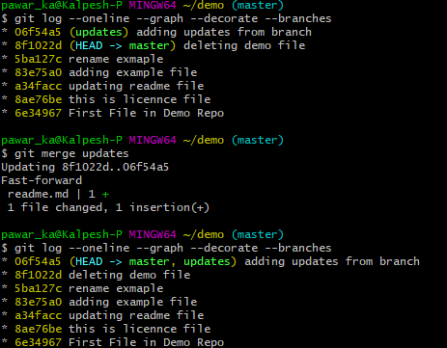

24)then last you can delete the child branch

git branch -d child

**25) Git Rebase**

git rebase master

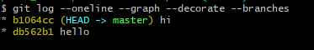

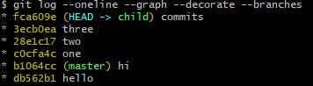

Rebase

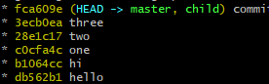

### Difference between merge and rebase

* When you do rebase a feature branch onto master, you move the base of the feature branch to master branch’s ending point. Using the rebase the graph becomes linear
* Merging takes the contents of the feature branch and integrates it with the master branch. As a result, only the master branch is changed. The feature branch history remains same.

Merge preserves history whereas rebase rewrites it.

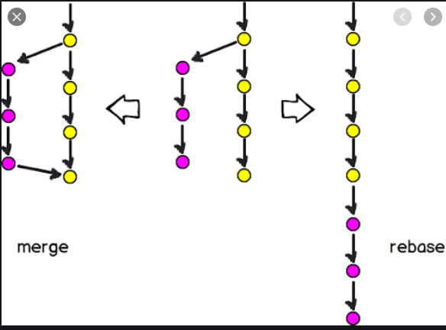

**24) How to pull the project from another repo**

git clone <repo url>

--Clone specific branch--

git clone -b <branch-name> --single-branch <repo url>

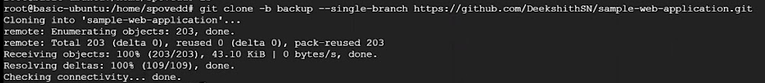

**25) how to pull repo from my remote repo (only changes will be added not full repo)**

Git pull <repo url>

**26) How to add remote repo to your local**

Git remote add origin <repo url>

### Git Stash

**27) Stash** --->it temporarily stores changes in stack (If you are busy in another task but don’t want to merge then you stash it and see it later)

e.g suppose there is master branch and child branch and on master you have the hello.java file.

You don’t want to merge the master and child so how we can save data to child?

so, the concept comes ahead i.e. stash

-->add one file in for master and write something

commit the changes

-->crate the child branch and do something/write in same file on child …don’t commit

git stash **or** git stash save”comment” -stash an item

git stash list -to see stashed items list

git stash apply stash@{0} -to apply stashed item (then add and commit)

git stash clear - clear the stash item

**Git Advanced Commands**

Git repository file structure

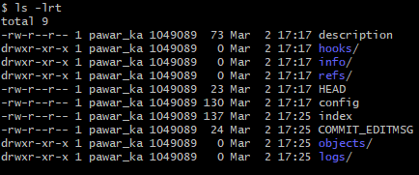

**How to show files**

$ git ls-files

hellow.txt

hi.txt

one.txt

three.txt

two.txt

**Rename the file**

git mv example.txt demo.txt

**Deleting the file**

git rm demo.txt

**If file deleted outside git then the run the below command**

git add -u

**How to diff the commit**

git diff a34facc HEAD

git difftool a34facc 5ba127c

Head points to last commit of current branch

**Create and checkout branch**

git checkout -b update

**how to diff two branches**

git diff master child

**How to check all the branches**

Git branch -a

**How to create the tag (When it is created it is added to the HEAD)**

Git tag <tag name>

git tag -a v1.0 -m "Release 1.0"

**Display the list of tags**

git tag –list

**How to see perticular commit content using tag**

Git show <tag-name)

git show v1.0

**How to delete the tag**

Git tag -d <tag name>

**If you want to see all the logs if something is deleted**

Git reflog

**How to set up the tool(gitdiff) in git**

git config --global diff.tool vimdiff

git difftool <commit point1> <commit point2>

🡪how to close difftool window :qa

**How to check files associated to sha or commit point**

Git show <commit point>

**What is the difference between git show and git log**

git show (it shows only last commit) and git log shows all the commit info

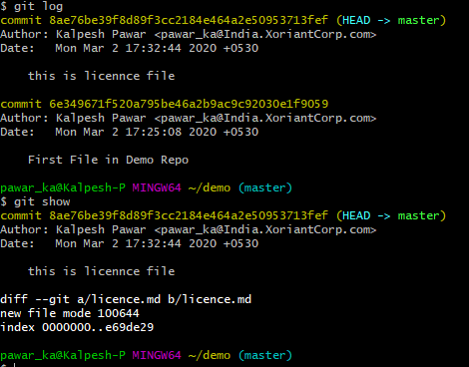

### Cherry Pick (Backward Merge)------

Suppose we have repository and having master and feature branch.

Master has 1 commit and feature branch has 3 new commits.

Suppose I want specific commit i.e. to commit (3) from feature want to apply it to master.

I don’t want all the commit from feature branch to master. I am interested in specific commit in feature one.

That’s why we use cherry-pick. If we want to pick all the commits from feature one to master, then we use merge

Git cherry-pick <commit-id>

git cherry-pick 7503f91faa2dfc78d68520798ec956e13106d62b

git cherry-pick --continue

git cherry-pick –abort

### git pull and fetch difference?

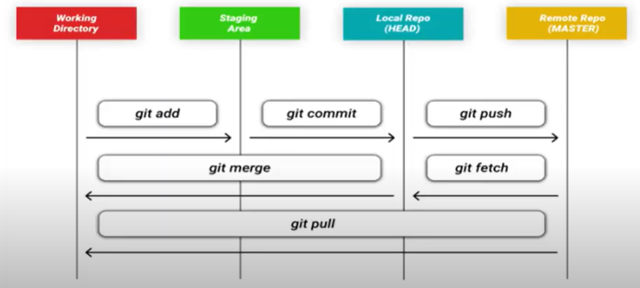

Refer above diagram-

git fetch only downloads new data from a remote repository - but it doesn't integrate any of this new data into your working files. It just download latest changes into local repository.Fetch is great for getting a fresh view on all the things that happened in a remote repository.  
Due to it's "harmless" nature, you can rest assured: fetch will never manipulate, destroy, or screw up anything.

Fetch from and integrate with another repository or a local branch

git fetch Download objects and refs from another repository.

It cannot change any of the file in your working repository

Git fetch is less destructive than pull

Git pull=git fetch+git merge

When you use pull, 'Git tries to automatically merge.

This means that pull not only downloads new data;

it also directly integrates it into your current working copy files.

It is context sensitive, so Git will merge any pulled commits into the branch you are currently working on.

pull automatically merges the commits without letting you review them first.

If you don’t carefully manage your branches, you may run into frequent conflicts

This has a couple of consequences:

Since "git pull" tries to merge remote changes with your local ones, a so-called "merge conflict" can occur.

### Git Hooks

Git hook allows you to run the custom scripts whenever certain important event occurs in the git life cycle such as committing, merging and pushing

**Git hooks** are scripts that Git automatically runs **before or after certain events**, like commits, merges, or pushes. They’re extremely useful for automating tasks such as:

Repository 🡪 .git/hooks/

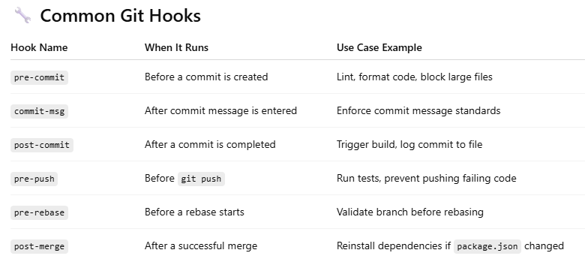

**Have You Used them in a Team Workflow?**

Yes — in many teams, especially those practicing CI/CD and code quality standards, Git hooks are used to:

* **Enforce commit messages** using commit-msg hook (Conventional Commits or JIRA ticket references).
* **Block commits** to protected branches like main or release.

created below hooks

=== prepare-commit-msg===

#!/bin/sh

echo "#please Enter Message" > $1

========pre-commit===

#!/bin/sh

allow=$(git commit -m "AERA")

if [ "$allow" != "true" ]

then

echo "commit message is wrong"

exit 1

else

git commit -m "AERA"

fi

=======

**Q. How do you find a list of files that has changed in a commit?**

git diff-tree -r {hash}

**Q. Have you ever encountered failed deployment? How you handled them?**

Obviously, then I followed the best practices by automating the things.

1) Automate the code testing (most of times it fails because of testing)

2) Use Docker for same environment

3) Use microservices

4) Overcome risks to avoid failure

**Q. What is ‘head’ in git and how many heads can be created in a repository?**

In Git, HEAD is a reference to the current commit you have checked out. It acts like a pointer to the tip of your current branch — essentially saying:

When you check out a branch, HEAD points to the latest commit on that branch.

When you create a new commit, Git updates HEAD to point to the new commit.

If you are in detached HEAD state, it means HEAD is pointing directly to a commit, not a branch (e.g., when checking out a specific commit by hash).

How many HEADs can exist in a Git repository?

Git has only one HEAD in your local working directory — it's a singular pointer.

However, a repository can have many branches, and each branch can be thought of as a "head" of a branch (note lowercase "head").

**Q. What is the difference between git clone and git fork**

git clone: Make a local copy of a repo

What it does:Downloads a local copy of an existing Git repository to your machine.

git fork

What it does:Creates a copy of the repository under your own GitHub account.

Make changes without affecting the original repo.

**Q. When to Use rebase (vs merge)**

Use Case Choose

You want a clean, linear history ✅ Rebase

You're working on a feature branch alone ✅ Rebase

You're syncing your feature with main before a PR ✅ Rebase

You're preserving public/shared history ❌ Avoid Rebase; ✅ Use Merge

You want to see branch divergence ✅ Merge

You’re resolving frequent merge conflicts ✅ Rebase (smaller, focused rebases help)

**Q. How to Recover a Deleted Commit**

1) Use git reflog to find the commit (This shows a log of all recent HEAD movements — including commits, checkouts, resets, rebases, etc.)

git reflog

2) Look for the commit message or hash of the one you lost. (e.g., def5678),

3) Create a new branch at that commit:

git checkout -b restore-commit def5678

or

git checkout main

git cherry-pick def5678

**Q. What Is a Git Submodule?**

A Git submodule is a way to include another Git repository inside your own repository.

It allows you to track an external project's commit and treat it like a subdirectory — without copying its code or merging its history.

✅ Why Use Git Submodules?

To reuse a shared library or dependency across multiple projects.

To keep external code separate from your own, while still version-controlled.

To pin a subproject to a specific commit rather than always tracking the latest changes.

✅ How It Works

When you add a submodule:

Git creates an entry in .gitmodules.

Git stores the submodule as a reference (commit hash), not as a regular folder.

The submodule points to a specific commit of the other repo

# Add a submodule

git submodule add <repository-url> <target-directory>

git submodule add https://github.com/example/library.git libs/library

# Clone with submodules

git clone --recurse-submodules <repo-url>

# Update submodule to latest from remote

cd libs/library

git pull origin main

cd ../

git add libs/library

git commit -m "Update submodule"

**1)      What is GIT?**

GIT is a distributed version control system and source code management (SCM) system with an emphasis to handle small and large projects with speed and efficiency.

**2)      What is a repository in GIT?**

A repository contains a directory named .git, where git keeps all of its metadata for the repository. The content of the .git directory are private to git.

**3)      What is the command you can use to write a commit message?**

The command that is used to write a commit message is “git commit –a”.  The –a on the command line instructs git to commit the new content of all tracked files that have been modified. You can use “git add<file>” before git commit –a if new files need to be committed for the first time.

**4)      What is the difference between GIT and SVN?**

The difference between GIT and SVN is

a)      Git is less preferred for handling extremely large files or frequently changing binary files while SVN can handle multiple projects stored in the same repository.

b)      GIT does not support ‘commits’ across multiple branches or tags.  Subversion allows the creation of folders at any location in the repository layout.

c)        Gits are unchangeable, while Subversion allows committers to treat a tag as a branch and to create multiple revisions under a tag root.

**5)      What are the advantages of using GIT?**

a)      Data redundancy and replication

b)      High availability

c)       Only one .git directory per repository

d)      Superior disk utilization and network performance

e)      Collaboration friendly

f)       Any sort of projects can use GIT

**6)      What language is used in GIT?**

GIT is fast, and ‘C’ language makes this possible by reducing the overhead of runtimes associated with higher languages.

**7)      What is the function of ‘GIT PUSH’ in GIT?**

‘GIT PUSH’ updates remote refs along with associated objects.

**8)      Why GIT better than Subversion?**

GIT is an open source version control system; it will allow you to run ‘versions’ of a project, which show the changes that were made to the code overtime also it allows you keep the backtrack if necessary and undo those changes.  Multiple developers can checkout, and upload changes and each change can then be attributed to a specific developer.

**9)      What is “Staging Area” or “Index” in GIT?**

Before completing the commits, it can be formatted and reviewed in an intermediate area known as ‘Staging Area’ or ‘Index’.

**10)   What is GIT stash?**

GIT stash takes the current state of the working directory and index and puts in on the stack for later and gives you back a clean working directory.  So in case if you are in the middle of something and need to jump over to the other job, and at the same time you don’t want to lose your current edits then you can use GIT stash.

**11)   What is GIT stash drop?**

When you are done with the stashed item or want to remove it from the list, run the git ‘stash drop’ command.  It will remove the last added stash item by default, and it can also remove a specific item if you include as an argument.

**12)   How will you know in GIT if a branch has been already merged into master?**

Git branch—merged lists the branches that have been merged into the current branch

Git branch—-no merged lists the branches that have not been merged

**13)   What is the function of git clone?**

The git clone command creates a copy of an existing Git repository.  To get the copy of a central repository, ‘cloning’  is the most common way used by programmers.

**14)   What is the function of ‘git config’?**

The ‘git config’ command is a convenient way to set configuration options for your Git installation.  Behaviour of a repository, user info, preferences etc. can be defined through this command.

**15)   What does commit object contain?**

a)      A set of files, representing the state of a project at a given point of time

b)      Reference to parent commit objects

c)       An SHAI name, a 40 character string that uniquely identifies the commit object.

**16)   How can you create a repository in Git?**

In Git, to create a repository, create a directory for the project if it does not exist, and then run command “git init”. By running this command .git directory will be created in the project directory, the directory does not need to be empty.

**17)   What is ‘head’ in git and how many heads can be created in a repository?**

A ‘head’ is simply a reference to a commit object. In every repository, there is a default head referred as “Master”.  A repository can contain any number of heads.

**18)   What is the purpose of branching in GIT?**

The purpose of branching in GIT is that you can create your own branch and jump between those branches. It will allow you to go to your previous work keeping your recent work intact.

**19)   What is the common branching pattern in GIT?**

The common way of creating branch in GIT is to maintain one as “Main“

branch and create another branch to implement new features. This pattern is particularly useful when there are multiple developers working on a single project.

**20)   How can you bring a new feature in the main branch?**

To bring a new feature in the main branch, you can use a command “git merge” or “git pull command”.

### Conflict in Git

**21)   What is a ‘conflict’ in git?**

A ‘conflict’ arises when the commit that has to be merged has some change in one place, and the current commit also has a change at the same place. Git will not be able to predict which change should take precedence.

**22)   How can conflict in git resolved?**

To resolve the conflict in git, edit the files to fix the conflicting changes and then add the resolved files by running “git add” after that to commit the repaired merge, run “git commit”.  Git remembers that you are in the middle of a merger, so it sets the parents of the commit correctly.

**23)   To delete a branch what is the command that is used?**

Once your development branch is merged into the main branch, you don’t need

development branch.  To delete a branch use, the command “git branch –d [head]”.

**24)   What is another option for merging in git?**

“Rebasing” is an alternative to merging in git.

**25)   What is the syntax for “Rebasing” in Git?**

The syntax used for rebase is “git rebase [new-commit] “

**26)   What is the difference between ‘git remote’ and ‘git clone’?**

‘git remote add’  just creates an entry in your git config that specifies a name for a particular URL.  While, ‘git clone’ creates a new git repository by copying and existing one located at the URI.

**27)   What is GIT version control?**

With the help of GIT version control, you can track the history of a collection of files and includes the functionality to revert the collection of files to another version.  Each version captures a snapshot of the file system at a certain point of time. A collection of files and their complete history are stored in a repository.

**28)   Mention some of the best graphical GIT client for LINUX?**

Some of the best GIT client for LINUX is

a)      Git Cola

b)      Git-g

c)       Smart git

d)      Giggle

e)      Git GUI

f)       qGit

**29)   What is Subgit? Why to use Subgit?**

‘Subgit’ is a tool for a smooth, stress-free SVN to Git migration.  Subgit is a solution for a company -wide migration from SVN to Git that is:

a)      It is much better than git-svn

b)      No requirement to change the infrastructure that is already placed

c)       Allows to use all git and all sub-version features

d)      Provides genuine stress –free migration experience.

**30)   What is the function of ‘git diff ’ in git?**

‘git diff ’ shows the changes between commits, commit and working tree etc.

**31)   What is ‘git status’ is used for?**

As ‘Git Status’ shows you the difference between the working directory and the index, it is helpful in understanding a git more comprehensively.

**32)   What is the difference between the ‘git diff ’and ‘git status’?**

‘git diff’ is similar to ‘git status’, but it shows the differences between various commits and also between the working directory and index.

**33)   What is the function of ‘git checkout’ in git?**

A ‘git checkout’ command is used to update directories or specific files in your working tree with those from another branch without merging it in the whole branch.

**34)   What is the function of ‘git rm’?**

To remove the file from the staging area and also off your disk ‘git rm’ is used.

**35)   What is the function of ‘git stash apply’?**

When you want to continue working where you have left your work, ‘git stash apply’ command is used to bring back the saved changes onto the working directory.

**36)   What is the use of ‘git log’?**

To find specific commits in your project history- by author, date, content or history ‘git log’ is used.

**37)   What is ‘git add’ is used for?**

‘git add’ adds file changes in your existing directory to your index.

**38)   What is the function of ‘git reset’?**

The function of ‘Git Reset’ is to reset your index as well as the working directory to the state of your last commit.

**39)   What is git Is-tree?**

‘git Is-tree’ represents a tree object including the mode and the name of each item and the SHA-1 value of the blob or the tree.

**40)   How git instaweb is used?**

‘Git Instaweb’ automatically directs a web browser and runs webserver with an interface into your local repository.

**41)   What does ‘hooks’ consist of in git?**

This directory consists of Shell scripts which are activated after running the corresponding Git commands.  For example, git will try to execute the post-commit script after you run a commit.

**42)   Explain what is commit message?**

Commit message is a feature of git which appears when you commit a change. Git provides you a text editor where you can enter the modifications made in commits.

**43)   How can you fix a broken commit?**

To fix any broken commit, you will use the command “git commit—amend”. By running this command, you can fix the broken commit message in the editor.

**44)   Why is it advisable to create an additional commit rather than amending an existing commit?**

There are couple of reason

a)      The amend operation will destroy the state that was previously saved in a commit.  If it’s just the commit message being changed then that’s not an issue.  But if the contents are being amended then chances of eliminating something important remains more.

b)      Abusing “git commit- amend” can cause a small commit to grow and acquire unrelated changes.

**45)   What is ‘bare repository’ in GIT?**

To co-ordinate with the distributed development and developers team, especially when you are working on a project from multiple computers ‘Bare Repository’ is used. A bare repository comprises of a version history of your code.

**46)   Name a few Git repository hosting services**

* Pikacode
* Visual Studio Online
* GitHub
* GitEnterprise
* SourceForge.net

# **Maven**

## **What is Maven?**

* **Maven is project management tool or build tool** used **primarily for Java projects.**
* **It Manage Dependenices**

## **What does POM xml contains?**

**POM is the fundamental unit of work in Maven.**

**It is an XML file that contains information about the project and configuration details used by Maven to build the project.It contains default values for most projects.**

**In the normal project development you will add JAR files and libraries as required. In Maven-based development, those JAR files, libraries are added to the project using this pom.xml. In the pom context we call those JAR files, libraries as dependencies.**

**In short the pom.xml will have all information to build your project.**

**For example you want to build a project and you have only the pom.xml sent to you via mail.**

**If there are enough entries in the pom.xml then that is all you need!**

**You can import it to Eclipse, Maven will download your source code from CVS, download various dependency jars (like Spring, Apache Commons), run your test cases, build the jar/war, deploy to your jboss/app server, generate a report of your code quality (using Sonar, maybe).**

**Each task you want to do will be mentioned as a goal.**

## **Key Features of Maven?**

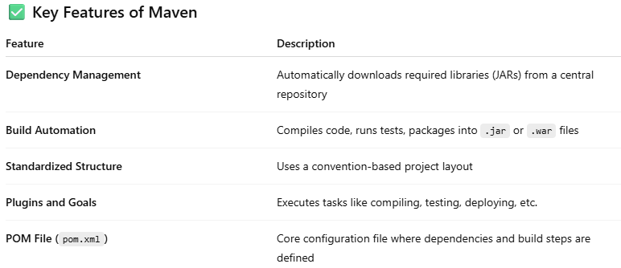

## **Maven Goals?**

**clean -deletes the target folder inside the project, which was created during last compilation and packaging process.**

**Validate - It checks if everything is in order (POM.xml, Configuration is proper, etc)**

**Compile - if I talk in term of java then, It take all .java and compile it to .class files.**

**Test - After Compile it goes and run the unit test cases.**

**Package - If all the above execute successfully then package execute. It will package the code in the format which you have defined in the code. Like .jar, .war, etc.**

**Install - After the package phase execute and generate the artifact. Install installs the artifact in the local repository. (Not in the server)**

**Deploy - Use it only if you publish your artifacts to remote repository so it can be shared with others to download. (Deploy or Push the artifact to artifactory (jfrog / nexus)**

**mvn -v check maven version same has to be updated in pom.xml**

**mvn verify**

## **What are settings you need to do before running mvn deploy**

**In server.xml and pom.xml, Artifactory (jfrog/nexus) details should be mentioned such as ip,name of the artificatory**

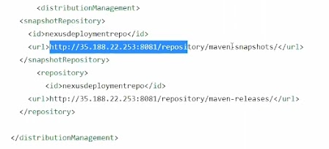

## **Sample pom.xml ?**

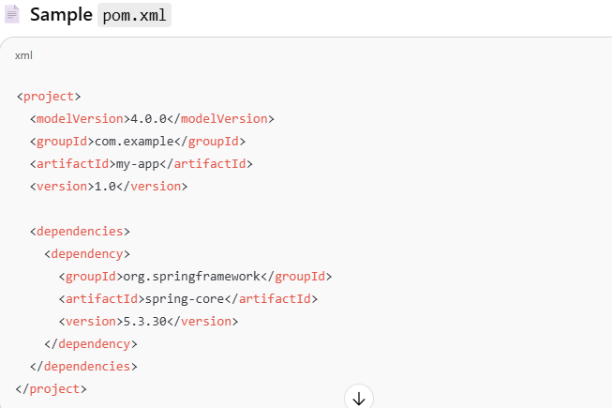

# **Teamcity(Continuous Integration)**

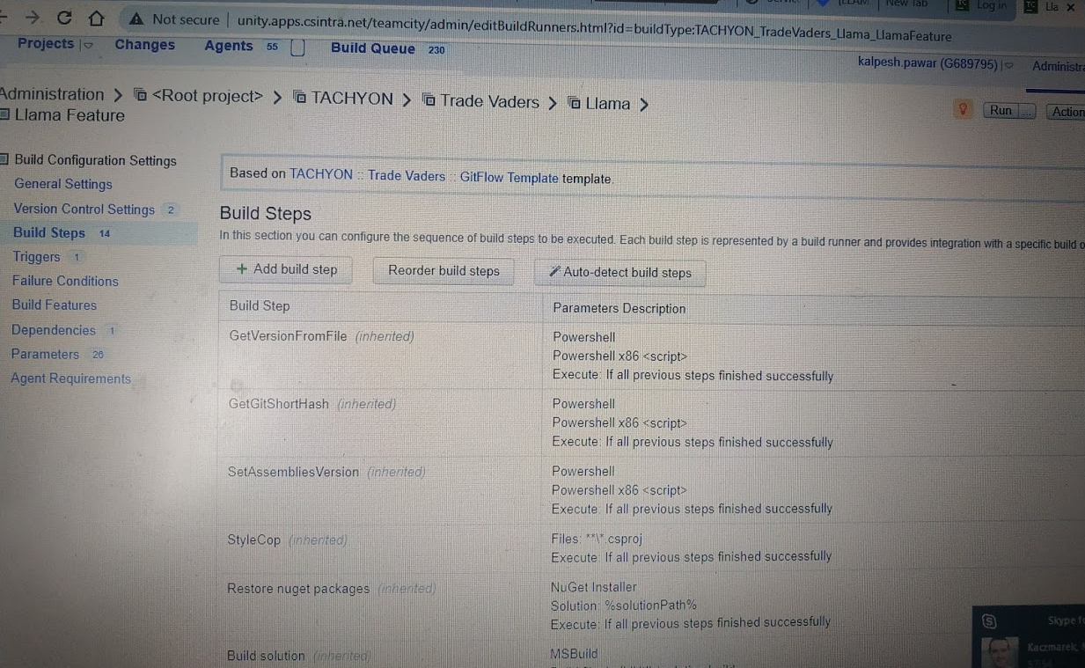

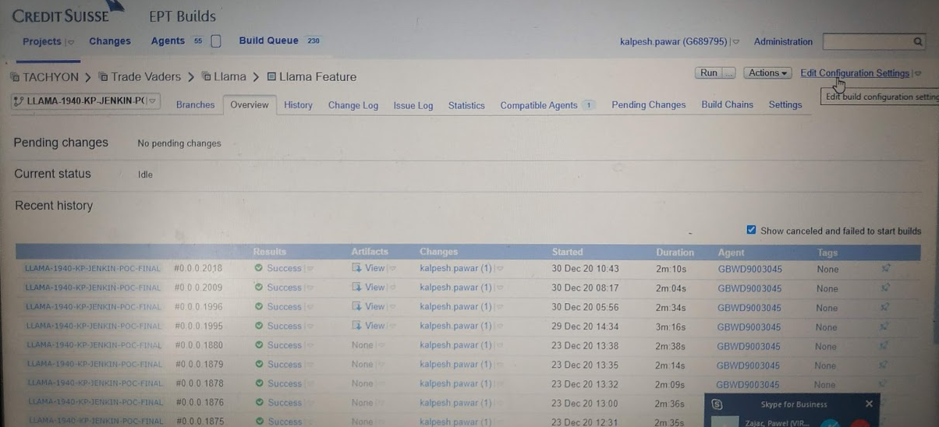

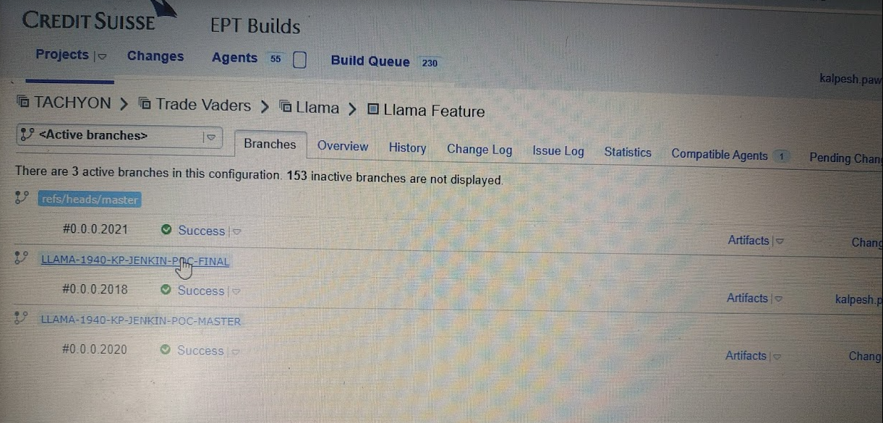

# **Jenkin(Continuous Integration)**



Install Jenkin for linux ------------>https://pkg.jenkins.io/redhat-stable/Download Jenkin for windows ------------><https://jenkins.io/download/>

Jenkin URL -localhost:8080

**1) What is Jenkins?**

Answer # Jenkins is an open source automation server. Jenkin is a continuous integration tool developed in Java.

It monitors the whole process and provides reports and notifications to alert.

The principle functionality of Jenkins is to keep a track of version control system and to initiate and monitor a build system if changes occur

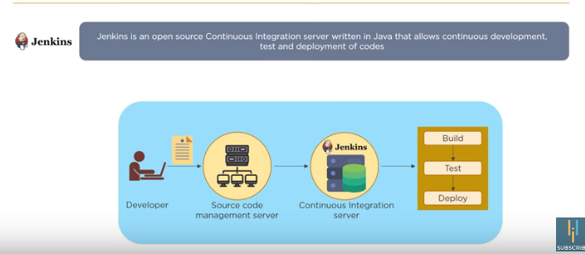

**what continuous integration is?**  
In software development, when multiple developers or teams are working on different segments of same web application, we need to perform integration test by integrating all modules.  In order to do that an automated process for each piece of code is performed on daily bases so that all your code get tested.

Answer # **Continuous Integration (CI)** is a development practice that requires developers to integrate code into a shared repository several times a day. Each check-in is then verified by an automated build, allowing teams to detect problems early.

Jenkins polls source code repositories for changes, triggers builds, runs tests, and deploys code.

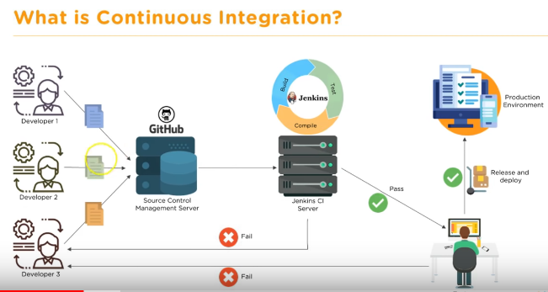

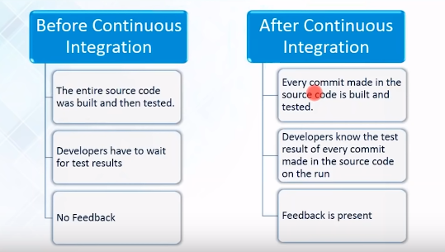

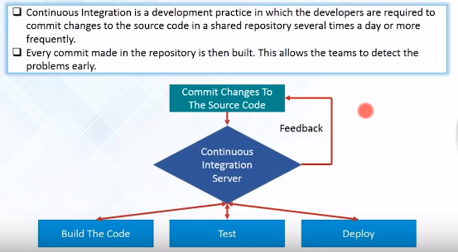

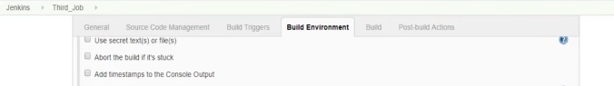

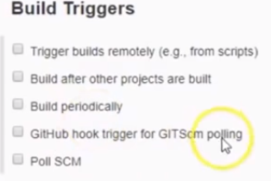

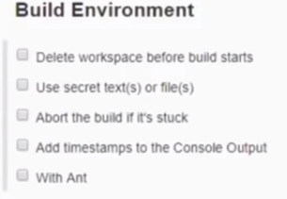

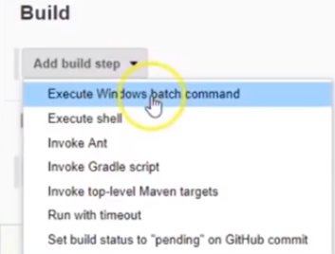

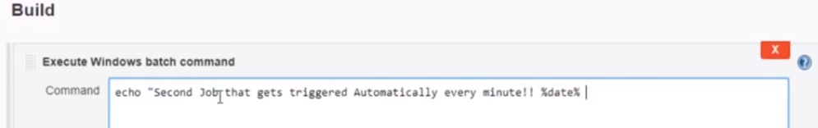

**===============================**

**Jenkin Roles and User related video**

<https://www.youtube.com/watch?v=FX322RVNGj4> [1:20:00]

Credit suisse Project stages

### CI/CD pipeline stages

There are four stages of a CI/CD pipeline

1. Source Stage,
2. Build Stage,
3. Test Stage,
4. Deploy Stage.

### Credit suisse Project stages

**---Dotnet Framework_---**

agent which supports dotnet framework

Checkout

setup version number

restore ( nuget resore src/sln)

build (msbuild.exe src/sln)

Create MSI packaege (createMSIInstaller.ps1 application_name vesrion)

Publish to artifactory (Jfrog)

Cleanup pipeline working dir

**--Dotnet core--**

agent which supports dotnet core

Checkout

setup version number

restore ( dotnet restore src/solutionfile)

build ( dotnet build src/sln)

unit test (dotnet test testfile)

Publish to artifactory (Jfrog)

Cleanup pipeline working dir

### Project Create the pipeline

Add Plugin to jenkin for the course - a) Maven integration plugin

b) Build Pipeline Plugin

c) GitHub Plugin

1) go to manage jenkin -->manage plugin --Available plugins then search for the github in filter

2) manage jenkin -->Global Tool Configuration-->jdk installation ---give name as java

3)do same for git and maven

manage jenkin -->Global Tool Configuration-->

Name -git

Path to Git executable =git.exe (its for windows) and click on install automatically

for Maven

---give name and click on install automatically at the last and say save

3) go to New Item

**Enter Item Name**-Clean maven as freestyle project then click ok

next screen will appear then go to

**source code management**-->git-->Repository URL (add the URL) then Go to

**Build** -->Invoke top-level Maven targets--->maven version (maven)

-->Goals (clean)

do above things for clean, compile, install, package, test

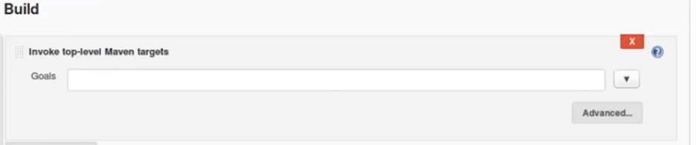

4) Crete new **pipeline** (if you give all the goals in one go in project then it’s difficult to understand where it is failing so build pipelines comes ahead by adding different project i.e clean,compile,install,test projects sin one area)

click on Jenkin--->click plus symbol near all--->create Clean_Compile_install_test pipeline

once it is done new window will open then **select the initial job** as -->created above (clean,complie,install,test) one by one and number of displayed build =1

5) How to add the dependency of goals on one other in pipeline i.e. compile should run after the clean goal is completed

open compile_maven-->configure-->Build Triggers-->**select Build after other projects are build**--->Clean_Maven (for Compile_Maven)

configure for the other goals as well

Clean_Compile(For Install_Maven)

Install_Maven (For Test_Maven)

and once it is done then run

==========================================

### configure a Freestyle Job in Jenkins

#### **✅Step 1: Open Jenkins Dashboard**

* URL: usually http://localhost:8080 or your Jenkins server
* Login if prompted

#### **✅ Step 2: Create a New Freestyle Project**

1. Click **“New Item”** in the sidebar.
2. Enter a **project name**.
3. Select **“Freestyle project”**.
4. Click **“OK”**.

#### **✅ Step 3: Configure the Freestyle Job**

#### 🔹 General

* Optionally add a **description**.
* Check “Discard old builds” to manage build history.
* Enable **GitHub project** if linking to a repo.

#### 🔹 Source Code Management

Choose either:

* **None**: If no source control is needed
* **Git**: Enter repository URL (e.g. https://github.com/user/repo.git)
  + Add credentials if private repo
  + Specify branch (*/main, */master, etc.)

#### 🔹 Build Triggers

* **Poll SCM**: Enter cron syntax (e.g. H/5 * * * * to poll every 5 mins)
* **Build periodically**: Time-based trigger
* **Trigger builds remotely**: Use a token-based URL
* **GitHub hook trigger**: React to GitHub webhooks

#### 🔹 Build Environment

* Set environment variables
* Delete workspace before build (optional)
* Use tools like Maven, Node, Python, etc., if configured

#### 🔹 Build Steps

Click **“Add build step”**, choose one:

* **Execute shell (Linux/macOS) or Execute Windows batch command**
* **Invoke top-level Maven targets**
* **Invoke Gradle script**
* **Execute Python script, etc.**

#### 🔹 Post-build Actions

* **Archive artifacts:** Save files like .jar, .war, or logs
* **Publish JUnit test result report**
* **Email notifications**
* **Deploy artifacts**

#### **Step 4: Save and Build**

* Click **“Save”**
* Click **“Build Now”**
* View console output under **Build # → Console Output**

==========================================

### Jenkin Groovy Pipeline

**New Item-🡪 Enter an Item Name🡪Select Pipeline as project🡪then put pipeline script**

**you can write pipeline using groovy in jenkin 2.0.**

**The use of groovy is when if the Jenkins fails to load then the jobs will also not available, so groovy code is useful for the create the pipeline jobs automatically**

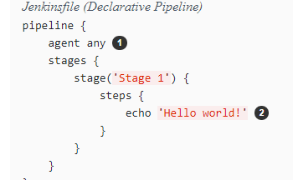

**==================**

*Jenkinsfile (Declarative Pipeline)*

pipeline {

agent any

stages {

stage('Compile Stage')

{

steps {

withMaven(maven : ‘maven_5_5_0) {

sh ‘mvn clean complie’

}

}

}

stage('Test Stage')

{

steps {

withMaven(maven : ‘maven_5_5_0) {

sh ‘mvn test’

}

}

stage('Deploy Stage') {

steps {

withMaven(maven : ‘maven_5_5_0) {

sh ‘mvn deploy’

}

}

}

}

**You can run the pipeline on various agent(nodes)(master and slave) like below using Parallel keyword**

pipeline {

agent none

stages {

stage('Run Tests') {

parallel {

stage('Test On Windows') {

agent {

label "windows"

}

steps {

bat "run-tests.bat"

}

post {

always {

junit "**/TEST-*.xml"

}

}

}

stage('Test On Linux') {

agent {

label "linux"

}

steps {

sh "run-tests.sh"

}

post {

always {

junit "**/TEST-*.xml"

}

}

}

}

}

}

}

**Pipeline syntax generator (Generate Groovy code using this)**

**===============================================**

### Declarative vs Scripted pipeline

**Declarative Pipeline**

* Overview:
  + - * Introduced to make pipelines easier to read and write
      * Uses a structured, opinionated syntax
      * Defined using pipeline { ... } block
* Pros:
  + - * Simpler and cleaner for most CI/CD use cases
      * Easy to understand and maintai
      * Built-in validation in Jenkins UI
      * Supports features like post, when, and environment
* Cons:
  + - * Less flexible for complex logic
      * Limited Groovy scripting

**Scripted Pipeline**

* Overview:
  + - * The original and more flexible format
      * Fully written in Groovy
      * Defined using node { ... } blocks
* Pros:
  + - * More flexible and powerful
      * Can write custom logic, loops, conditionals, functions
      * Good for dynamic and advanced workflows
* Cons
  + - * Harder to read and maintain
      * No UI validation
      * Can become complex quickly

**When to Use What?**

* + Use Declarative for standard CI/CD workflows (build → test → deploy)
  + Use Scripted when you need advanced logic, loops, or dynamic agent selection

**=============================================**

### [declarative pipeline on multiple nodes](https://stackoverflow.com/questions/43764447/jenkinsfile-and-multiple-nodes)

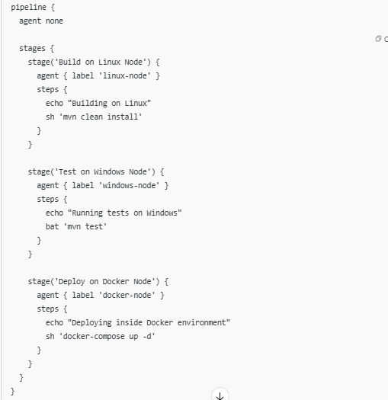

### [Scripted pipeline on multiple nodes](https://stackoverflow.com/questions/43764447/jenkinsfile-and-multiple-nodes)

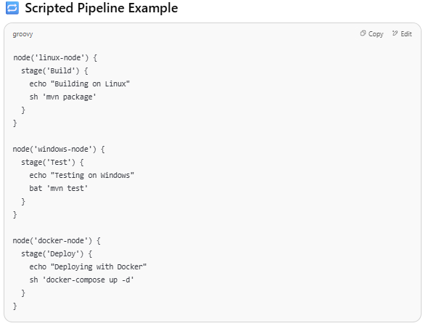

### Jenkins Pipeline Parallel executions (On master and Chlid Branch)

<https://www.youtube.com/watch?v=-YkMHwRnKgI&t=75s>

NewItem🡪Enter Item Name🡪 Select Pipeline

Now in the Pipeline Script use this groovy script

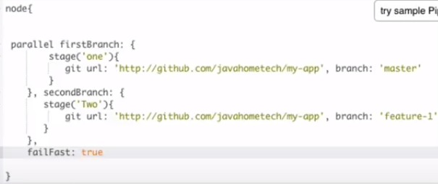

==================================================================================

### **How to add Jenkin slave from master**

**(youtube-** <https://www.youtube.com/watch?v=JHoy3lDZOfY&t=662s> 7:00:00) or

<https://www.youtube.com/watch?v=hQcFE0RD0cQ&t=330s> 2:53:00

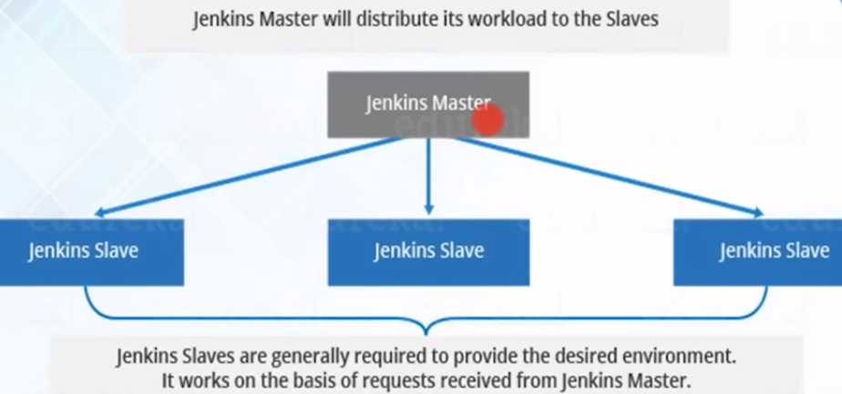

**Why need master slave configuration**

* 1. Parallel processing
  2. Jenkins master/slave architecture is used for distributed build environments, where the workload of building projects is distributed to multiple agent nodes, and we can use different environments for each build

**connect the slaves using JNLP connection from master**

go to Jenkin master ---> manage Jenkins--->configure global security-->agents -->select the random from TCP port for JNLP agents-->save

Manage Jenkin-🡪Manage Nodes🡪New Node🡪Give Name-🡪Permanent agent

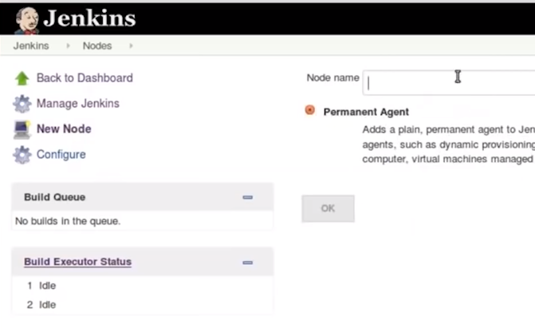

Now Configure It

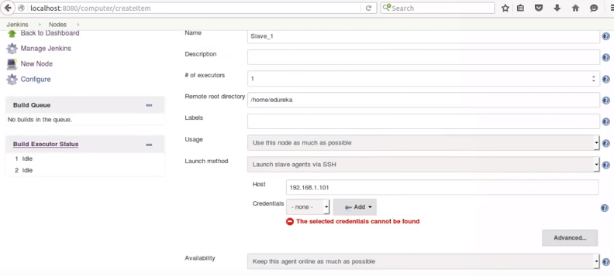

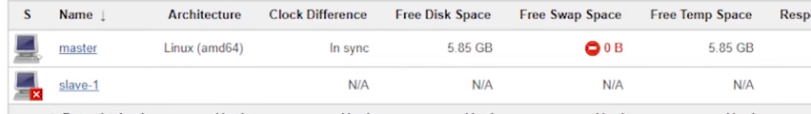

Then check on slave server if slave.jar is added or add it

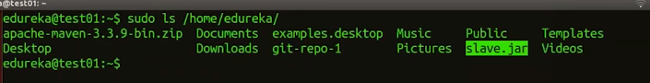

Once done execute the below highlighted command on slave machine where jar file is save

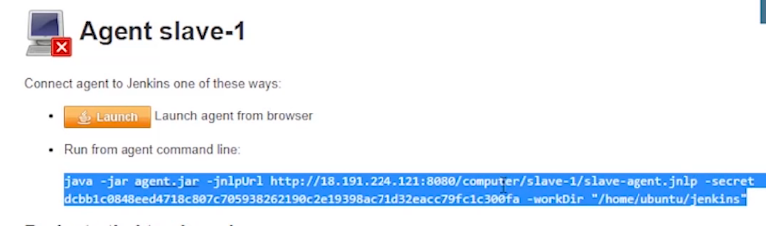

Then slave get connected

### **run job/script on slave**

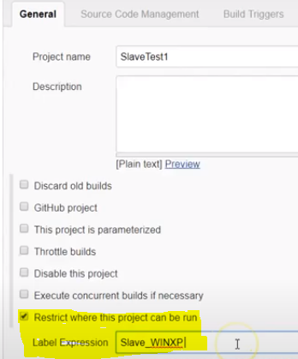

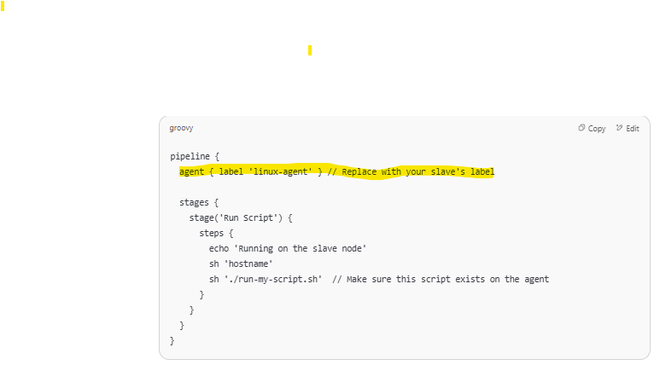

### How to parameterize job in jenkin

Create the free style project and then select

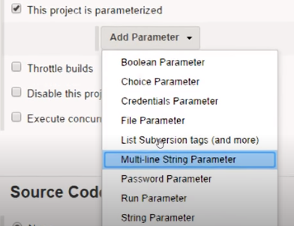

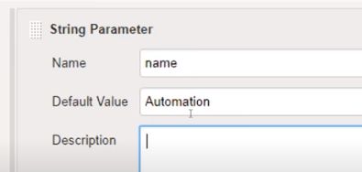

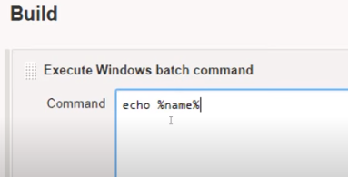

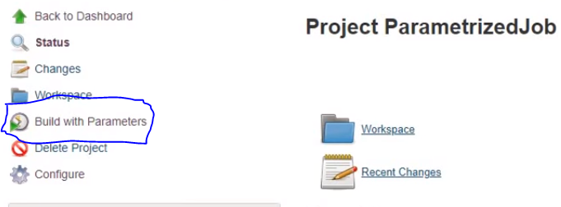

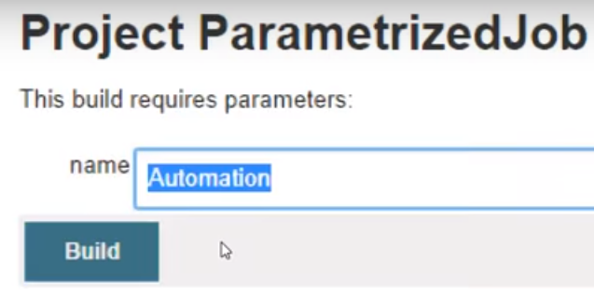

==========================================

### User Management

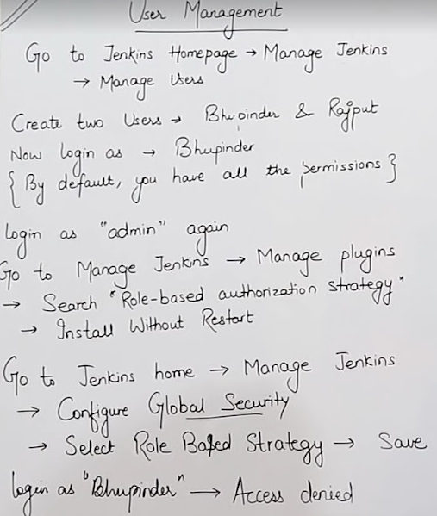

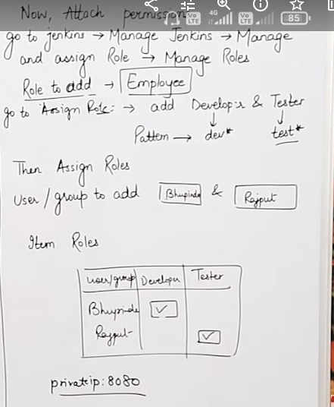

### Other Features of Jenkin

1)Email and slack installation and sharing

2)Creation of slack account and interlink with the jenkin please check the PPT for this

====Code Review using Jenkin i.e Sonar======

Download SonarCube ----https://www.sonarqube.org/downloads/

once downloaded go to bin -->windows-x86-64

in this folder u can see start stop ---->so go to command prompt from this path only and run startSonar.bat

once is started integrating it with jenkin

==============================================================

[**difference between freestyle project and pipeline in jenkins**](https://stackoverflow.com/questions/43314155/difference-between-freestyle-project-and-pipeline-in-jenkins)

The difference is that in Pipeline we have the ability to break our jobs out in to different stages and we can have whatever stages we'd like to represent the process we use to deploy software and of course, if anything goes wrong, we can see which stage had the problem;

**Such ass**

**1) checkout (code checkout from git)**

**2) Maven clean package**

**3)archival (post build action)**

**Q. How will you secure Jenkin**

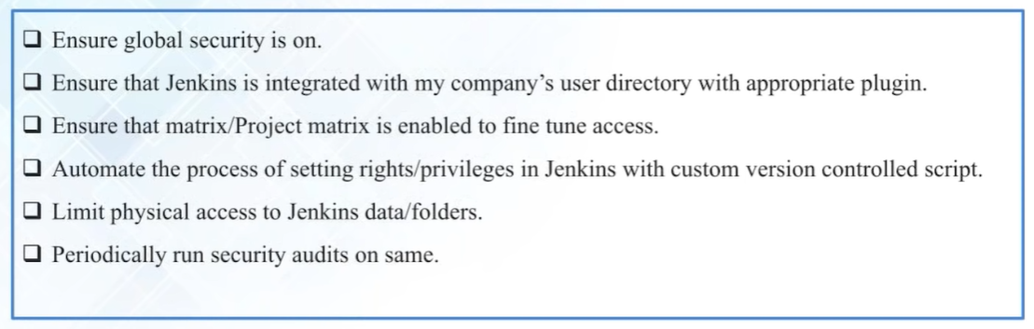

**Q. Mention what are the commands you can use to start Jenkins manually?**  
To start Jenkins manually, you can use either of the following  
(Jenkins_url)/restart: Forces a restart without waiting for builds to complete  
(Jenkin_url)/safeRestart: Allows all running builds to complete

**Q. Mention some of the useful plugins in Jenkins?**

Below I have mentioned some important Plugins:

* Maven 2 project
* Git
* Amazon EC2
* HTML publisher
* Copy artifact
* Join
* Green Balls

**Q. What is the requirement for using Jenkins?**  
To use Jenkins you require  
A source code repository which is accessible, for instance, a Git repository  
A working build script, e.g., a Maven script, checked into the repository

**Jenkins Interview Questions # 3) What is Maven and what is Jenkins?**

Answer # **Maven is a build tool**, in short a successor of ant. It helps in build and version control. However, **Jenkins is continuous integration system**, where in maven is used for build. Jenkins can be used to automate the deployment process.

**Jenkins Interview Questions # 14) What is the difference between Maven, Ant**and**Jenkins?**

Answer # Maven and ANT are build tool but main difference is that maven also provides dependency management, standard project layout and project management. On difference between Maven, ANT and Jenkins, later is a continuous integration tool which is much more than build tool.

**Q. Mention what are the advantages of Jenkins?**  
Advantage of Jenkins include At integration stage, build failures are cached  
For each code commit changes an automatic build report notification generates  
To notify developers about build report success or failure, it is integrated with LDAP mail server  
Achieves continuous integration agile development and test driven development  
With simple steps, maven release project is automated  
Easy tracking of bugs at early stage in development environment than production

**Jenkins Interview Questions # 6) Why do we use Jenkins with selenium?**

Answer # Running **Selenium tests in Jenkins** allows you to run your tests every time your software changes and deploy the software to a new environment when the tests pass. Jenkins can schedule your tests to run at specific time.

**Jenkins Interview Questions # 7) What are CI Tools?**

Answer # Here is the list of the top 8 **Continuous Integration tools**:

* Jenkins
* TeamCity
* Travis CI
* Go CD
* Bamboo
* GitLab CI
* CircleCI
* Codeship

**Jenkins Interview Questions # 8) What is a CI CD pipeline?**

Answer # A **continuous integration** and deployment pipeline (**CD/CI**) is such an important aspect of a software project. It saves a ton of manual, error-prone deployment work. It results in higher quality software for continuous integration, **automated tests**, and code metrics.

**Jenkins Interview Questions # 9) What is build**pipeline**in Jenkins?**

Answer # Job chaining in **Jenkins** is the process of automatically starting other job(s) after the execution of a job. This approach lets you build **multi-step build pipelines** or trigger the rebuild of a project if one of its dependencies is update0d.

**Q. Explain how can create a backup and copy files in Jenkins?**  
Jenkins saves all the setting, build artifacts and logs in its home directory, to create a back-up of your Jenkins setup, just copy this directory. You can also copy a job directory to clone or replicate a job or rename the directory.

**Q. Explain how you can clone a Git repository via Jenkins?**  
To clone a Git repository via Jenkins, you have to enter the e-mail and user name for your Jenkins system.  For that, you must switch into your job directory and execute the “git config” command.

**Q. Explain how you can set up Jenkins job?**  
To create a project that is handled via jobs in Jenkins.  Select New item from the menu, once this done enter a name for the job and select free-style job. Then click OK to create new job in Jenkins.  The next page enables you to configure your job.

**Q. Mention what are the two components Jenkins is mainly integrated with?**  
Jenkin is mainly integrated with two components  
Version Control system like GIT, SVN  
And build tools like Apache Maven.

Q. What is the difference between Maven, Ant and Jenkins ?  
Maven and Ant are Build Technologies whereas Jenkins is a continuous integration tool.

**Q. Which SCM tools Jenkins supports?**  
AccuRev, CVS, Subversion, Git, Mercurial, Perforce, Clearcase and RTC

**Q. What are the various ways in which build can be scheduled in Jenkins?**  
Builds can be triggered by source code management  commits.  
Can be triggered after completion of other builds.  
Can be scheduled to run at specified time ( crons )  
Manual Build Requests

**Q. What is the relation between hudson and Jenkins?**  
Hudson was the earlier name and version of current Jenkins. After some issue , the project name was changed from Hudson to Jenkins.

**Q. What you do to make sure that your project build doesn’t break in Jenkins?**  
I make sure that I perform successful clean install on my local machine with all unit tests.Then I make sure that I check in all code changes.  
Then I do a Synchronize with repository to make sure that all required config and POM changes and any difference is checked into the repository.

**Q. What you do when you see a broken build for your project in Jenkins?**  
I will open the console output for the build and will try to see if any file changes were missed.  
If not able to find the issue that way, Will clean and update my local workspace to replicate the problem on my local and will try to solve it.

**Q. Tell us a bit about what your service and plugin do. Who is it for? What are the highlights of your plugin?  
LOADER.IO** is a simple-to-use cloud-based load testing service. The service is designed for developers and people who need to ensure applications are performing as they should. It allows developers to perform large-scale load tests on demand, which lets them understand the scalability and performance of their applications. We realize Jenkins is the preferred build service for a lot of our users, and we know providing a way for them to implement, measure and improve application performance during the continuous build cycle is important. So we wrote a Jenkins plugin that allows load testing to be brought into the continuous build and deployment process with ease.

**Q. Which SCM tools does Jenkins support?**  
Jenkins supports the following SCM tools:  
1. AccuRev  
2. CVS  
3. Subversion  
4. Git   
5. Mercurial  
6. Perforce  
7. Clearcase  
8. RTC

**Q. How can you setup Jenkins jobs?**  
Follow these steps:  
Select new item from the menu.  
After that enter a name for the job and select free-style job.  
Then click OK to create new job in Jenkins.  
The next page enables you to configure your job.

**Jenkins Interview Questions # 13) What is the tool used for provisioning and configuration?**

Answer # Ansible is an agent-less configuration management as well as orchestration tool. In Ansible, the configuration modules are called “Playbooks”. Like other tools, Ansible can be used for cloud provisioning.

**Q. What are the key features of Jenkins?**

* Easy setup and configuration
* Large plugin ecosystem
* Supports distributed builds
* Integrates with most tools (Git, Maven, Docker, etc.)

**Q. What is the difference between freestyle and pipeline jobs?**

* **Freestyle**: GUI-configured, basic jobs.
* **Pipeline**: Scripted in Groovy, more powerful, supports complex workflows.

**Q. What is a Jenkinsfile?**

A text file that defines the CI/CD pipeline using Groovy syntax. Stored in the project’s source code repo

**Q. How does Jenkins integrate with Git?**

Jenkins uses the Git plugin to clone repositories and trigger builds based on code changes.

**Q. How do you trigger a Jenkins build automatically?**

* SCM polling
* Webhooks (e.g., GitHub)
* Manual triggers
* Scheduled (cron syntax)

**Q. How do you handle secrets and credentials in Jenkins?**

* Use **Jenkins Credentials Manager**
* Store secrets securely and reference them in jobs via variables

**Q. What are stages and steps in a Jenkins pipeline?**

* **Stages**: Logical divisions (e.g., Build, Test, Deploy)
* **Steps**: Commands or scripts inside a stage

**Q. How would you roll back a failed deployment in Jenkins?"**

* **Version Deployments (Best Practice)**

• Keep artifacts in Nexus, Artifactory, or Jenkins archive

• Tag successful builds (e.g., v1.2.3)

• On failure, re-deploy a previous version

*stage('Rollback') {*

*steps {*

*echo "Rolling back to previous stable version"*

*sh './deploy.sh --version=1.2.2'*

*}*

*}*

* **Rollback Docker Images**
* **Git-based Rollback (Revert Commit)**

• Reverting a commit

• Checking out a previous tag

• Re-deploying the code

### Secure Jenkins in a production env ?

Securing Jenkins in a production environment is **critical** to protect your code, credentials, and deployment infrastructure. Here’s a breakdown of **best practices** to secure Jenkins:

1. **Enable Authentication**

* Go to **Manage Jenkins → Configure Global Security**
* Choose **“Jenkins’ own user database”**, LDAP, or SSO (e.g., GitHub, SAML, Google OAuth)
* Disable anonymous access
* Enforce **strong passwords** or use **SSO**

2. **Set Up Authorization**

* Use **Role-Based Access Control (RBAC)** via the **Role-Based Strategy plugin**
* Create roles like admin, dev, qa, readonly
* Assign fine-grained permissions to jobs, folders, credentials, etc.

3. **Use HTTPS**

* Terminate SSL at a reverse proxy like **Nginx** or **Apache**, or configure Jenkins with an HTTPS certificate directly
* Redirect all HTTP to HTTPS

4. **Limit Plugin Usage**

* Install only **trusted, verified plugins**
* Regularly audit and remove unused plugins
* Keep plugins updated to patch vulnerabilities

5. **Secure Credentials**

* Store secrets using **Jenkins Credentials Plugin**
* Never hard-code secrets in Jenkinsfile
* Use credentials binding (withCredentials) to inject them securely during jobs

6. **Audit and Logging**

* Enable **Audit Trail plugin** or **Audit Log plugin** to monitor:
  + Job changes
  + User logins
  + Config changes
* Keep system logs for investigation

7. **Restrict CLI and Script Console Access**

* Limit access to the **Groovy script console** and **CLI**
* These are powerful tools that can compromise the system if misused

8. **Use Folders and Project-Based Security**

* Organize jobs into folders by team or function
* Apply specific roles to folders to isolate access

9. **Run Jenkins as a Non-root User**

* Run the Jenkins process under a restricted user account
* Limit system-level access to Jenkins processes and files

10. **Secure Build Agents**

* Use SSH authentication or inbound JNLP with secret tokens
* Ensure agents are not running as root and are isolated
* Use containers (e.g., Docker) or ephemeral agents for better isolation

11. **Backups and Disaster Recovery**

* Regularly back up Jenkins home (/var/lib/jenkins) and job configs
* Store backups securely and automate restoration testing

### How do you ensure high availability for Jenkins?

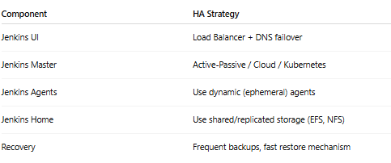

**===================================================**

# **DOCKER**

<https://rominirani.com/docker-tutorial-series-a7e6ff90a023>

<https://rominirani.com/docker-swarm-tutorial-b67470cf8872>

**What is Docker and why we need?**

Docker is a containerization platform which packages your application and all its dependencies together in the form of containers to ensure that your application works seamlessly in any environment be it development or test or production.

**What is difference between docker and dockerhub**

Dockerhub is central repository which is on cloud which holds all the codebase

**Docker Concept--->**

User has downloaded centos/java/tomcat and installed on his machine--->this software is handed over other person (commit and push) --------->another person can pull the changes after User does the commit to changes

It is open source, Docker is containerisation platform ..so it’s simple than the virtual machine and its light weighted (low CPU and low memory)

**Docker Image**-Its template for your docker container

**Container** Containers are nothing light weight alternative to virtual machine.

It is run time instance of docker image.

Container contain my application (that contains binaries and libraries and dependencies)

Docker Container-With the help of Images you can create as many docker containers as many you want

**Features of Container**

* Lightweight
* Less resources are used
* Booting of containers is very fast
* Can start, stop, kill, remove containers easily and quickly

**Disadvantages of Docker**

* Docker is not good solution for application that requires rich GUI
* Difficult to manage large amount of containers
* Docker does not provide cross platform compatibility means if an application is designed to run in a docker container on windows then it cannot run on linux and vice versa
* Docker is suitable when the development OS and testing OS are same

**Any Best 3 practices of docker**

- Always keep dockefile in empty directory

- Use official images when possible

- Use more specific tags

**Difference Between docker attach and docker exec**

“docker exec” creates the new process in the container’s environment

docker exec is specifically for running new things in already started container ,be it a shell or some other process.

while “docker attach” just connect the standard Input/output of the main process inside the main container to corresponding standard input/output error of current terminal.

Docker attach Connects **to the main process** of the container (usually PID 1) to view logs or interact with a container’s default process and it can be disruptive — closing the terminal **can stop** the container (unless you detach safely)

### Difference between Docker and Virtualization

In virtualization, separate kernel is present in host operating system but in containerization you do not have and because of that containers are very small, they have bare minimum libraries for container to behave as particular operating system

**Docker is faster and lighter** because it reuses the host OS kernel [Like multiple apps running on the same OS, each in its own sandbox],

while **virtualization gives stronger isolation** but with higher overhead [Like full computers running inside your actual computer, each with its own OS]

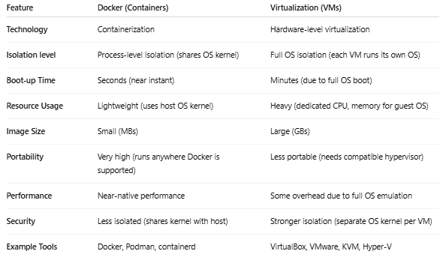

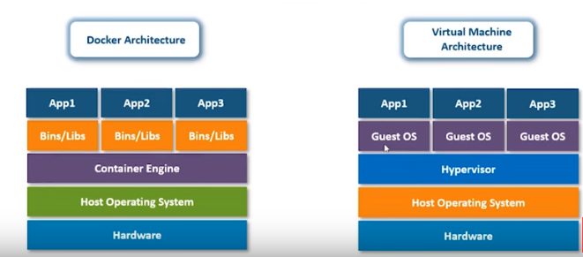

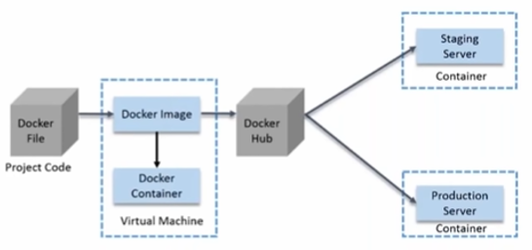



### Docker Container Lifecycle

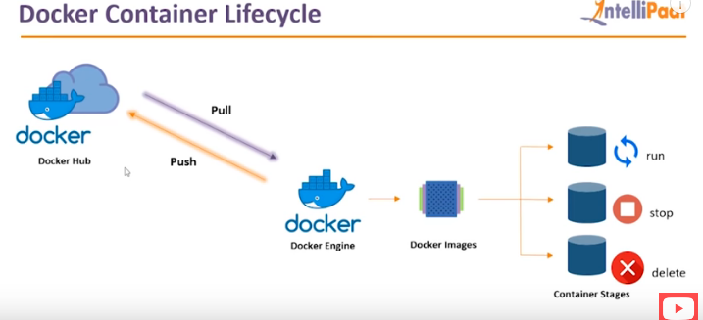

### Docker Commands





**---------------------------cheet sheet----------------------------**

<https://devhints.io/docker>

-

<https://www.jrebel.com/blog/docker-commands-cheat-sheet>

<https://design.jboss.org/redhatdeveloper/marketing/docker_cheatsheet/cheatsheet/images/docker_cheatsheet_r3v2.pdf>

<https://github.com/wsargent/docker-cheat-sheet#security>

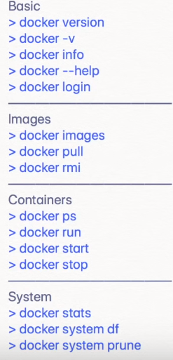

----------------------------------------------------------------------------------------

docker inspect <container_id> --give the ip of the container

--------------------------------------------------------------------------------------------------

Service docker start --start the docker

docker --version --1.12.5

docker -v

docker –help --(ex. Docker images –help)

docker COMMAND --help

docker info --gives the several pieces of information about the OS

docker stat --give information about CPU and memory

docker system df --system usage info

-------------------------**Pull the Image from DockerHub**---------------

docker pull centos:latest

-------------------------- **Images**------------------------------------

docker images --u can see all the images which on my local

docker search <image-name> --search the image on Dockerhub

docker history <image_name> --check the history of image

**docker** rmi $(**docker** images -q) --Delete all images

---------------------------- **Container ---------------------------------**

docker inspect <container_id> --give all the details of container

docker create busybox echo hi --create the container but not run

docker run ubuntu cat “/etc/releases” --create+run the container

docker run centos:latest

docker run tomcat:9 --tagging (version 9 will be downloaded)

docker run centos:latest sleep 5 --sleep for 5 Sec

docker run -d tomcat:9 --run in background (d-detached)

docker attach <container_id> --bring it back to foreground

docker run -it -d centos:latest --run the container interactive mode

-i -> interativemode

T -> terminal

docker top <container_id> -- show top processes of container

docket stats <container_id> --show stat of running comtainer <me,cpu>

docker logs <container_id> -- retrieve log output

docker system prune --delete the stopped container,dangling image

And unused network

docker inspect <container_id) --shows details(show attached volume as well) will show you json format

----------------------------**View containers**------------------------------

docker ps --will list only active containers

docker ps -a ---will list all container containers

-----------------------------**Start/Stop/Pause/kill/delete Container**------------

docker start <contern id> --stop the container

or

docker start -ai <container_name> --will go inside container

docker stop <contern id> --stopping the container id

docker pause <container name>

use case -1) patch the sever

2) not to use the much services

3) if port conflict is there then stop one

docker unpause <container name> --unpause the container

docket kill <contern id> --Kill the container

docker kill $(docker ps -q) -- Kill all running containers

docker rm $(docker ps -a -q) -- Delete all stopped containers

--------------------------**-Command to list container status**---------------

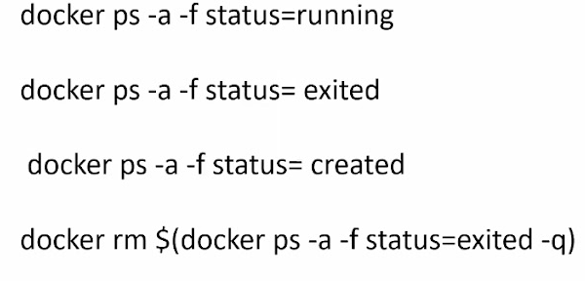

-----------------**Executing command inside container** -----------

docker exec -it <container_id> bash

docker exec -it <container_id> redis-cli

--you will act as root **for** container

After this you can go inside container update the container using *apt-get update*

Once container is created then you can check the difference with the original one

*Docker diff <container_name>*

----------------------------- **Port Mapping-----------------------------------------------**

docker run -p 8080:8080 jenkins

----------------------------**Delete image and container**----------------------------------

docker rmi <image id> or <image name> -----delete the image

docket rmi -f centos:latest ----it will delete the image but the container will be there (container will become orphan).U can start the container only if there is image

docker rm <container id> or <container name> ----- delete the container

----------------**Create the new image once changes are done in container**-----------

docker commit <container id> <new image name> ---Saving changes inside container

-----------------------------------**Push the image on the dockerhub**------------------

docker login --First logging to docker so that u can push and pull from dockerhub

docker push centos --upload on the docker hub repository

----------------------------**Other Commands**-------------------------------------

docker tag centos registry-host/kalpeshpawar/centos ----give tag (taaging)

Q- Deploy a mysql database using the mysql image and name it mysql-db.

Set the database password to use db_pass123. Lookup the mysql image on Docker Hub and identify the correct environment variable to use for setting the root password.

Answer- Command: docker run -d -e MYSQL_ROOT_PASSWORD=db_pass123 --name mysql-db mysql

------------------------------------------------------------------------------------

### install apache server in container

1) docker pull ubuntu

2) docker run -it -d ubuntu

3) docker exec -it <container-id> bash

--we are now in container now install the apache---

3) apt-get update

Or yum install update

4) apt-get install apache2

Or yum install httpd

5) service apache2 start

Or systemctl start httpd

6) sudo docker ps

7) create new image using above container

docker commit <container-id> <new image name>

e.g docker commit <container-id> kalpesh/apache

8> check whether my new image is working properly

i> docker run -it -p 82:80 -d kalpesh/apache --apache will run on port 82 instead 80 (-p used for mapping the port)

ii> docker exec -it <container-id> bash

iii> service apache2 start

9) Push the image to the dockerhub

docker login

docker push kalpesh/apache

10) check the image on the dockerhub

------------------------------------------------------------------------------------

### Dockerfile

Docker file is a text document that contains all the commands a user could call on the command line to assemble an image.

Save the file using - Dockerfile

### Dockerfile Components

**FROM**: For base image, this command must be on the top of the dockerfile

creates a layer from the ubuntu: Docker image.

**RUN**: To execute the command, it will create a layer in image

This will run inside the container.

**Maintainer**: Author/Owner/Description

**COPY**: Copy files from local system (Docker VM),

we need to provide the source and destination.

(We can’t download the file from internet or any remote repo)

While ADD has some features

(like local-only tar extraction and remote URL support)

**ADD**: similar to copy but, it provides the feature to download the files

from internet, also we extract file at docker image side

**EXPOSE**: To expose the ports such as port 8080 for tomcat

**WORKDIR**: To set working directory for container. You can directly land in this dir

**CMD**: Executes commands during the container creation

(specifies what command to run within the container)

**ENTRYPOINT**: Similar to CMD but has the higher priority over CMD.

first command will be executed by entrypoint only

**ENV**: Environment variable

**Docker file for above steps**

**FROM ubuntu**

**RUN apt-get update ---inside container**

**RUN apt-get -y install apache2 --inside container**

**ADD . /var/www/html -------- (adding file or updating data inside the container)**

**ENTRYPOINT apachectl -D FOREGROUND --run the apache in foreground**

**ENV name intellipaat**

**Docker File contents**

**FROM ubuntu**

**RUN apt-get update**

**RUN apt-get -y install apache2**

**ADD . /var/www/html ------(ADD source destination)**

**CMD <start the service> ----it work like chckconfig**

**COPY . /app**

**ENTRYPOINT apachectl -D FOREGROUNF --run the apache in foreground**

**ENV**

### Entrypoint vs Cmd

Use of EntryPoint (e.g Don’t provide sleep parameter on command line mention it in playbook as entrypoint)

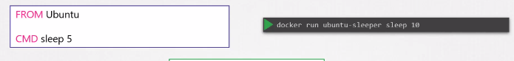



You can use both at a time so that default values are get added in command in case if no parameter is provided

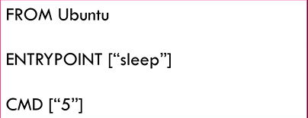



**================================================**

**Another Examples of dockerfile**

1)

FROM ubuntu

WORKDIR /tmp

RUN echo “hi” > /tmp/testfile

ENV myname Kalpesh

COPY testfile /tmp

ADD test.tar.gz /tmp

2)

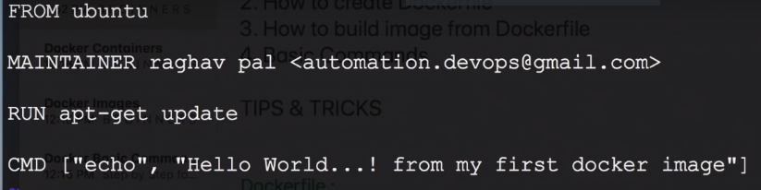

**3)**

FROM alpine

RUN apk add --update redis

RUN apk add --update gcc

CMD ["redis-server"]

=================================

4)

FROM node:4.6

WORKDIR /app

ADD . /app

RUN npm install

EXPOSE 3000

CMD npm start

===================================

5)

FROM node:alpine

WORKDIR /usr/app [Safe place to keep the application]

copy ./package.json ./ [This is constant file(package.json) so copy the package.json to temporaty container] if this file overwrite the files accidently in root folder so use "WORKDIR" command as above

RUN npm install

copy ./ ./ [Copy all files again to minimize the rebuild of npm install if we make change in index.js]

CMD ["npm", "start"]

===================================

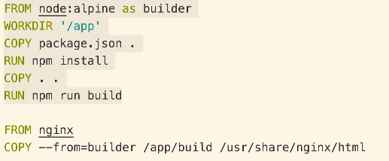

**==================================**

Convert below instruction to dockerfile (Source <https://github.com/mmumshad/simple-webapp-flask>)

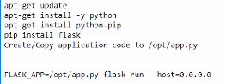

Dockerfile for above command

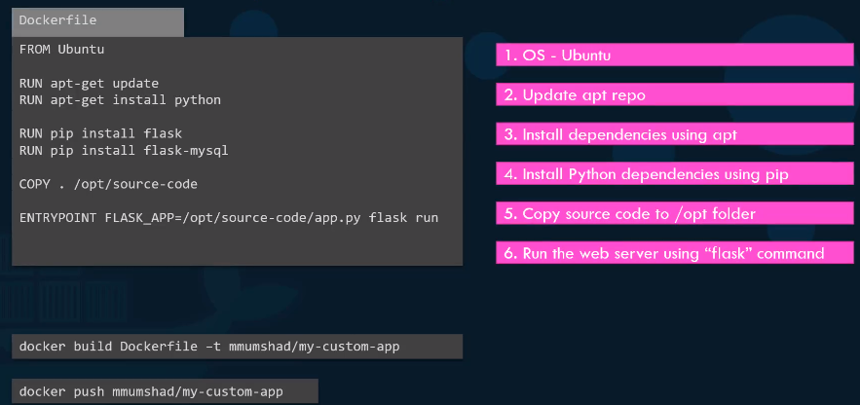

### How to run the dockerfile

docker build -t ImageName:TagName dir

**example**

sudo docker build –t myimage:0.1.

ex. docker build -t kalpesh/redis:latest

**how to run the dockerfile which is having different name i.e Dockerfile.dev**

**-->**docker build -f Dockerfile.dev

* -t − is to mention a tag to the image
* ImageName − This is the name you want to give to your image.
* TagName − This is the tag you want to give to your image.
* Dir − The directory where the Docker File is present

2) Port mapping to container from source machine after build the image from the dockerfile

docker run -p 8080:8080 kalpesh/redis:latest

------------------------------------------------------------------------------------

### Docker Volume

If something happens with the container (Crash) then there are chances that data also not present in that container so to avoid this problem, then Docker Volume concept comes ahead

1) Volume is simply a directory inside our container

2) Firstly we have to declare the directory as a volume and then share the volume

3) Even if we stop container, still we can access volume.

4) Volume will be created in one container

5) You can declare a directory as a volume only while creating Container

6) you cannot create volume from existing container

7) you can share one volume across any number of container

8) Docker volume are used to persist data across the lifetime of a container

9) volume which is storage outside the container and mapped with the inside the container

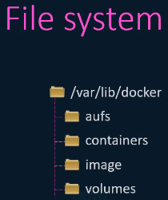

========================================

**Creating Volume from Dockerfile**

1) Create a dockerfile and write

FROM ubuntu

VOLUME ["/myvolume""]

2) Then Create the image from this dockerfile

docker bulid -t myimage .

3) Now create the container from this image and run

docker run -it --name testcontainer1 myimage /bin/bash

4) now you do ls ,you can see myvolume dir inside container

5) Now share the volume with another container (testcontainer2)

docker run -it --name testcontainer2 --privileged=true --volumes-from testcontainer1 ubuntu /bin/bash

(--previleged=true means this container also make changes in the volume)

now after creating the testcontainer2,myvolume is visible,Whatever you do in one volume,can see from other volume

touch /myvolume/samplefile

6)docker start testcontainer1

7) docker attach testcontainer1

8) ls myvolume (you can see samplefile here)

===================================================

**Now try to create volume by using commands**

1) docker run -it --name newcontainer1 -v /volume1 ubuntu /bin/bash

cd volume1

touch testfile

ls

exit

2) now create one more container (newcontainer2) and share the volue

docker run -it --name newcontainer2 --privileged=true --volumes-from newcontainer1 ubuntu /bin/bash

cd volume1

ls

3) now container is share so you can check whether you are see same file from another container

====================================

**Volumes (Host to container) means from your base machine to container connectivity**

1) verify files in /home/ec2-user

ls /home/ec2-user

2) mapping of host machine directory "/home/ec2-user" with docker volume directory "/kalpesh"

docker run -it --name hostcontainer -v /home/ec2-user:/kalpesh --privileged=true ubuntu /bin/bash

3) now go to kalpesh directory inside the container do "ls" now you can see all the files from host

touch myfile

exit

4) now check on host machine that you can see this file "myfile"

5) Again, add the few file on host machine and check inside the docker volume

docker start hostcontainer

docker attach hostcontainer

ls /Kalpesh

===============================================================================

**Some other manual commands**

1) create the volume

docker volume create test

docker volume ls

2) Check the volumes present

docker volume ps

docker volume ls

docker volume inspect <volume_name>

3) docker volume rm

4) docker volume prune --remove all unused docker volume

5) docker volume inspect <volume_name>

* 1. Mapping the volume (attaching to container)

docker run -it --mount source=test, target=/app -d ubuntu



Source =Name of the volume

Target=Where You want to map

* 1. Go inside the container add files inside app dir

docker exec -it <container-id> bash

cd app

* 1. Run new container using same below command and check the files in app (files are now share bet 2 container)

docker run -it –mount source=test, target=/app -d ubuntu

* 1. How to remove the volume

Docker volume rm <volume_name>

### Docker Port Expose and Publish

**Difference between expose and publish (-p)**

If you specify neither expose nor -p, the service in the container will only be accessible from inside the container itself

If you only expose a port not -p, then service in the container is not accessible from outside docker but will be accessible only inside the docker container, so this is good for intra-container communication

If you do publish (-p) but do not expose, it is open to the public (outside world) and automatically also open to the other docker container (Hence -p include expose)

-Commands-

1. docker run -td –name techserver -p 80:80 ubuntu (host:container)
2. docker ps
3. docker port techserver
4. docker exec -it techserver /bin/bash
5. apt-get update
6. apt-get install apache2 -y
7. cd /var/www/html
8. echo “hello” > index.html
9. service apache2 restart

docker run -td –name myjenkins -p 8080:8080 jenkins

how to map the source code folder to container using volume to avoid rebuild after changes in the source code

docker run -p 3000:3000 -v /app/node_modules -v ${pwd}:/app IMAGE_ID

how to map the desktop folder to jenkin home folder using volume

docker run --name Myjenkins -p 9090:8080 -p 5000:5000 -v /Users/pawar_ka/Desktop/Jenkins_Home:/var/jenkins_home Jenkins

how to map the volume to jenkin home folder using volume

docker run --name Myjenkins -p 9090:8080 -p 5000:5000 -v test:/var/jenkins_home jenkins

-------------------------------------------------------------------------------------------

### ****Docker Compose****

**how to run multiple container(microservice) with a single command**

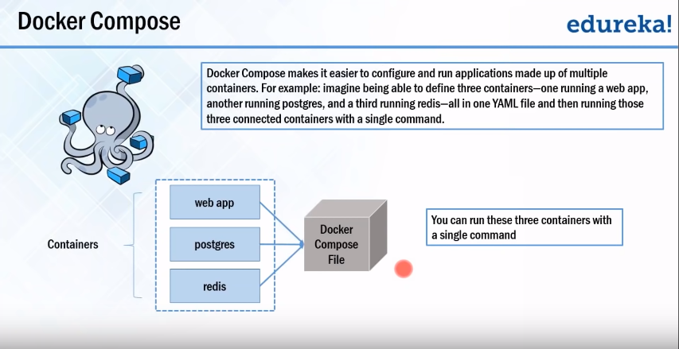

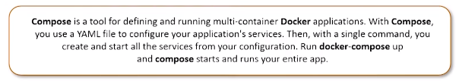

**=================================================**

**Detailed explanation using the diagram**

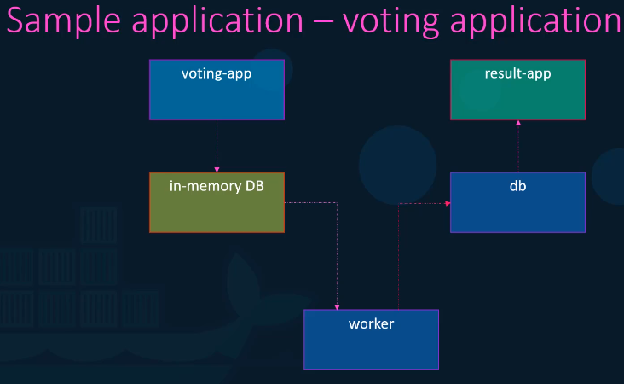

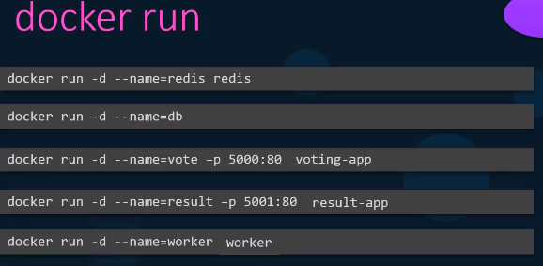

When we run the the application it will fail because there is no link between the containers.

So using the links the above docker commands will be as below

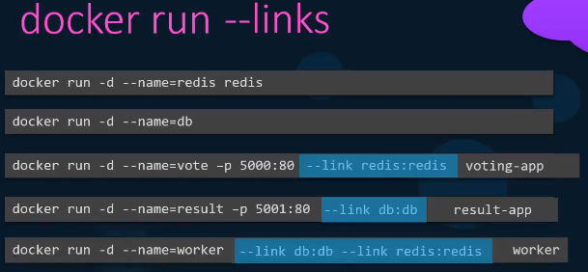

Convert above statements in docker compose as below

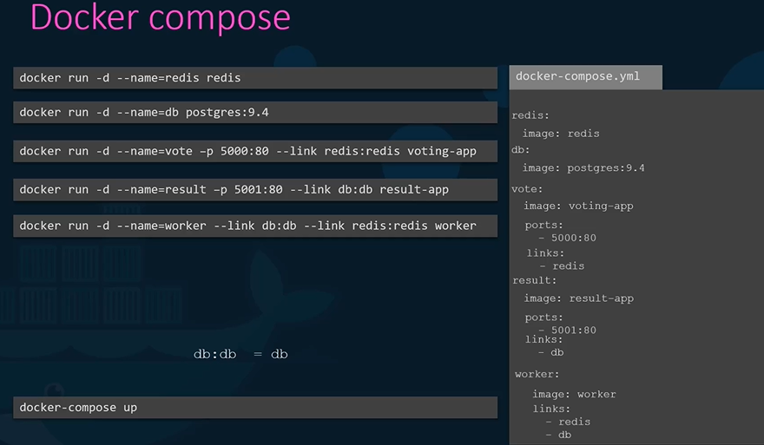

If there is not official image then you can build in docker compose file as below

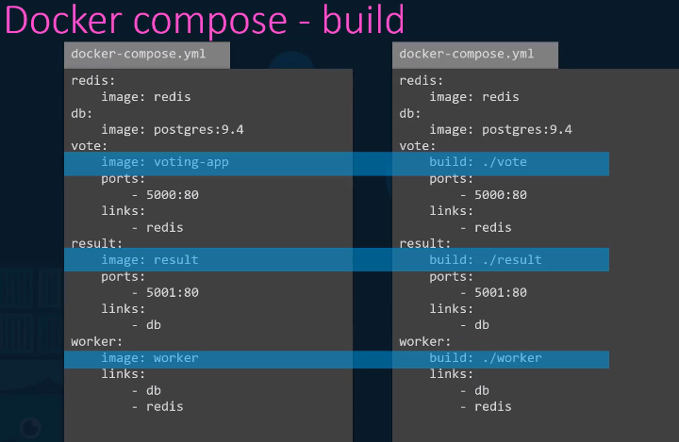

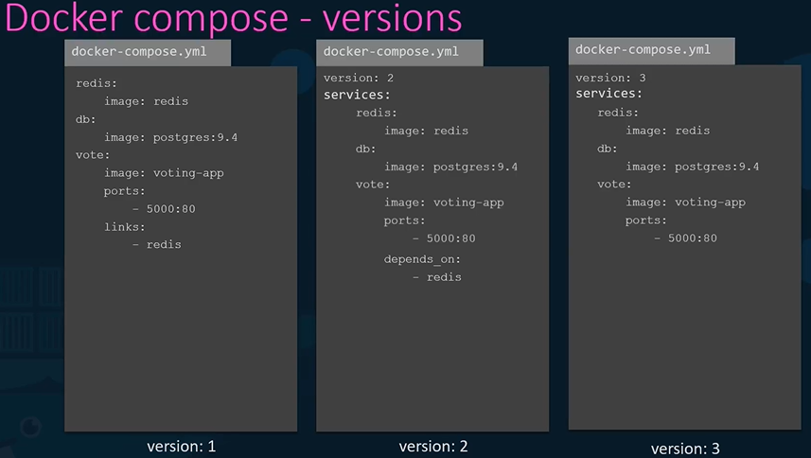

Docker Compose network

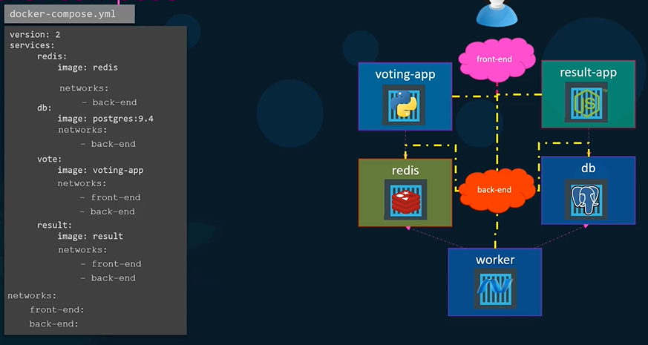

**===========================================**

We have below two containers of two images (node.js projcet)

1) creating 1st container using the dockerfile in current dir

==Dockerfile in cur dir (having application consisting of index.js and ackage.json)========

FROM node:alpine

WORKDIR /usr/app

copy ./package.json ./

RUN npm install

copy ./ ./

CMD ["npm", "start"]

=====================

2) creating the redis container using below

docker run redis

-->

so we have to connect both of them by using the docker compose so write

the file "docker-compose.yml" as below

#############################################################

=====docker-compose.yml=================

version : ‘3’

services: --similar like container

redis-server:

Image: ‘redis’

node-app:

build: . --This will run dockerfile inside the directory

ports:

- “4001:8081”

volume: --Mapping two differnt directories

- /app/node_modules --source code directory

- .:/app -- directory inside the container

============Comlex example==================

version: '3'

services:

postgres:

image: 'postgres:latest'

redis:

image: 'redis:latest'

server:

build:

dockerfile: Dockerfile.dev

context: ./server (location of dockerfile)

volumes:

- /app/node_modules

- ./server:/app

environment:

- REDIS_HOST=redis

- REDIS_PORT=6379

docker run myimage ----similar to---> docker-compose up

docker build . ----similar to---> docker-compose up --build

1) check the validity of docker-compose file

docker-compose config

2) Launch docker compose in background

docker compose up -d

3) how to stop the docker compose

docker-compose down

4) Check the container inside the docker-compose

docker-compose ps

5) Stopping the docker-compose containers

docker-compose down

6) Container maintenance with compose ( if server crashes)

use below restart policies as following in docker-compose.yml file to avoid failure

1)no 2)always 3) on-failure 4) unless-stopped

version : ‘3’

services: --similar like container

redis-server:

Image: ‘redis’

node-app:

**restart: always**

build: .

ports:

- “4001:8081”

5) Check the version

docker_compose –v

### Docker Networking

Docker uses its own networking system to allow **containers to talk to each other**, to the host, and to the outside world.

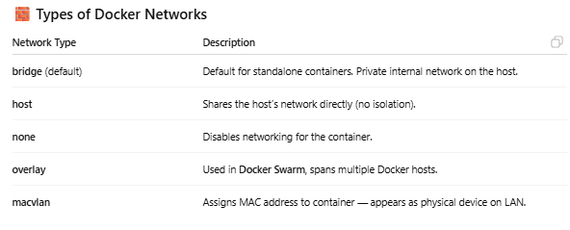

**Basic Networking Commands**

* List networks

docker network ls

* Inspect a network

docker network inspect bridge

* Create a custom network

docker network create mynetwork

* Run container on that network

docker run -d --name app1 --network=mynetwork nginx

* Connect existing container to a network

docker network connect mynetwork app1

* Disconnect a container

docker network disconnect mynetwork app1

### Docker Registery

A **Docker Registry** is a **repository** where **Docker images** are stored, shared, and managed. It acts like a version-controlled storage system for container images, allowing you to **push**, **pull**, and **distribute** your containerized applications.

Example

1) Dockerhub

2) GitHub Container Registry (ghcr)

3) Amazon ECR (Elastic Container Registry)

4) Google Artifact Registry / GCR

5) Azure Container Registry (ACR)

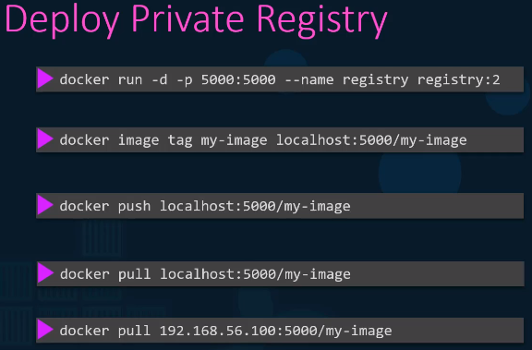

### Environment Variable in Docker

docker run **-e MY_VAR=value** myimage

docker run -**e VAR1=value1 -e VAR2=value2** myimage

**===================================================**

### Docker Swarm (Container orchestration tool)

Docker swarm is clustering and scheduling tool for Docker containers. It works like ELB and autoscaling group

**Container orchestration –** The Process of organizing multiple containers in microservice.

Bug in one service, does not affect other services.

Container communicate with each other with JSON so there is no barrier of specific technology.

**Why we use Docker Swarm**

To counter the problems of monolithic Applications, we came up with a micro services architecture. In micro services the code base is on the different servers whereas in monolithic the codebase on the single server. Container mapping is there.

When you delete the Docker container by mistakenly/accidently then whole website is gone in Docker

This is the traditional method using in the container and micro services.

Then there was something called container orchestration which became very popular which basically says all the containers health will be monitored by Docker itself.

If there is any container which goes down /container which is not healthy then what Docker swarm does it automatically repairs, it by stopping the container and launching new one and end user will realise what happen

-health check on every container

-Ensure all containers are up on every system

-Scaling the containers up or down depending on the load

-adding updates/changes to all the container

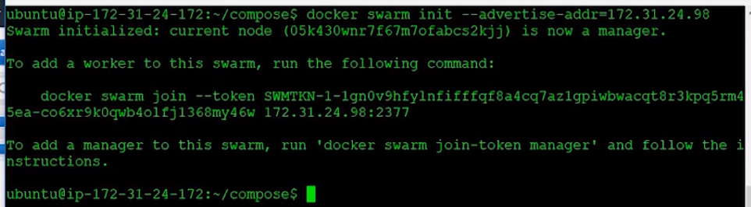

Step 1 : Create Docker machines (to act as nodes for Docker Swarm)

Create one machine as manager and others as workers

* docker-machine create --driver hyperv manager1
* docker-machine create --driver virtualbox manager1 (for mac)

if you get this error --- docker-machine:Error with pre-create check: “exit status 126” then run below command

* brew cask install virtualbox; (This command will create virtual box )

Step 2 : create two worker machine

* docker-machine create --driver hyperv worker1
* docker-machine create --driver virtualbox worker1 (for mac)

* docker-machine create --driver hyperv worker2
* docker-machine create --driver virtualbox worker2 (for mac)

Step 3 : Check machine created successfully

- docker-machine ls

- docker-machine ip manager1

Step 3 : SSH (connect) to docker machine

- docker-machine ssh manager1

- docker-machine ssh worker1/2

Step 4 : How to check the ip of manager and worker machine

- docker-machine ip manager1

- docker-machine ip worker/2

Step 5 : Initialize Docker Swarm

First you have to create the leader node(private ip of machine) using the below command and then you can add many nodes in cluster using “docker join” command which is mentioned below

- docker swarm init --advertise-addr MANAGER_IP



- docker node ls

(this command will work only in swarm manager and not in worker)

Step 6 : Join workers in the swarm

Get command for joining as worker in manager node run command

- docker swarm join-token worker

This will give command to join swarm as worker

- docker swarm join-token manager

This will give command to join swarm as manager

SSH into worker node (machine) and run command to join swarm as worker

In Manager Run command - docker node ls to verify worker is registered and is ready

Do this for all worker machines

Step 6 : On manager run standard docker commands

--docker info

check the swarm section

no of manager, nodes etc

Now check docker swarm command options

- docker swarm

Step 7 : Run containers on Docker Swarm

- docker service create --replicas 3 -p 80:80 --name serviceName nginx (this has to be run on manager)

e.g docker service create --replicas 3 -p 80:80 --name web nginx (this has to be run on manager)

Check the status:

- docker service ls

- docker service ps serviceName

Check the service running on all nodes

Check on the browser by giving ip for all nodes

Step 8 : Scale service up and down

On manager node

docker service scale serviceName=2

Inspecting Nodes (this command can run only on manager node)

- docker node inspect nodename

- docker node inspect self

- docker node inspect worker1

Step 9 : Shutdown node

* docker node update --availability drain worker1
* docker node update --availability drain worker2

Step 10 : Update service

- docker service update --image imagename:version web

- docker service update --image nginx:1.14.0 serviceName

Step 11 : Remove service

docker service rm serviceName

e.g docker service rm web1

Step 12 : to leave the swarm

- docker swarm leave

Step 13 :to stop/remove the machine

- docker-machine stop machineName (e.g worker1/2)

- docker-machine rm machineName (e.g worker1/2)

### Docker Questions

**Q. Without using Docker, Can you see the processes running inside the container form the outside.**

**Yes using**

**ps -aux |grep watch**

**Q1. What is Docker and why we need?**

Docker is a containerization platform which packages your application and all its dependencies together in the form of containers so as to ensure that your application works seamlessly in any environment be it development or test or production.

**Q. What is the advantage of Docker over hypervisors?**  
Docker is light weight and more efficient in terms of resource uses because it uses the host underlying kernel rather than creating its own hypervisor.

**What is Docker Container?**

[Docker Container](https://tekslate.com/tutorials/docker) is the instantiation of docker image. In other words, it is the run time instance of images. Images are set of files whereas containers are the one who run the image inside isolated.

**How is Docker different from other container technologies?**

Well, Docker is a quite fresh project. It was created in the Era of Cloud, so a lot of things are done much nicer than in other container technologies. Team behind Docker looks to be full of enthusiasm, which is of course very good. I am not going to list all the features of Docker here, but I will mention those which are important to me.

Docker can run on any infrastructure, you can run docker on your laptop, or you can run it in the cloud.

Docker has a Container HUB, it is a repository of containers which you can download and use. You can even share containers with your applications.

Docker is quite well documented.

**Difference between Docker Image and container?**

Docker container is the runtime instance of docker image.

Docker Image does not have a state, and its state never changes as it is just set of files whereas docker container has its execution state.

**Q. How to create Docker container?**  
You can create a Docker container out of any specific Docker image of your choice and the same can be achieved using the command given below:  
docker run -t -i command name  
The command above will create the container and also starts it for you. In order to check whether the Docker container is created and whether it is running or not, you could make use of the following command. This command will list out all the Docker containers along with its statuses on the host that the Docker container runs.  
docker ps -a

**What is the use case for Docker?**

Well, I think, docker is extremely useful in development environments. Especially for testing purposes. You can deploy and re-deploy apps in a blink of an eye.

Also, I believe there are use cases where you can use Docker in production. Imagine you have some Node.js application providing some services on the web. Do you need to run full OS for this?

Eventually, if docker is good or not should be decided on an application basis. For some apps, it can be sufficient, for others not.

**How exactly are containers (Docker in our case) different from hypervisor virtualization (vSphere)? What are the benefits?**

To run an application in a virtualized environment (e.g., vSphere), we first need to create a VM, install an OS inside and only then deploy the application. To run the same application in docker, all you need is to deploy that application in Docker. There is no need for additional OS layer. You just deploy the application with its dependent libraries, docker engine (kernel, rovides the rest.This table from a Docker official website shows it in a quite clear way.

Another benefit of Docker, from my perspective, is speed of deployment. Let’s imagine a scenario:

**Benefits:** No need of deploying full OS for each instance of the application. Deploying a container takes seconds.

**Docker is the new craze in virtualization and cloud computing. Why are people so excited about it?**

I think it’s the lightweight nature of Docker combined with the workflow. It’s fast, easy to use and a developer-centric DevOps-ish tool. Its mission is basically: make it easy to package and ship code. Developers want tools that abstract away a lot of the details of that process. They just want to see their code working. That leads to all sorts of conflicts with Sys Admins when code is shipped around and turns out not to work somewhere other than the developer’s environment. Docker turns to work around that by making your code as portable as possible and making that portability user-friendly and simple.

**What, in your opinion, is the most exciting potential use for Docker?**

It’s the build pipeline. I mean I see a lot of folks doing hyper-scaling with containers, indeed you can get a lot of containers on a host, and they are blindingly fast. But that doesn’t excite me as much as people using it to automate their dev-test-build pipeline.

**How is Docker different from standard virtualization?**

Docker is operating system level virtualization. Unlike hypervisor virtualization, where virtual machines run on physical hardware via an intermediation layer (“the hypervisor”), containers instead run user space on top of an operating system’s kernel. That makes them very lightweight and very fast.

======================================================

# **Ansible (Basic)**

Centos Playground - <https://www.katacoda.com/courses/centos/playground>

Sample E-Commerce application - <https://github.com/kodekloudhub/learning-app-ecommerce>

Simple web-app code- <https://github.com/mmumshad/simple-webapp>

<https://www.learnitguide.net/2018/02/ansible-roles-explained-with-examples.html>

check the yaml syntax on -<http://www.yamllint.com/> or atom editor tool

docker run -it -d mmumshad/ubuntu-ssh-enable --ssh enable image by mumshad

Username-root

password-Passw0rd



**---Configuration Management Tools--**

-Puppet

-Chef

-Saltstack

-Ansible

Its Configuration management tool.

Configuration management is nothing but management of software on top of on hardware

Ansible tower is the dashboard for ansible

-Used for Scaling up and scaling down

-Used for fast deployment

-Used in for the Rollback for previous version

-Used for Security and compliance

-Used for Provisioning

- Playbooks are written in YAML

- Need to make the ssh connection

--**Features of ansible--**

1)Ansible is agent less

2)simple to install

3)more than 750 inbuilt module

**---Ansible---**

Modules

APIs

Plugins

======================================================================

### Ansible Architecture

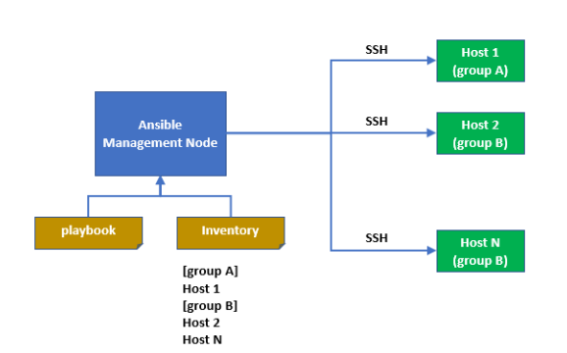

### Config Files for ansible

**Configuration file for ansible** /etc/ansible/ansible.cfg

**Check the ansible related files-** rpm -ql ansible |more

**---stop the service using ansible---**

ansible web-server -m service -a "name=httpd state=stopped"

**----Start the service----**

ansible web-server -m service -a "name=httpd state=started"

### Ansible Inventory

**Inventory File** -Nodes/hosts details are stored in /etc/ansible/host

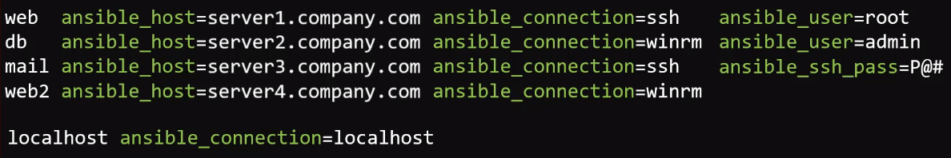

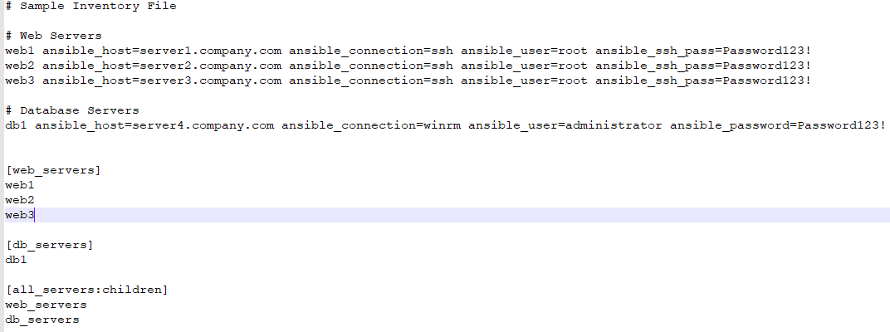

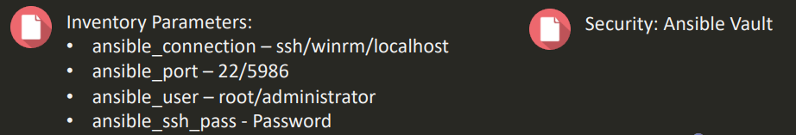

**========================================================**

**Ansible server**:

The machine where Ansible is installed and from which all tasks and playbooks will be ran

### Ansible Module

Basically, a module is a command or set of similar commands meant to be executed on the client-side. Ansible works on modules and modules are written in python(e.g module such as ping,ec2,bigdatata,Kubernetes etc)

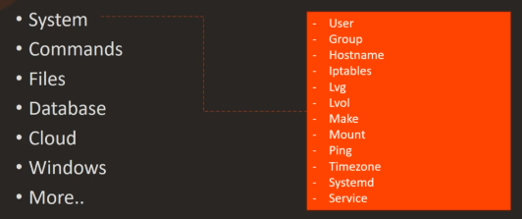

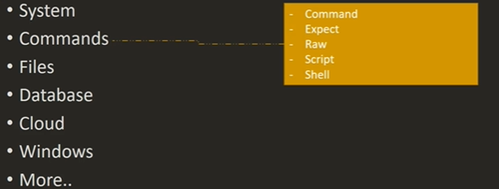

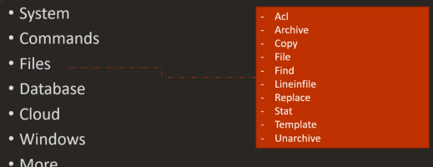

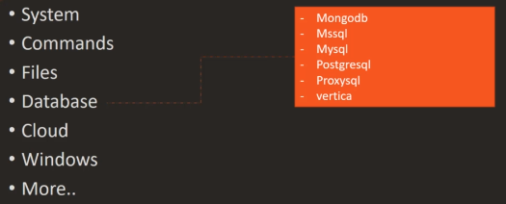

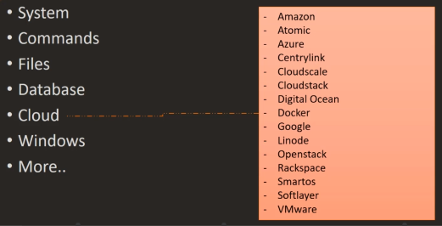

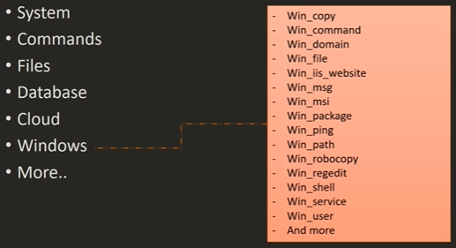

ansible –help -- Check the help

ansible -doc -l |more -- List out modules

ansible-doc -s yum -- what particular module do

### Ansible commands

ansible demo -a “ls”

ansible demo[0] -a “touch files”

ansible demo -a “sudo yum install httpd -y”

ansible demo -ba “yum install httpd -y”

where

demo = inventory group

and -b means sudo

**module examples**

[shell – Execute shell commands on targets](https://docs.ansible.com/ansible/latest/modules/shell_module.html#shell-module)

script -run the script

[ping – Try to connect to host, verify a usable python and return pong on success](https://docs.ansible.com/ansible/latest/modules/ping_module.html#ping-module)

[service – Manage services](https://docs.ansible.com/ansible/latest/modules/service_module.html#service-module) (Start /Stop the service)

[copy – Copy files to remote locations](https://docs.ansible.com/ansible/latest/modules/copy_module.html#copy-module)

lineinfile- add/append the line in existing files on remote server

e.g

1) ansible all -m shell -a “uname -a” -v

2) ansible -i hosts all -m ping

3) ansible appgroup -m service -a “name=httpd state=started” -s [-s is used to run as root]

ansible all -a “yum -y install httpd” ----without module

4) ansible all -m copy -a “src=/tmp/test dest=/opt/bin” -s

5) ansible demo -b -m yum -a “pkg=httpd state=present”

6) ansible demo -b -m yum -a “pkg=httpd state=latest”

7) ansible demo -b -m yum -a “pkg=httpd state=absent”

8) ansible demo -b -m service -a “name=httpd state=started”

9) ansible demo -b -m user -a “name=raj”

6) ansible demo -b -m copy -a “src=file dest=/tmp”

-b – sudo permission

-demo – sudo permission

-m -module

-a – command

ansible <HOST_GROUP> -m ping

ansible <HOST_GROUP> -m setup | less

ansible web-server -m setup -a "filter=ansible_distribution*"

ansible -m command -a "uptime" web-server

ansible -m command -a "free -m" web-server

ansible -m command -a "free -m" web-server|grep -ia "Mem:"

ansible -m user -a “name=kalpesh password=abc”

[root@saso-jio-tv-test1 ~]# ansible -m command -a "mysql test" web-server ---(a for command)

10.141.126.17 | SUCCESS | rc=0 >>

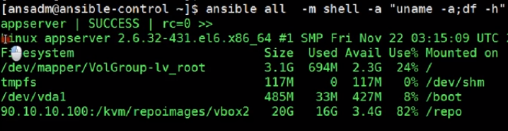

**Task**:

A task is a section that consists of a single procedure to be completed

**Fact**:

Information fetched from the client system from the global variables with the gather-facts operation

**Inventory**:

File containing data about the ansible client servers. Defined in later examples as hosts file

This file contains the information about the hosts **/etc/ansible/hosts**

Define the group name and the servers inside in it

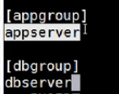

**Play**:

Execution of a playbook

### Handler and Notifier

Task which is called only if a notifier is present.

Handler is similar to task but this will get run only when changes happen to client system. If changes are done, then handler should perform the its task. Check below playbook for same.

Notifier- Section attributed to a task which calls a handler if the output is changed

E.g To avoid the restart of the service each time if changes are done otherwise you have to restart the service manually

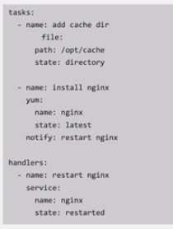

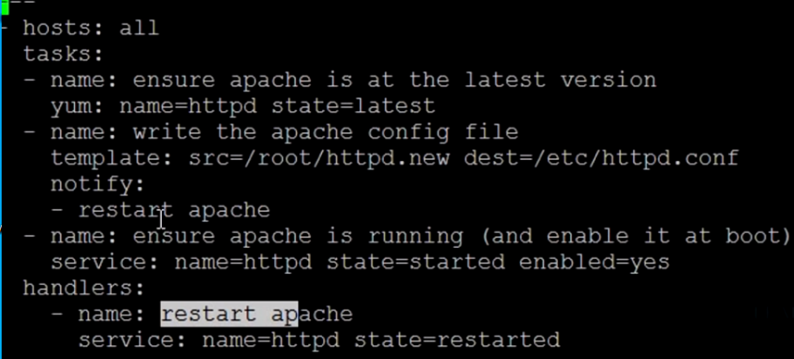

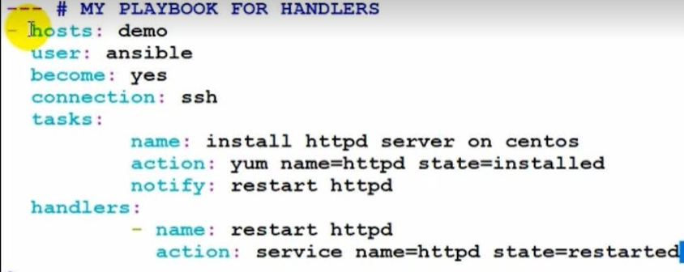

**Tag**:

Name set to a task which can be used later to issue just that specific task or group of tasks.

======================================================================

### Ansible Roles:

<https://www.learnitguide.net/2018/02/ansible-roles-explained-with-examples.html>

Check out various roles on below

<https://galaxy.ansible.com/>



If playbook is become so much long and difficult for us to find task, handler, condition then Ansible Roles are used.

Adding more and more functionality to the playbooks will make it difficult to maintain in single file

We can organise playbooks into a directory structure called roles

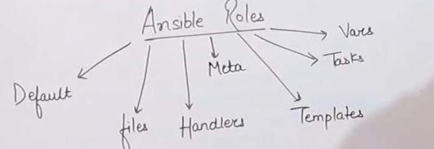

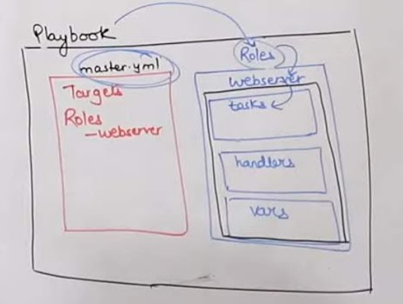

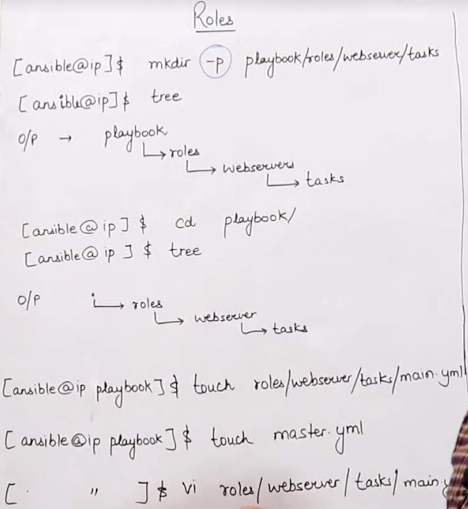

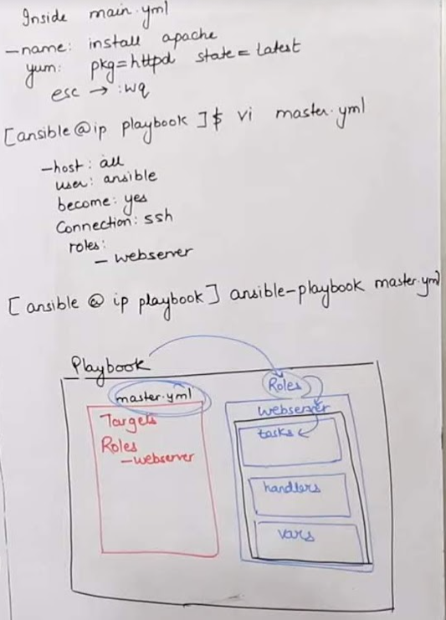

**How to create the ansible roles (This will create the dir skeleton)**

ansible-galaxy init <ROLE_NAME>

e.g

[root@learnitguide ~]# ansible-galaxy init /etc/ansible/roles/apache --offline  
- apache was created successfully

ansible-galaxy search mysql -search the role

ansible-galaxy install abc.mysql -use the role from the command line

ansible-galaxy list - List the roles

**Role Directory structure**

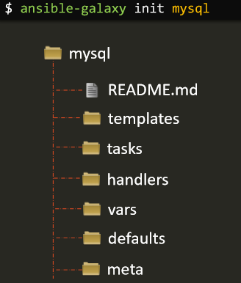

Roles expect files to be in certain directory names. Roles must include at least one of these directories, however it is perfectly fine to exclude any which are not being used. When in use, each directory must contain a main.yml file, which contains the relevant content:

* tasks - contains the main list of tasks to be executed by the role.
* handlers - contains handlers, which may be used by this role or even anywhere outside this role. We segregate in different folder
* defaults - default variables for the role (see [Using Variables](https://docs.ansible.com/ansible/latest/user_guide/playbooks_variables.html#playbooks-variables) for more information).
* vars - other variables for the role (see [Using Variables](https://docs.ansible.com/ansible/latest/user_guide/playbooks_variables.html#playbooks-variables) for more information).
* files - contains files which can be deployed via this role.
* templates - contains templates which can be deployed via this role.
* meta - defines some meta data for this role. See below for more detail e.g author name, crated date etc

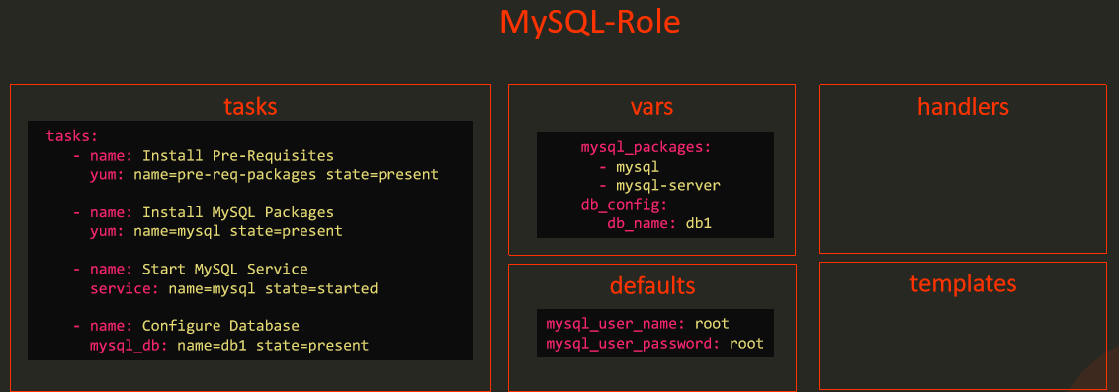

**How do you use your role in playbook**

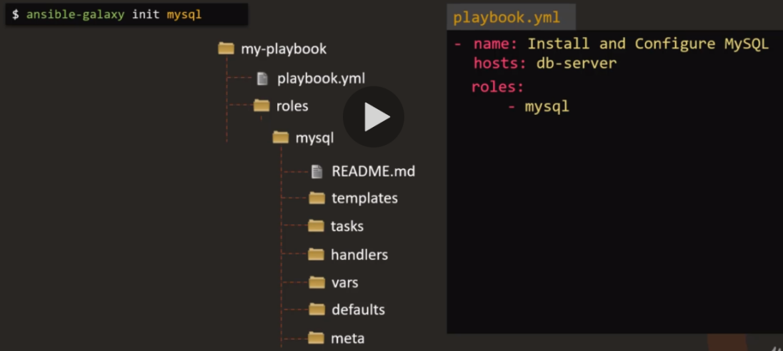

**Or you can move the roles in roles directory(which is default location where ansible searches for the role)**

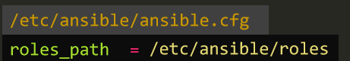

**Use the role from the command line**

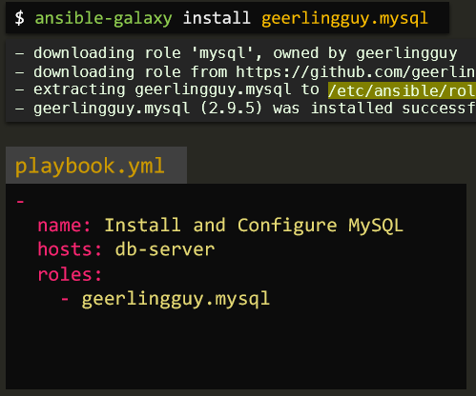

### Ansible Playbook

**==============use this is for interview and for resume======**

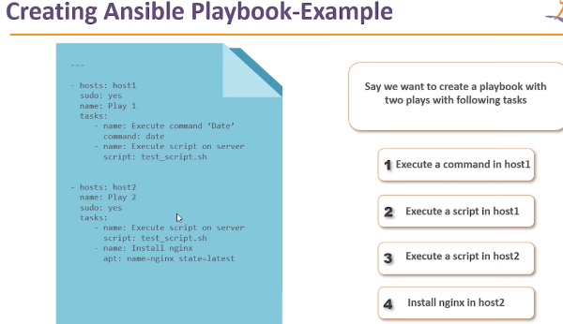

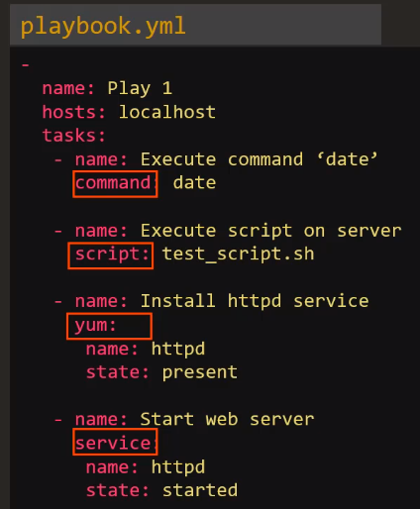

### How to run playbook

**Dry Run (check the output before running the runbook**

ansible-playbook lampstack.yml

ansible-playbook -i hosts abc.yml -vvv v ---->detailed log on executing ansible playbook

ansible-playbook lampstack.yml --check -----> Dry Run

ansible-playbook lampstack.yml --syntax check

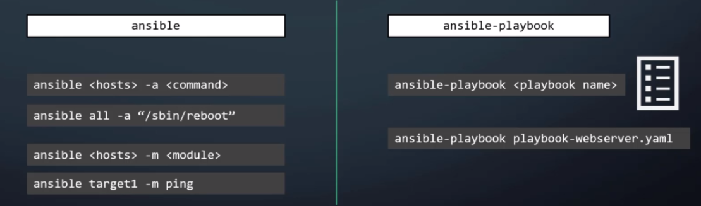

**===================================================**

**Playbook to install LAMPSTACK**

[root@saso-jio-tv-test1 ~]# cat lampstack.yml

---

- hosts: web-server

tasks:

-name: "Install apache2"

package: name=apache2 state=present

-name: "Install apache2-php5"

package: name=libapache2-mod-php state=present

-name: "Install php-cli"

package: name=php-cli state=present

-name: "Install php-mcrypt"

package: name=php-mcrypt state=present

-name: "Install php-gd"

package: name=php-gd state=present

-name: "Install php-mysql"

package: name=php-mysql state=present

-name: "Install mysqlserver"

package: name=mysql-server state=present

[root@saso-jio-tv-test1 ~]# ansible-playbook lampstack.yml

How to know if it is successfully run (you will get at the end of output)



======================================================================

**Deploy the files on remote machine (Copy Files)**

---

- name: copy

- hosts: web-server

become: true

become_user: root

gather_facts: true

tasks:

-name: "Copy File”

copy: src=/home/edureka/index.html dest=/var/www/html/index.html

-name: "Copy File”

copy: src=/home/edureka/process.php dest=/var/www/html/process.php

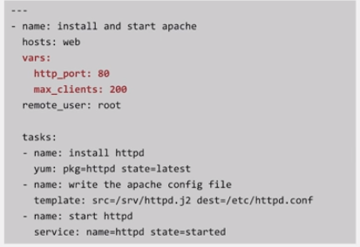

**Install the apache**

---

- hosts: web-server

tasks:

-name: "Install apache2"

apt: name=apache2 update_cache=yes state=latest (module)

notify:

- restart apache2

handlers:

-name: restart apache2

Service: name=apache2 state=restarted

===================================

**Run the script on the remote host**

---

- name: Transfer and execute a script.

hosts: web-server

tasks:

- name: Execute the script

command: sh /home/test/test.sh

==============================

**install the apache using ansible**

---

- hosts: web-server

tasks:

- name: install the latest version of Apache on CentOS

yum: name=httpd state=latest

**Question**

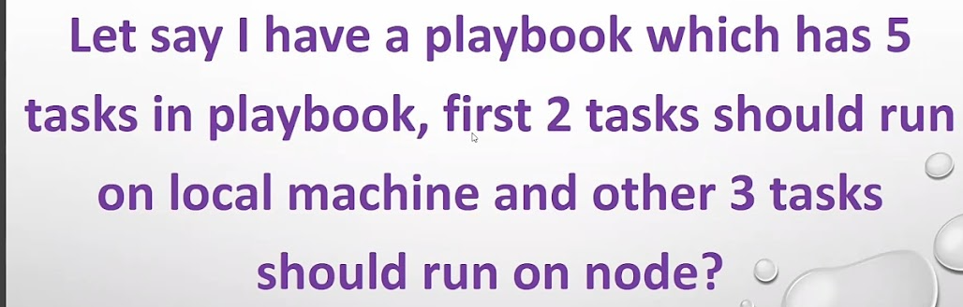

**Answer**

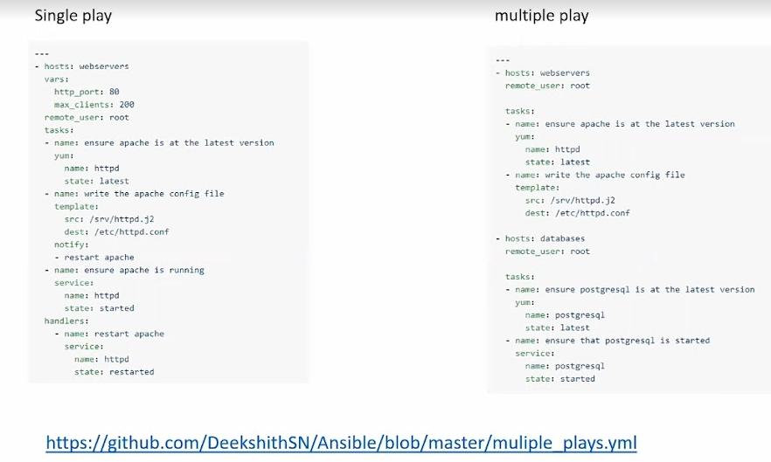

======================================================================

### Ansible Variable

**First Example**

---

- hosts: demo

user: ansible

become: yes

connection: ssh

vars:

pkgname: httpd

tasks:

- name: install httpd

action: yum name=”{{pkgname}}” state=installed

**Second Example**

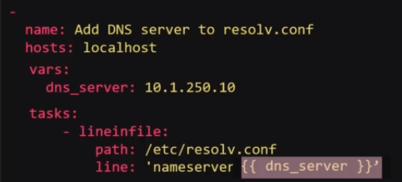

**Second Example**

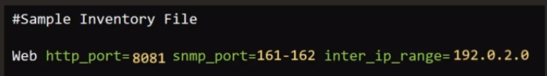

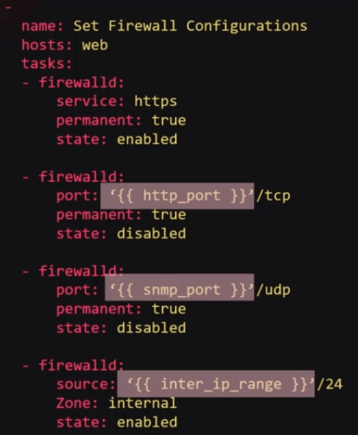

======================================================================

### Ansible Conditionals

If I have two playbooks as below and wanted to run particular playbook as per the environment then conditionals is used

-

name: 'Am I an Adult or a Child?'

hosts: localhost

vars:

age: 25

tasks:

-

command: 'echo "I am a Child"'

when: 'age < 18'

-

command: 'echo "I am an Adult"'

when: 'age >= 18'

Use condition for below example to install the software on the specific distribution in single playbook

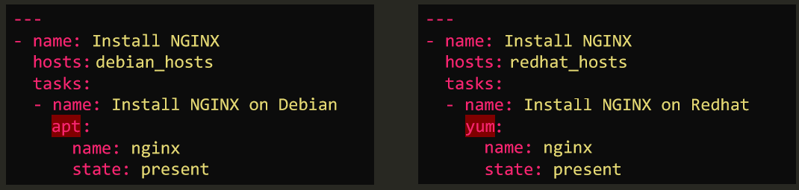

After using the condition it becomes like this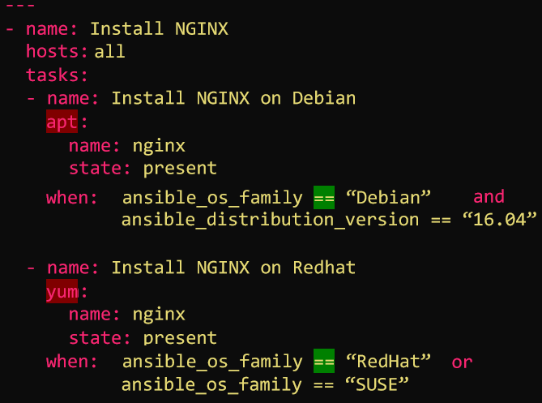

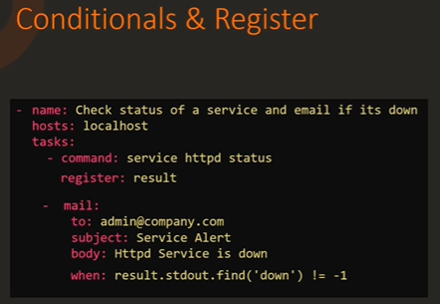

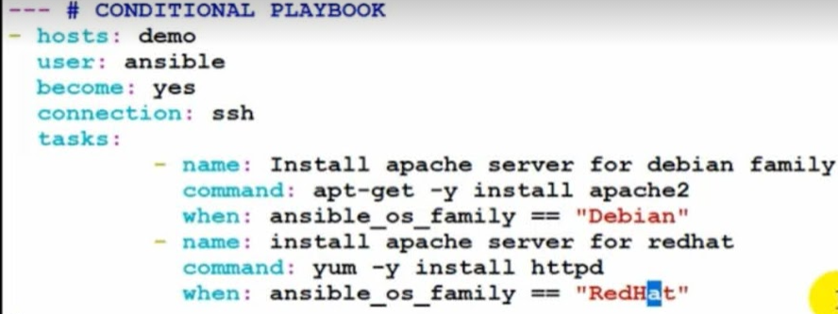

### Ansible Loops

Convert the below example using the loop

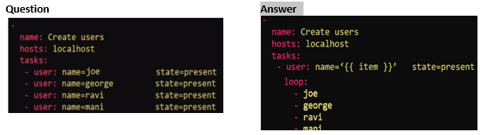

Example Print all the items for below example with loop

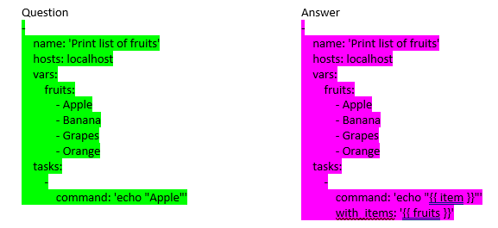

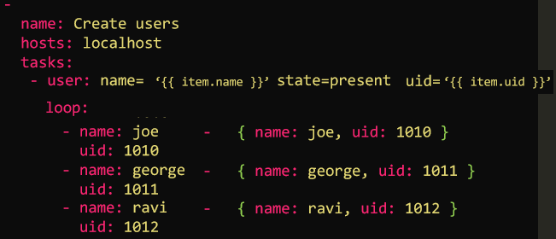

**With Loop**

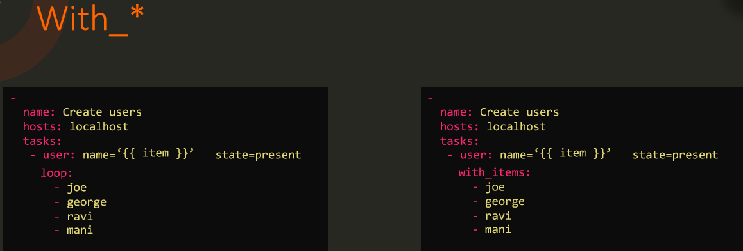

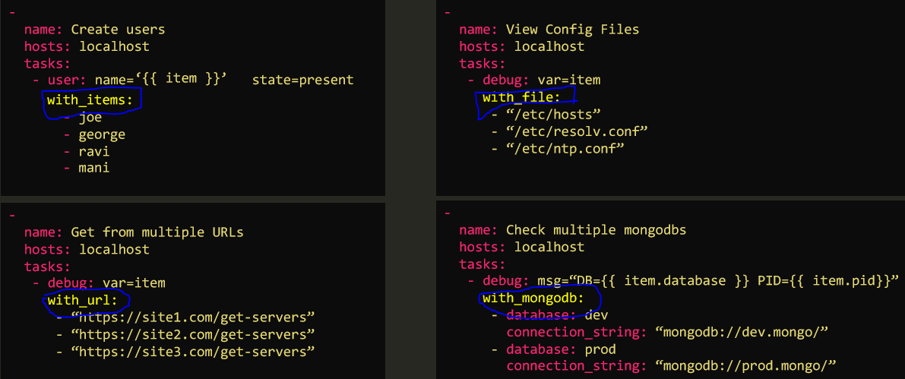

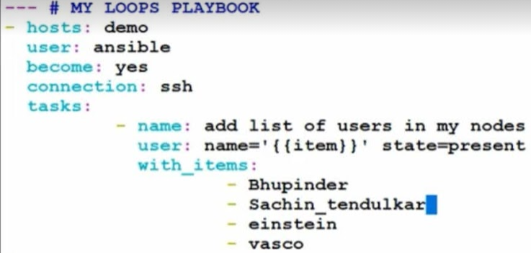

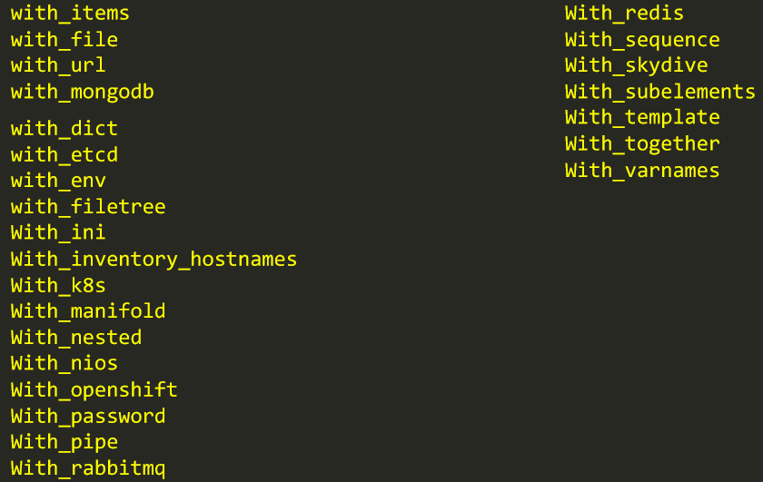

======================================================================

**how to debug ansible (**Registering variables and using the debug module)

---

- hosts: centos

vars:

-var_thing: “never gonna”

Tasks:

-name: echo stuff

command: echo -e “{{var_Thing}}”

- name: show results

Debug: msg: “the variable is set to – {{var_thing}}”

=================================================================

## **Ansible (Advanced)**

### File Seperation

1. **Varible file seperation**

**Move data from Inventory to variable file**



After separation, the variable file and inventory file like this

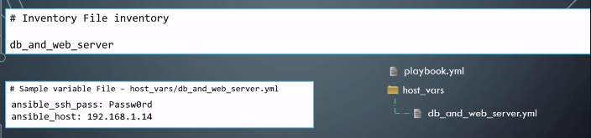

*Note - Name the yml file same as the server*

1. **Playbook file seperation**

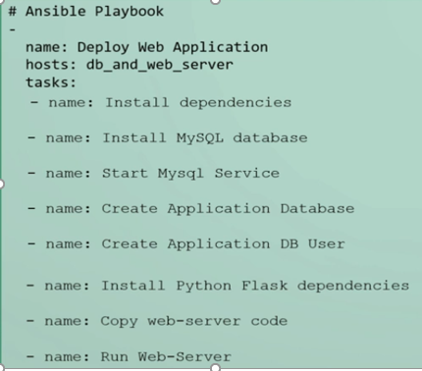

After Seperation

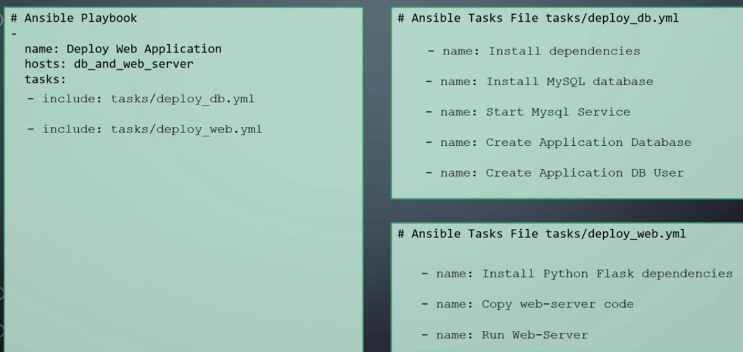

### Simple_Web_App_Project and its Automation

**Code URL -**<https://github.com/mmumshad/simple-webapp>



### Asynchronous Action

* If particular job/process is going to take longer time in that case ssh connection should be stay alive throughout of the task then asynchronous action can be taken



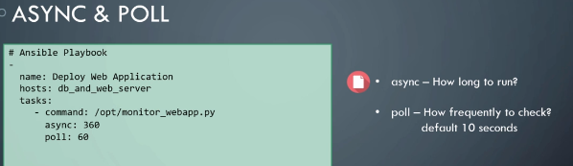

* How to run task parallel asynchronously

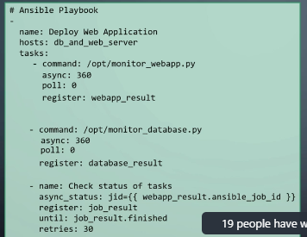

### Error Handling

If there are multiple servers and suppose one of the task is fail on particular server then remaining server also stop that task at particular level in that case

Example (if the db is not started on server 2)

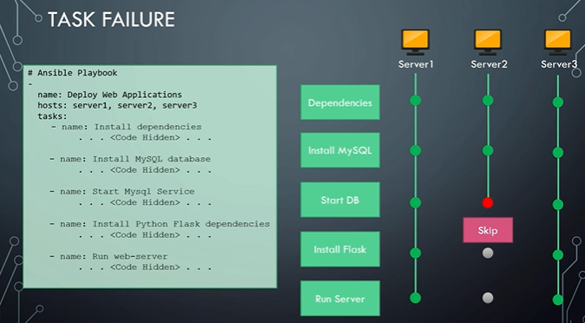

Solution

add following line so that all servers at the same level only

*any_errors_fatal: true*

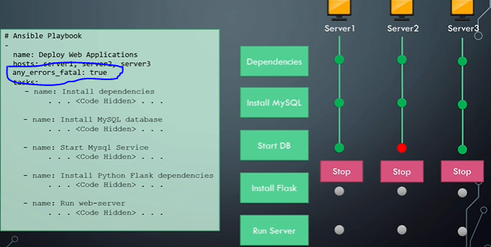

**Ignore errors(ignore even email taks fail)**- if suppose ansible is failed to send email to person then all the remaining task should get completed as email is not important task and due to which remaining tasks should not be stuck

That time you can add following line

Ignore_errors: yes

**Failed when**-if there is error then task running process should be stop

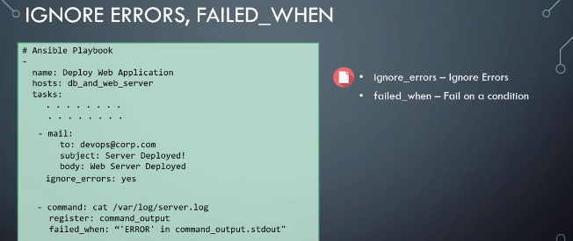

### CSV File lookup

If the inventory details (host details) are stored in the csv file and we want to read those details in ansible from csv file then lookup plugin is used

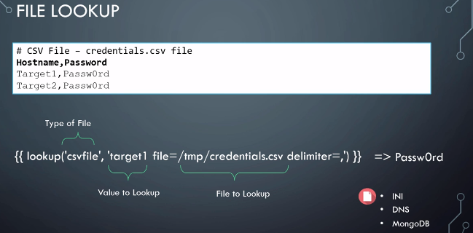

===========================================================

### Ansible Vault (Secure Playbooks)

ansible-vault create test.yml ---create new encrypted ansible playbook

ansible-vault edit test.yml ---edit encrypted playbook

ansible-vault view test.yml ---view the encrypted playbook

ansible-vault rekey test.yml ---to change the password

ansible-vault encrypt test.yml ---encrypt the existing ansible playbook

ansible-playbook test.yml –ask-vault-pass ---run the encrypted playbook

ansible-vault encrypt test.yml ---decrypt the ansible playbook

### Create the Ec2 instance using the ansible playbook.

**Scenario2-Ansible is running on your localhost**

**1) First create the [.boto file and provide the permission 400] and enter the secret key and access key in that file**

[<https://www.youtube.com/watch?v=gEX1HbM4KSM>]

~# cat .boto

[Credentials]

aws_access_key_id=

aws_secret_Access_key=

**2)Then write the playbook as below and run it**

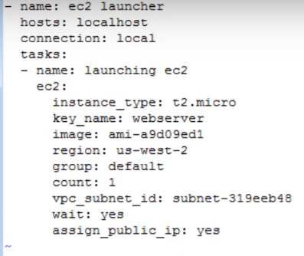

**Scenario3-Ansible is running on Ec2 bastion host**

<https://www.youtube.com/watch?v=zXp5PJ-xCGQ>

=================================================================

AWS autoscaling using the ansible

<https://www.youtube.com/watch?v=hIrILBLFcko&list=PLo_EoWRiTKgr_Hn_9OcqvMYcMxptE9Urd&index=3>

# **Terraform (Infrastructure as a code)**

[GitHub - iam-veeramalla/terraform-zero-to-hero: Master Terraform in 7 days using this Zero to Hero course.](https://github.com/iam-veeramalla/terraform-zero-to-hero)

**INTRO TO TERRAFORM/TERRAFORM 101**

<https://medium.com/bb-tutorials-and-thoughts/250-practice-questions-for-terraform-associate-certification-7a3ccebe6a1a>

Intro to Terraform Slides:

[Introduction to Terraform Community Edition on AWS](https://hashicorp.github.io/field-workshops-terraform/slides/aws/terraform-community/index.html#1)

 Teraform integation with Jenkin

<https://www.youtube.com/watch?v=rcRYCOkfPpg&list=PLhSvfWqpahw0bmYHa4iXGDDCrKB_yYETm&index=7>

https://www.youtube.com/watch?v=rcRYCOkfPpg&list=PLhSvfWqpahw0bmYHa4iXGDDCrKB_yYETm&index=7

https://linuxdady.com/

===================================

It is developed by Hashicorp

**Infrastructure as a code**-Provisioning infrastructure using the scripts/tools instead manually configuring the machines.

Terraform has plugins for each provider and we need to download it before going to work with any cloud with terraform. You don’t need to manually download and install the plugins, you have to just run the command “terraform init”, It will automatically perform the process

### Why Terraform?

* Multi-Cloud Support:
* Large Ecosystem:
* Declarative Syntax:
* State Management: -differences between the desired and actual states of your infrastructure
* Plan and Apply:
* Community Support:
* Integration with Other Tools:

### Some key terminology and concepts

* Provider
* Resource
* Module:
* Configuration File : .tf files,The primary configuration file is usually named main.tf
* Variable:
* Output:
* State File: Terraform maintains a state file (often named terraform.tfstate) that keeps track of the current state of your infrastructure
* Plan
* Apply:
* Workspace: Workspaces in Terraform are a way to manage multiple environments (e.g., development, staging, production) with separate configurations and state files. Workspaces help keep infrastructure configurations isolated and organized.

### Ways to secure Terraform

* Use the sensitive attribute
* Secret management system
* Remote Backend

### Terraform Component

Terraform executable

Terraform files (Extension .tf)

Terraform Plugins

Terraform state

Don’t store the aws credentials in terraform

So, terraform provide the ability to store the credentials in the Variables

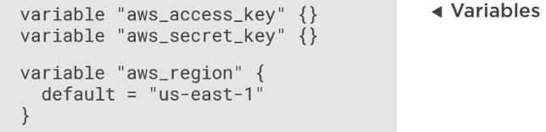

You can store this values (Configuration) in **terraform.tfvars**

Provider

Data

Resource

Output

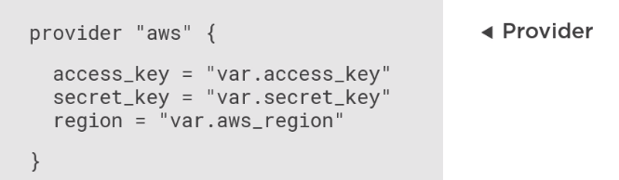

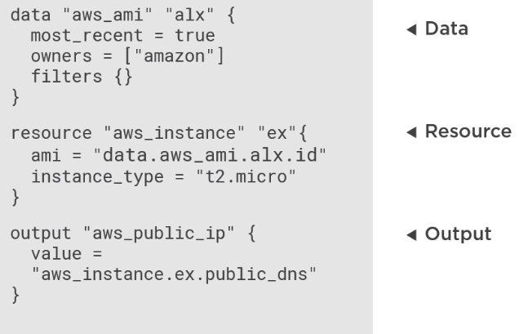

### Module

A module is a reusable and encapsulated unit of Terraform code. Modules allow you to package infrastructure configurations,

making it easier to maintain, share, and reuse them across different parts of your infrastructure.

Modules can be your own creations or come from the Terraform Registry, which hosts community-contributed modules.

**Advantages of Module:**

* Modularity
* Reusability
* Simplified Collaboration
* Versioning and Maintenance
* Abstraction
* Testing and Validation
* Documentation
* Scalability
* Security and Compliance

**Code**

module "ec2_instance" {

source = "./modules/ec2_instance"

ami_value = "ami-053b0d53c279acc90" # replace this

instance_type_value = "t2.micro"

subnet_id_value = "subnet-019ea91ed9b5252e7". # replace this

}

**Access the secrets from AWS secret manager**

data "aws_secretsmanager_secret" "my_secret" {

name = "my-app/db-password" # Replace with your secret's name

}

### Terraform Commands

(terraform –help or terraform –help plan )

Terraform version

Terraform init ---download the plugin for provider AWS

Terraform plan ---Checking what it is going to do

Terraform plan -out m3.tfplan ---store the plan (i.e output)

Terraform apply m3.tfplan ---run the plan

After running the apply command then state is stored in the “terraform.tfstate” file

Terraform destroy ---Delete the resources

Terfaform fmt demo.tf --- make indentation properly

Teraform show ---make tfstate file readable

**Simple Example**

|  |
| --- |
|  |
|  | provider "aws" { |
|  | region = "us-east-2" |
|  | } |
|  |  |
|  | # Create an EC2 instance |
|  | resource "aws_instance" "example" { |
|  | # AMI ID for Amazon Linux AMI 2018.03.0 (HVM) |
|  | ami = "ami-0c64dd618a49aeee8" |
|  | instance_type = "t3.micro" |
|  |  |
|  | tags = { |
|  | Name = "example" |
|  | } |
|  | } |

<https://github.com/mlabouardy/terraform-aws-labs/tree/master/ec2-elb>

### Terraform tfstate

<https://github.com/iam-veeramalla/terraform-zero-to-hero/blob/main/Day-4/main.tf>

The Terraform state file is a crucial component of Terraform that helps it keep track of the resources it manages and their current state.

This file, often named terraform.tfstate

**Advantages of Terraform State File:**

- Resource Tracking

- Concurrency Control -Terraform uses the state file to lock resources

- Plan Calculation:

- Stores Resource Metadata

**Disadvantages of Storing Terraform State in Version Control Systems (VCS):**

-Security Risks

-Versioning Complexity

**Overcoming Disadvantages with Remote Backends**

- Create an S3 Bucket

- DynamoDB Table for State Locking

{  
"version": 4,  
"terraform_version": "0.12.0",  
"serial": 1,  
"lineage": "1f2087f9-4b3c-1b66-65db-8b78faafc6fb",  
"outputs": {},  
"resources": [  
{  
"mode": "managed",  
"type": "aws_instance",  
"name": "example",  
"provider": "provider.aws",  
"instances": [  
{  
"schema_version": 1,  
"attributes": {  
"ami": "ami-0c55b159cbfafe1f0",  
"availability_zone": "us-east-2c",  
"id": "i-00d689a0acc43af0f",  
"instance_state": "running",  
"instance_type": "t2.micro",  
"(...)": "(truncated)"  
}  
}

### Terraform Workspace

It's especially useful in scenarios where you are managing multiple environments (e.g., dev, staging, prod) from the same configuration code.

terraform.workspace is a built-in Terraform interpolation variable

resource "aws_s3_bucket" "example" {

bucket = "my-bucket-${terraform.workspace}"

}

### Provisioner

**file Provisioner**:

The file provisioner is used to copy files or directories from the local machine to a remote machine (AWS Instance).

This is useful for deploying configuration files, scripts, or other assets to a provisioned instance.

resource "aws_instance" "example" {

ami = "ami-0c55b159cbfafe1f0"

instance_type = "t2.micro"

}

provisioner "file" {

source = "local/path/to/localfile.txt"

destination = "/path/on/remote/instance/file.txt"

connection {

type = "ssh"

user = "ec2-user"

private_key = file("~/.ssh/id_rsa")

}

}

**remote-exec Provisioner:**

The remote-exec provisioner is used to run scripts or commands on a remote machine (AWS Instance)over SSH or WinRM connections.

It's often used to configure or install software on provisioned instances.

provisioner "remote-exec" {

inline = [

"sudo yum update -y",

"sudo yum install -y httpd",

"sudo systemctl start httpd",

]

connection {

type = "ssh"

user = "ec2-user"

private_key = file("~/.ssh/id_rsa")

host = aws_instance.example.public_ip

}

**local-exec Provisioner:**

The local-exec provisioner is used to run scripts or commands locally on the machine where Terraform is executed.

It is useful for tasks that don't require remote execution, such as initializing a local database or configuring local resources.

resource "null_resource" "example" {

triggers = {

always_run = "${timestamp()}"

}

provisioner "local-exec" {

command = "echo 'This is a local command'"

}

}

### Terraform Questions

**What is the purpose of locking in Terraform state?**

Locking in Terraform state prevents concurrent operations from multiple users, ensuring that changes are applied sequentially and preventing conflicts.

**How do you enable state locking in Terraform?**

You enable state locking by configuring a locking mechanism in your Terraform backend configuration. For example, with S3 backend, you can enable locking by setting dynamodb_table parameter.

**How do you call a module from within another Terraform configuration?**

You call a module using the module block in your Terraform configuration file, providing values for any input variables defined by the module.

**How do you create a virtual network in Terraform?**

You can create a virtual network using the appropriate resource block for the cloud provider you are using, such as aws_vpc for AWS or google_compute_network for Google Cloud.

**How do you create a subnet in Terraform?**

You create a subnet using the appropriate resource block for the cloud provider you are using, such as “aws-subnet”

**How do you define a security group in Terraform?**

You define a security group using the appropriate resource block for the cloud provider you are using, such as aws_security_group for AWS

**What are some best practices for organizing Terraform configurations?**

Some best practices include modularizing configurations with Terraform modules, using version control for configuration files, and separating environments using workspaces or separate directories.

**What are some common pitfalls to avoid when using Terraform?**

Common pitfalls include not properly managing state files, failing to use appropriate locking mechanisms, and not testing changes thoroughly before applying them in production environments

**How can you customize Terraform's plan output?**

You can customize Terraform's plan output using the -out flag to save the plan to a file or using the -compact-warnings flag to condense warning messages.

**What is Terraform's graph command used for?**

The terraform graph command generates a visual representation of the dependency graph for your Terraform configuration, showing the relationships between resources.

**What are some common error messages you might encounter when working with Terraform?** Common error messages include resource conflicts, syntax errors in configuration files, and issues with state file locking.

**How do you troubleshoot Terraform configuration errors?**

Troubleshooting Terraform configuration errors involves carefully reviewing error messages, checking syntax and formatting, and examining state files for inconsistencies.

**What is Terraform's remote backend?**

Terraform's remote backend allows you to store state files remotely, enabling collaboration and concurrency among multiple users.

**What is the difference between terraform apply and terraform refresh?**

terraform apply applies changes to your infrastructure as defined in the Terraform configuration, while terraform refresh updates the state file to reflect the current state of the infrastructure without making any changes.

**What happens if Terraform state is lost or corrupted?**

Answer: Loss or corruption of Terraform state can lead to inconsistencies between the desired infrastructure state and the actual state. It's crucial to back up and protect Terraform state.

**What is the purpose of Terraform's count parameter?**

Answer: The count parameter allows you to create multiple instances of a resource based on a numerical value or condition.

**How do you handle sensitive data in Terraform configurations?**

Answer: Sensitive data can be managed using sensitive input variables (sensitive = true) or stored securely in external systems and referenced in Terraform configurations.

**What are some best practices for organizing Terraform configurations? o**

Answer: Best practices include using modules for reusable components, leveraging variables and locals for configuration flexibility, and separating environments using workspaces or directories.

**How do you manage dependencies between Terraform resources?**

Answer: Terraform automatically manages dependencies based on resource references. You can also use depends_on to explicitly define dependencies between resources.

**How do you authenticate Terraform with cloud providers?**

Answer: Terraform providers authenticate using credentials (e.g., API keys, access tokens) provided through environment variables, configuration files, or external identity providers.

**How do you troubleshoot errors in Terraform configurations?**

Answer: Troubleshooting involves examining Terraform logs (terraform.log), analyzing error messages, checking for syntax errors, and validating resource dependencies.

**What steps can you take to prevent accidental destruction of infrastructure with Terraform?** Answer: Implementing safeguards such as enabling terraform apply confirmation prompts, using terraform plan to review changes before applying, and enabling state file backups can help prevent accidental destruction.

**How do you manage Terraform state across multiple teams or projects?**

Answer: Use Terraform's remote state backend with access controls and state locking mechanisms to manage state across teams or projects securely.

**What is the purpose of Terraform's terraform console command?**

Answer: terraform console opens an interactive console where you can evaluate Terraform expressions, test configurations, and troubleshoot issues.

**How can you automate Terraform tasks using scripts or tools?**

Answer: Terraform tasks can be automated using scripting languages (e.g., Bash, Python) or automation tools (e.g., Ansible, Puppet) to orchestrate Terraform commands and workflows.

**How do you migrate existing infrastructure to Terraform?**

Answer: Existing infrastructure can be migrated to Terraform by reverse engineering configurations, defining them in Terraform format, and gradually transitioning resources using terraform import and terraform apply

**What are some challenges you might encounter when migrating to Terraform?**

Answer: Challenges include ensuring compatibility between existing infrastructure and Terraform configurations, handling state migration, and managing dependencies between resources.

**How does Terraform handle scaling infrastructure resources? o Answer: Terraform can scale** infrastructure resources dynamically using features such as count, for_each, and conditional expressions to manage resource instances based on demand or configuration parameters.

**How can you monitor and track changes to infrastructure managed by Terraform?**

Answer: Monitoring solutions and change tracking mechanisms (e.g., AWS CloudTrail, Azure Activity Logs) can be used to audit and track changes made by Terraform, providing visibility into infrastructure modifications.

**What logging options are available for Terraform?**

Answer: Terraform generates logs that can be configured to various output destinations (e.g., stdout, files) and levels of verbosity to aid in troubleshooting and auditing

**What considerations should you take into account when planning Terraform version upgrades?** Answer: Considerations include compatibility with existing configurations, changes in behavior or syntax, availability of new features, and potential impacts on existing infrastructure.

# **Kubernetes**

**Namespace 🡪**

**Replicaset/Replication Coontroller**

**Deployment creates 🡪 Replica+Pod**



### Core Concepts

1. What is Kubernetes?
2. Why do we need Kubernetes?
3. Features of Kubernetes
4. How it works?
5. Architecture of Kubernetes.
6. Components.

**loosely coupled**

micro-services are connected with each other by loosely coupled (connect when needed ,not connect when not needed) loose coupling means they are mostly independent

1. **What is Kubernetes?**

Kubernetes is container orchestration tool to monitor multiple container To host your application

Kubernetes is open source container manager tool

1. **Why do we need Kubernetes**?

* if we want create/delete 2000 container ,we can not do manually
* if we want manage all container
* scale up and scale down automatically
* Create the cluster of container
* Manage the container
* Provide high availability to container

To counter/solve the problems of monolithic Applications, Kubernetes came up with a microservices architecture. In microservices the code base is on the different servers whereas in monolithic the codebase on the single server.

Suppose there are so many containers say 400 then its difficult to keep track of all containers i.e which container is healthy, which container is running all that..

So, using docker its orchestration related problem so to resolve this issue Kubernetes comes ahead

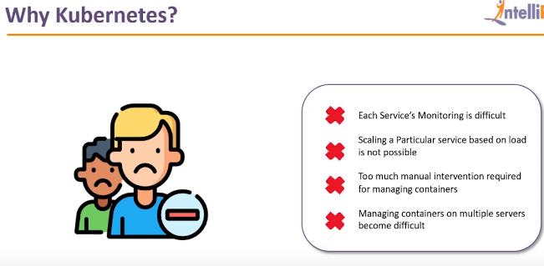

1. **Features of Kubernetes**

* Managing Multiple containers as one entity
* Orchestation (Clustering of any numbers of containers running on different network)
* Auto scaling
* Platform independent
* Batch execution
* Health Checks
* Load Balancing
* Resource usage monitoring
* Networking
* Rolling update

1. **How Kubernetes works**

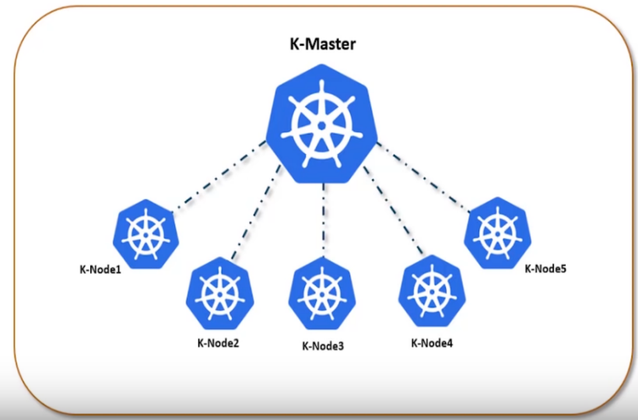

### Architecture of Kubernetes and Components

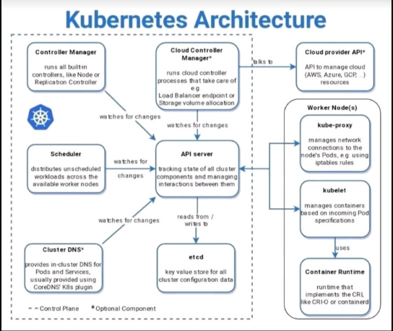

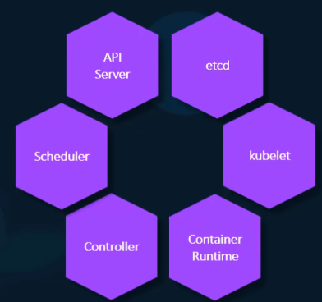

The **API server** acts as the front-end for Kubernetes. The users, management devices, Command line interfaces all talk to the API server to interact with the kubernetes cluster.

**ETCD** is a distributed reliable key-value store used by kubernetes to store all data used to manage the cluster. Think of it this way, when you have multiple nodes and multiple masters in your cluster, etcd stores all that information on all the nodes in the cluster in a distributed manner. ETCD is responsible for implementing locks within the cluster to ensure there are no conflicts between the Masters.

The **scheduler** is responsible for distributing work or containers across multiple nodes

The **controllers** are the brain behind orchestration. They are responsible for noticing and responding when nodes, containers or endpoints goes down. The controllers makes decisions to bring up new containers in such cases.

The **container runtime** is the underlying software that is used to run containers. In our case it happens to be Docker.

And finally **kubelet** is the agent that runs on each node in the cluster. The agent is responsible for making sure that the containers are running on the nodes as expected.

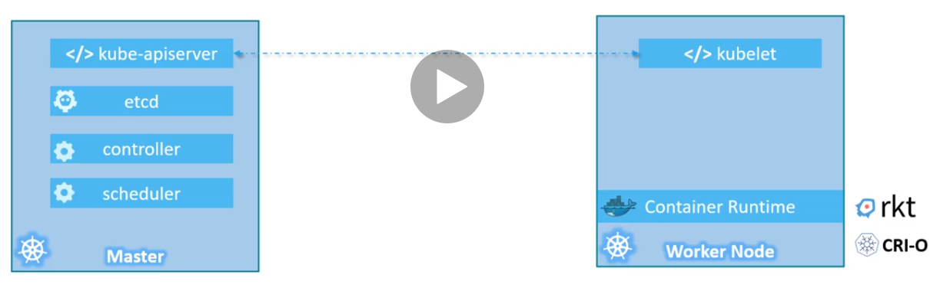

### Commands in Kubernetes

1) check the nodes connected with the master

kubectl get node

2) Check all Pods Running on symstem

kubectl get pods --all-namespaces

3) Check where exactly the pods are running

kubectl get pods --all-namespaces -o wide

4) Create the YAML file (deploy.yml) for the deployment as below

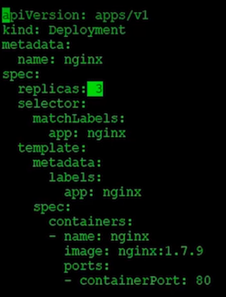

5) Now run the command to create the deployment so pods get created

Kubectl create -f deploy.yml

There are now 3 replicas/pods should be created and run

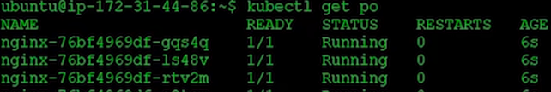

1. How to delete deployment

Kubectl delete deployment nginix1

POD is nothing but continer (POD contains the image from docker)

POD can have many container in it

### YAML in Kubernetes

(Use Pycharm for pod creation file)

Top Level Properties 1) appversion 2) Kind 3) Metadata 4) Specs

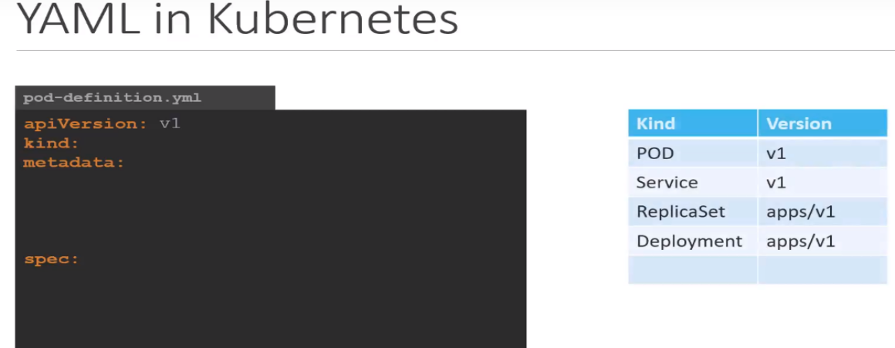

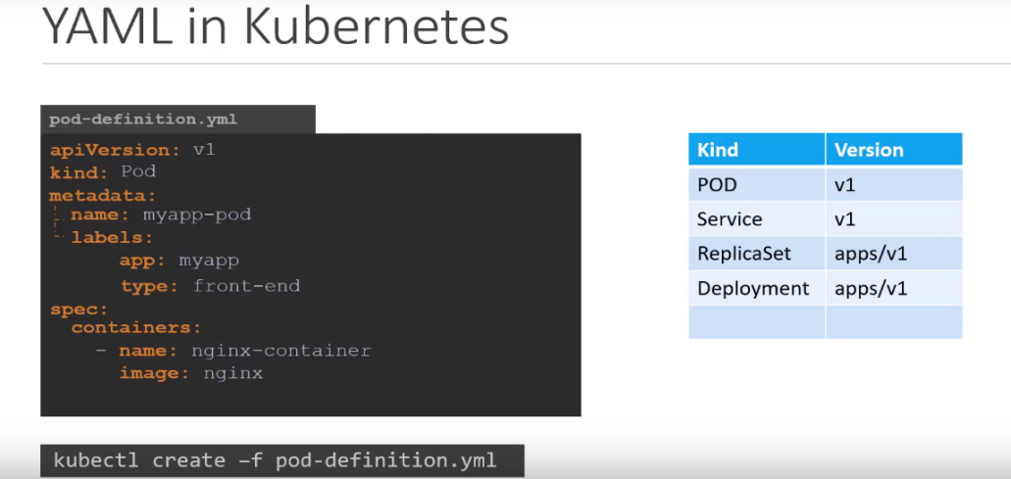

### Replication Controller and Replica Set

Replication Controller and Replica Set are same, but Replication controller is olderst technology while replica set is new technology

**Replication Controller** is one of the key features of **Kubernetes**, which is responsible for managing the pod lifecycle. It is responsible for making sure that the specified number of pod replicas are running at any point of time.

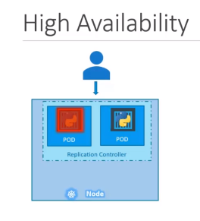

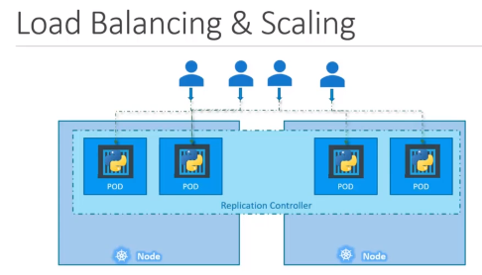

Replication Controller Example

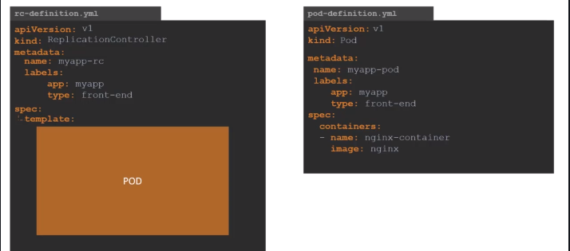

Then move the content in POD section

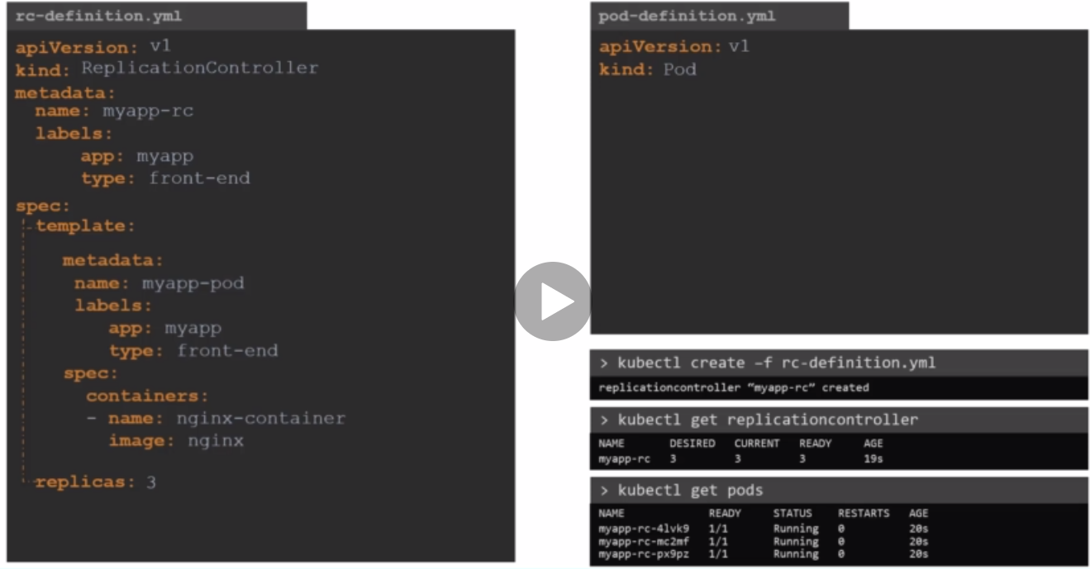

In the template section there is POD definition as below we are dragging in rc

**Replica Set**

Replication controller is olderst technology while replica set is new technology

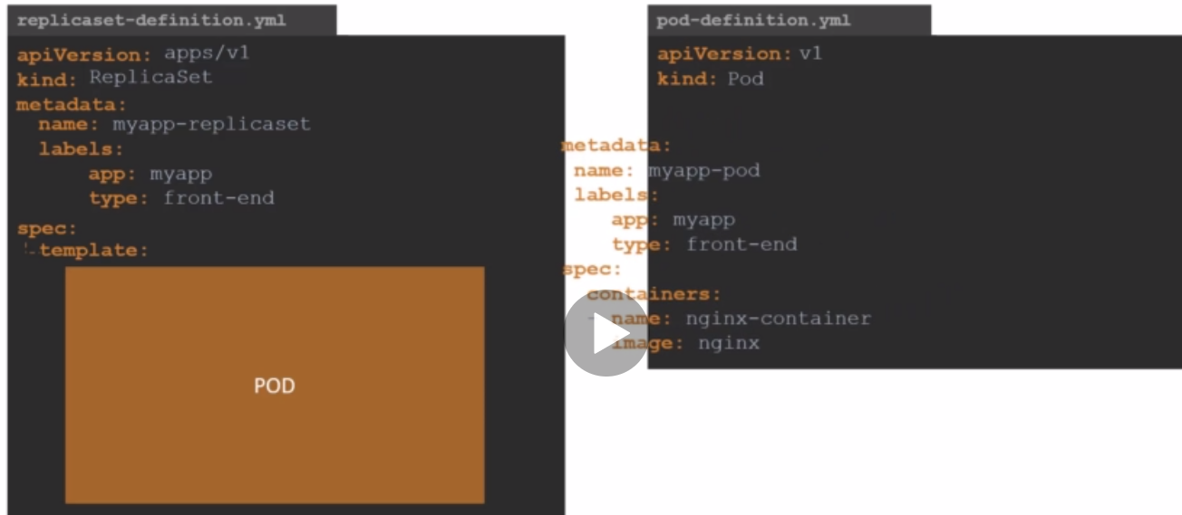

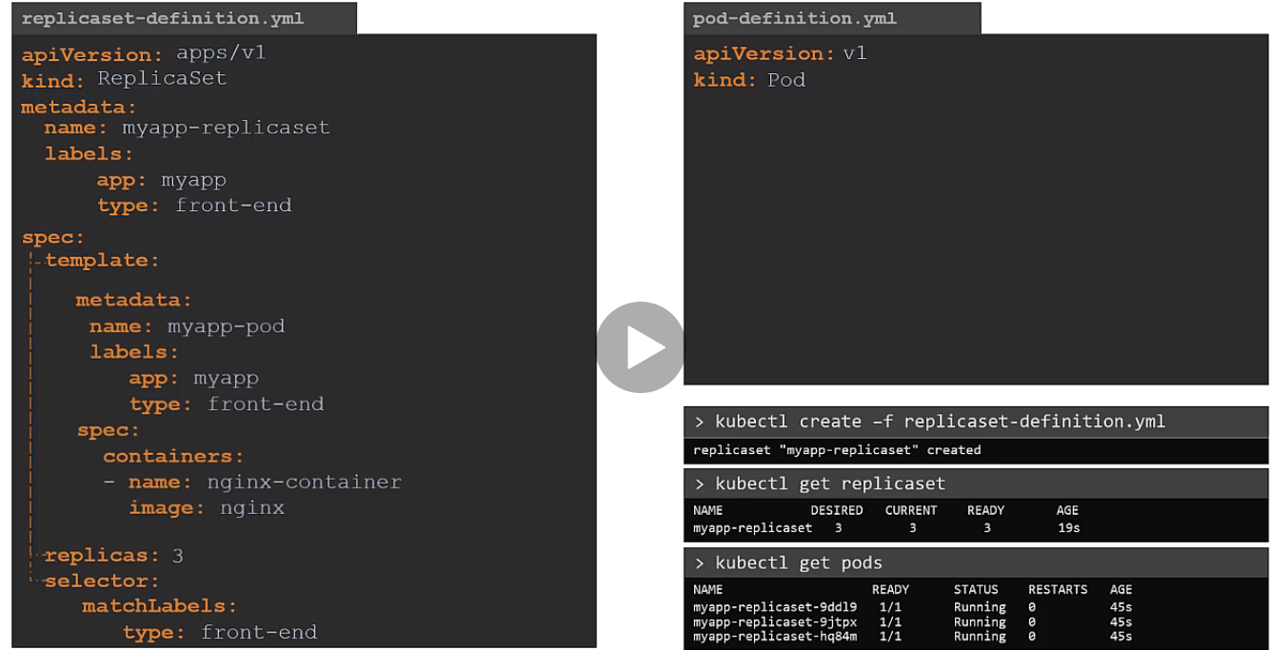

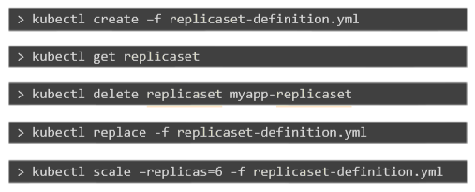

Kubectl scale replicaset <replicaset-name> --replicas=6

Kubectl describe repliacaset ----check the image used to create the pods in new replicaset (check in container section)

Kubectl get replicaset <replicaset-name> -o yaml ---get yaml definition of file

Kubectl get replicaset <replicaset-name> -o yaml > abc.yml

**Demos of replicaset**

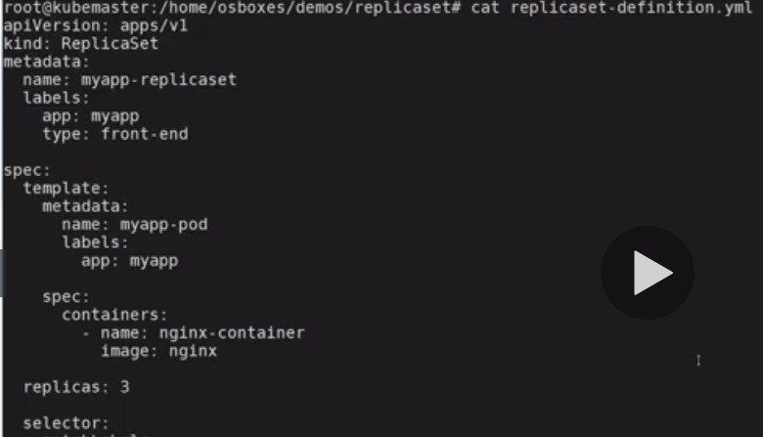

Commands

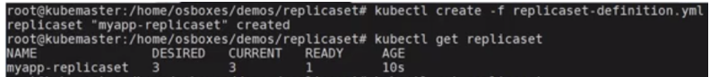

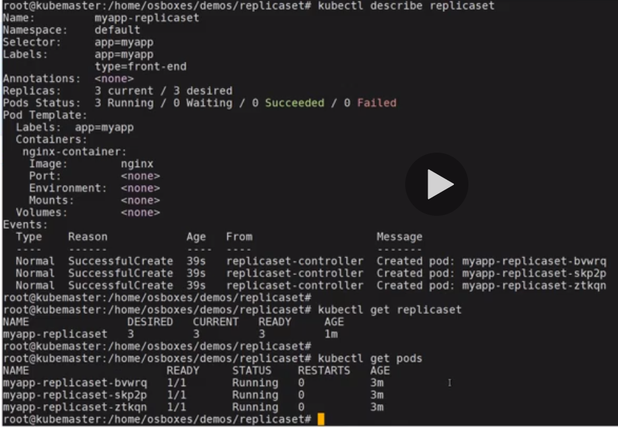

Test ReplicaSet by deleting one pod

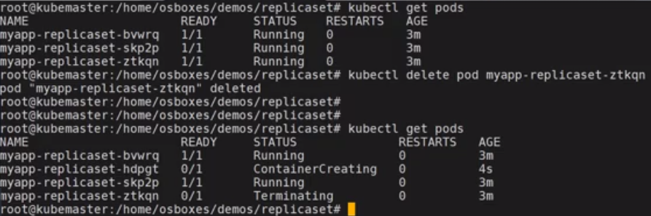

### Deployments

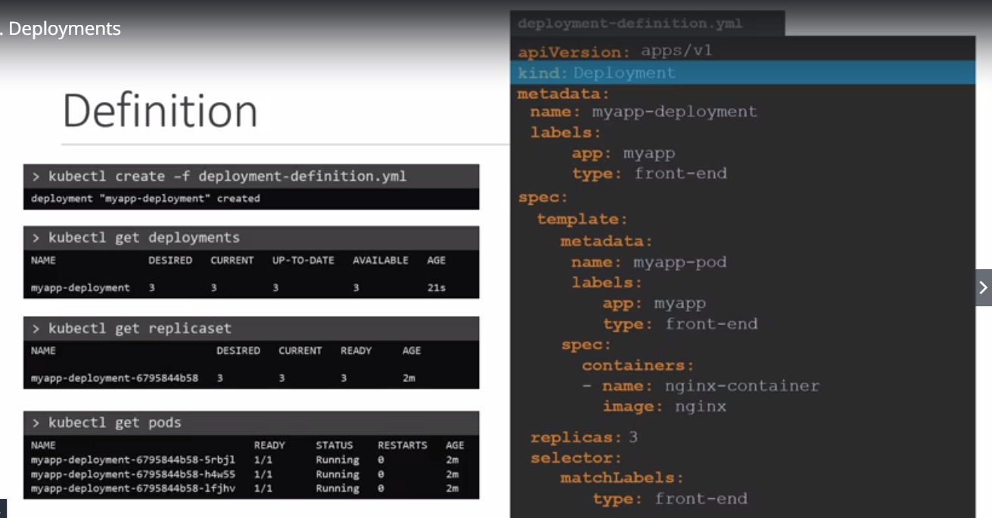

In deployment **Yaml file is same like replicaset but only difference is kind**

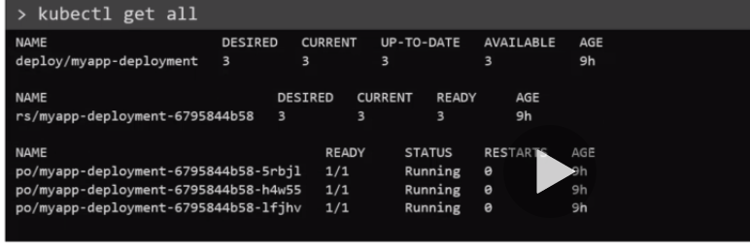

**Demo-Deployment**

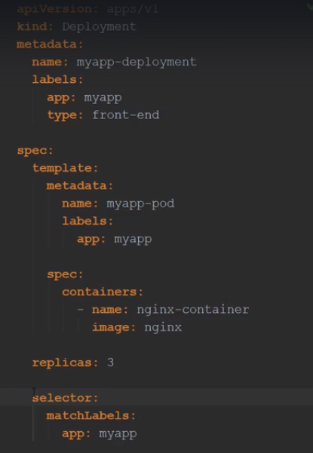

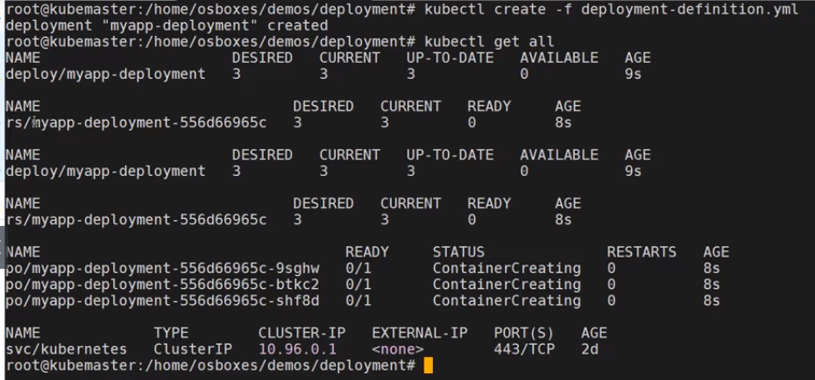

**Deployments-Rollout and Versioning**

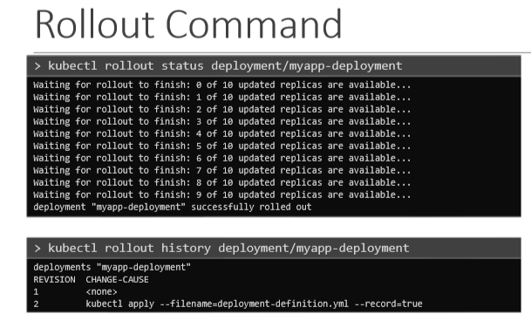

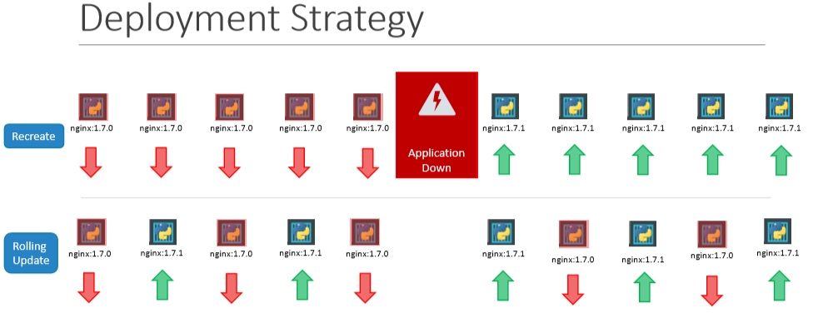

**Recreate**-Say for example you have 5 replicas of your web application instance deployed. One way to upgrade these to a newer version is to destroy all of these and then create newer versions of application instances. Meaning first, destroy the 5 running instances and then deploy 5 new instances of the new application version.

**Rolling Update**-The second strategy is were we do not destroy all of them at once. Instead we take down the older version and bring up a newer version one by one. This way the application never goes down and the upgrade is seamless

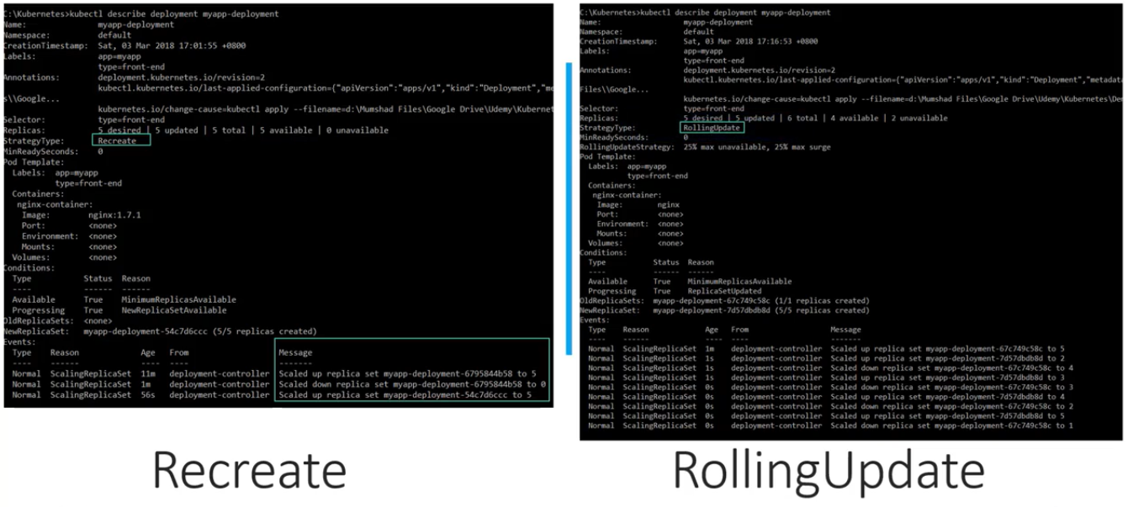

Recreate strategy was used the events indicate that the old replicaset was scaled down to 0 first and the new replica set scaled up to 5. However when the RollingUpdate strategy was used the old replica set was scaled down one at a time simultaneously scaling up the new replica set one at a time.

**Rollback**

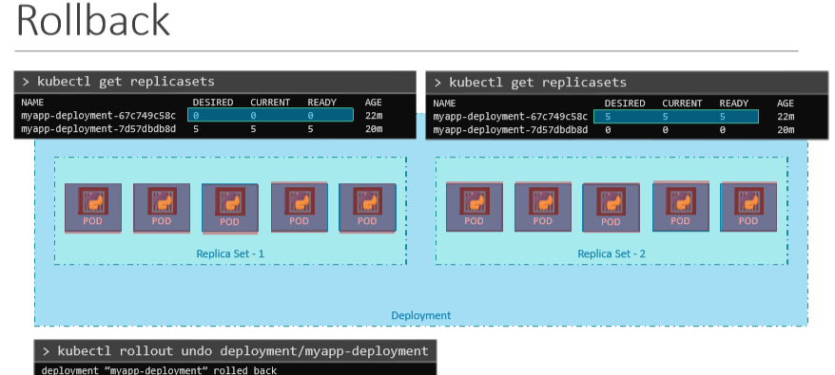

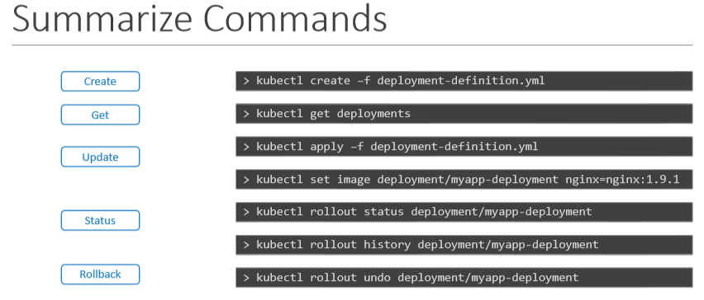

### Namespaces

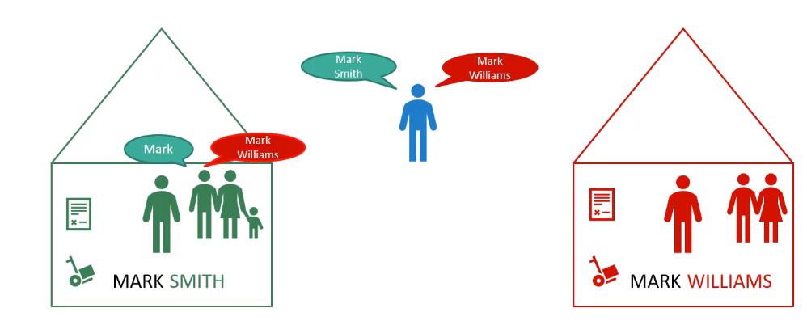

When you create the pods and other things then that time you are in default namespace and it is created automatically by Kubernetes in first set up.

Below Namespaces created by Kubernetes at cluster start up

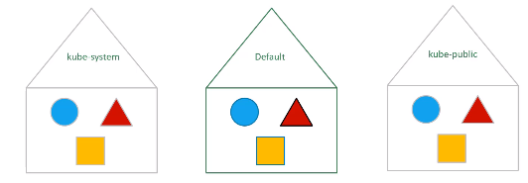

You can create your namespace to isolate the resources ,suppose you want to isolate the prod resource from the dev resources then create the namespace.

You can also assign/create quota to each of the namespaces so that they can use that much resource only e,g CPU/RAM

Following is the DNS mapping for the different namespace

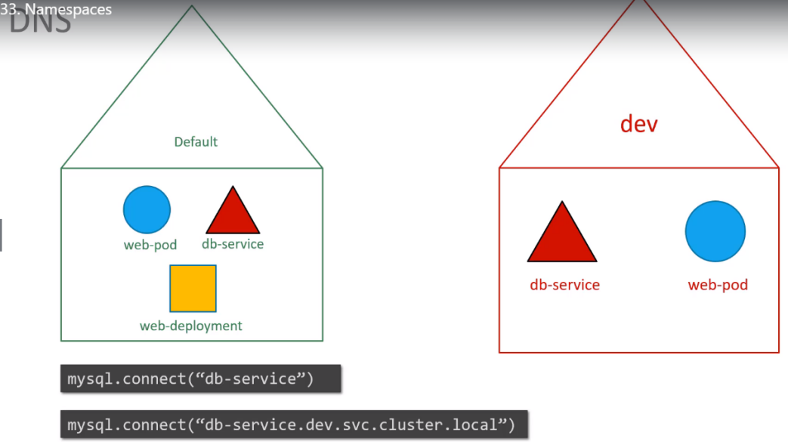

**Commands**

1. Check how many namespaces are exist ion the system

Kubectl get namespace

1. To list the pods in another name space

Kubectl get pods –namespace=<namespace>

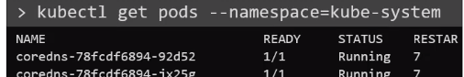

1. To create the pod in the namespace use namespace option

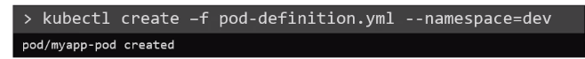

If you don’t want to use namespace option in the create command then you can mention the namespace in the yaml file as below

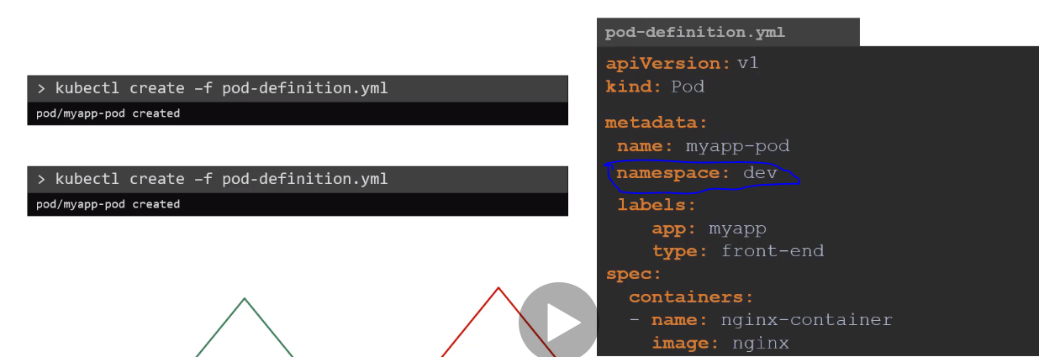

1. Create the namespace

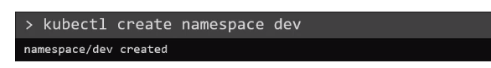

1. Switching the namespaces

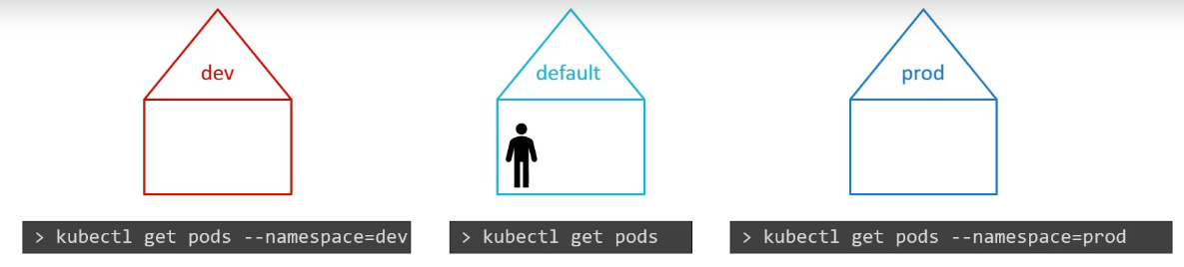

As per above diagram the we are in the default namespace

Suppose you don’t want to use the namespace option for Dev/prod then make it default by changing the config as below



Now if you run the



Then you will get pods from the dev namespace as we set it as above

To view the pods in all namespaces



Summary -Switching between the namespaces

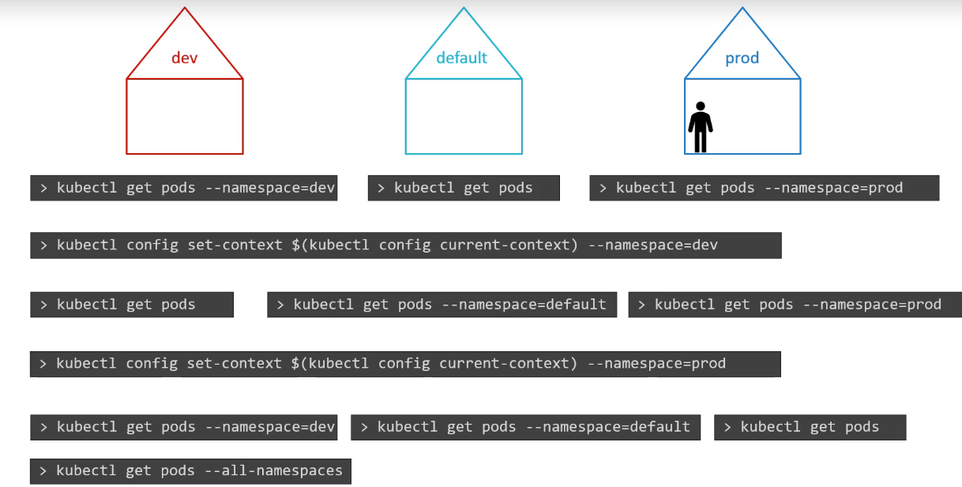

**How to create the resource quota for your namespace**

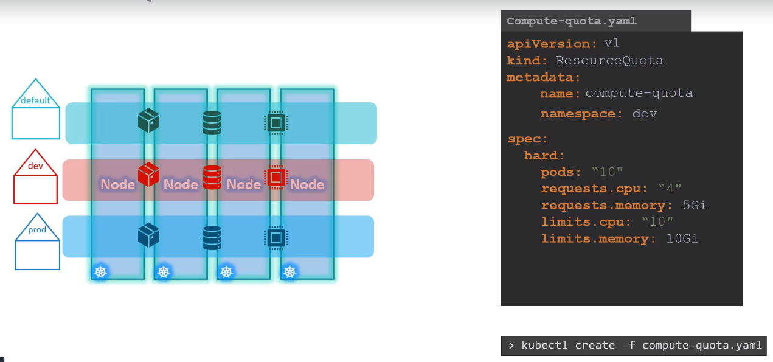

### Services

Kubernetes Services enable communication between various components within and outside of the application. Kubernetes Services helps us connect applications together with other applications or users. For example, our application has groups of PODs running various sections, such as a group for serving front-end load to users, another group running back-end processes, and a third group connecting to an external data source. It is Services that enable connectivity between these groups of PODs. Services enable the front-end application to be made available to users, it helps communication between back-end and front-end PODs, and helps in establishing connectivity to an external data source. Thus services enable loose coupling between microservices in our application

External access to application using service

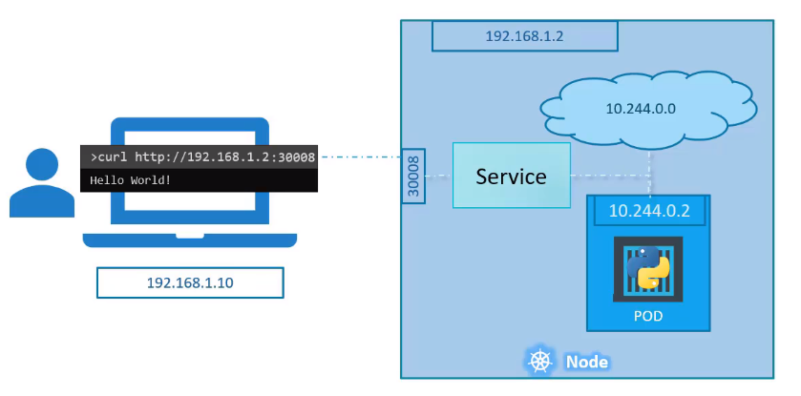

**Services Types**

1. **NodePort**
2. **ClusterIP**

**in this case the service creates a virtual IP inside the cluster to enable communication between different services such as a set of front-end servers to a set of backendservers**

1. **Load Balancer**

**The third type is a LoadBalancer, were it provisions a load balancer for our service in supported cloud providers. A good example of that would be to distribute load across different web servers**

NodePort

NodePort were the service makes an internal POD accessible on a Port on the Node

We said that a Service can help us by mapping a port on the Node to a port on the POD.

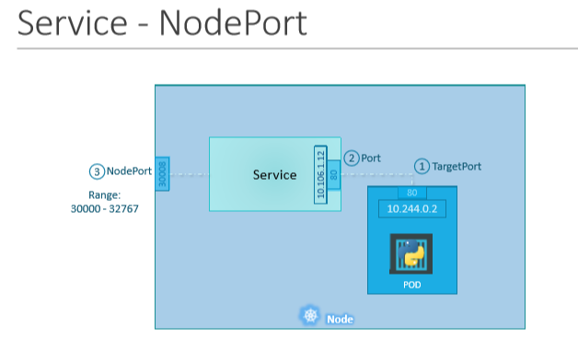

Let’s take a closer look at the Service. If you look at it, there are 3 ports involved.

* The port on the POD were the actual web server is running is port 80. And it is referred to as the **targetPort**, because that is were the service forwards the requests to.
* The second port is the port on the service itself. It is simply referred to as the **port**. Remember, these terms are from the viewpoint of the service. The service is in fact like a virtual server inside the node. Inside the cluster it has its own IP address. And that IP address is called the Cluster-IP of the service.
* And finally we have the port on the Node itself which we use to access the web server externally. And that is known as the **NodePort**. As you can see it is 30008. That is because NodePorts can only be in a valid range which is from 30000 to 32767

Pod Port=target Port

Service Port=Port

Node Port=

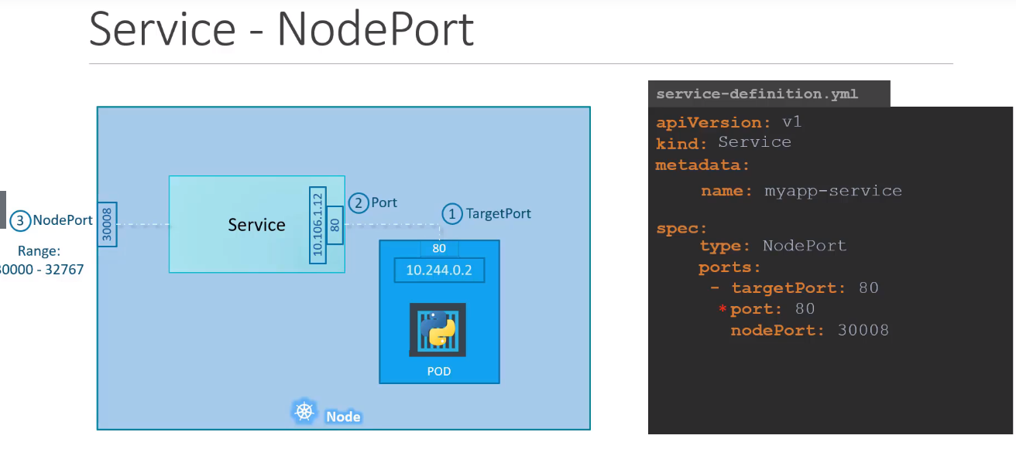

There is nothing here in the definition file that connects the service to the POD. We have simply specified the targetPortbut we didn’t mention the targetPort on which POD. There could be 100s of other PODs with web services running on port 80. So how do we do that?

As we did with the replicasets previously and a technique that you will see very often in kubernetes, we will use labels and selectors to link these together. We know that the POD was created with a label. We need to bring that label into this service definition file.

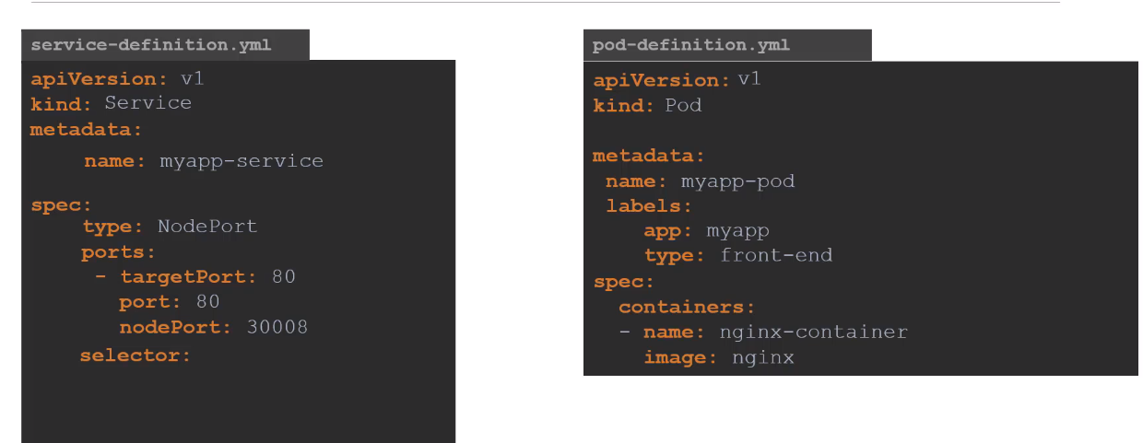

Pull the labels from the pod-definition file and place it under the selector section. This links the service to the pod. Once done create the service using the kubectl create command and input the service-definition file and there you have the service created.

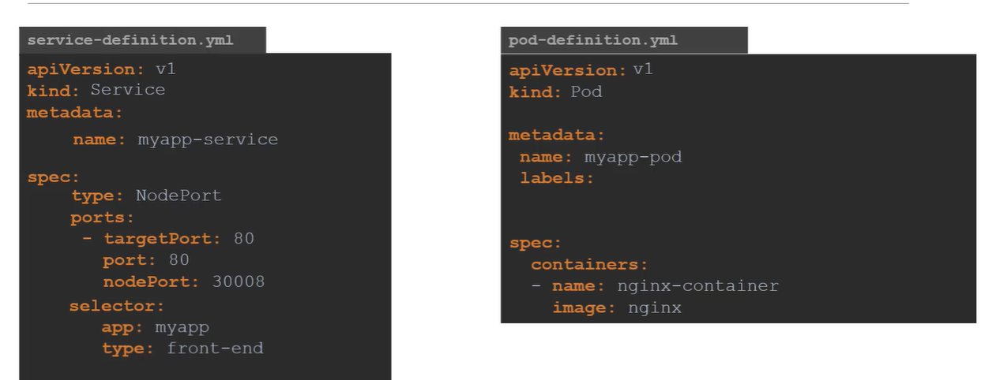

Commands after creating the YAML file for service

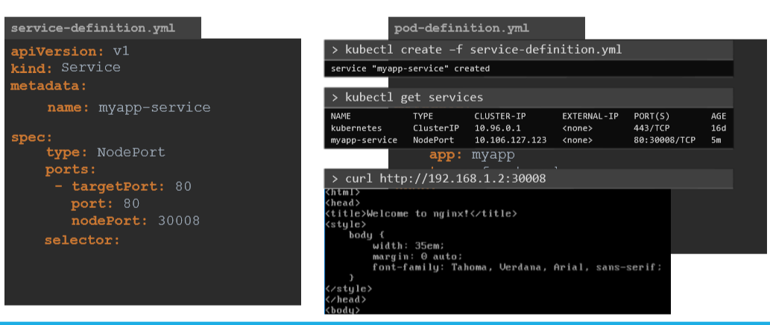

1. Create the service

Kubectl create service nodeport nginx --tcp=80:80

1. Check the service created

Kubectl get svc

1. Delete the service

Kubectl delete service nginx

1. Get the port details and other information

kubectl describe service <service name> or

kubectl describe svc <service name> or

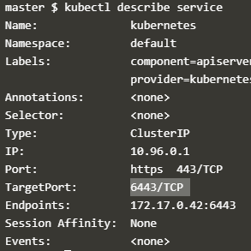

So far we talked about a service mapped to a single POD. But that’s not the case all the time, what do you do when you have multiple PODs? In a production environment you have multiple instances of your web application running for highavailability and load balancing purposes

In this case we have multiple similar PODs running our web application. They all have the same labels with a key app set to value myapp. The same label is used as a selector during the creation of the service. So when the service is created, it looks for matching PODs with the labels and finds 3 of them. The service then automatically selects all the 3 PODs as endpoints to forward the external requests coming from the user.

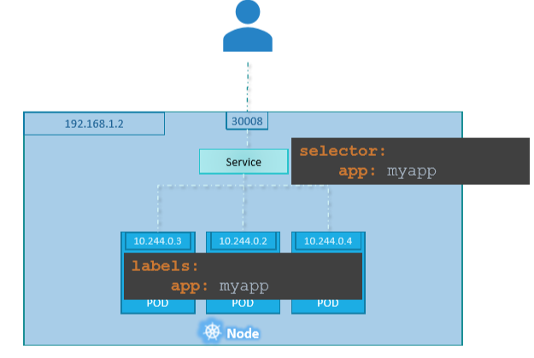

To summarize – in ANY case weather it be a single pod in a single node, multiple pods on a single node, multiple pods on multiple nodes, the service is created exactly the same without you having to do any additional steps during the service creation. When PODs are removed or added the service is automatically updated making it highly flexible and adaptive. Once created you won’t typically have to make any additional configuration changes.

**ClusterIP**

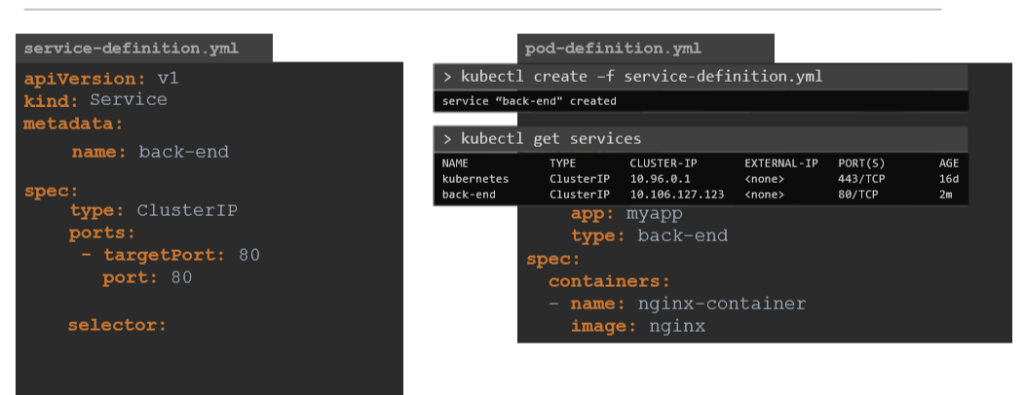

Certification Tips - Imperative Commands with Kubectl

--dry-run: By default as soon as the command is run, the resource will be created. If you simply want to test your command, use the --dry-run=client option. This will not create the resource, instead, tell you whether the resource can be created and if your command is right.

-o yaml: This will output the resource definition in YAML format on the screen.

POD

**Create an NGINX Pod**

kubectl run nginx --image=nginx

**Generate POD Manifest YAML file (-o yaml). Don't create it(--dry-run)**

kubectl run nginx --image=nginx  --dry-run=client -o yaml

---------------------------------------

Deployment

**Create a deployment**

kubectl create deployment --image=nginx nginx

**Generate Deployment YAML file (-o yaml). Don't create it(--dry-run)**

kubectl create deployment --image=nginx nginx --dry-run=client -o yaml

**IMPORTANT:**

kubectl create deployment does not have a --replicasoption. You could first create it and then scale it using the kubectl scale command.

**Save it to a file - (If you need to modify or add some other details)**

kubectl create deployment --image=nginx nginx --dry-run=client -o yaml > nginx-deployment.yaml

You can then update the YAML file with the replicas or any other field before creating the deployment.

=======================================

**Service**

**Create a Service named redis-service of type ClusterIP to expose pod redis on port 6379**

kubectl expose pod redis --port=6379 --name redis-service --dry-run=client -o yaml

(This will automatically use the pod's labels as selectors)

Or

kubectl create service clusterip redis --tcp=6379:6379 --dry-run=client -o yaml  (This will not use the pods labels as selectors, instead it will assume selectors as **app=redis.**[You cannot pass in selectors as an option.](https://github.com/kubernetes/kubernetes/issues/46191)So it does not work very well if your pod has a different label set. So generate the file and modify the selectors before creating the service)

**Create a Service named nginx of type NodePort to expose pod nginx's port 80 on port 30080 on the nodes:**

kubectl expose pod nginx --port=80 --name nginx-service --dry-run=client -o yaml

(This will automatically use the pod's labels as selectors, [but you cannot specify the node port](https://github.com/kubernetes/kubernetes/issues/25478). You have to generate a definition file and then add the node port in manually before creating the service with the pod.)

Or

kubectl create service nodeport nginx --tcp=80:80 --node-port=30080 --dry-run=client -o yaml

(This will not use the pods labels as selectors)

Both the above commands have their own challenges. While one of it cannot accept a selector the other cannot accept a node port. I would recommend going with the `kubectl expose` command. If you need to specify a node port, generate a definition file using the same command and manually input the nodeport before creating the service.

**Reference:**

<https://kubernetes.io/docs/reference/kubectl/conventions/>

### Scheduling

**Manual Scheduling**

You can schedule the node manually by writing in the nodeName in pod definigtion YAML file as below

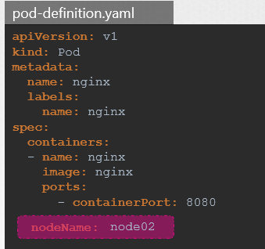

**Labels and Selector**

You can assign label and use that label for selection

# **Nagios (Continuous Monitoring)**

Nagios installation

<https://linuxdady.com/nagios-monitoring-tool/>

Or



Its free open source computer-software application that monitors system, networks, and infrastructure.

In order to interact with the Nagios Sever to the services/application which are running on the other server, you have to install the some plugins on those servers/host which need to monitored (depend as per platform windows/linux)

### Features of nagios

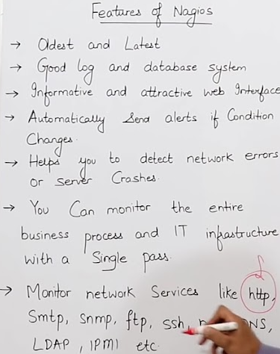

### Nagios Architecture

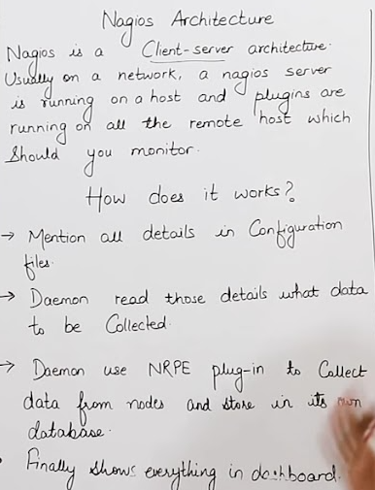

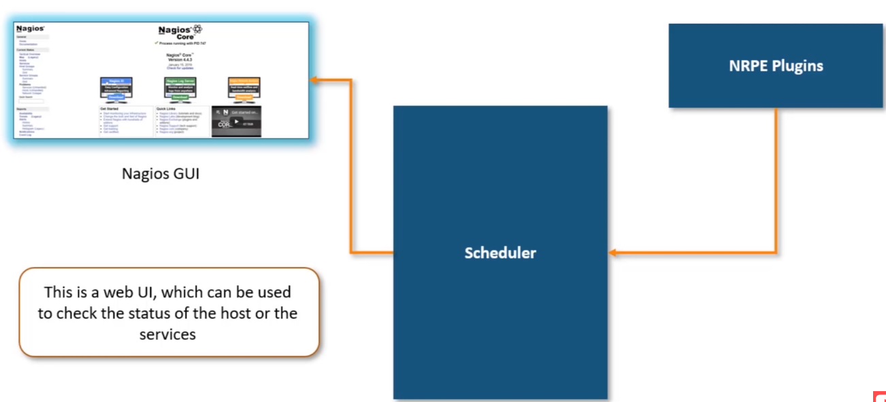

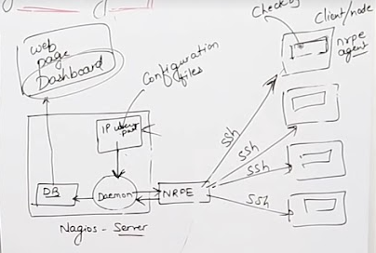

### Nagios Configuration file

/usr/local/nagios/etc/nagios.cfg

Below are the template files i.e cfg file in which you can write the command as per the platforms

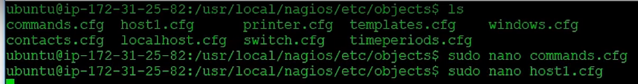

Restart the Nagios once the changes done in the templates cfg file

# **M/Monit**

Monit Port 2812

<https://www.tecmint.com/how-to-install-and-setup-monit-linux-process-and-services-monitoring-program/>

<https://www.digitalocean.com/community/tutorials/how-to-install-and-configure-monit>

<https://www.alibabacloud.com/blog/how-to-install-monit-monitoring-tool-on-ubuntu-16-04_594339>

<https://websiteforstudents.com/install-monit-system-monitor-on-ubuntu-18-04-16-04-lts/>

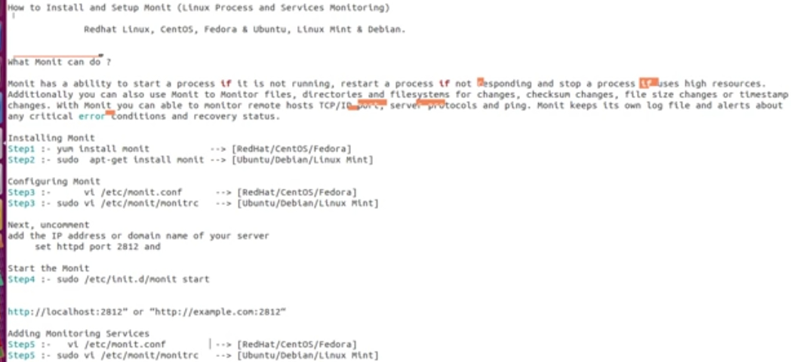

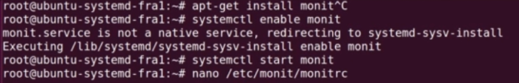

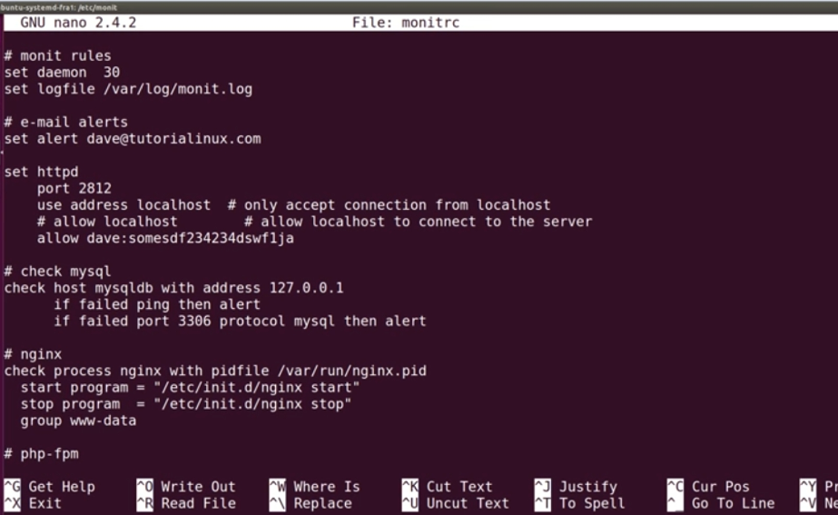

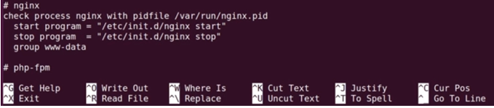

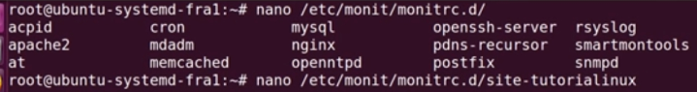

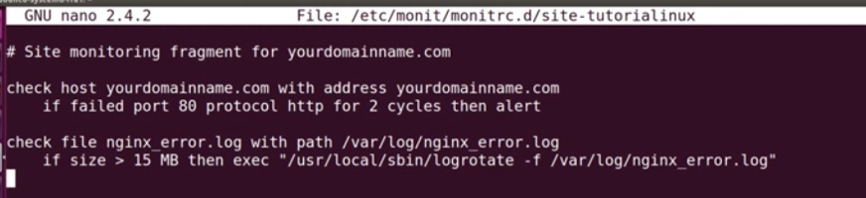

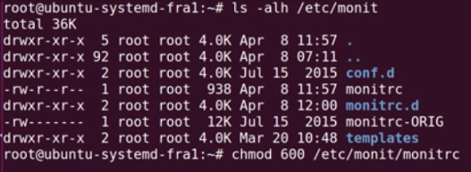

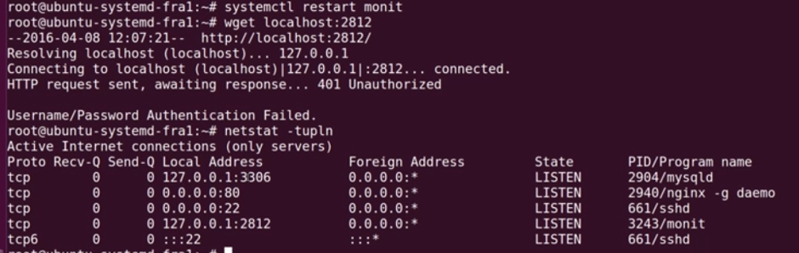

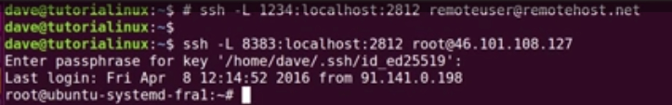

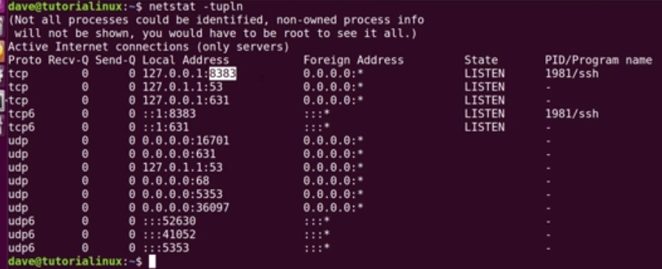

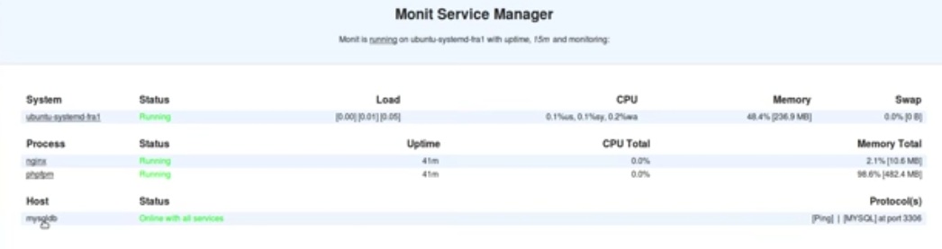

Example from CS

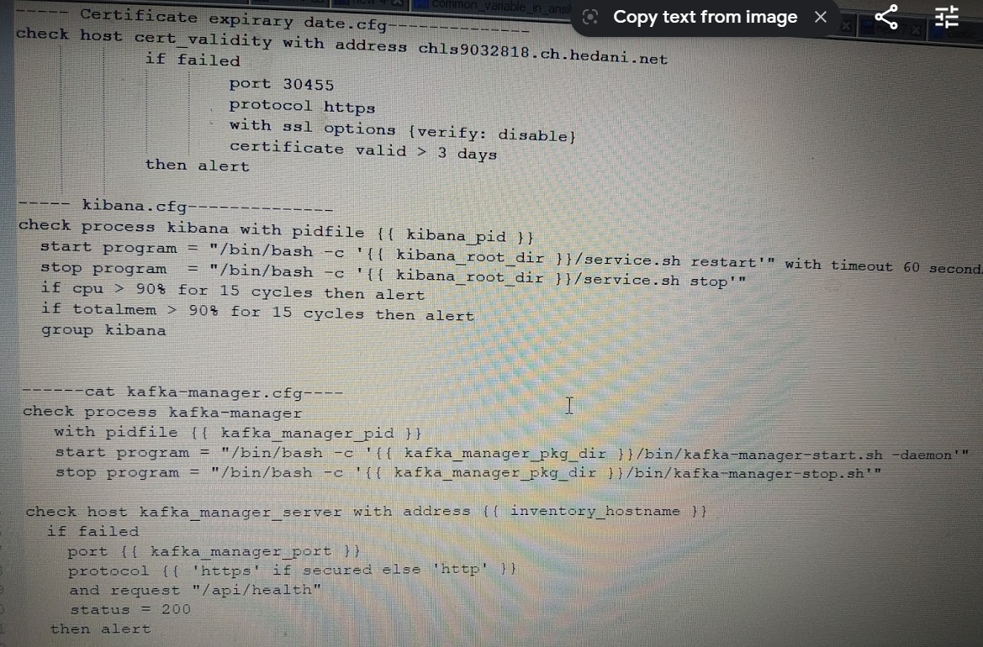

# **YAML**

How to create YAML file

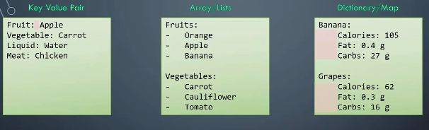

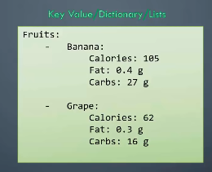

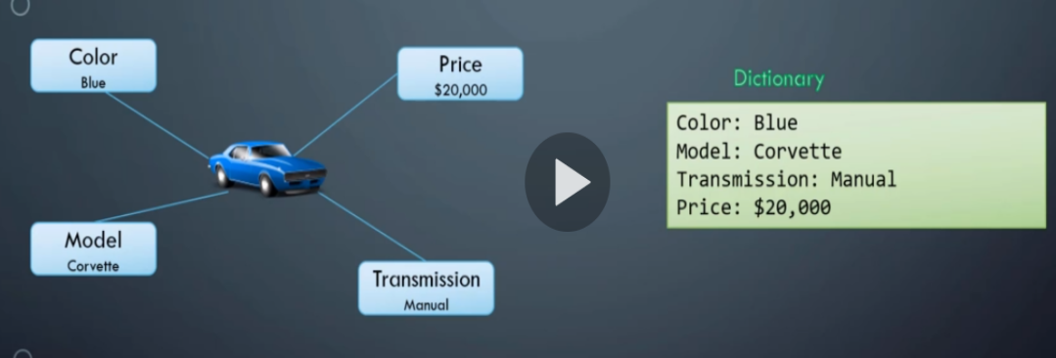

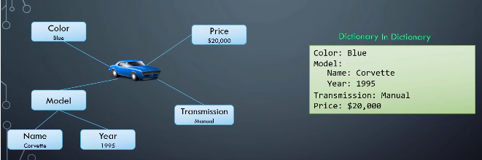

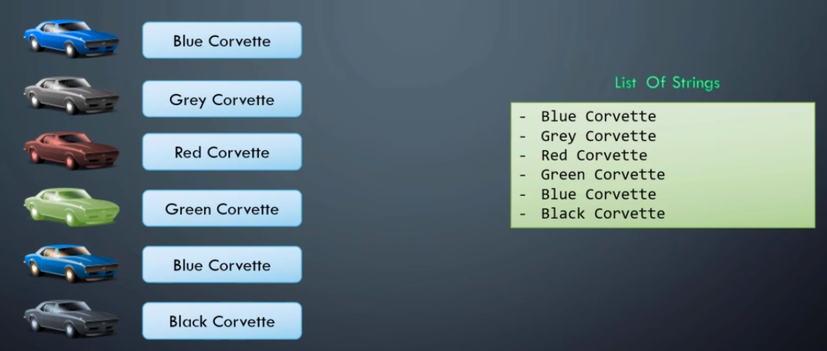

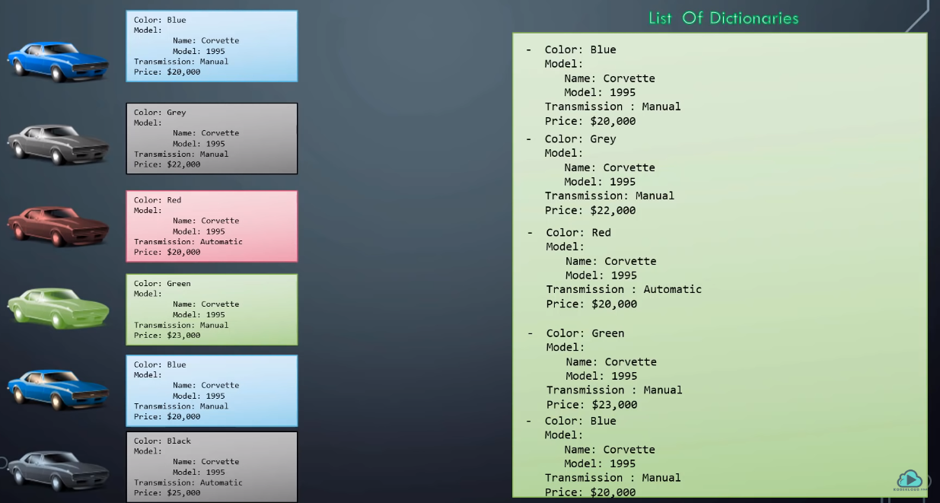

Dictionary -Unordered

List-Ordered

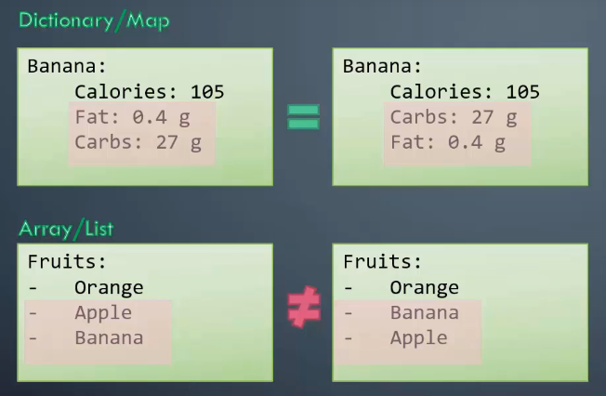

# **Apache** **Tomcat**

**1. What Is Apache Tomcat?:**

In simple words, **Apache** is a web-server meant to serve static web-pages. ... **Apache Tomcat**, on the other hand, is an application server meant to serve Java applications (Servlets, JSPs etc). You can serve web-pages as well through **Tomcat**, but it is less efficient at that as compared to **Apache**.

**Apache** is an HTTP web server which serve as HTTP. **Apache Tomcat** is a java servlet container. It features same as web server but is customized to execute java servlet and JSP page

Tomcat is a web server and a Servlet/JavaServer Pages container. It is often used as an application server for strictly web-based applications but does not include the entire suite of capabilities that a **Java EE** application server would supply. Links: Apache Tomcat home page.

Tomcat is Java Servlet container and web server from the Apache Software foundation

Apache tomcat server is java web application server

Apache Tomcat is an open-source web server and Servlet/JSP container developed by the Apache Software Foundation. Tomcat implements several Java EE specifications including Java Servlet, Java Server Pages (JSP), Java EL, and WebSocket, and provides a "pure Java" HTTP web server environment for Java code to run in.

So basically Apache is an HTTP Server, serving HTTP. Tomcat is a Servlet and JSP Server serving Java technologies.

**what is difference between web server and application server and Web Server**

**Web Server -**

Server on which your website is hosted. This server will have installed web servers such as IIS, apache, etc.

**Application Server -**

Server on which your created applications which are utilizing your database, web service, etc. This application server will host business layer (wrapped with web services), scheduled jobs, windows services, etc.

**Database Server -**

Database server will have your one or more database hosted such as Oracle, Sql Server, MySql, etc.

### 2. default port for HTTP and HTTPS?

The default port for HTTP is 80 and HTTPS 443. Checkout default ports for other applications

### 3. configuration file name?

httpd.conf is the main configuration file used in Apache.

### 4. check the version of running Apache Web Server?

root@lab ~]# rpm -qa |grep httpd

httpd-2.2.15-54.el6.centos.x86_64

httpd-tools-2.2.15-54.el6.centos.x86_64

[root@lab ~]#

### 5. How to know if a web server is running?

ps -ef |grep httpd

netstat -anlp |grep 8080

### 6. How to install Apache web server?

yum install httpd

### 7. How to ensure Apache listen on only one IP address on the server?

Listen 10.10.10.10:80

### 8. How to ensure Apache process run with non-root/nobody user?

User apache

Group apache

### 9. Can you change the listening port from default to something else?

Yes, it’s possible by specifying the port number in **Listen** directive.

Ex: to make Apache listen on 9000 port to 10.10.10.10 IP address.

Listen 10.10.10.10:9000

**10. How To We Can Change Tomcat Default Port?**

8080 is the default HTTP port that Tomcat attempts to bind to at startup.  To change this, we need to change port in $ TOMCAT_HOME /conf/**server.xml**, in that we can search 8080 and after getting below statement

<Connector port="8080" protocol="HTTP/1.1"  connectionTimeout="20000"  redirectPort="8443" />

We can change 8080 to other port like 8081, we need to restart tomcat to take effect. We required changes in URL as <http://localhost:8081/>.

**11.What Is Default Session Time Out In Tomcat?**

The default session timeout 30 minutes in tomcat and can change in $TOMCAT_HOME/conf/web.xml via modify below entry

<session-config>

<session-timeout>30</session-timeout>

</session-config>

### ****12. Explain Directory Structure Of Tomcat?****

**Directory structure of Tomcat are:**

**bin -** contain startup, shutdown, and other scripts (*.sh for UNIX and *.bat for Windows systems) and some jar files also there.

**conf -** Server configuration files (including server.xml) and related DTDs. The most important file in here is server.xml. It is the main configuration file for the container.

**lib -** contains JARs those are used by container and Servlet and JSP application programming interfaces (APIs).

**logs -** Log and output files.

**webapps –** deployed web applications reside in it .

**work -** Temporary working directories for web applications and mostly used during in JSP compilation where JSP is converted to a Java servlet.

**temp -** Directory used by the JVM for temporary files .

12. How to secure Website hosted on Apache Web Server?

There are multiple ways to [secure the Apache web server](https://geekflare.com/apache-web-server-hardening-security/) including the following.

* Implementing SSL
* Integrating with WAF (Web Application Firewall) like ModSecurity, etc.
* Using [cloud-based security provider](https://geekflare.com/cloud-waf-to-stop-website-attacks/)

**13. What are the log files generated by Apache?**

There are two popular log files created;

* access.log – all request details with the [status code](https://geekflare.com/http-status-code-infographics/)
* error.log – capture all the errors within apache or connecting in backend

### 14. What is Virtual Hosting?

Virtual Hosting in Apache allows you to host multiple websites on a single instance. You can either create **IP based** or **Name based** on virtual hosting.

### 15. How to put Log level in Debug mode?

Often needed when you are troubleshooting the issue and wish to capture more details. You can change the logging level to debug by ensuring the following in httpd.conf file.

LogLevel debug

### 16. Which module is required to enable SSL?

The mod_ssl module must be uncommented before SSL implementation.

LoadModule auth_basic_module modules/mod_ssl.so

### 17. What’s the WebLogic module name?

mod_wl_22.so

**18. What is the log level available in Apache?**

The default configuration is set to “**warn**” however, the following is possible too.

* debug
* info
* warn
* notice
* crit
* alarm
* emerg
* error

### 19. What is DocumentRoot?

DocumentRoot directive is the configuration where you can specify the folder location from where the static files will be served. It’s also called as Web Root.

Default DocumentRoot location is /var/www/html

### 20. How to deploy war or JAVA applications in Apache?

I am afraid, Apache is a Web Server, and Java-based application deployment is not possible with it. However, you can integrate Java application server like WebLogic, WebSphere, JBoss where you can deploy war, ear files

### 20. How to verify httpd.conf file to ensure no configuration syntax error?

httpd –t will help you to check the syntax.

[root@lab httpd]# /usr/sbin/**httpd -t**

Syntax OK

[root@lab httpd]#

### 21. How to ensure web server is getting started after server reboot?

If running Linux, then you can put a script in /etc/init.d/ and enable to [start on boot](https://geekflare.com/how-to-auto-start-services-on-boot-in-linux/) using chkconfig command

Let’s say you create a file called **apache** and put under /etc/init.d

chkconfig --add apache

chkconfig apache on

### 22. How would you kill the Apache process if graceful stop doesn’t work?

If running on Linux, then can use kill command.

Find out the PID of Apache by using ps -ef |grep http

Then kill it

kill $PIDNUMBER

### 23. How to hide server version details in HTTP response header?

Add the following in httpd.conf file and restart the web server

ServerTokens Prod

ServerSignature Off

### 24. What does 200, 403 & 503 HTTP error code mean?

* 200 – content found and served OK
* 403 – tried to access restricted file/folder
* 503 – the server is too busy to serve the request and, in another word, – service unavailable.
* Refer [HTTP Response Code infographic](https://geekflare.com/http-status-code-infographics/) for more.

1. Informational – 1XX
2. Success – 2XX
3. Redirection – 3XX
4. Client Error – 4XX
5. Server Error – 5XX

### 25. How to disable trace HTTP request?

Add the following in httpd.conf file and restart the instance

TraceEnable off

### 26. How to troubleshoot port conflict issue?

[netstat](https://geekflare.com/netstat/) would be useful to troubleshoot the port conflict issue. If running multiple instances on a single server then it would be recommended to have absolute IP:Port configured for Listen directive.

### 27. How to start the tomcat



# **Autosys**

### 1. What is a Job in Autosys? Define it.

Autosys is an automated job control system for scheduling, monitoring, and reporting.

These jobs can reside on any Autosys-configured machine that is attached to a network. An Autosys job is any single command, executable, script, or Windows batch file. Each Autosys job definition contains a variety of qualifying attributes, including conditions specifying when and where a job should be run.

**Autosys Jobs**  
There are three types of jobs,  
- Command Jobs :  execute commands  
- File watcher Jobs:  watch for the arrival of a specified file.  
- Box Jobs: are containers that hold other jobs (including other boxes). A box job can be used to organize and control process flow. The box itself performs no actions, although it can trigger other jobs to run. An important feature of this type of job is that boxes can be put inside of other boxes.

**2.How will you define/insert a job in Autosys?**

There are two ways by which we can define a job in Autosys.  
►Using the Graphical User Interface (GUI).  
►Using the Job Information Language (JIL)

### 3. What is JIL in Autosys?

JIL stands for Job Information Language.  
  
JIL is a specification language, with its own syntax, that is used to describe when, where, and how a job should run. When you enter the jil command, you get the jil command prompt, at which you can enter the job definitions one line at a time using this special language. When you exit the jil command-line interface, the job definition is loaded into the database. Alternatively, you can enter the definition as a text file and redirect the file to the jil command. In this case, the jil command activates the language processor, interprets the information in the text file, and loads this information in the database

### 4. Autosys – System Components

**Autosys – System Components**

[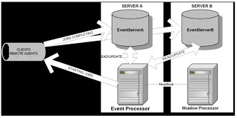](http://2.bp.blogspot.com/-_dN-NNEuBgI/UBTx9F1ROwI/AAAAAAAAAH0/yGvMWONZMsk/s1600/autosys1.jpg)

It has server–client architecture and requires 3rd party database or bundled version of Sybase.  
Event server : Database containing the job definitions and events.  
Event Processor : The daemon which reads from the event server and sends job stream to the Remote agent.  
Remote Agent : The Remote agent is the client component of Autosys and will execute the command as defined and write the result back to Event Server.  
Shadow Processor : The daemon running on the server which takes over from the Event Processor if it is interrupted.  
3rd machine : An Autosys Remote agent that acts as the tie breaker if the Event process and Shadow process lose connectivity with each other.  
  
**Autosys – Process Flow**  
  
The diagram in the following figure and the numbered explanations that follow it illustrate how Unicenter Autosys JM performs its most basic function – starting a job (that is , executing a command) on a client Machine.   
[Note : In following figure, the major components are shown as separate entities. Typically, event processor and event server are installed on the same server machine along with a required remote agent, and other remote agents are installed on separate client machines.]

[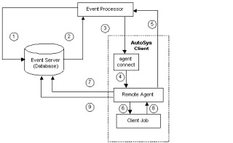](http://4.bp.blogspot.com/-PHpOEtGNw5c/UBTygdyUh_I/AAAAAAAAAH8/UZ8emP7hidw/s1600/autosys2.jpg)

1.   The Event processor scans the event server for the next event to process. If no event is ready, the Event processor scans again in five seconds.

2.   The Event processor reads from the event server that an event is ready. If event is a STARTJOB event, the job definition and attributes are retrieved from Event server, including the command and pointer (full path name on the client machine) to the profile to be used for the job. In addition for jobs running on windows machines, the event processor retrieves from the database the userIDs and passwords required to run the job on client machine.  
  
3.   The Event processor processes event. If the event is STARTJOB, the Event processor attempts to establish a connection with remote agent on the client machine, and passes job attributes to client machine. The Event processor sends a CHANGE_STATUS event making in the event server that the job is in STARTING status.  
  
4.   On a unix machine, the inetd invokes the remote agent. On a windows machine, the remote agent logs onto the machine as the user, defined as the job’s owner, using the userIDs and passwords passed to it from event processor.  
  
5.   The remote agent sends an acknowledgment back to the Event processor indicating that it has received the job parameters. The socket connection is terminated. At this point, the Event processor resumes scanning the Event server database, looking for events to process.  
  
6.   The remote agent starts a process and executes command in the job definition.  
  
7.   The remote agent issues a CHANGE_STATUS event marking in the Event server that the job is in running state.  
  
8.   The client job process runs to completion, then returns an exit code to the remote agent and quits.  
  
The remote agent sends the Event server a CHANG_STATUS event corresponding to the completion status of the job and passes back an exit code, using the communication facilities of the database. If the return status is SUCCESS, the remote agent deletes the log file in its temporary file directory on the client machine. The remote agents quits..

### 5. Explain INACTIVE status in Autosys jobs.

The job has not yet been processed. Either the job has never been run, or its status was intentionally altered to turn off its previous completion status.

### 6. Explain ON_HOLD in Autosys?

When a job is put on hold, it will not be run until it receives the JOB_OFF_HOLD event or FORCE START. ON_HOLD is equivalent to stop the current execution process.   
  
**Example:**  
There are 4 jobs, say Job A, Job B, Job C and Job D. Consider all these jobs reside in a box job named box_1. The box job is started now. After starting the box job user immediately realized that there is a mistake in command script name in Job C. So, he put the Job C ON HOLD before it starts. Thus, he ensures the job will run proper way.

### 7. Explain ON_ICE in Autosys.

This job is removed from all conditions and logic, but is still defined. Operationally, this condition is like deactivating the job. It will remain on ice until it receives the JOB_OFF_ICE event.   
  
Please remember that the job, which is defined after the job ON ICE, will immediately start even though some conditions are specified for that job with the previous one. This is the important note about ON ICE.  
  
**Simple question ...**  
A box job contains 10 jobs. The jobs are in sequential order. Consider the Job 5 is ON ICE and it has the dependency with only Job 4. If the box job is started, what will be the jobs will be running immediately ?  
  
Yes. The first job as well as the 6 th job will be starting immediately since ICE instructs next job to run immediately.

### 8. What is the difference between ON HOLD and ON ICE in Autosys ?

This is the very important and most expected question in Autosys.  
  
The difference between on hold and on ice is that when an on hold job is taken off hold, if its starting conditions are already satisfied, it will be scheduled to run, and it will run. On the other hand, if an on ice job is taken off ice, it will not start, even if its starting conditions are already satisfied. This job will not run until its starting conditions reoccur.   
  
The other major distinction is that jobs downstream from the job that is on ice will run as though the job succeeded. Whereas, all dependent jobs do not run when a job is in on hold—nothing downstream from this job will run.

### 9. What does the job term ACTIVATED mean in Autosys ?

The top-level box that this job is in is now in the RUNNING state, but the job itself has not started yet. You can see the status of the job when you have just started the Box job of that particular job.

### 10. What is the meaning of the job status STARTING in Autosys?

The job is ready and going to start. The event processor has initiated the start job procedure with the remote agent

### 11. Explain the job term RUNNING in Autosys?

The job is running. The job is processing data. The job will be in running status until it process the data. If the job is a box job, this value simply means that the jobs within the box are running. If it is a command or file watcher job, the value means that the process is actually running on the remote machine.

### 12. When will the job be SUCCESS in Autosys?

If the job exited with an exit code 0, then that job is interpreted as success. However, a range of values up to the maximum exit code for success can be reserved for each job to be interpreted as success. If the job is a box job, this value means that all the jobs within the box have finished with the status SUCCESS (the default), or the Exit Condition for Box Success evaluated to true.

### 13. When will the job be FAILURE in Autosys?

The job exited with an exit code greater than the maximum exit code for success. By default, any number greater than zero is interpreted as failure. If the job is a box job, a FAILURE status means either that at least one job within the box exited with the status FAILURE (the default), or that the Exit Condition for Box Failure evaluated to true. Unicenter AutoSys JM issues an alarm if a job fails.

### 14. When will be the job in TERMINATED status in Autosys?

A job can be terminated if a user sends a KILLJOB event or if it was defined to terminate if the box it is in failed. If the job itself fails, it has a FAILURE status, not a TERMINATED status. A job may also be terminated if it has exceeded the maximum runtime (term_run_time attribute, if one was specified for the job), or if it was killed from the command line through a UNIX kill command. Unicenter AutoSys JM issues an alarm if a job is terminated.

### 15. Explain job RESTART in Autosys.

The job was unable to start due to hardware or application problems, and has been scheduled to restart.

### 16. Explain QUE_WAIT status in Autosys.

The job can logically run (that is, all the starting conditions have been met), but there are not enough machine resources available. The job will start only if it has adequate resources to process.

**17. Sample JIL file in Autosys**

insert_job: jobname  
job_type: c  
box_name: which box holds this job  
description: What the job is doing  
machine: servername  
permission: gx,wx  
owner: account  
command: batch_file or Script  
std_out_file: "c:\AutoSysLog\Test.log"  
std_err_file: "c:\AutoSysLog\Test.Err.log"  
min_run_alarm: 0  
max_run_alarm: 30  
job_terminator: yes  
box_terminator: yes

### 18. What is an Instance in Autosys?

The term instance is used to represent a licensed version of Unicenter AutoSys JM and at least one client machine running a unique Remote Agent. In reality, the operation is likely to have dozens of Remote Agents communicating concurrently with the same database. Any status changes or service requests posted to the database are called Events.

### 19. Graphical User Interface in Autosys

The GUI lets you interactively set the attributes that describe when, where, and how a job should run. You create job definitions using the GUI Control Panel and the dialogs you can launch from it.   
  
The fields in the GUIs correspond to the AutoSys JIL sub-commands and attributes. In addition, from the GUI Control Panel, you can open applications that lets you define calendars, monitors, and reports, and let you monitor and manage jobs.

### 20. Three types of jobs in Autosys

There are three types of Unicenter AutoSys JM jobs:  
  
**Command, File Watcher, and Box.**  
  
Command - Execute a command. Generally a input file is given in which the required commands reside.  
File Watcher - Special type of job in AutoSys. It will wait for a file. It will not start the job until the file arrives. This type of job will be helpful when you integrate your project from various modules.  
Box - A box is a container of other jobs. A box does nothing in execution but it holds and preserves the jobs. In projects, start time is specified in Box jobs so that it will automatically starts once the time has arrived.

### 21. Box job started but inner jobs are not running in Autosys - why ?

This problem is a familiar one and one of the important notes in Autosys.  
  
**Scenario 1: (Meeting dependency)**   
Remember that even if the box job started, the inner jobs will only run when they satisfy all the conditions specified.  
For example let us take a box job A in which an inner job "a" resides. The job "a" has the dependency with a job "b" which resides in another box job B. So, "a" is scheduled to run after the job "b". Now, If box A is force started, job "a" will not start since it waits for job "b" to complete. Job "a" will start automatically once job "b" over.  
  
**Scenario 2: (Meeting timelines)** Consider several inner box jobs are defined under a super box job. The start time for the super box job is 10:00 and the start time for the inner jobs is 11:00. Now, if the super box job is started, will the inner box jobs run immediately ? No, they will not. Inner jobs obey the timing pattern strictly and they will start running once they meet the timelines.

### 22. Box job in Autosys -Explain

A Box job is a container of other jobs.  
A box job will do **nothing in execution process** but it can control the inner jobs when and how they should run. If a box job is started, it will start the inner jobs automatically.  
  
Generally, the jobs which do similar operations or generic functions will be grouped together under a box job.  
We can set the start time and run calendars for a box job to control the execution.  
  
**Feature of a Box job:**  
When a box job is in running status (After starting), it will be in success state only if all of its inners jobs succeeded.  
The box job fails when any one of the inner job fails.  
A box job can contain other box jobs. The box job which is superior to all other box jobs is called as Super box.

**Default Box Job behaviour**  
Some important rules to remember about boxes are:  
- Jobs run only once per box execution.  
- Jobs in a box will start only if the box itself is running.  
- As long as any job in a box is running, the box remains in RUNNING state; the box cannot complete until all jobs have run.  
- By default, a box will return a status of SUCCESS only when all the jobs in the box have run and the status of all the jobs is "success”.  
- By default, a box will return a status of FAILURE only when all jobs in the box have run and the status of one or more of the jobs is "failure."  
- Unless otherwise specified, a box will run indefinitely until it reaches a status of SUCCESS or FAILURE.  
- Changing the state of a box to INACTIVE (via the sendevent command) changes the state of all the jobs in the box to INACTIVE.

### 23. If you want to remove the run calendar and start times from a job, how will you execute with JIL file?

In Autosys, there is a command called date_conditions which enables the run calendar and start time.  
  
If date_conditions=1 then the above parameters will be enabled and if date_conditions=0, the parameters will be disabled. Thus, while executing the JIL, date_conditions=0 needs to be set for a job to remove the run calendar and start times

### 24. Is Machine name needed for a Box job in Autosys?

Machine name is not needed for a Box job. Machine name is need for other types of jobs like commands and file watchers. Machine name is primarily required to run the script. Since Box job is the holder of other jobs and it does nothing in the execution process, Machine name is not required for a box job.

### 25. Deleting a Box in Autosys - Explain

delete_box: box_name command is used to delete the box. This command will delete all the inner jobs of the box job also. To delete the box job alone leaving its content jobs intact, you have to render delete_job: box_name.

### 26. Delete a job in Autosys - Explain

delete_job: job_name command is used to delete the job. In order to delete a job, you need to simply give delete_job command. No more commands or attributes are needed for deleting.

### 27. What are the system components in Autosys?

Event server  
Event processor  
Remote Agent

### 28. Event server in Autosys - Explain

Event server can also be called as Autosys database (RDBMS).   
It is the repository unit which stores system information and events, job, monitoring, reporting definitions.  
  
Autosys can operate in dual server mode. Therefore, if you lose one event server due to hardware/network problems, another server will handle your work without any loss of information or functionality.

### 29. What are different starting conditions for Autosys job?

Autosys determines whether to start or not to start a job based on the evaluation of the starting conditions (or starting parameters) defined for the job.

These conditions can be one or more of the following:  
- Date and time scheduling parameters are met (it is or has passed the specified date and time).  
- Starting Conditions specified in the job definition evaluate to true.  
- For jobs in a box, the box must be in the RUNNING state.  
- The current status of the job is not ON_HOLD or ON_ICE.  
Every time an event changes any of the above conditions, Autosys finds all the jobs that may be affected by this change, and determines whether or not to start them.

### 30. Difference Between Autosys and Crontab

Autosys (Now called CA Workload Automation) is a centralized job management tool.

Crontab is a inbuilt feature in UNIX systems used to schedule and run scripts/commands.

Autosys Help to run thousands of jobs at time in different systems (windows, Linux, Mainframe etc)

Crontab Jobs can be triggered only in UNIX systems

Autosys is widely used in banking systems to run n+ lakh jobs in enterprise application environment.

Crontab is used to schedule few jobs in a client machine.

In Autosys Jobs historical information (status) can be extracted from database.

Crontab Not possible to extract historical information for a large number of jobs.

Autosys can trigger different types of jobs includes command jobs, script, Box jobs, File watcher jobs, FTP jobs etc.

Can trigger only commands and scripts.

### 31. Autosys Job Status

Autosys keeps track of the current status of every job. Following are the statuses –

INACTIVE (IN) - The job has not yet been processed. Either the job has never been run, or its status was intentionally altered to “turn off” its previous completion status.  
ACTIVATED (AC) - The top-level box job is in RUNNING state, but the job itself has not started yet.  
STARTING (ST) - The event processor has initiated the start job procedure with the Remote Agent.  
RUNNING (RU) - The job is executing. If the job is a box job, this value simply means that the jobs within the box may be started (other conditions permitting). If it is a command or file watcher job, the value means that the process is actually running on the remote machine.  
SUCCESS (SU) - The job exited with an exit code equal to or less than the “maximum exit code for success.” By default, only the exit code “0” is interpreted as “success.”   
FAILURE (FA) - Job exited with an exit code greater than “maximum exit code for success.” Any number greater than zero is interpreted as “failure.” Autosys issues an alarm if a job fails.  
TERMINATED (TE) - The job terminated while in the RUNNING state. A job can be terminated if a user sends a KILLJOB event or if it was defined to terminate if the box it is in failed. A job may also be terminated if it has exceeded the maximum run time or if it was killed from command line through UNIX kill command. Autosys issues an alarm if a job is terminated.  
RESTART (RE) - Job was unable to start due to hardware or application problems, and has been scheduled to restart.  
QUE-WAIT (QU) - The job can logically run (that is, all the starting conditions have been met), but there are not enough machine resources available.  
ON_HOLD (OH) - This job is on hold and will not be run until it receives the JOB_OFF_HOLD event.  
ON_ICE (OI) - This job is removed from all conditions and logic, but is still defined to Autosys. Operationally, this condition is like deactivating the job. It will remain on ice until it receives the JOB_OFF_ICE event.

Job On Ice-Depedent job will run infact we call job on ice as success condition

Job On Hold -Depedent job wont run

### 32. JIL file and example

**Attributes of AUTOSYS**

Job_name :  
script :  
owner:  
machine it has to run on :  
day:  
date:  
week:  
error log :  
output log :  
alarm :

**Sample jil code / Writing jil code**  
insert_job: template job_type: c  
box_name: box1  
command: ls -l  
machine: localhost  
owner: lyota01@TANT-A01  
permission: gx,ge,wx,we,mx,me  
date_conditions: 1  
days_of_week: all  
start_times: “15:00, 14:00″  
run_window: “14:00 - 6:00″  
condition: s (job1)  
description: “description field”  
n_retrys: 12  
term_run_time: 60  
box_terminator: 1  
job_terminator: 1  
std_out_file: /tmp/std_out  
std_err_file: /tmp/std_err  
min_run_alarm: 5  
max_run_alarm: 10  
alarm_if_fail: 1  
profile: /tmp/.profile  
  
**Explanation of each line:**  
Insert_job: this will let the Autosys server to recognize the job and inserts into Autosys DataBase. Jobtype: there are two types of jobs namely box and child ( c=child, b=box)  
box_name: this is the box job name: box job can have more than 1 child jobs.  
commands: this is where you tell Autosys, what to do when the job runs.   
machine: name of the machine where you want to run the job.  
owner: owner of the job.  
permissions:  
date_conditions: 1 if you have any specifications.  
days_of_week: on which days of the week you want the job to run.  
start_time: the time at which the job should kick-off.  
run_window: this option is for monitoring jobs. Job will run continuously for specified time window.  
conditions: You can specify the dependencies. like success of some other job.  
description:  
n_retrys: no of retrys on a failure.  
term_run_job: the job will terminate if it runs for specified time.  
box_terminator: if 1, terminates box job depends on term_run_time.  
job_terminator: if 1, terminates child job depends on term_run_time.  
std_out_file: standard output file (log) for the job  
std_err_file: Error log file if the job fails  
min_run_alarm: if the job terminates/completed within that time it generate an alarm  
max_run_alarm: if the job runs for more than the specified time, it generate an alarm  
alarm_if_fail: generates an alarm if the job fails  
profile: the file where you can keep all your variables (variable names)  
  
We don’t use all the above options in all the jobs, it depends on the requirements.

Here is a sample job which will verify a particular process is running or not.  
/* —————– SAP_UAT_MU03_C —————– */  
insert_job: SAP_UAT_MU03_C

job_type: c  
command: /local/SAP/processCheckUAT.sh  
machine: MU03-UAT  
owner: admin@MU03-UAT  
permission: gx,wx,mx,me  
days_of_week: all  
start_times: “15:00, 14:00″  
description: “Job used for Run testing of process”  
alarm_if_fail: 1  
max_exit_success: 1  
  
**To Insert a new Autosys job as JIL code**  
issue command "jil"  
bash-3.00$ jil >>1>  
"The following prompt will appear" copy paste the jil code u have made example of jil code below.  
At the end the "C" or "B" determines if the job is box job or child job.  
If the jil is inserted properly, then successful message will come and exit; else it will show error.

For Example -

•       Insert Box using JIL  
jil    
jil>>01> insert_job: box_TG_cafe   job_type: b          
jil>>02>  owner: autosys  
jil>>03>  permission: gx,wx,mx  
jil>>04>  date_conditions: 1  
jil>>05>  days_of_week: sa  
jil>>06>  start_times: "16:00"  
jil>>07>  condition: s(box_TG_post_dp_batch)  
jil>>08>  description: "CAFE Extract"  
jil>>09>  alarm_if_fail: 0  
jil>>10>  group: TG_cafe  
jil>>11> exit  
    ___________________________________________________________________  
CAUAJM_I_50204 Inserting/Updating Job: box_TG_cafe  
CAUAJM_I_10122 Job 'box_TG_cafe' scheduled: 01/07/2012 16:00:00  
CAUAJM_I_50205 [Database](http://www.blogger.com/) Change WAS Successful! __________________________________________________________________

•       Insert Command using JIL

jil    
jil>>01> insert_job: job_TG_extract_customer_premise_info   job_type: c  
jil>>02>  box_name: box_TG_cafe  
jil>>03>  command: sudo -u energyop –i $${CISSOURCE}/CAFE/extract_cust_premise_info.sh  
jil>>04>  machine: TGDB  
jil>>05>  owner: autosys  
jil>>06>  permission: gw,gx  
jil>>07>  condition: s(job_customer_enroll_info)  
jil>>08>  description: "extract_customer_premise_info"  
jil>>09>  std_out_file: $${CISAUTOLOGS}/extract_customer_premise_info_out.log  
jil>>10>  std_err_file: $${CISAUTOLOGS}/extract_customer_premise_info_err.log  
jil>>11>  alarm_if_fail: 0  
jil>>12>  group: TG_cafe  
jil>>13> exit  
____________________________________________________________________  
CAUAJM_I_50204 Inserting/Updating Job: job_TG_extract_customer_premise_info  
CAUAJM_I_50205 Database Change WAS Successful!  
____________________________________________________________________

•       Insert File Watcher using JIL

jil   
jil>>01> insert_job: fw_TG_CW27505_Extract_Premise  job_type: f   
jil>>02>  box_name: box_TG_cafe  
jil>>03>  machine: TGFTP  
jil>>04>  owner: energyop  
jil>>05>  permission: gw, gx  
jil>>06>  condition: s(job_TG_extract_customer_premise_info)  
jil>>07>  description: "CW27505_Extract_Premise_yyyy-mm-dd.dat.gz file watcher"  
jil>>08>  watch_file: $${CISFTPFTP}/CAFE/out/CW27505_Extract_Premise_$${DATEA}.dat.gz  
jil>>09>  watch_interval: 60  
jil>>10>  alarm_if_fail: 0  
jil>>11>  group: TG_cafe  
jil>>12> exit  
________________________________________________________________  
CAUAJM_I_50204 Inserting/Updating Job: fw_TG_CW27505_Extract_Premise  
CAUAJM_I_50205 Database Change WAS Successful!  
________________________________________________________________

### 33. Autosys Command - Autorep

The command reports information about a job status and also job definition. It also reports information about job overrides and global variables.  
**Syntax** :  
autorep (-J job_name /-M machine_name /-G global_name) [-s -d -q -o over_num] [-r run_num]

Autorep -j job_name ---display the job details(i.e.name,last_start,last_end,ST)

Autorep -j job_name -d ---more details about the job

Autorep -j job_name -q ---to get the JIL definition of Job

Autorep -q -j job_name --- Viewing JIL code for any Autosys job

Autorep -j job_name -d -t ---will get the time zone with detailed info

Autorep -j job_name -d -t -1 ---Will give detailed for the last 1 run of the job

Autorep -M ALL ---to list down all the machine on the data server

Autorep -j box_job -s -L 2 ---Summary report of box upto last 2 level

Autorep -G ALL/DAY ---to check global name changed history   
autorep -J (job name here) -r (No of runs back)  --- To obtain the information of previous runs  
  
**Autosys Command - sendevent**  
This command send events to Autosys for a variety of purposes, including starting or stopping autosys jobs, stopping the Event processor, and putting a job on hold. This command is also used to set autosys global variables or cancel a scheduled event.  
  
Following are the example of sendevent command frequently used.  
sendevent -E FORCE_STARTJOB  -j   
sendevent -E STARTJOB  -j   
sendevent -E JOB_ON_HOLD  -j : Job now on hold   
sendevent -E JOB_OFF_HOLD -j : Job now released.   
sendevent -E CHANGE_STATUS -s SUCCESS -j : Job status changed to success   
sendevent -E JOB_ON_ICE -j : Job now "on ice"   
sendevent -E JOB_OFF_ICE -j : Job taken off "ice". Beware of dependancies!!   
sendevent -E KILLJOB -j : Job "Killed"   
sendevent -e CHANGE_STATUS -s INACTIVE -j   
sendevent –E STOP_DEMON : Shutdown autosys  
sendevent –E SET_GLOBAL –G “var_name=/home/dinesh” : To set variable in autosys

sendevent is normally used with "-E" & -J option  
-J job_name : Specifies name of the job to event should be sent. This option is required for all events except STOP_DEMON, COMMENT, ALARM, or SET_GLOBAL  
-E event: Specifies the any one of following events to be sent.

STARTJOB  
KILLJOB  
DELETEJOB                                                    
FORCE_STARTJOB  
JOB_ON_ICE  
JOB_OFF_ICE  
JOB_ON_HOLD  
JOB_OFF_HOLD  
CHANGE_STATUS                                           
STOP_DEMON  
CHANGE_PRIORITY  
COMMENT  
ALARM  
SET_GLOBAL  
SEND_SIGNAL

|  |
| --- |
| **Other Autosys Commands**  # Reports the current status of a specific job, or the value of an Autosys global variable.  autostatus -J job_name [-S instance]  #To see job report  autorep –w –j  # To find dependent downstream jobs and their status.  job_depends –c –w –j  # Load autosys JIL file  jil < JIL_source  # Find unique commands currently being used  autorep -J PARTIALJOBNAME% -q | grep "command:" | awk -F: '{print $2}'|  awk '{print $1}' | sort -u > /tmp/cmds.txt  # Forecast report from date to infinity: job_depends -t -J ALL -F "mm/dd/yyyy"  # Display all jobs scheduled to run between these two dates: job_depends -t -J ALL -F:06/01/2008 -T:06/30/2008  # check if the event processor is up and running chk_auto_up  # Display list of available time zones: autotimezone -l   # Get version information autoflags -a  # View Remote Agent log autosyslog -J jobname  # To start autosys GUI panel autosc &  # Verify both client & server are correctly configured autoping -m machine_name  # To convert jobs from crontab to autosys jobs. Below command will create a file1.jil in present directory.  cron2jil –f file1  #Prints, adds & deletes custom calendar definations  autocal_asc  # To change, edit, exec superusers, change DB passwds, change remote authentication method  autosys_secure  [COURTESY - All helping hands and helpful websites on internet.] |

# **Data Warehouse and BI**

**BI**-Business Intelligence is the activity which contributes to the growth of the company.

BI is the act of transforming raw/operation data into useful information for business analysis.

BI is based on business warehouse technology extract information from company’s operational system.

The data is transformed (cleaned and integrated) and loaded into data warehouse.

## Data WareHouse

**Data warehouse** system used for reporting and data analysis. From using this data analysis, we derived logical conclusion that helps in improving our business.

It is central location where consolidated data from multiple locations (databases are stored)

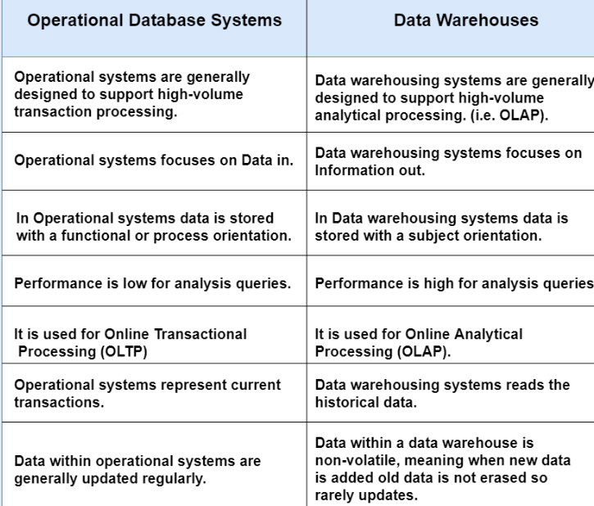

## **Data Warehouse Architecture**

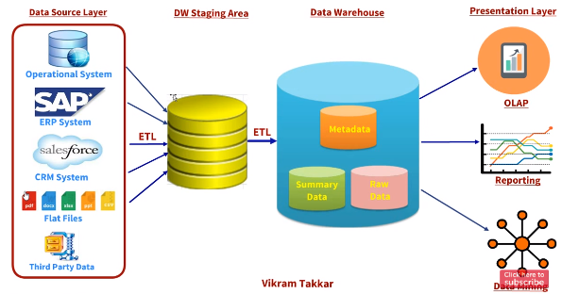

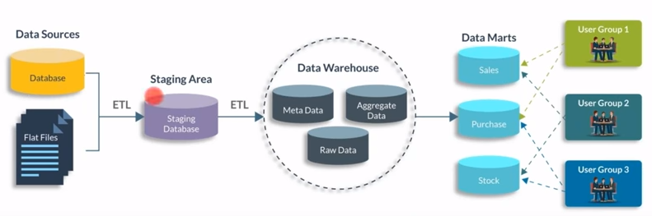

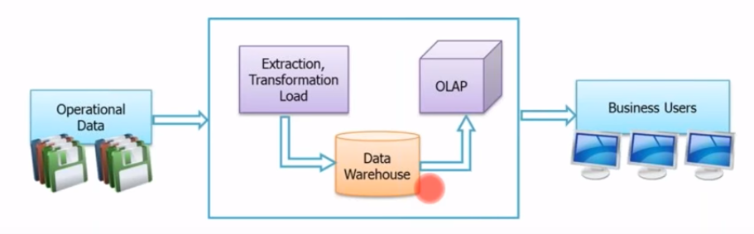

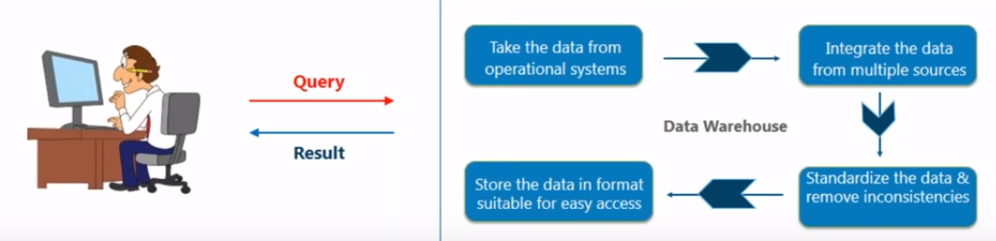

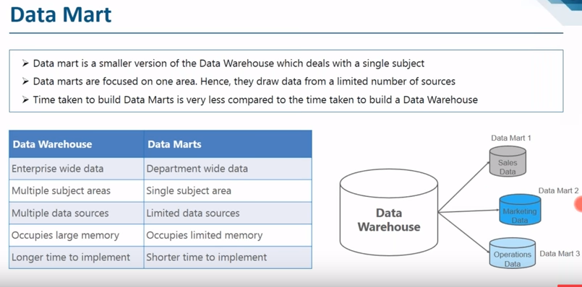

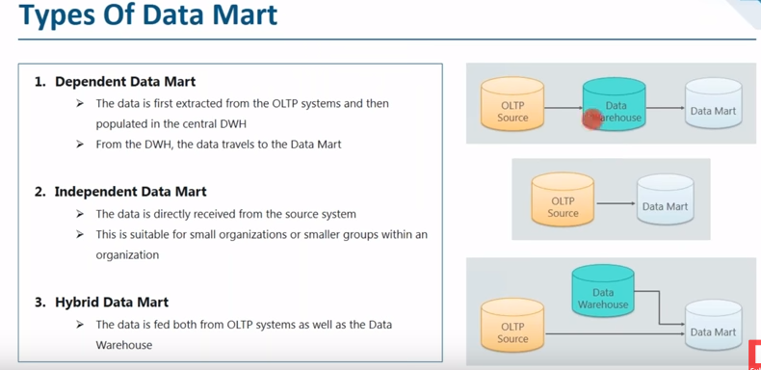

## **Difference between OLTP and OLAP**

OLTP (On-line Transaction Processing)

OLAP (On-line Analytical Processing)

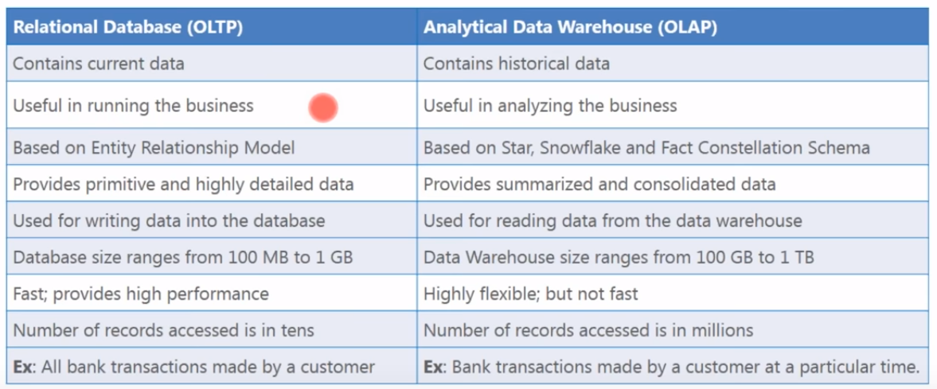

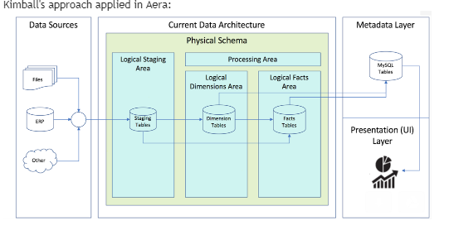

## **Dimensions and Facts**

Dimensions and Facts are basic building block of data warehouse

For warehouse developer the primary challenge to find out what is dimension and what is fact

**Fact** is measurement of business and it provide quantitative information about business process.

Measures are mostly aggregate of the data from that we can come up with the conclusion

Measures are mostly stored fact tables

**Dimensions** are stored in dimension table. It describes fact or business numbers.

Dimensions are mostly talk about the measures. Without dimensions we cannot measure fact.

Users can do slicing and dicing for data to get business information.

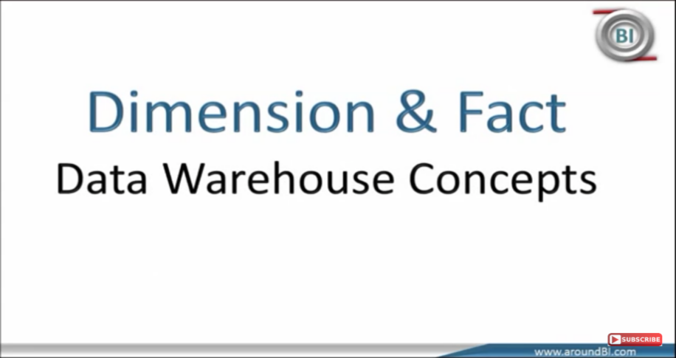

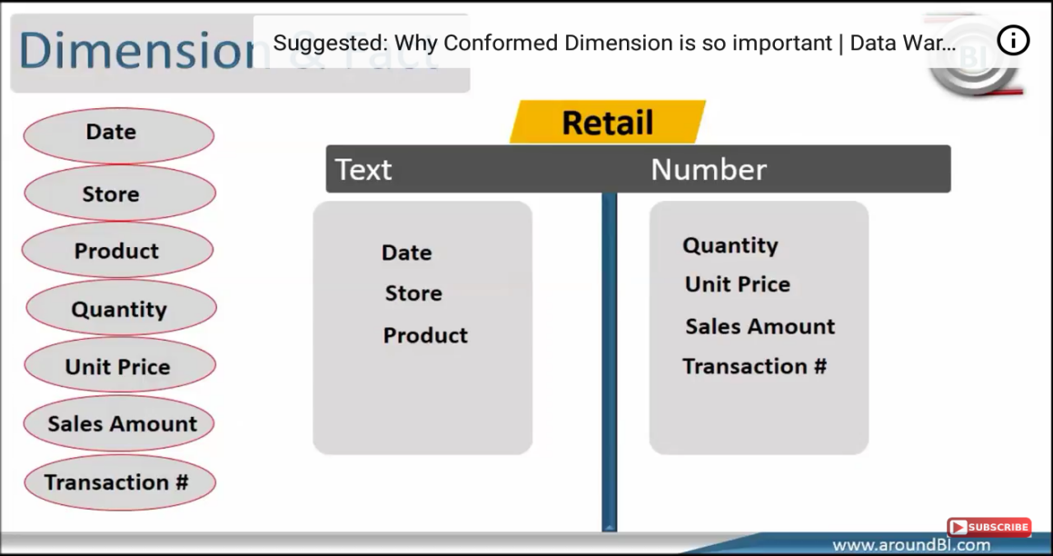

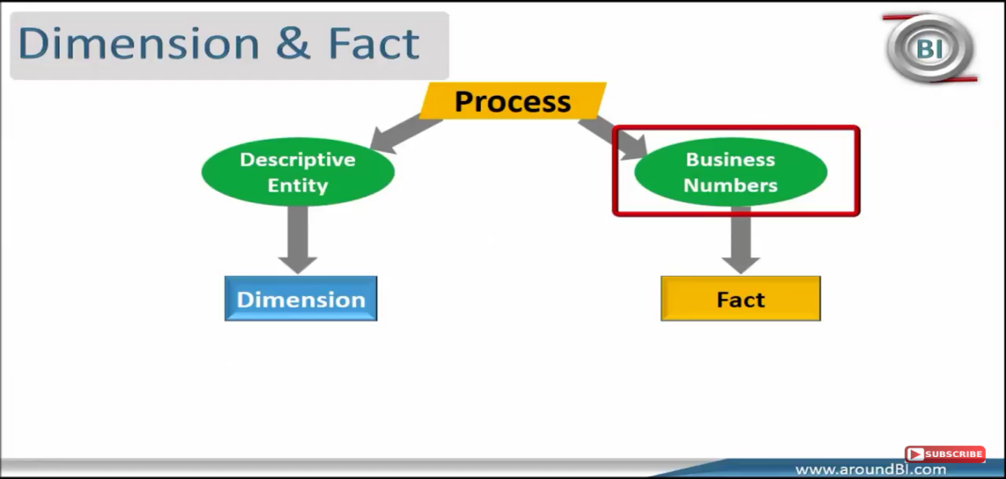

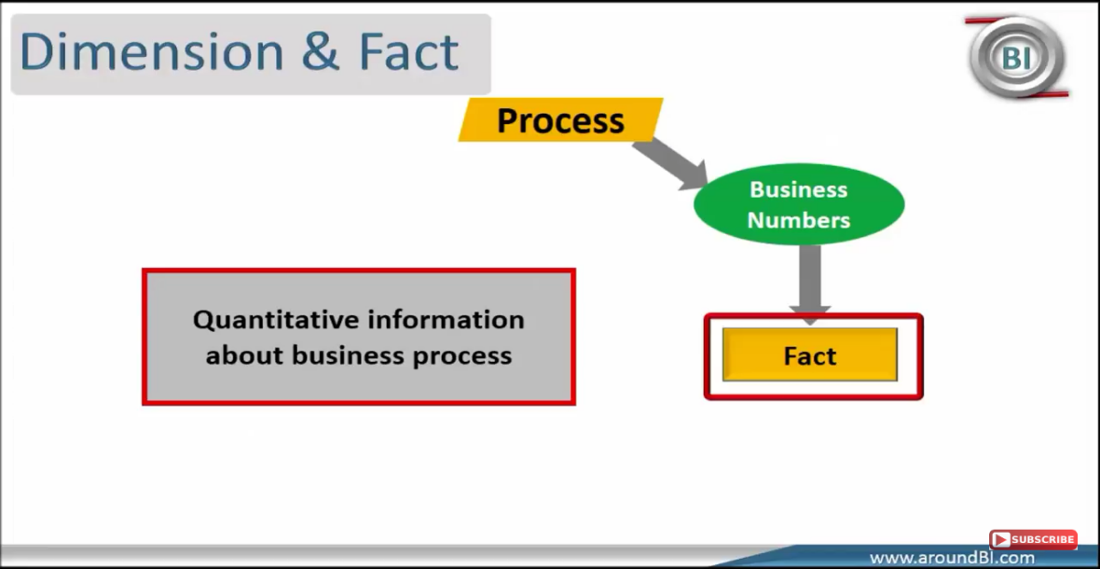

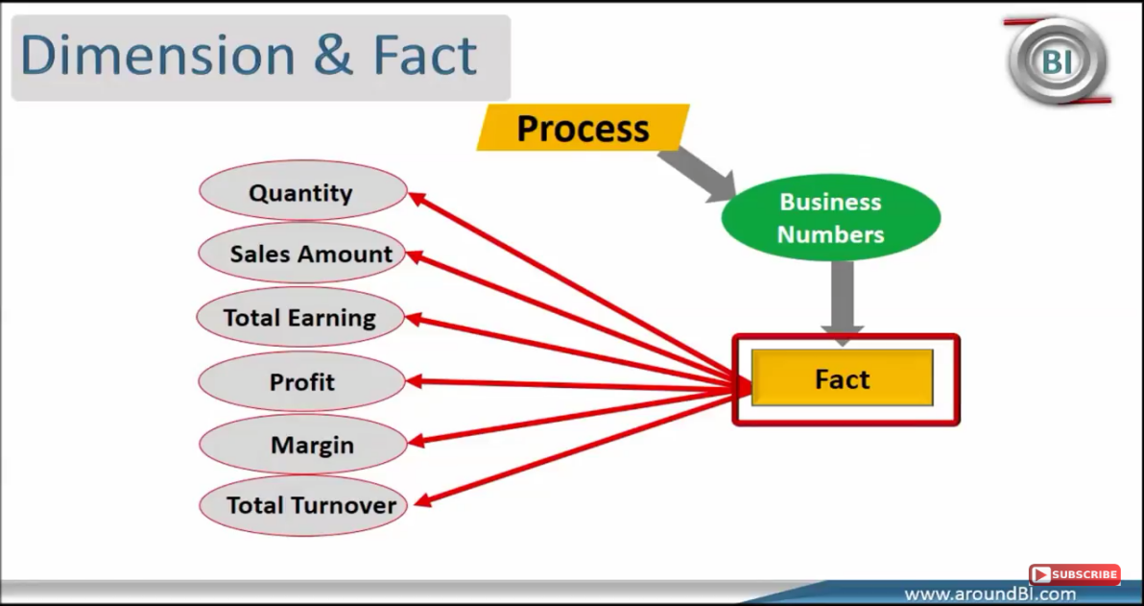

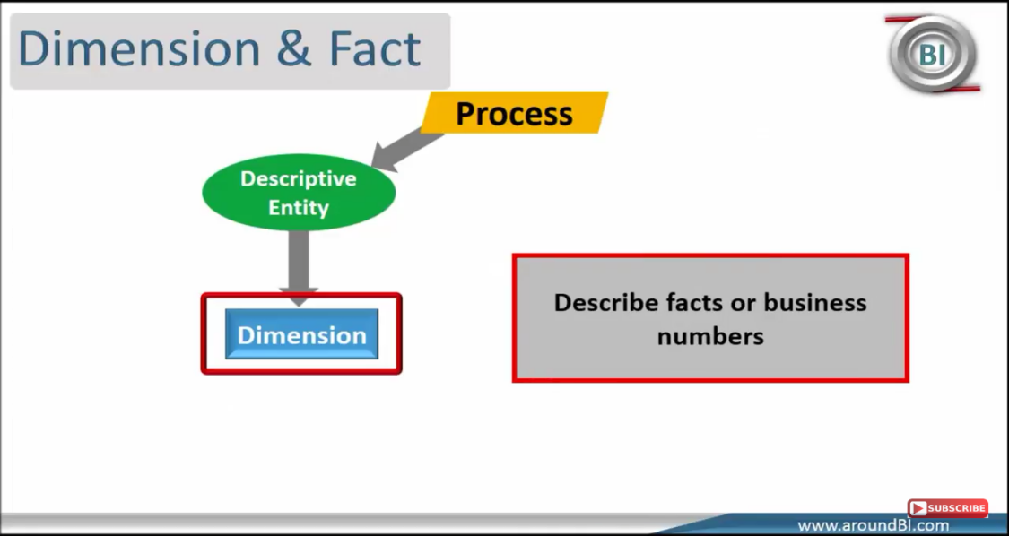

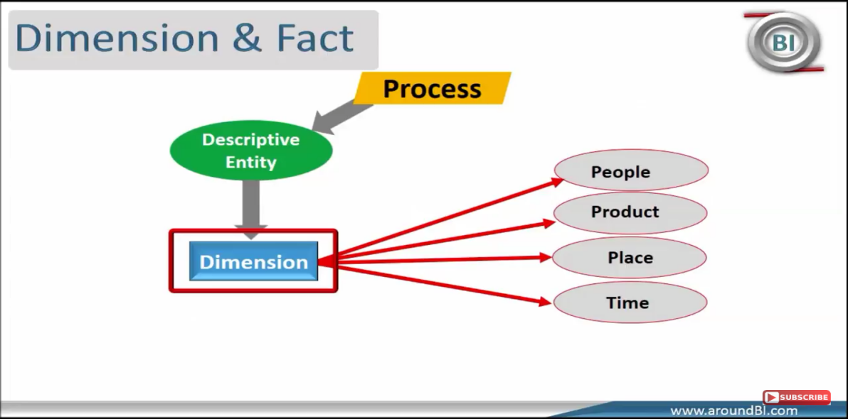

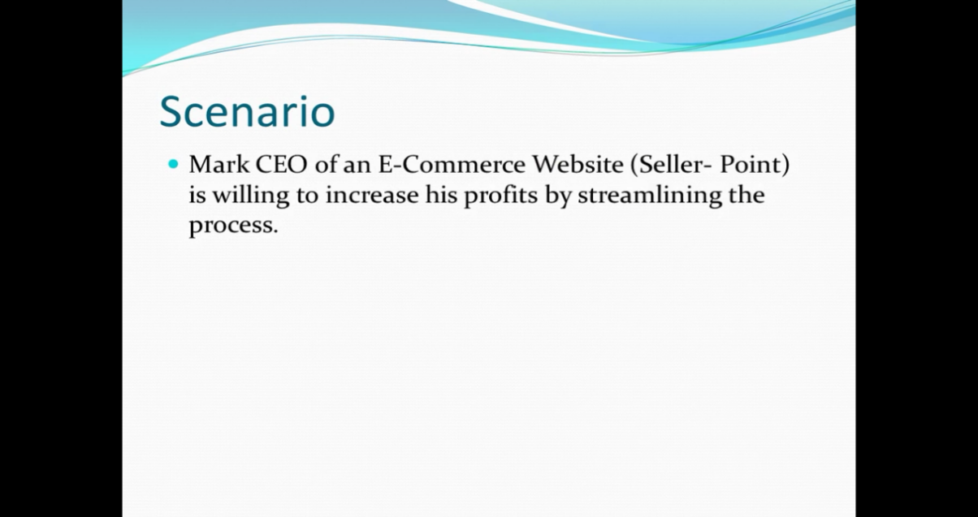

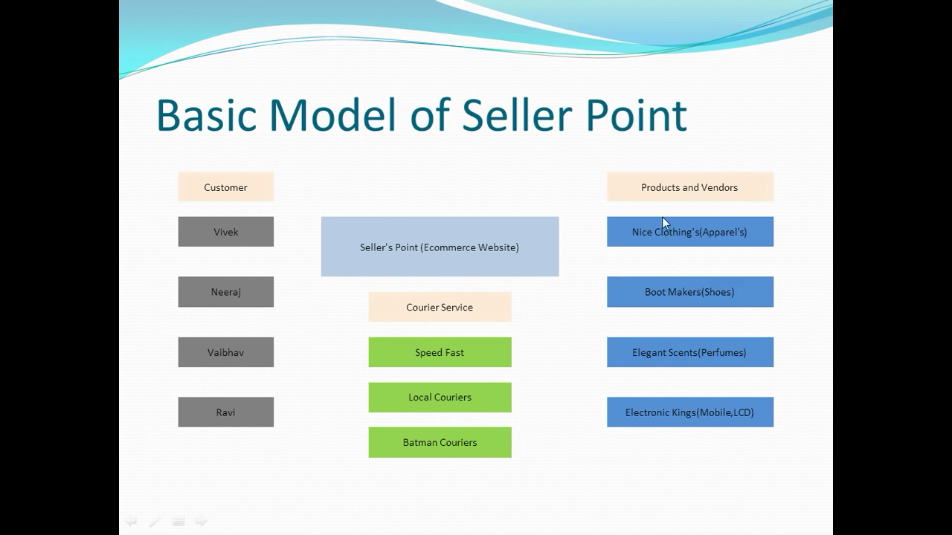

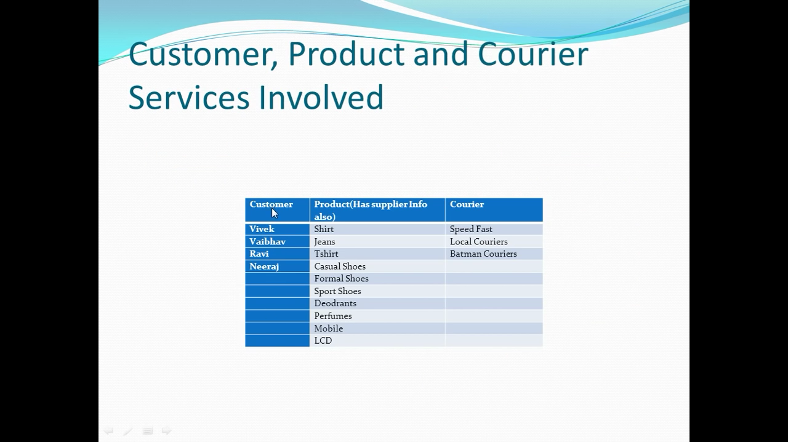

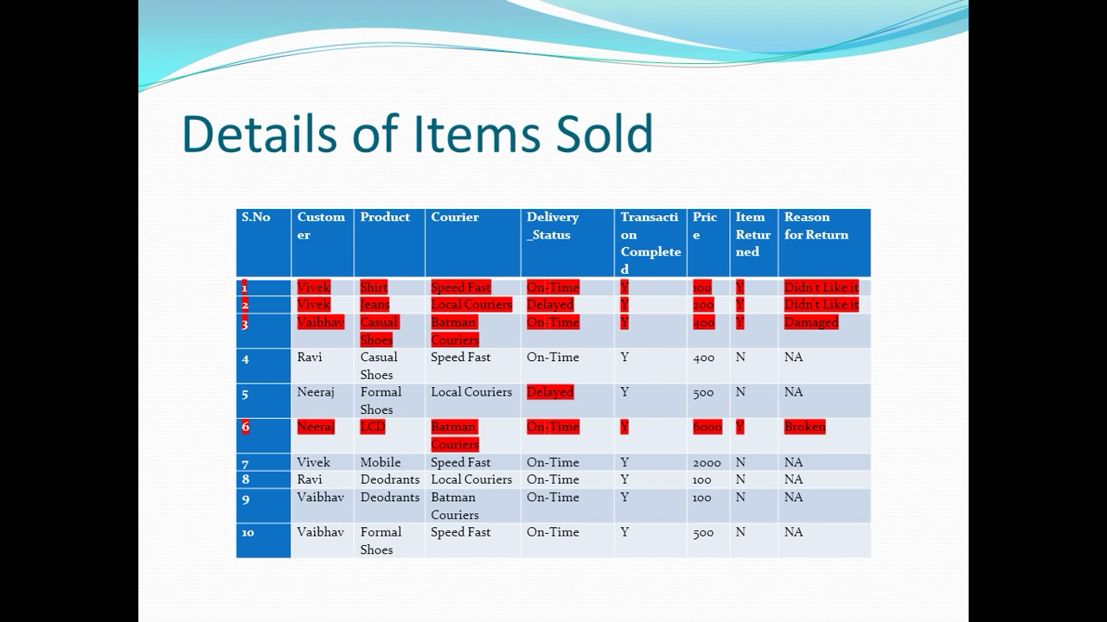

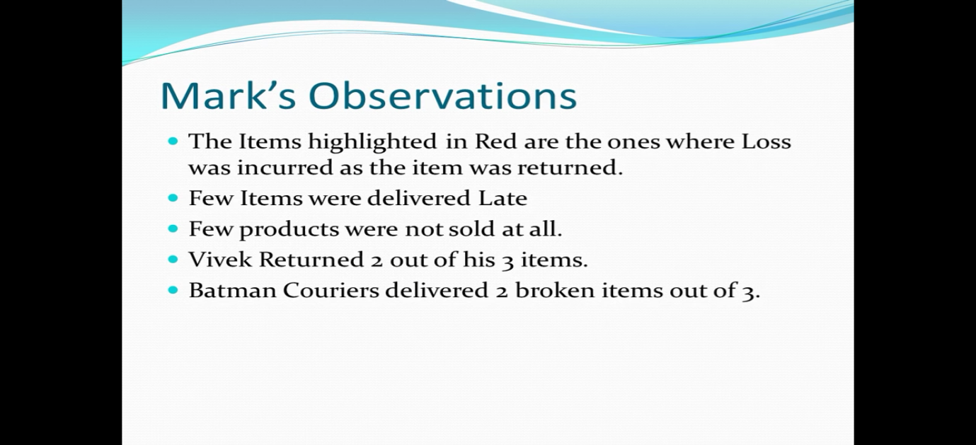

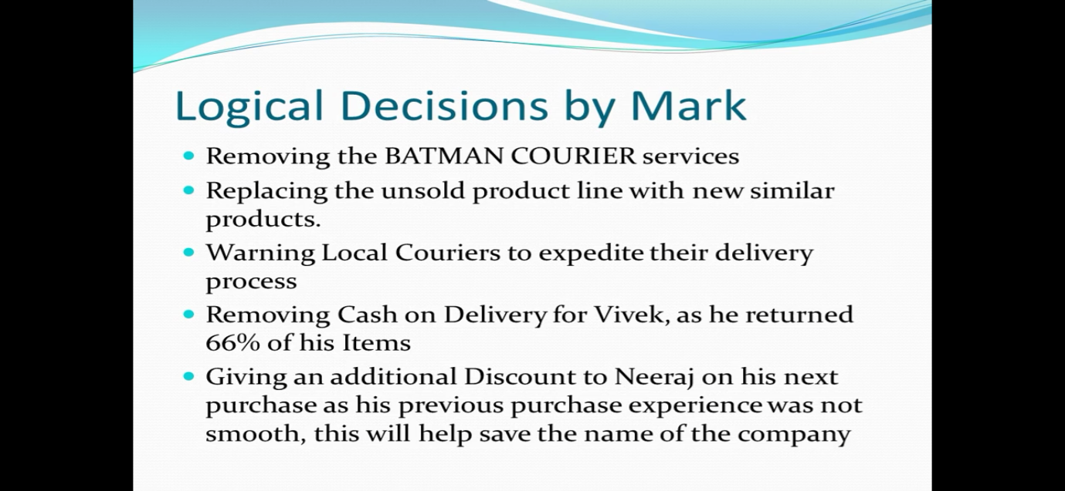

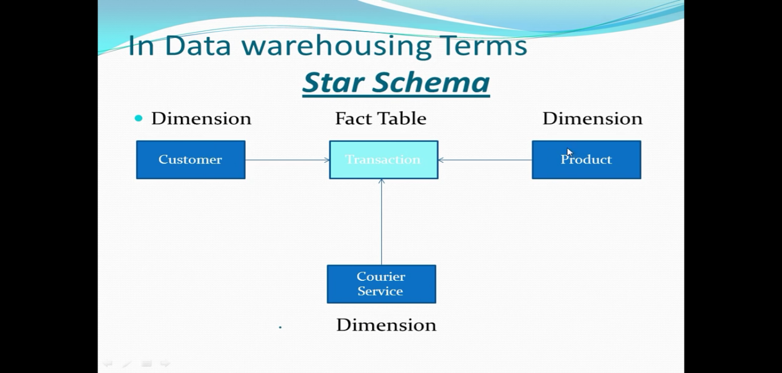

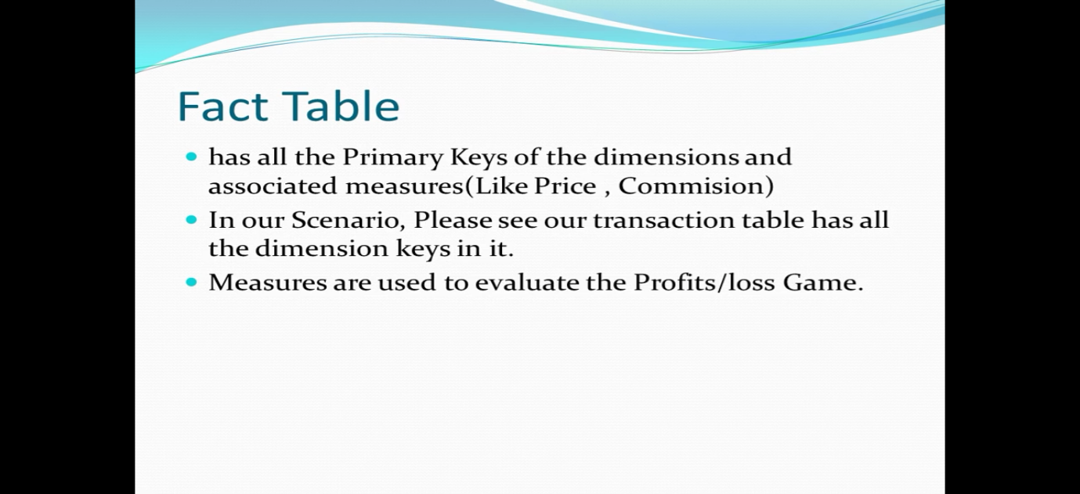

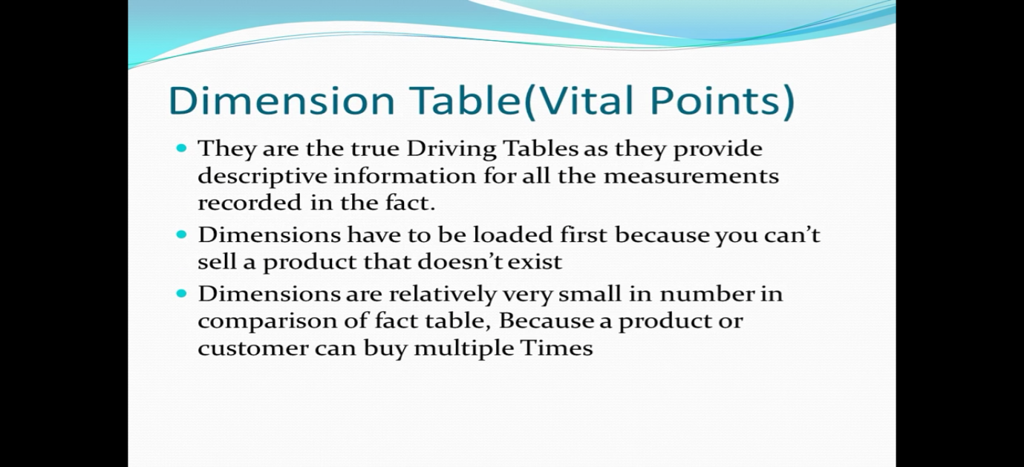

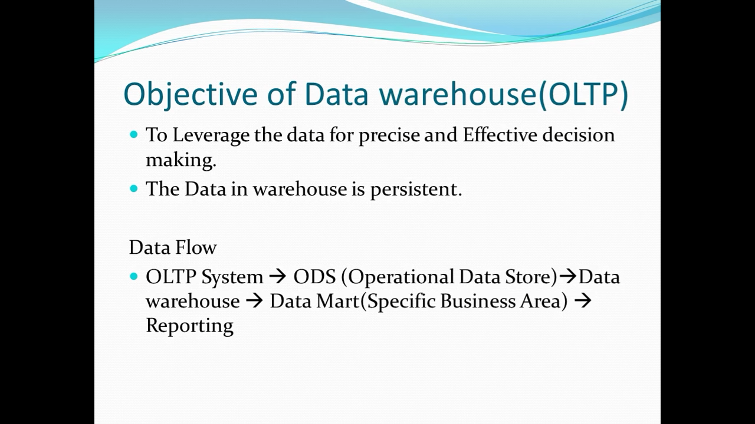

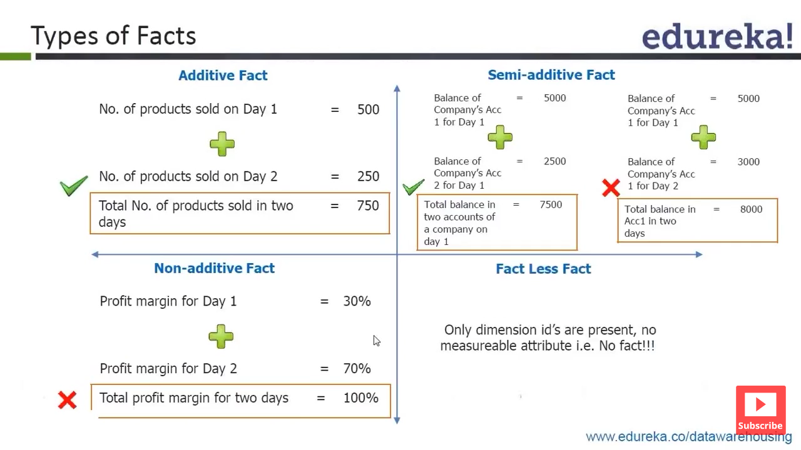

## **ETL**

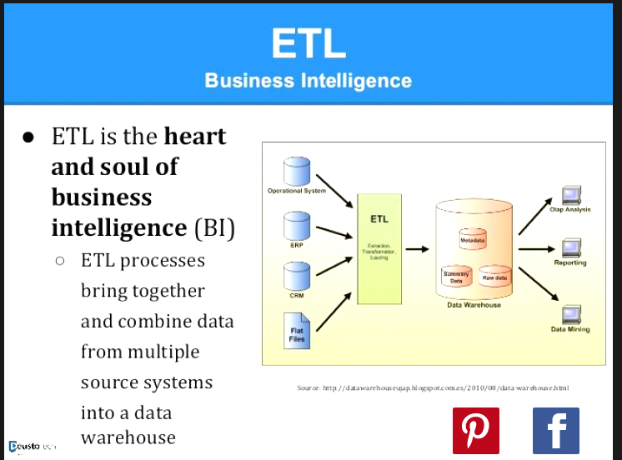

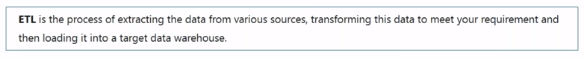

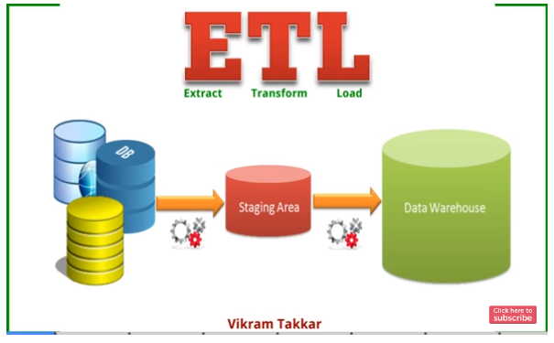

**Extraction-**Data extract from source system to staging area (it is raw data)

**Transform**-An important function of transformation is the cleaning of data, which aims to pass only "proper" data to the target.(major tasks are Data selection,matching,data cleansing, Consolidations)

**Load**-The load phase loads the data into the end target from staging area, which may be a simple delimited flat file or a [data warehouse](https://en.wikipedia.org/wiki/Data_warehouse).

ETL tools

1)Informatica 2)IBM storage 3)Clover ETL 4)SQL server 5)Talend 6) Abinitio

=======================================================

# **WebLogic(11g)**

Default Port-7001s

Oracle WebLogic Server is a Java EE **application server** currently developed by Oracle Corporation

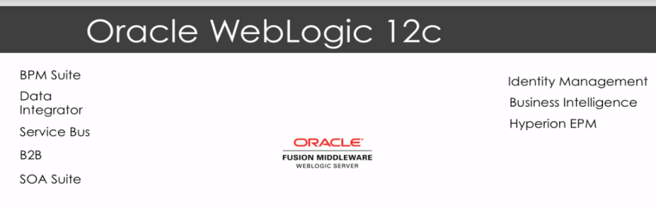

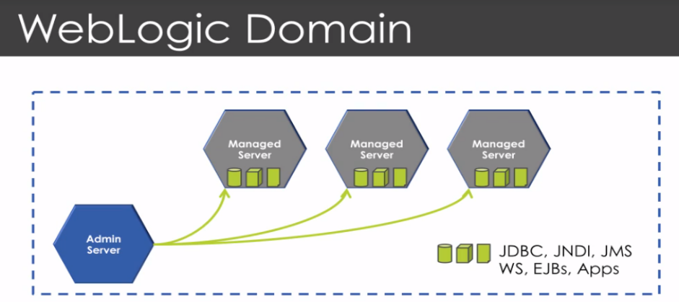

**Weblogic Domain**

Logically related group of WebLogic servers and resources. Default WebLogic contains only Admin server which is good for development activities

But in productions system you will create the managed servers

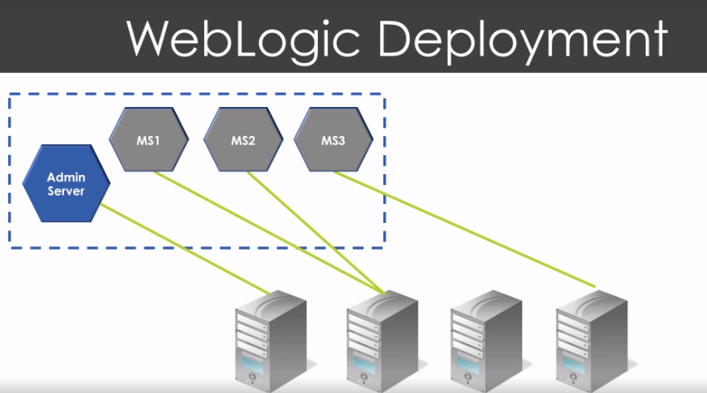

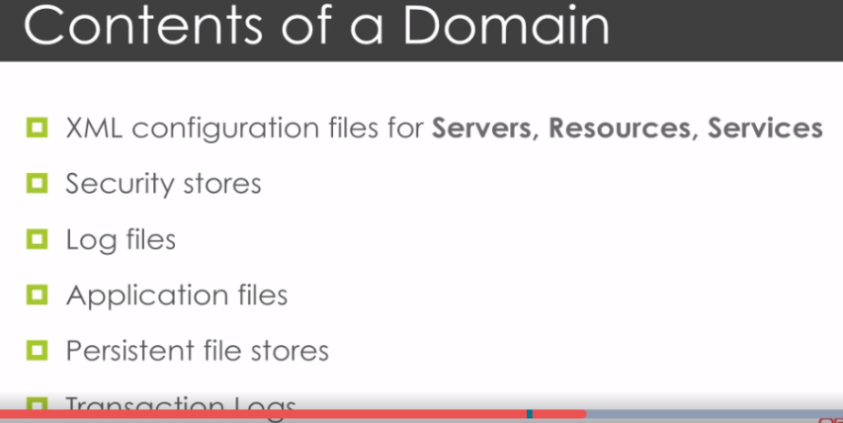

Creating the weblogic domain (run config.sh)

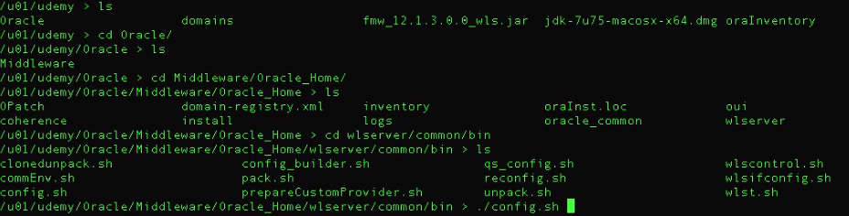

Then next screen will appear for creation of base_domain

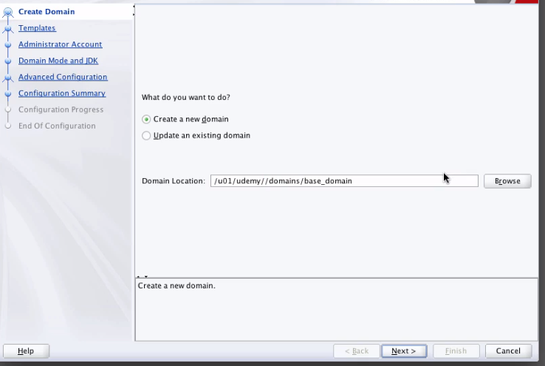

Once it is done you will see base_domain directory will be created and other directories will also get created

Config.xml file location

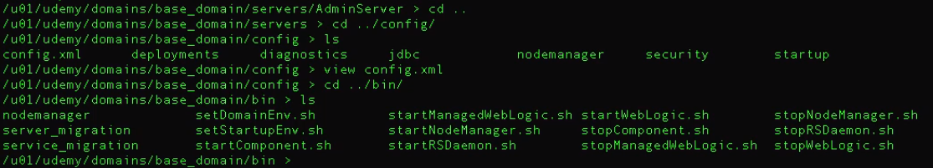

Log dir WebLogic

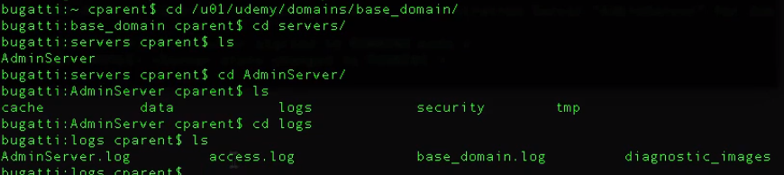

cd domain

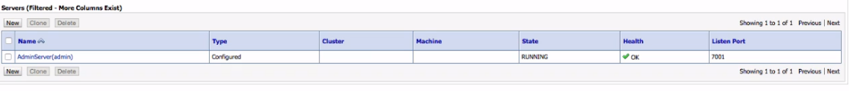

1. Starting of weblogic server

C:\bea\wlserver_10.3\samples\domains\wl_server

Path-http://10.21.3.54:7001/console

2)Xml file path that show the info about the jms..connection factorty,

C:\bea\wlserver_10.3\samples\domains\wl_server\config\jms\examples-jms.xml

3)foreign server has 3 tabs

1)general

2)connection factories

3)Destination

**Admin server**

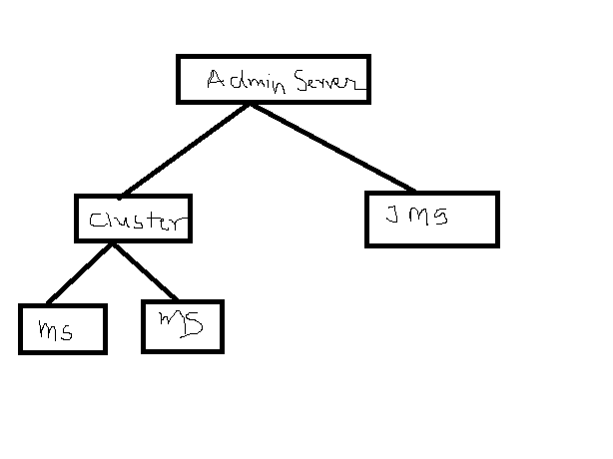

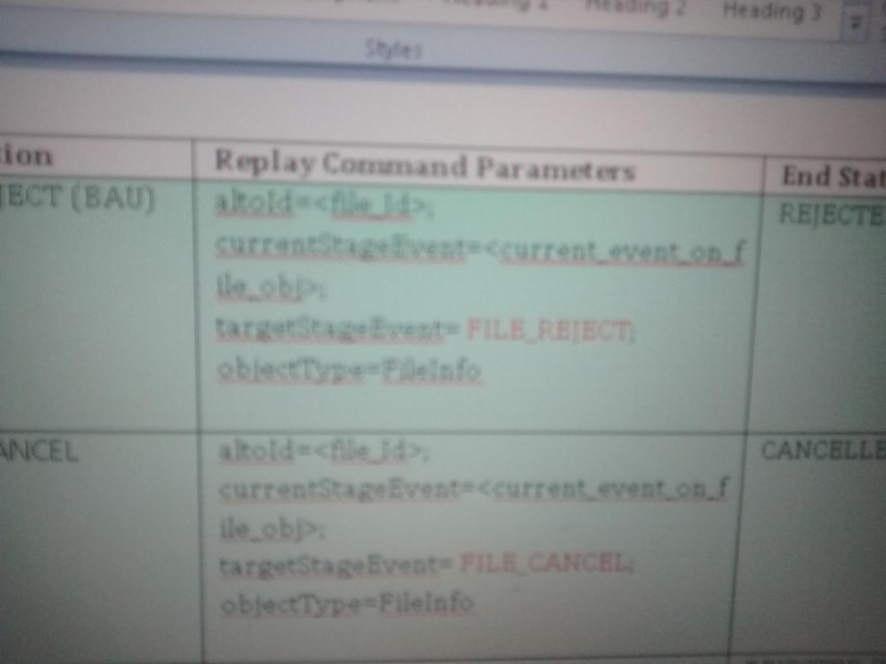

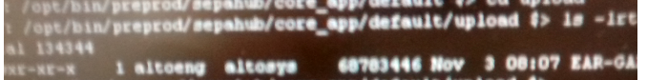



Path Set For Deployment

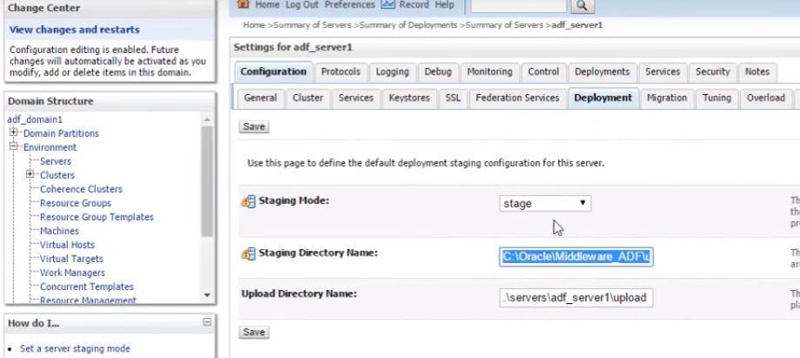

**How to Deploy the File**

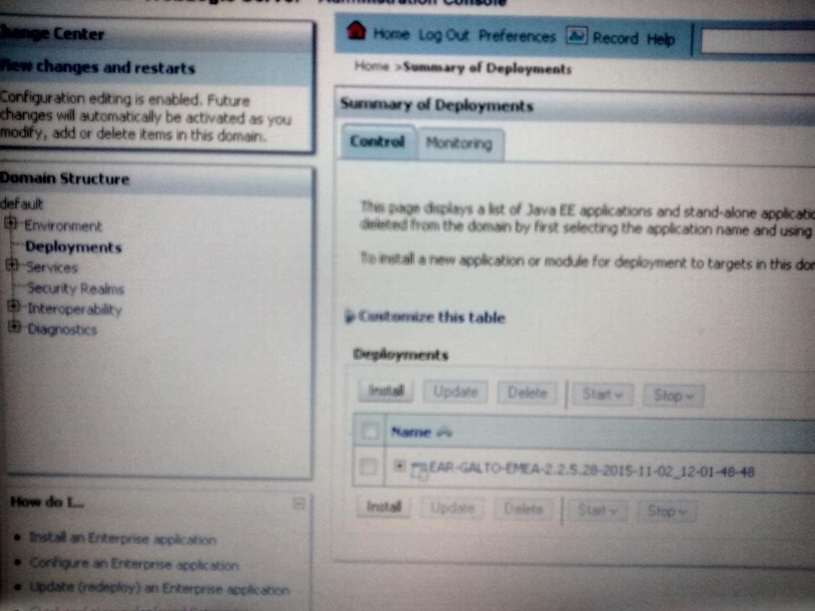

Start Stop

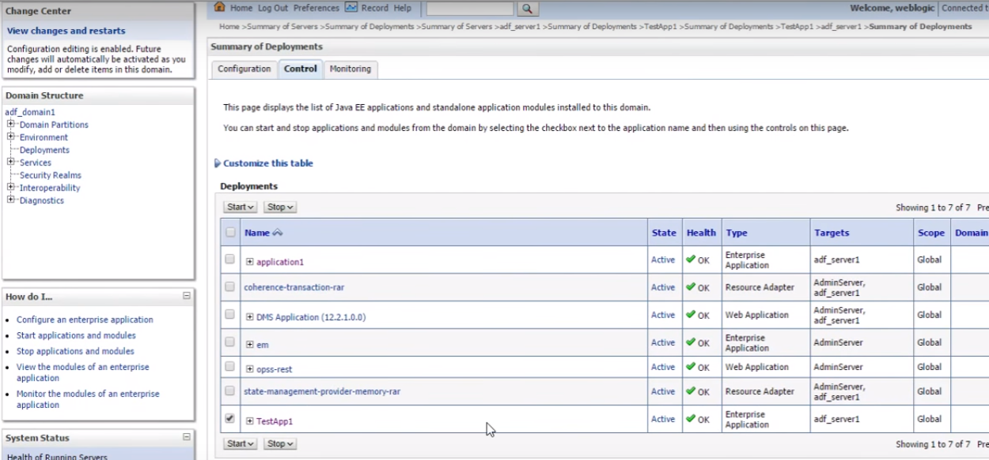

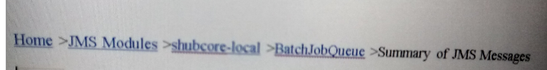

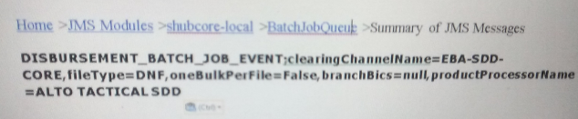

**Backup**

What is data backup

Why you should backup

What data should you backup

Types of Backup

1. Full backup
2. Incremental (first you take the full backup then after whatever the changes happen after that only data will be backup)
3. Differential (first you take the full backup then after differential backup will be taken)

--What is archive bit

When you create the new file then in properties(general🡪advanced) (file is ready for archiving is tick means backup is not yet taken)

Netbackup

3 tier architecture

You can take backup on disk ,cloud

**===================================================**

**TCP DUMP(Wireshark)**

If it is not much more information in the logs, then for debugging purpose we use tcpdump

TCPdump is a utility used to capture and analyse packets on network interfaces.

You can say this utilty is used to monitor the network

For packet capturing.TCPdump utilizes the licap library

1. tcpdump -h --Check version)
2. tcpdump -i eth0 -- Capture Packets from Specific Interface
3. tcpdump -c 5 -I eth0 ---Capture only N Number of Packets
4. tcpdump -A –i eth0 ---Print Captured packets in ASCII
5. tcpdump -D ----- Display available interfaces
6. tcpdump -XX -i eth0 ---Display captured packets in HEX and ASCII
7. tcpdump -w filedata.pacp -i eth0 ---Capture and save packets in a File
8. tcpdump -r filedata.pacp ---Read captured packets file
9. tcpdump -n -I eth0 --Capure IP address packets
10. tcpdump -i eth0 tcp --Capture only TCP packets
11. tcpdump -i eth0port 22 --capture packets from specific port
12. tcpdump -i eth0 src 192.168.0.2 --Capture packets from source ip
13. tcpdump -i eth0 desc 50.116.66.139 --Capture packets from dest IP
14. tcpdump -nn ---to monitor the live monitoring
15. tcpdump -ni wlan0 (n-do not convert ip to there hostname i-for interface wlan0-interface )
16. tcpdump -ni wlan0 **icmp** it will give result gfor ping command
17. tcpdump -ni wlan0 **port 22** it will give result ssh for ping command
18. tcpdump -ni wlan0 **port not 22** (incoming and outgoing conncetion except port 22)
19. tcpdump -ni wlan0 **port not 22 and port 80** (You will see packets of port 80n not port 22)
20. sudo tcpdump -i any (packets on all interfaces)
21. sudo tcpdump -i any -w icmp.pcap icmp (writing in the file icmp.pcap)
22. sudo tcpdump -i any -c 5 (stop the tcp after capturing few packets on all interfaces)

**how to read pcap files**

file filedata.pacp

tcpdump -r filedata.pcap

tcpdump -ttttr filedata.pcap (in readable format to understand the time)

==================================================

**PLSQL**

1. **What is PL SQL ?**

PL SQL is a procedural language which has interactive SQL, as well as procedural programming language constructs like conditional branching and iteration.

1. **Differentiate between % ROWTYPE and TYPE RECORD.**

**% ROWTYPE** is used when a query returns an entire row of a table or view.

**TYPE RECORD,** on the other hand, is used when a query returns column of different tables or views.

1. **Explain uses of cursor.**

Cursor is a named private area in SQL from which information can be accessed. They are required to process each row individually for queries which return multiple rows.

**if there is ever a need to process the rows, on a row-by-row basis**, then cursors are

your choice. Performance of the cursor is not good as join

1. **Explain the uses of database trigger.**

A PL/SQL program unit associated with a particular database table is called a database trigger. It is used for :

1)Audit data modifications.

2)Log events transparently.

3)Enforce complex business rules.

4)Maintain replica tables

5)Derive column values

6)Implement Complex security authorizations

1. **What are the two types of exceptions.**

Error handling part of PL/SQL block is called Exception. They have two types : user_defined and predefined.

1. **Show some predefined exceptions.**

DUP_VAL_ON_INDEX

ZERO_DIVIDE

NO_DATA_FOUND

TOO_MANY_ROWS

CURSOR_ALREADY_OPEN

INVALID_NUMBER

INVALID_CURSOR

PROGRAM_ERROR

TIMEOUT _ON_RESOURCE

STORAGE_ERROR

LOGON_DENIED

VALUE_ERROR

etc.

**9.Show how functions and procedures are called in a PL SQL block.**

Function is called as a part of an expression.

total:=calculate_sal(‘b644’)

Procedure is called  as a statement in PL/SQL.

calculate_bonus(‘b644’);

1. **Explain Commit, Rollback and Savepoint.**

For a COMMIT statement, the following is true:

* Other users can see the data changes made by the transaction.
* The locks acquired by the transaction are released.
* The work done by the transaction becomes permanent.

A ROLLBACK statement gets issued when the transaction ends, and the following is true.

* The work done in a transition is undone as if it was never issued.
* All locks acquired by transaction are released.

It undoes all the work done by the user in a transaction. With SAVEPOINT, only part of transaction can be undone.

1. **Define Implicit and Explicit Cursors.**

A cursor is implicit by default. The user cannot control or process the information in this cursor.

If a query returns multiple rows of data, the program defines an explicit cursor. This allows the application to process each row sequentially as the cursor returns it.

1. **Explain mutating table error.**

It occurs when a trigger tries to update a row that it is currently using. It is fixed by using views or temporary tables, so database selects one and updates the other.

1. **When is a declare statement required?**

DECLARE statement is used by PL SQL anonymous blocks such as with stand alone, non-stored procedures. If it is used, it must come first in a stand alone file.

1. **How many triggers can be applied to a table?**

A maximum of 12 triggers can be applied to one table.

1. **What is the importance of SQLCODE and SQLERRM?**

SQLCODE returns the value of the number of error for the last encountered error whereas SQLERRM returns the message for the last error.

1. **If a cursor is open, how can we find in a PL SQL Block?**

the %ISOPEN cursor status variable can be used.

1. **Show the two PL/SQL cursor exceptions.**

Cursor_Already_Open

Invaid_cursor

**Q. What is SQL and also describe types of SQL statements?**

SQL stands for Structured Query Language. SQL is a language used to communicate with the server to access, manipulate and control data.

There are 5 different types of SQL statements.

1) Data Retrieval: SELECT

2) Data Manipulation Language (DML): INSERT, UPDATE, DELETE, MERGE

3) Data Definition Language (DDL): CREATE, ALTER, DROP, RENAME, TRUNCATE.

4) Transaction Control Statements: COMMIT, ROLLBACK, SAVEPOINT

5) Data Control Language (DCL): GRANT, REVOKE

**Q. What is an alias in SQL statements?**

Alias is a user-defined alternative name given to the column or table. By default column alias headings appear in upper case. Enclose the alias in a double quotation marks (“ “) to make it case sensitive. “**AS**” Keyword before the alias name makes the SELECT clause easier to read.

For ex: Select empname AS name from employee; (Here AS is a keyword and “name” is an alias).

**Q. What is a Literal? Give an example where it can be used?**

A Literal is a string that can contain a character, a number, or a date that is included in the SELECT list and that is not a column name or a column alias. Date and character literals must be enclosed within single quotation marks (‘ ‘), number literals need not.

For ex: Select last_name||’is a’||job_id As “emp details” from employee; (Here “is a” is a literal).

**Q. What are SQL functions? Describe in brief different types of SQL functions?**  
SQL Functions are very powerful feature of SQL. SQL functions can take arguments but always return some value.  
There are two distinct types of SQL functions:

**1) Single-Row functions:** These functions operate on a single row to give one result per row.

Types of Single-Row functions:

1) Character

2) Number

3) Date

4) Conversion

5) General

**2) Multiple-Row functions:** These functions operate on groups of rows to give one result per group of rows.

Types of Multiple-Row functions:

1) AVG

2) COUNT

3) MAX

4) MIN

5) SUM

6) STDDEV

7) VARIANCE

**Q. Explain character, number and date function in detail?**

**Character functions:**accept character input and return both character and number values. Types of character function are:

a) Case-Manipulation Functions: LOWER, UPPER, INITCAP

b) Character-Manipulation Functions: CONCAT, SUBSTR, LENGTH, INSTR, LPAD/RPAD, TRIM, REPLACE

**Number Functions:**accept Numeric input and return numeric values. Number Functions are: ROUND, TRUNC and MOD

**Date Functions:**operates on values of the Date data type. (All date functions return a value of DATE data type except the MONTHS_BETWEEN Function, which returns a number. Date Functions are MONTHS_BETWEEN, ADD_MONTHS, NEXT_DAY, LAST_DAY, ROUND, TRUNC.

**Q. Explain Conversion function in detail?**

Conversion Functions converts a value from one data type to another. Conversion functions are of two types:

Implicit Data type conversion:

1) VARCHAR2 or CHAR To NUMBER, DATE

2) NUMBER To VARCHAR2

3) DATE To VARCHAR2

Explicit data type conversion:

1)  TO_NUMBER

2)  TO_CHAR

3)  TO_DATE

**TO_NUMBER** function is used to convert Character string to Number format. TO_NUMBER function use fx modifier. Format: TO_NUMBER ( char[, ‘ format_model’] ). fx modifier specifies the exact matching for the character argument and number format model of TO_NUMBER function.

**TO_CHAR** function is used to convert NUMBER or DATE data type to CHARACTER format. TO_CHAR Function use fm element to remove padded blanks or suppress leading zeros. TO_CHAR Function formats:TO_CHAR (date, ‘format_model’).Format model must be enclosed in single quotation marks and is case sensitive.

For ex: Select TO_CHAR (hiredate, ‘MM/YY’) from employee.

**TO_DATE** function is used to convert Character string to date format. TO_DATE function use fx modifier which specifies the exact matching for the character argument and date format model of TO_DATE function. TO_DATE function format: TO_DATE ( char[, ‘ format_model’] ).

For ex: Select TO_DATE (‘may 24 2007’,’mon dd rr’) from dual;

======================================================

**SQUID (Web Proxy Server)**

Squid is used to block the website i.e it works like proxy server. Run on 3128 port.

Install the squid on the linux machine

-**yum install squid or sudo apt-get install squid**

-set the machine ip in firefox (edit-prefernces-advnase and set manual proxy ip)

Configure squid to block some url so use below command and you can see acl(access control list)

It is the list of all the ports ,url or ip addresses are mentioned

**Sudo gedit /etc/squid/squid.conf**

On line 680 there is below line

**http_access deny all** (this line deny all the urls)

do

**http_access allow all** (will give access to all)

if you want to block specific sites then

acl blocked_websites dstdomian .facebook.com .twitter.com

**http_accsess deny blocked_websites**

then restart squid

**sudo service squid restart**

**===================================================**

**FTP (file transfer protocol)**

FTP uses a client-server architecture. Users provide authentication using a sign-in protocol, usually a username and password, however some FTP servers may be configured to accept [anonymous FTP](http://www.webopedia.com/TERM/A/anonymous_FTP.html) logins where you don't need to identify yourself before accessing files. Most often, FTP is secured with [SSL](http://www.webopedia.com/TERM/S/SSL.html)/[TLS](http://www.webopedia.com/TERM/T/TLS.html).

**How to FTP**

Files can be transferred between two computers using FTP software. The user's computer is called the local host machine and is connected to the Internet. The second machine, called the remote host, is also running FTP software and connected to the Internet.

* 1. Yum install vsftpd
  2. chkconfig vsftpd on
  3. service vsftpd start
  4. netstat -tulpn |grep 21 (tcp port)
  5. Test the ftp server access on browser.

<ftp://192.168.20.0>

* 1. To disable anonymous access

Vi vsftpd and disable the anonymous access

7)service vsftpd start

gedit vsftpd.conf

anonymous_enable=YES

Local_enable=YES

Write_Enable=YES

**====================================================**

**PostFix(Configure mail server)**

How to install and configure postfix to send mail by using gmail as mail relay

1. sudo apt-get install postfix
2. cd /etc/postfix
3. vi main.cf ..edit mynetwork and mydestination

home_mailbox=maildir/

1. service postfix restart
2. telnet localhost 25
3. netstat tulpn |grep 25

**===================================================**

**Splunk (Push Logs to Splunk)**

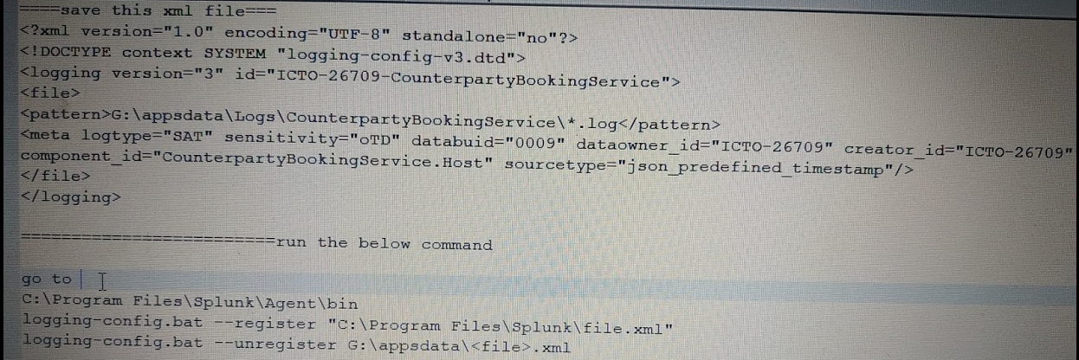

# **DATABASE(SQL)**



**1) What is SQL**

* SQL stands for **Structured Query Language**.
* It is designed for managing data in a relational database management system (RDBMS).
* SQL is a database language, it is used for database creation, deletion, fetching rows and modifying rows etc.

## **What is Schema**

Design of a database is called the schema. Schema is of three types: Physical schema, logical schema, and view schema.

**Type of Schema**

1) Physical schema

2) logical schema

3) View schema

**Create the schema in database**

CREATE USER smith IDENTIFIED BY password

GRANT CREATE TABLE TO smith;

## **What is Database**

A **database** is an organized collection of data.

The **main purpose** of database is to operate large amount of information by storing, retrieving and managing.

There are many **databases available** like MySQL, Sybase, Oracle, Mango DB, Informix, SQL Server etc.

**SQL** (Structured Query Language) is used to perform operations on the records stored in database such as updating records, deleting records, creating, and modifying tables, views etc.

SQL is just a query language; it is not a database. To perform SQL queries, you need to install any database for example Oracle, MySQL, MongoDB, SQL Server, etc.

**SQL management tool-** DBVisualizer

What is default schema created for the MySQL and oracle

Oracle- Sys

MySql- MyDB

**How to connect mysql from Linux**

mysql -u root -p

**What is the 11g in oracle and 12c in oracle**

**11g**-11g is Oracle's grid computing product group including (among other things) a database management system (DBMS) and an application server. In addition to supporting grid computing features such as resource sharing and automatic load balancing, 10g products automate many database management tasks

**12c** -Oracle 12c is a version of the Oracle Database. The "c" stands for "cloud" to indicate that 12c is "cloud enabled".

**what are the prerequisites to connect the oracle DB**

**If installed locally**

**Remotely**

To connect to an Oracle Database, a client application must identify the database and present appropriate credentials. The connection mechanism depends on the type of client and whether it is running locally or remotely. Some connections require the installation of Oracle Client software.

## **parameters you pass while connecting to DB**

There are several methods for specifying login credentials. For example, a client may present login credentials at the time of the connection, as shown below. The system will prompt for a password and establish a connection.

SQL>CONNECT *username* @ "*hostname*[:*port*][/*databasename*]"

sqlplus -s ${DBUSER}/${DBUSERPASSWORD}@//${HOST}:${PORT}/${SERVICE_NAME} <<EOF

mysql -h csmysql.cs.cf.ac.uk -u *username* -p *database*

Connection Name, username/password, hostname, port, SID

**2) What is DBMS/RDBMS?**

**DBMS** is special software program that helps users create maintain a database

* Makes it easy to manage large amount of info
* Handles security (Username/Password)
* Backups
* Import/export data

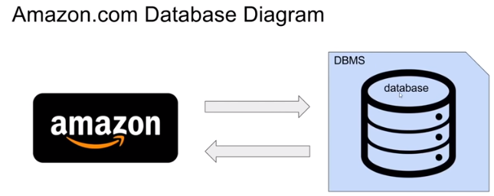

**RDBMS** stands for Relational Database Management System. RDBMS store the data into the collection of tables, which is related by common fields between the columns of the table.

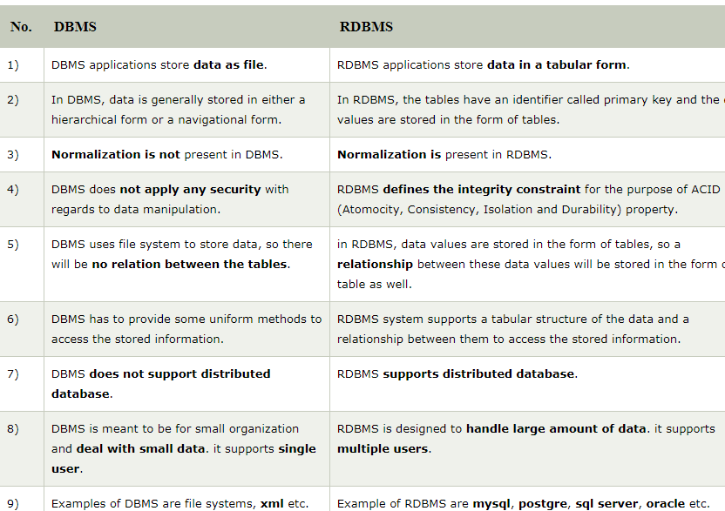

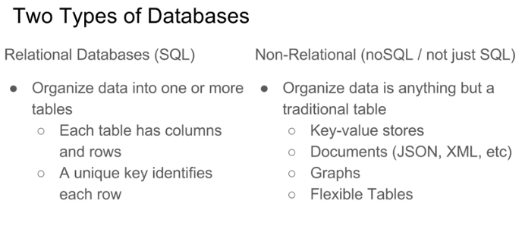

**3) Data Types**

It is property that specifies the type of data

Numeric, Date, Character, Unicode, Binary,Timestamp,BLOB,Decimal

**Constraints**

Not null, Unique, check constraint, index

Default- set default if there is null value

primary key, foreign key, check constraint

Add constraint to default value

Alter table (table_name) add constraint (constraint_name) default(default_value) for (column_name)

Unique values will be unique in the row after setting this data type

**Operator**

Arithmetic,

logical

And, or, like, not null, >, <, >=, <=

4) What is database Normaliation

## database Normaliation

Database normalization is the process of organizing data to minimize data redundancy (data duplication), which in turn ensures data consistency.

Problem of Data Redundancy

1. Disk Space Wastage
2. Data Inconsistency
3. DML queries can become slow

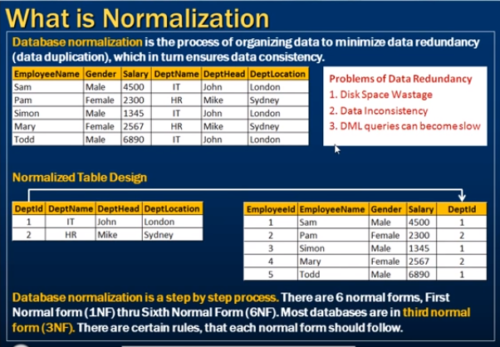

**What do you mean by data integrity?**

Data integrity defines accuracy of data, consistency of data stored in database,

## **SQL Commands**

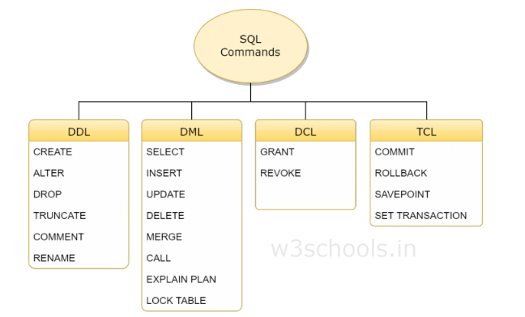

DDL-data Definition language (This statement doesn’t need commit)

DML-data Modification Language (This statement needs commit)

DCL-Data Control language

TCL-Transaction Control language

**5) What is a primary key?**

## primary key

**(**combination of not null and unique**)**

A [primary key](http://searchoracle.techtarget.com/tip/Seven-rules-for-well-behaved-primary-keys) is a column (or columns) in a table that uniquely identifies the rows in that table.

This is a special kind of unique key, and it has implicit NOT NULL constraint. It means, Primary key values cannot be NULL.

**6) Can a table have two primary keys**?

No. A table can have only one primary key.

However, that primary key can consist of two columns. For example, consider this table of DatabaseProducts:

One primary key consisting of one column; or

One composite primary key consisting of two or more columns.

create table DatabaseProducts

( Company varchar(20)

, Product varchar(20)

, Release varchar(10)

, constraint DatabaseProductPK

primary key (Company, Product)

)

**7) What is a foreign key?**

## foreign key

A FOREIGN KEY in one table points to a PRIMARY KEY in another table.

A foreign key is a column or group of columns in a relational database table that provides a link between data in two tables

A foreign key is a key used to link two tables together. This is sometimes called a referencing key.

**Definition**: Foreign keys are the columns of a table that points to the primary key of another table. They act as a cross-reference between tables.

Relationship needs to be created between two tables by referencing foreign key with the primary key of another table.

CREATE TABLE Orders  
(  
O_Id int NOT NULL PRIMARY KEY,  
OrderNo int NOT NULL,  
P_Id int FOREIGN KEY REFERENCES Persons(P_Id)  
)

## **Primary Key and Foreign Key difference**

|  |  |  |
| --- | --- | --- |
| **Item** | **Primary Key** | **Foreign Key** |
|  | Primary Key uniquely identify a record in the table | Foreign Key is a field in the table that is primary key in another table |
| Null Values | Primary key cannot accept null values | foreign key can accept multiple null values |
| Number of times | We can have only one primary key in a table | We can have more than one foreign key in a table |
| Duplicate value | Duplicate values are not allowed | Duplicate values are allowed |
| Indexed | Automatically indexed | No index automatically created |
| Consists of one or more column | Yes | Yes |

**8) what is unique key and what is the difference between unique key and the primary key**

A **unique key** is a set of one or more than one fields/columns of a table that uniquely identify a record in a database table. ... The **unique key** and primary **key** both provide a guarantee for uniqueness for a column or a set of columns. There is an automatically defined **unique key** constraint within a primary **key** constraint.

However, you can have many UNIQUE constraints per table, but only one PRIMARY KEY constraint per table.

**Primary Key:**

* There can only be one primary key in a table
* In some DBMS it cannot be NULL - e.g. MySQL adds NOT NULL
* Primary Key is a unique key identifier of the record

**Unique Key:**

* Can be more than one unique key in one table
* Unique key can have NULL values
* It can be a candidate key
* Unique key can be NULL and may not be unique

**Command**-Alter table “table_name” add constraint “constaint_name” unique (“column_name”)

If you enter the duplicate record, then you will get an error

“Violation of UNIQUE KEY constraint, cannot insert duplicate key

Alter table “table_name” drop constraint “constaint_name”

**9) Can I delete all the record using delete command**

Yes, we can without where clause

**10) what is Index and why it is created, how it is created**

## **Index**

An index is used to speed up searching in the database

The INDEX is used to create and retrieve data from the database very quickly. An Index can be created by using a single or group of columns in a table. When the index is created, it is assigned a ROWID for each row before it sorts out the data. Proper indexes are good for performance in large databases, An index helps to speed up **SELECT** queries and **WHERE** clauses, but it slows down data input, with the **UPDATE** and the **INSERT** statements. Indexes can be created or dropped with no effect on the data.

Indexes can also be unique, like the **UNIQUE** constraint, in that the index prevents duplicate entries in the column or combination of columns on which there is an index. you can create index on single column or on the multiple columns

* Indexes should not be used on small tables.
* Tables that have frequent, large batch updates or insert operations.
* Indexes should not be used on columns that contain a high number of NULL values.
* Columns that are frequently manipulated should not be indexed.

CREATE INDEX index_name

on table_name (column1, column2);

**identify the index**

SELECT *

FROM sys.indexes

**Difference between Clustered and NonClustered Index:**  
1. **Only one clustered index per table**, whereas you can have more than one non clustered index (Cluster index automatically created while creating table having primary key)  
2. **Clustered index is faster than a non clustered index**, because, the non-clustered index has to refer back to the table, if the selected column is not present in the index.  
3. **Clustered index determines the order of rows in the table**, and hence doesn't require additional disk space, but where as a Non Clustered index is stored seperately from the table, additional storage space is required.

**11) How to Find and Delete Duplicate Rows with SQL**

## Delete Duplicate Rows and group by

**First Method -**

Best URL- <https://www.oracletutorial.com/advanced-oracle-sql/find-duplicate-records-oracle/>

1. select * from fruits;

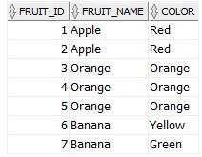



SELECT fruit_name,color,COUNT(*)

FROM fruits

GROUP BY fruit_name,color

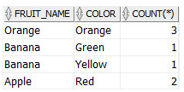



SELECT fruit_name,color,COUNT(*)

FROM fruits

GROUP BY fruit_name,color

HAVING COUNT(*) > 1;

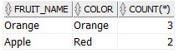



SELECT * FROM fruits

WHERE (fruit_name, color) IN

(SELECT fruit_name,color

FROM fruits

GROUP BY fruit_name, color

HAVING COUNT(*) > 1

)

ORDER BY fruit_name, color;

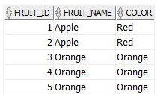

## **Second Method (Finding duplicate records using analytic function**

SELECT f.*,

COUNT(*) OVER (PARTITION BY fruit_name, color) c

FROM fruits f

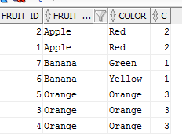

WITH fruit_counts AS (

SELECT f.*,

COUNT(*) OVER (PARTITION BY fruit_name, color) c

FROM fruits f

)

SELECT * FROM fruit_counts

WHERE c > 1 ;

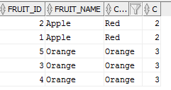

**Third Method**

SELECT *

FROM TABLE A

WHERE EXISTS (

SELECT 1 FROM TABLE

WHERE COLUMN_NAME = A.COLUMN_NAME

AND ROWID < A.ROWID

)

**==================================================**

**One Duplicate is found how to delete it,**

select * from fruits;

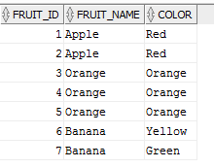



select min(FRUIT_ID)

from fruits

group by fruit_name, color;

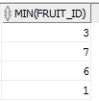



delete fruits

where FRUIT_ID not in

(

select min(FRUIT_ID)

from fruits

group by fruit_name, color

)

;

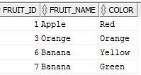

## **Aggregate functions**

1. Count()  
2. Sum()  
3. avg()  
4. Min()  
5. Max()

**You can use multiple aggregate functions with the group by clause**

Select City, Gender, SUM(Salary) as TotalSalary, COUNT(ID) as TotalEmployees  
from tblEmployee  
group by City, Gender

You cannot use where clause for the aggregate function

e.g. select * from employee where sum(salary) > 400s

you can use it with the having

having sum(salary) >400

**12) What is a join?**

## **Joins**

This is a keyword used to query data from more tables based on the relationship between the fields of the tables. Keys play a major role when JOINs are used.

Types of join

* 1. Cross join
  2. Inner join
  3. Outer join-Left,Right and Full Outer
  4. self
* (INNER) JOIN: Select records that have matching values in both tables.
* LEFT (OUTER) JOIN: Select records from the first (left-most) table with matching right table records.
* RIGHT (OUTER) JOIN: Select records from the second (right-most) table with matching left table records.
* FULL (OUTER) JOIN: Selects all records that match either left or right table records.

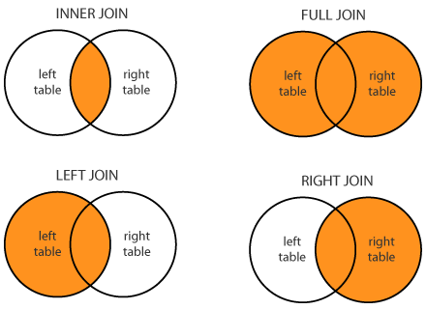

**Syntax**

Select columnlist

From leftTable

JoinType RightTable

On JoinCondition

**Select * from regions_coy;**

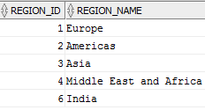

**select * from countries_copy;**

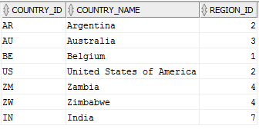

**Inner join.**

Inner join return rows when there is at least one match of rows between the tables.

select region_name,country_name

from regions_coy

inner join countries_copy

on regions_coy.REGION_ID=countries_copy.REGION_ID;

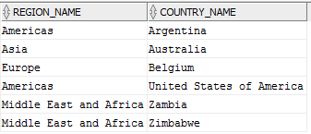

**Right Join (Right Outer).**

Right join return rows which are common between the tables and all rows of Right hand side table. Simply, it returns all the rows from the right hand side table even though there are no matches in the left hand side table.

select region_name,country_name

from regions_coy

right join countries_copy

on regions_coy.REGION_ID=countries_copy.REGION_ID;

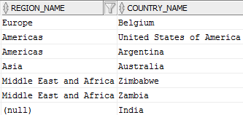

**Left Join (Left Outer).**

Left join return rows which are common between the tables and all rows of Left hand side table. Simply, it returns all the rows from Left hand side table even though there are no matches in the Right hand side table.

select region_name,country_name

from regions_coy

left join countries_copy

on regions_coy.REGION_ID=countries_copy.REGION_ID;

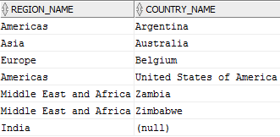

**Full Join.**

Full join return rows when there are matching rows in any one of the tables. This means, it returns all the rows from the left hand side table and all the rows from the right hand side table.

select region_name,country_name

from regions_coy

full join countries_copy

on regions_coy.REGION_ID=countries_copy.REGION_ID;

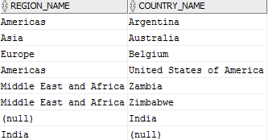

**Cross join (Cartesian Join)**

There is no On condition (Clause) in the cross join. The output is the multiplication

e.g if there are 5 rows in left table and 4 rows in right table then output of the cross join will be 40 records.

select region_name,country_name

from regions_coy

cross join countries_copy;

the above query will return 35 records

**Another Difficult Example**

In below example id is primary In one table and personid is foreign key in two table.

What will the output of inner,left,right and cross join.

All the queries will return count 15.

“on a.CUSTOMER_ID=b.ordernumber”;

**select * from one;**

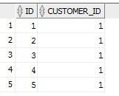

**select * from two;**

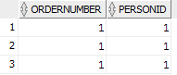

The Output will be same for all joins as below

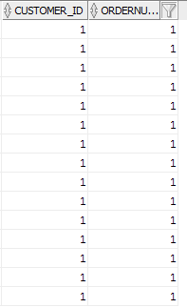

**How to get nonmatching rows from left table/How to get non matching rows from right table/How to get non matching rows from left table**

This is very simple, Write the query for the particular join (inner,left,right) and at the end of query put the condition as where condition is NULL

e.g. “Where id is NULL”

**Self-Join (joining table with itself, We are treating single table as two tables)**

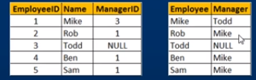

Consider the above example 1 st table is input and second table is output

Mikes managerid is 3 which is Todd’s id, so we are referencing same table

How to get the output using self join

**Left Self Join tblEmployee table**

Select E.Name as Employee, M.Name as Manager  
from tblEmployee E  
Left Join tblEmployee M  
On E.ManagerId = M.EmployeeId

**Inner Self Join tblEmployee table:**  
Select E.Name as Employee, M.Name as Manager  
from tblEmployee E  
Inner Join tblEmployee M  
On E.ManagerId = M.EmployeeId  
  
**Cross Self Join tblEmployee table:**  
Select E.Name as Employee, M.Name as Manager  
from tblEmployee  
Cross Join tblEmployee

## **join and union difference**

**Union-**In Union number of columns should be equal in both combining table using union clause and data type should be same

Both joins and unions can be used to combine data from one or more tables into a single result. ... Whereas a join is used to combine columns from different tables, the union is used to combine rows.

## **Union All and union difference**

Union All combine all the records from two tables including the duplicate while union removes the duplicates. For Union All, it requires equal number of columns in both tables and have same datatype and also has to be in same order

## **Interview Questions on Sql queries**

**Employee Table**

|  |  |  |  |  |  |  |
| --- | --- | --- | --- | --- | --- | --- |
| Employee_id | first_name | last_name | gender | position | department_id | Salary |
| 1 | A | P | M | aaa | 1 | 131321 |
| 2 | B | Q | F | sss | 2 | 131 |
| 3 | C | R | M | ccc | 1 | 4245 |
| 4 | D | S | F | eee | 2 | 5522 |

**Department Table**

|  |  |
| --- | --- |
| department_id | Department_name |
| 1 | IT |
| 2 | Sales |

1. return employee records with highest salary

select *

from employee

where salary=(select max(salary) from employee)

1. return the highest salary in employee table

select max(salary) from employee

1. Select the 2nd highest salary from employee table

Select max(salary)

from employee

where salary not in (select max(salary) from employee)

1. Find nth highest salary

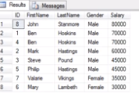

Select top 1 salary from

(Select distinct top 2 salary --only change number 2 to other to check nth

From employees

Order by salary desc) Result

Order by salary

1. select range of employees based on id

select * from employee where employee_id beween 2 and 4

1. return an employee_name with the highest salary and the employee’s department

select e.first_name,e.last_name,e.salary,d.department_name

from employee e inner_join department d

on e.employee_id=d.department_id

where salary in(select max(salary) from employee)

1. return highest salary,employee_name,department _name for each department

select e.first_name,e.last_name,e.salary,d.department_name

from employee e inner_join department d

on e.employee_id=d.department_id

where salary in(select max(salary) from employee group by department_id)

**Display result of nth rows from nth position**

1. **SELECT column-names**
2. **FROM table-name**
3. **ORDER BY column-names**
4. **OFFSET n ROWS**
5. **FETCH NEXT m ROWS ONLY**

Ex: Get the 10th to 15th most expensive products sorted by price

SELECT Id, ProductName, UnitPrice, Package

FROM Product

ORDER BY UnitPrice DESC

OFFSET 10 ROWS

FETCH NEXT 5 ROWS ONLY

## **merge statement**

------merge statement syntax

( <https://www.youtube.com/watch?v=1e8ofn5yx08>)

merge into target_table

using (Source_Table/Source query)

on <matching condition> ---condition how to two table join

when matched then

update <column value pair> ---update target table from source

when not matched then

insert <column value pair> -----insert data from source to target

e.g

----keep the source and target table in sync

merge into emp_tgt tgt

using emp src

on (tgt.empno=src.empno)

when matched then

update set

tgt.name=src.name,

tgt.job=tgt.job,

tgt.mgr=src.mgr

when not matched

insert (tgt.empno,tgt.name,tgt.job,tgt.mgr)

values (src.empno,src.name,src.job,src.mgr)

==================

## **Wild cards in SQL**

* 1. %
  2. _
  3. []
  4. [^]

**Functions in SQL (NULL FUNCTIONS)  
ISNULL()**-This function replaces the NULL value with other word

Select ISNULL(NULL,’No Manager’) 🡪output “No Manager”

**COALESE()**-This function replaces the NULL value with other word

Select COALESCE(NULL,’No Manager’) 🡪output “No Manager”

**IFNULL()-This used n Mysql**

In Oracle you can achieve it using the **NVL**

This function is also returns the first “NOT NULL” value

**13) String Functions in sql**

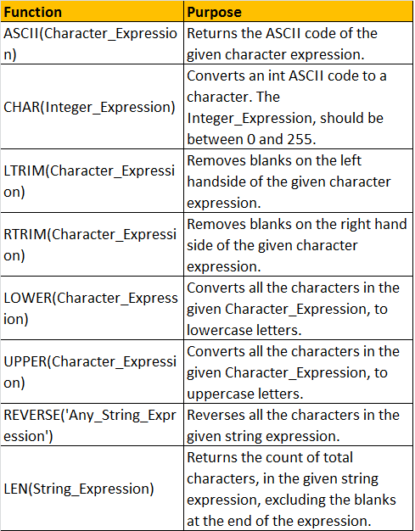

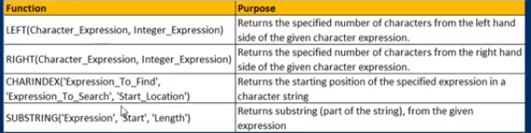

Also check out for below few functions

Replicate

Space

Patindex

Replace

Stuff

**14) Date Time Functions in MYSQL**

select current_timestamp();

select curdate();

select current_date();

select current_time();

select GETDATE();

select sysdate();

select GETUTCDATE();

select ISDATE(Getdate()); --is true

select day(getdate());

select dayname(getdate());

select dayofmonth(getdate());

select dayofweek(getdate());

select dayofyear(getdate());

select month(getdate());

select year(getdate());

select yearweek(getdate());

select month('2018-09-26');

datepart();dateadd(),datediff();

**date conversion functions in Oracle**

To_Date(),To_Char(),TO_NUMBER()

In mysql cast function is used for the same

**15) Mathematical Functions**

|  |  |
| --- | --- |
| **Name** | **Description** |
| [ABS()](https://docs.oracle.com/cd/E17952_01/mysql-5.0-en/mathematical-functions.html#function_abs) | Return the absolute value |
| [ACOS()](https://docs.oracle.com/cd/E17952_01/mysql-5.0-en/mathematical-functions.html#function_acos) | Return the arc cosine |
| [ASIN()](https://docs.oracle.com/cd/E17952_01/mysql-5.0-en/mathematical-functions.html#function_asin) | Return the arc sine |
| [ATAN()](https://docs.oracle.com/cd/E17952_01/mysql-5.0-en/mathematical-functions.html#function_atan) | Return the arc tangent |
| [ATAN2(), ATAN()](https://docs.oracle.com/cd/E17952_01/mysql-5.0-en/mathematical-functions.html#function_atan2) | Return the arc tangent of the two arguments |
| [CEIL()](https://docs.oracle.com/cd/E17952_01/mysql-5.0-en/mathematical-functions.html#function_ceil) | Return the smallest integer value not less than the argument |
| [CEILING()](https://docs.oracle.com/cd/E17952_01/mysql-5.0-en/mathematical-functions.html#function_ceiling) | Return the smallest integer value not less than the argument |
| [CONV()](https://docs.oracle.com/cd/E17952_01/mysql-5.0-en/mathematical-functions.html#function_conv) | Convert numbers between different number bases |
| [COS()](https://docs.oracle.com/cd/E17952_01/mysql-5.0-en/mathematical-functions.html#function_cos) | Return the cosine |
| [COT()](https://docs.oracle.com/cd/E17952_01/mysql-5.0-en/mathematical-functions.html#function_cot) | Return the cotangent |
| [CRC32()](https://docs.oracle.com/cd/E17952_01/mysql-5.0-en/mathematical-functions.html#function_crc32) | Compute a cyclic redundancy check value |
| [DEGREES()](https://docs.oracle.com/cd/E17952_01/mysql-5.0-en/mathematical-functions.html#function_degrees) | Convert radians to degrees |
| [EXP()](https://docs.oracle.com/cd/E17952_01/mysql-5.0-en/mathematical-functions.html#function_exp) | Raise to the power of |
| [FLOOR()](https://docs.oracle.com/cd/E17952_01/mysql-5.0-en/mathematical-functions.html#function_floor) | Return the largest integer value not greater than the argument |
| [LN()](https://docs.oracle.com/cd/E17952_01/mysql-5.0-en/mathematical-functions.html#function_ln) | Return the natural logarithm of the argument |
| [LOG()](https://docs.oracle.com/cd/E17952_01/mysql-5.0-en/mathematical-functions.html#function_log) | Return the natural logarithm of the first argument |
| [LOG10()](https://docs.oracle.com/cd/E17952_01/mysql-5.0-en/mathematical-functions.html#function_log10) | Return the base-10 logarithm of the argument |
| [LOG2()](https://docs.oracle.com/cd/E17952_01/mysql-5.0-en/mathematical-functions.html#function_log2) | Return the base-2 logarithm of the argument |
| [MOD()](https://docs.oracle.com/cd/E17952_01/mysql-5.0-en/mathematical-functions.html#function_mod) | Return the remainder |
| [PI()](https://docs.oracle.com/cd/E17952_01/mysql-5.0-en/mathematical-functions.html#function_pi) | Return the value of pi |
| [POW()](https://docs.oracle.com/cd/E17952_01/mysql-5.0-en/mathematical-functions.html#function_pow) | Return the argument raised to the specified power |
| [POWER()](https://docs.oracle.com/cd/E17952_01/mysql-5.0-en/mathematical-functions.html#function_power) | Return the argument raised to the specified power |
| [RADIANS()](https://docs.oracle.com/cd/E17952_01/mysql-5.0-en/mathematical-functions.html#function_radians) | Return argument converted to radians |
| [RAND()](https://docs.oracle.com/cd/E17952_01/mysql-5.0-en/mathematical-functions.html#function_rand) | Return a random floating-point value |
| [ROUND()](https://docs.oracle.com/cd/E17952_01/mysql-5.0-en/mathematical-functions.html#function_round) | Round the argument |
| [SIGN()](https://docs.oracle.com/cd/E17952_01/mysql-5.0-en/mathematical-functions.html#function_sign) | Return the sign of the argument |
| [SIN()](https://docs.oracle.com/cd/E17952_01/mysql-5.0-en/mathematical-functions.html#function_sin) | Return the sine of the argument |
| [SQRT()](https://docs.oracle.com/cd/E17952_01/mysql-5.0-en/mathematical-functions.html#function_sqrt) | Return the square root of the argument |
| [TAN()](https://docs.oracle.com/cd/E17952_01/mysql-5.0-en/mathematical-functions.html#function_tan) | Return the tangent of the argument |
| [TRUNCATE()](https://docs.oracle.com/cd/E17952_01/mysql-5.0-en/mathematical-functions.html#function_truncate) | Truncate to specified number of decimal places |

**Example**

1. select TO_DATE('2003/07/09', 'yyyy/mm/dd') from dual;

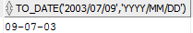

1. select to_char(sysdate,'yyyy-mm-dd') from dual;

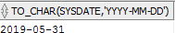

1. to char for particular date (lets say 1999-05-06)

WITH dates AS (

SELECT date'1999-05-06' d FROM dual

)

SELECT d "Original Date",

to_char(d, 'dd-mm-yyyy') "Day-Month-Year",

to_char(d, 'hh24:mi') "Time in 24-hr format",

to_char(d, 'iw-iyyy') "ISO Year and Week of Year"

FROM dates;



**16)**

## [**Execution sequence of Group By, Having and Where,order by clause in SQL Server?**](https://stackoverflow.com/questions/1130062/what-is-the-execution-sequence-of-group-by-having-and-where-clause-in-sql-serve) **[WGHOL] (wagholi)**

**FROM** & **JOIN**s determine & filter rows  
**WHERE** more filters on the rows  
**GROUP BY** combines those rows into groups  
**HAVING** filters groups  
**ORDER BY** arranges the remaining rows/groups  
**LIMIT** filters on the remaining rows/groups

**17)** [**What's the difference between HAVING and WHERE?**](https://stackoverflow.com/questions/287474/whats-the-difference-between-having-and-where)

## HAVING and WHERE

When GROUP BY is not used, HAVING behaves like a WHERE clause

HAVING: is used to check conditions after the aggregation takes place.  
WHERE: is used to check conditions before the aggregation takes place.

**1.** ***WHERE clause*** can be used with - Select, Insert, and Update statements, whereas ***HAVING clause*** can only be used with the Select statement.

**2.** ***WHERE*** filters rows before aggregation (GROUPING), whereas, ***HAVING*** filters groups, after the aggregations are performed.

**3.** Aggregate functions cannot be used in the ***WHERE clause***, unless it is in a sub query contained in a **HAVING clause**, whereas, aggregate functions can be used in Having clause.

**4.**From the performance point of view having is slower than where because it executes after aggregation

**18) difference between delete, truncate and drop**

## delete, truncate and drop

The DROP command removes a table from the database. All the tables' rows, indexes and privileges will also be removed. ...

DROP and TRUNCATE are DDL commands, whereas DELETE is a DML command.

DELETE operations can be rolled back (undone), while DROP and TRUNCATE operations cannot be rolled back

We cannot use where in Truncate command whereas where is used in delete

The DELETE statement removes rows one at a time

**What is Stored Procedure**

In a database management system (DBMS), a **stored procedure** is a set of **Structured Query Language** (**SQL**) statements with an assigned name that's **stored** in the database in compiled form so that it can be shared by several programs.

If you are writing same query over and over again then you can save that in stored procedure with given name

CREATE PROCEDURE spGetEmployees

AS

SELECT name,Gender FROM tblEmployee

END

Execute🡪 spGetEmployees

Drop proc spGetEmployees

**19) What is a View?**  
A view is nothing more than a**saved SQL query**. A view can also be considered as a **virtual table**.

Advantages

1. Security
2. Reduce the burden who is new to Db

## Stored Procedure and View difference

|  |  |  |
| --- | --- | --- |
| **S.No.** | **View** | **Stored Procedure** |
| 1 | Does not accepts parameters | Accept parameters |
| 2 | Can be used as a building block in large query. | Cannot be used as a building block in large query. |
| 3 | Can contain only one single Select query. | Can contain several statements like if, else, loop etc. |
| 4 | Cannot perform modification to any table. | Can perform modification to one or several tables. |
| 5 | Can be used (sometimes) as the target for Insert, update, delete queries. | Can not be used as the target for Insert, update, delete queries. |

**20) What is Functions in SQL**

**Functions** are computed values and cannot perform permanent environmental changes to **SQL** Server (i.e. no INSERT or UPDATE statements allowed). A **Function** can be used inline in **SQL** Statements if it returns a scalar value or can be joined upon if it returns a result set.

21) what is difference between count(*) and count(1) and count(0)

COUNT(*) will count the number of rows, while COUNT(expression) will count non-null values in expression

and COUNT(column) will count all non-null values in column. Since both 0 and 1 are non-null values,

COUNT(0)=COUNT(1) and they both will be equivalent to the number of rows COUNT(*)

22) what will output of select 1

It will print all the values as 1

## Why use functions instead of stored procedure in sql

we cannot perform DML operations using functions, We can use it to retrieve data only.  
  
But Interviewer asked me, Stored procedures could also retrieve data then why use functions.

We can use the function in select and where clause but cannot in stored procedure

Select date(); --we can use

Select sp__procedure –we cant

|  |  |
| --- | --- |
| **Stored Procedure** | **Functions** |
| 1.Can have both input / output parameters | 1.Can have only input parameters |
| 2. Stored procedure can’t call from the functions | 2.Functions can call from the stored procedures |
| 3.It’s optional to return the value, as somestimes it returns 0 or n values | 3.It’s should return the value |
| 4. It allows insert/update/delete/select | 4.It allows only select statement |
| 5.Procedures can’t be utilized in a select statement | 5.Function is embedded in a select statement |
| 6.Procedure cannot be used in SQL statements with WHERE/HAVING/SELECT | 6.SQL statements can be used with WHERE/HAVING/SELECT |
| 7. Exception can be handled by try-catch block | 7.Here, we can’t handle the exception, using try-catch block |

**Deterministic and Nondeterministic Functions:**  
Deterministic functions always return the **same result** any time they are called with a specific set of input values and given the same state of the database.   
**Examples**: Sum(), AVG(), Square(), Power() and Count()  
  
**Note**: All aggregate functions are deterministic functions.  
  
**Nondeterministic functions** may return **different results** each time they are called with a specific set of input values even if the database state that they access remains the same.  
**Examples**: GetDate() and CURRENT_TIMESTAMP  
  
Rand() function is a **Non-deterministic function**, but if you provide the **seed value**, the function becomes **deterministic**, as the same value gets returned for the same seed value.

**Temporary Tables (Its available for that session only)**

Temporary tables get created in the TempDB and are automatically deleted when they are no longer used.

Temporary Tables are a great feature that lets you store and process intermediate results by using the same selection, update, and join capabilities that you can use with typical SQL Server tables.

The temporary tables could be very useful in some cases to keep temporary data. The most important thing that should be known for temporary tables is that they will be deleted when the current client session terminates.

As stated earlier, temporary tables will only last if the session is alive.

Different Types of Temporary tables

1. Local Temporary Table (one #)  
   Create Table **#PersonDetails** (Id int, Name nvarchar(20))
2. Global Temporary Table: (Two ##)

Create Table **#EmployeeDetails** (Id int, Name nvarchar(20))

---In oracle below is the syntax to create the temp tables---

CREATE GLOBAL TEMPORARY TABLE tmptable as SELECT * FROM regions_coy;

---How to check temp table is present --

select table_name from all_tables where temporary = 'Y';

---insert in the temp tables is similar to other inserts

insert into TMPTABLE values (1,'abc');

## **What is Trigger**

A **trigger** is a special kind of stored procedure that automatically executes when an event occurs in the database **server**. DML **triggers** execute when a user tries to modify data through a data manipulation language (DML) event. DML events are INSERT, UPDATE, or DELETE statements on a table or view.

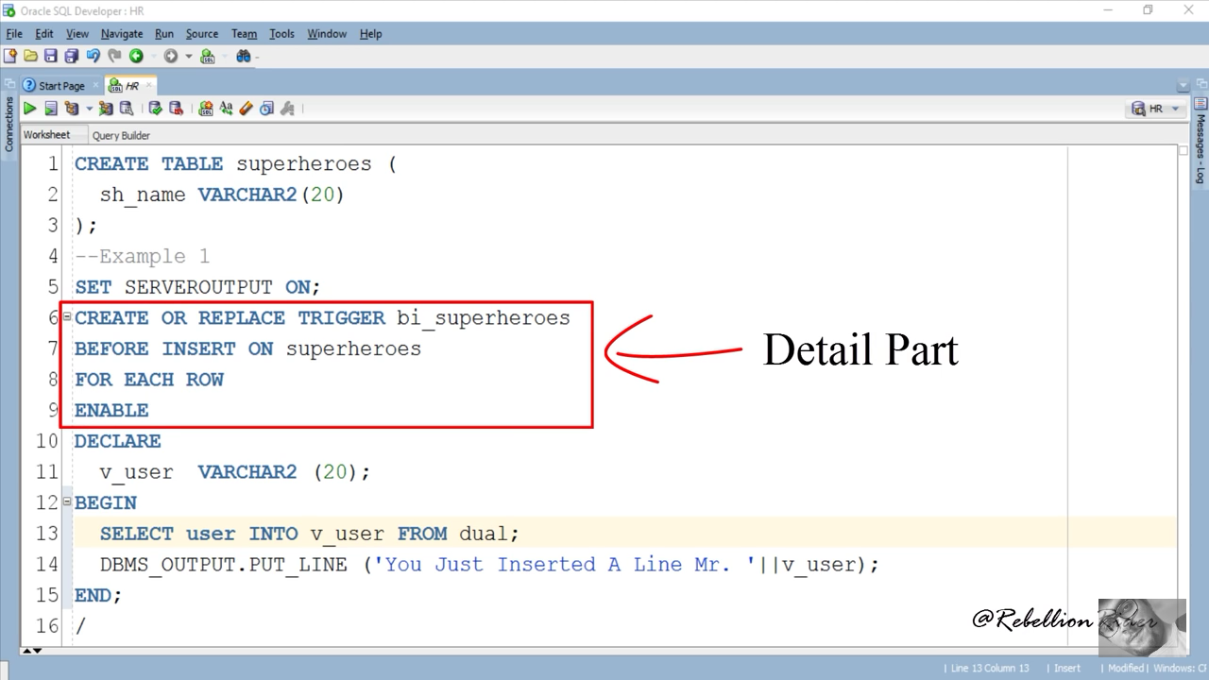

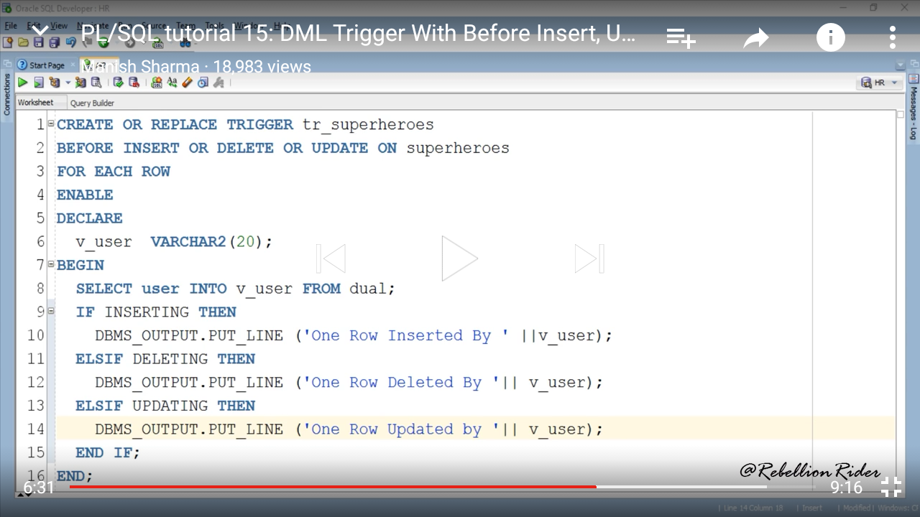

## **What is Cursor**

Cursor is pointer to memory area called context area and assigned to hold the information about the processing of a SELECT statement or DML statement

A **cursor** is a temporary work area created in the system memory when a **SQL**statement is executed. A **cursor** contains information on a select statement and the rows of data accessed by it. This temporary work area is used to store the data retrieved from the database and manipulate this data.

**if there is ever a need to process the rows, on a row-by-row basis**, then cursors are your choice. Performance of the cursor is not good as join

Ex.Rows returned by query

Number of rows processed by a query

Steps Of creating explicit Cursor

Declare

Open

Fetch

Close

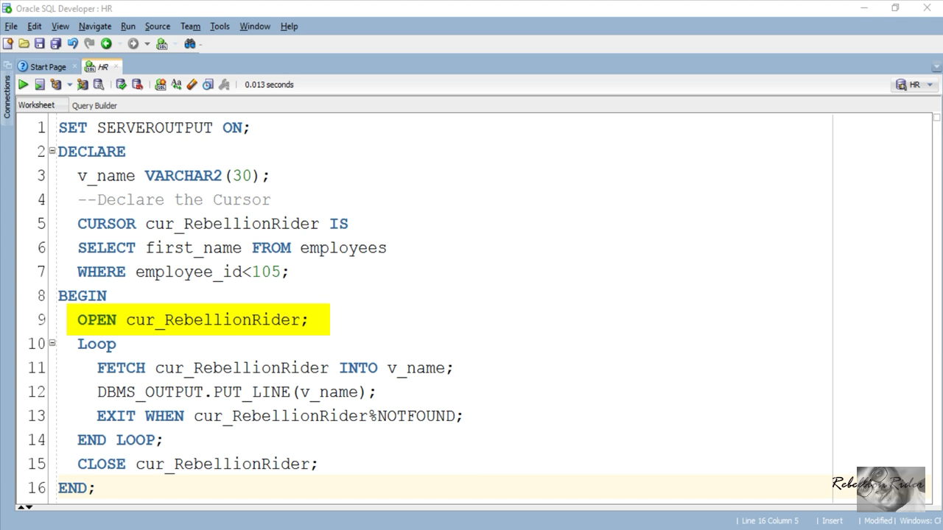

***What is foreign key constraint violation***

If you are entering the data in the foreign key table which is not matching or not related to the primary key data that time you will get the exception. Data is verified due to foreign key constraint. So we need to data integrity

***When to use the check_contraint***

Suppose there is column say “age” and you want the add value to that column but in that you can not add negative value because ‘age’ not is negative value so in that case check_contraint is used for that column.

Its Boolean value which will return true or false.

If it is true then value is allowed to add

If it is false then value is not allowed to add

If it is set and inserting the wrong value then you will throw an error “insert statement conflicted with the check constraints ‘’ the conflict occurred in database ‘DB_name’ table ‘table_name’”

Add constraint

Alter table “table name” add constraint “constaint_name” check <AGE > 0 AND AGE <150>

Remove constraint

Alter table “table name” Drop constaint “constaintname”

***How to assign primary key value automatically***

[IDENTITY](http://docs.oracle.com/database/121/DRDAA/migr_tools_feat.htm#DRDAA109) columns were introduced in Oracle 12c, allowing for simple auto increment functionality in modern versions of Oracle.

create table "table_name"

{

id int identity(1,1) primary key

}

if you insert the value manually after setting "Identity Column" then you will get an error

"An expplicit value for the identity column in table "table_name"

can only be specified when a column list is used and IDENTITY insert is on

SET IDENTITY_INSERT "table_name" ON

SET IDENTITY_INSERT "table_name" OFF

**What is mean by distinct \***

Value should be distinct across all the columns

**What is difference between unique and distinct**

UNIQUE(Constraint):- Can be only once for a column in a   
table

DISTINCT(Clause):- Used in select query to retrieve distinct  
(non repeated) data from table(s)

SELECT DISTINCT and SELECT UNIQUE behave the same way in oracle.

While DISTINCT is ANSI SQL standard, UNIQUE is an Oracle specific statement.

**What will be the output of the below command**

Select * from “table_name” where name like ‘[ABC]’

It will give output whose name starts with A,B and C

**How to create the table from existing table**

CREATE TABLE table_name AS

SELECT * from table

**How to create the table structure from existing table**

CREATE TABLE table_name AS

SELECT * from table where 1=2

## How to find the database performance issue

--using the explain plan in oracle. check the cost of the query and also check if any parallel query is running at the same time

Database performance issues are a common cause of web application bottlenecks. Most of these problems boil down to a lack of indexing, inefficient queries, and the misuse of data types, which can all be easily fixed. The challenge is identifying them before they reach production.

=====================================================

# **ITIL**

## **What is ITIL?**

The ITIL (Information Technology Infrastructure Library) is a framework designed to standardize the selection, planning, delivery, and maintenance of IT services within a business. The goal is to improve efficiency and achieve predictable service delivery.

## **What are the benefits and advantages of ITIL?**

Organizational benefits of adopting ITIL best practices include:

Improved service delivery and customer satisfaction

* ITIL is proven and used worldwide
* Reduced costs through improved use of resources
* Greater visibility of IT costs and assets
* Better management of business risk and service disruption or failure
* More stable service environment to support constant business change

**What is the incident management?**

Incident management is the activity to identify, analyze, and right issues to avoid the same occurrence in future. It dealt with either an incident response team or an incident management team.

## **Incident Vs Problem**

**What is an Incident?**

An incident is an event that leads to an unplanned disruption of service.

## **What is a Problem?**

A problem is the underlying cause that leads to an incident. A problem may be something that could lead to the same incident occurring again, or lead to another incident entirely. The problem is essentially the root cause of an incident or incidents.

## **Type Of changes**

* **Standard**: a pre-authorized change that is low risk, relatively common, and follows a procedure or work instruction
* **Emergency**: A change that must be implemented as soon as possible, for example, to resolve a major Incident or implement a security patch.
* **Normal**: Any service change that is not a Standard or Emergency Change. Predefined plans which require approval and CAB authorisation
* **Escalated** -A Change that must be approved or implemented outside of the Normal Change process or window, but is not an Emergency Change, is an Escalated Change.
* **Expedited changes –** changes that are required quickly due to a pressing need such as legal requirement or a business need but are not related to restoring service

## **Change Management Process**

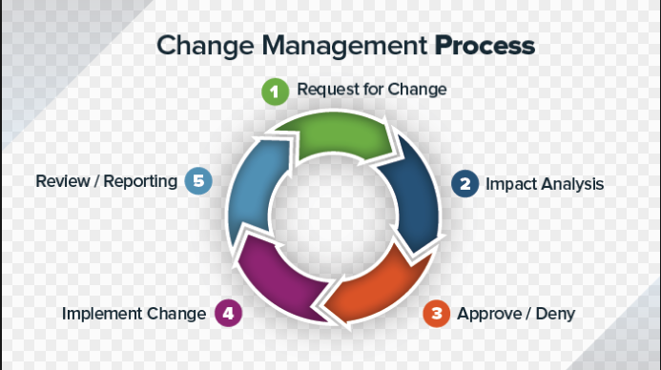

**The incident processes**

* Incident identification
* Incident logging
* Incident categorization
* Incident prioritization
* Incident response
* Initial diagnosis
* Incident escalation
* Investigation and diagnosis
* Resolution and recovery
* Incident closure

## **Difference between priority and severity**

**Priority** means how fast it must be fixed. **Priority** is related to scheduling to resolve the problem. **Severity** means how severe it is affecting the functionality.

**High Priority**, **Low Severity bug** :- If the company name is misspelled in the home page of the website,then the **priority** is **high** and **severity** is **low** to fix it. **High Severity**, **Low Priority** :- Web page not found when user clicks on a link

Priority depends upon impact and urgency

**==================================================**